As filed with the Securities and Exchange Commission on August 4, 2026
Registration No. 333
_____________________________________________________________________________________________
UNITED STATES
SECURITIES AND EXCHANGE COMMISSION
WASHINGTON, DC 20549
_____________________________________________________________________________________________
FORM S-8
REGISTRATION STATEMENT UNDER THE SECURITIES ACT OF 1933
____________________________________________________________________________________
COCA-COLA EUROPACIFIC PARTNERS PLC
(Exact name of registrant as specified in its charter)
_____________________________________________________________________________________________

England and Wales 98-1267571
(State or other jurisdiction of (I.R.S. Employer
incorporation or organization) Identification No.)

Pemberton House, Bakers Road
Uxbridge, UB8 1EZ, United Kingdom
+44 (0)1895 231 313
(Address, including zip code, and telephone number of registrant’s principal executive offices)
_____________________________________________________________________________________________

Amended and Restated Rules and Trust Deed of the Coca-Cola Europacific Partners plc UK Share Plan
Rules of the Coca-Cola Europacific Partners plc Employee Share Purchase Plan
(Full title of the plans)
____________________________________________________________________________________
The Corporation Trust Company
Corporate Trust Center
1209 Orange St.
Wilmington, DE 19801
(Name and address of agent for service)

(800) 677-3394
(Telephone number, including area code, of agent for service)
____________________________________________________________________________________
Indicate by check mark whether the registrant is a large accelerated filer, an accelerated filer, a non-accelerated filer, a smaller reporting company, or an emerging growth company. See the definitions of “large accelerated filer,” “accelerated filer”, “smaller reporting company” and “emerging growth company” in Rule 12b-2 of the Exchange Act.

Large accelerated filer |  |  | x |  |  | Accelerated filer |  |  | o
Non-accelerated filer |  |  | o |  |  | Smaller reporting company |  |  | o
 |  |  |  |  |  | Emerging growth company |  |  | o
If an emerging growth company, indicate by check mark if the registrant has elected not to use the extended transition period for complying with any new or revised financial accounting standards provided pursuant to Section 7(a)(2)(B) of Securities Act. o

EXPLANATORY NOTE

This registration statement is being filed by Coca-Cola Europacific Partners plc (the “Registrant”) pursuant to General Instruction E of Form S-8 in connection with (i) the Amended and Restated Rules and Trust Deed of the Coca-Cola Europacific Partners plc UK Share Plan (as so amended and restated to date, the “Amended UK Share Plan”) and (ii) the Rules of the Coca-Cola Europacific Partners plc Employee Share Purchase Plan (as so amended to date, the “Amended ESPP”), to cover an additional 1,300,000 and 6,100,000 ordinary shares of the Registrant, €0.01 nominal value per share (the “Ordinary Shares”), reserved for issuance under the Amended UK Share Plan and the Amended ESPP, respectively. These Ordinary Shares are additional securities of the same class as other securities for which a previous registration statement on Form S-8 (File No. 333-233695) was filed on September 10, 2019 (the “Original Form S-8”), with the Securities and Exchange Commission (the “Commission”) relating to these plans.

Pursuant to General Instruction E to Form S-8, the contents of such registration statement are incorporated herein by reference and made a part hereof, except to the extent supplemented, amended or superseded by the information set forth herein.

This registration statement registers only the additional securities described above and does not otherwise modify or update the prior registration statement.

PART I

INFORMATION REQUIRED IN THE SECTION 10(a) PROSPECTUS

The document(s) containing the information specified in Part I are not required to be filed with the U.S. Securities and Exchange Commission (the “SEC” or the “Commission”) as part of this Registration Statement in accordance with Rule 428 of the Securities Act of 1933, as amended (the “Securities Act”), and will be delivered to participants in accordance with such rule.

PART II

INFORMATION REQUIRED IN THE REGISTRATION STATEMENT

Item 8. Exhibits

Exhibit No. |  |  | Description
4.1 |  |  | Amended and Restated Rules and Trust Deed of the Coca-Cola Europacific Partners plc UK Share Plan, as amended and restated as of 30 April 2025*
4.2 |  |  | Coca-Cola Europacific Partners plc Employee Share Purchase Plan, as amended as of 14 November 2025*
5.1 |  |  | Opinion of Slaughter and May regarding legality*
23.1 |  |  | Consent of Independent Registered Public Accounting Firm*
24.1 |  |  | Power of Attorney*
107 |  |  | Filing Fee Table*
* Filed herewith.

SIGNATURES

Pursuant to the requirements of the Securities Act of 1933, the Registrant certifies that it has reasonable grounds to believe that it meets all of the requirements for filing on Form S-8 and has duly caused this registration statement to be signed on its behalf by the undersigned, thereunto duly authorized, in the City of Uxbridge, Middlesex, United Kingdom, on August 4, 2026.
Coca-Cola Europacific Partners plc
By: /s/ Svetlana Walker
Name: Svetlana Walker
Title: General Counsel & Company Secretary

Each person whose signature appears below constitutes and appoints Svetlana Walker as his or her attorney-in-fact and agent, to sign one or more registration statements on Form S-8 and any or all amendments (including post-effective amendments) to such registration statements in connection with the registration under the U.S. Securities Act of 1933, as amended, of ordinary shares of Coca-Cola Europacific Partners plc (the “Company”) pursuant to the Coca-Cola Europacific Partners plc UK Share Plan and the Coca-Cola Europacific Partners plc Employee Share Purchase Plan, and to file the same, with all exhibits thereto, and other documents in connection therewith, with the U.S. Securities and Exchange Commission, granting to said attorney-in-fact and agent full power and authority to perform any act in connection with any of the foregoing as fully to all intents and purposes as he or she might do in person, hereby ratifying and confirming all that said attorney-in-fact and agent may lawfully do or cause to be done by virtue hereof. Each attorney-in-fact and agent is hereby granted full power of substitution and revocation with respect hereto.

Pursuant to the requirements of the Securities Act, this registration statement has been signed by the following persons in the capacities indicated on August 4, 2026.

Signature |  |  | Title |  |  | Date
/s/ *  Damian Gammell |  |  | Chief Executive Officer and Director  (Principal executive officer) |  |  | August 4, 2026
/s/ *  Ed Walker |  |  | Chief Financial Officer  (Principal financial officer) |  |  | August 4, 2026
/s/ *  Ivan Stoykov |  |  | Chief Accounting Officer  (Principal accounting officer) |  |  | August 4, 2026
/s/ *  Sol Daurella |  |  | Chairman and Director |  |  | August 4, 2026
/s/ *  Rob Appleby |  |  | Director |  |  | August 4, 2026
/s/ *  Manolo Arroyo |  |  | Director |  |  | August 4, 2026
/s/ *  John Bryant |  |  | Director |  |  | August 4, 2026
/s/ *  José Ignacio Comenge |  |  | Director |  |  | August 4, 2026

/s/ *  Laurence Debroux |  |  | Director |  |  | August 4, 2026
/s/ *  Nathalie Gaveau |  |  | Director |  |  | August 4, 2026
/s/ *  Álvaro Gómez-Trénor Aguilar |  |  | Director |  |  | August 4, 2026
/s/ *  Mary Harris |  |  | Director |  |  | August 4, 2026
/s/ *  Alfonso Líbano Daurella |  |  | Director |  |  | August 4, 2026
/s/ *  Nicolas Mirzayantz |  |  | Director |  |  | August 4, 2026
/s/ *  Mark Price |  |  | Director |  |  | August 4, 2026
/s/ *  Mario Rotllant Solá |  |  | Director |  |  | August 4, 2026
/s/ *  Nancy Quan |  |  | Director |  |  | August 4, 2026
/s/ *  Uvashni Raman |  |  | Director |  |  | August 4, 2026
/s/ *  Dessi Temperley |  |  | Director |  |  | August 4, 2026
* By: /s/ Svetlana Walker
Svetlana Walker, Attorney-in-Fact

AUTHORIZED REPRESENTATIVE

Pursuant to the requirements of Section 6(a) of the Securities Act of 1933, the Authorized Representative has duly caused this Registration Statement to be signed on its behalf by the undersigned, solely in its capacity as the duly authorized representative of Coca-Cola Europacific Partners plc in the United States, in the City of Newark, Delaware, on the 4th day of August, 2026.

Authorized Representative
Puglisi & Associates
By: /s/ Donald J. Puglisi
Name: Donald J. Puglisi
Title: Managing Director of Puglisi & Associates

Calculation of Filing Fee Tables
S-8
COCA-COLA EUROPACIFIC PARTNERS plc
Table 1: Newly Registered Securities
 | Security Type | Security Class Title | Fee Calculation Rule | Amount Registered | Proposed Maximum Offering Price Per Unit | Maximum Aggregate Offering Price | Fee Rate | Amount of Registration Fee
1 | Equity | Ordinary Shares, par value EUR 0.01 per share | Other | 1,300,000 | $ 111.06 | $ 144,378,000.00 | 0.0001381 | $ 19,938.60
2 | Equity | Ordinary Shares, par value EUR 0.01 per share | Other | 6,100,000 | $ 111.06 | $ 677,466,000.00 | 0.0001381 | $ 93,558.05
Total Offering Amounts: |  |  |  |  |  | $ 821,844,000.00 |  | $ 113,496.65
Total Fee Offsets: |  |  |  |  |  |  |  | $ 0.00
Net Fee Due: |  |  |  |  |  |  |  | $ 113,496.65
Offering Note
1 | Represents an increase of 1,300,000 ordinary shares, EUR 0.01 nominal value per share (Ordinary Shares), of Coca-Cola Europacific Partners plc (the Registrant) to be issued under the Amended and Restated Rules and Trust Deed of the Coca-Cola Europacific Partners plc UK Share Plan as amended and restated to date (the Amended UK Share Plan). Ordinary Shares available for issuance under the original Coca-Cola Europacific Partners plc UK Share Plan were previously registered on a Registration Statement on Form S-8 filed with the Securities and Exchange Commission on September 10, 2019 (File No. 333-233695) (the Original Form S-8). Pursuant to Rule 416(c) (Rule 416(c)) under the Securities Act of 1933, as amended (the Securities Act), this Registration Statement also covers an indeterminate number of Ordinary Shares under the Amended UK Share Plan which may be offered or issued by reason of stock splits, stock dividends or similar transactions effected without the receipt of consideration which results in an increase in the number of outstanding Ordinary Shares. Estimated in accordance with Rule 457(c) and (h) under the Securities Act, solely for the purpose of calculating the registration fee on basis of $111.06, the average of the high and low prices of the Ordinary Shares, as quoted on the Nasdaq Global Select Market on 29 July 2026.
2 | Represents an increase of 6,100,000 Ordinary Shares to be issued under the Rules of the Coca-Cola Europacific Partners plc Employee Share Purchase Plan as amended to date (the Amended ESPP). Ordinary Shares available for issuance under the original Coca-Cola Europacific Partners plc Employee Share Purchase Plan were previously registered on the Original Form S-8. Pursuant to Rule 416(c), this Registration Statement also covers an indeterminate number of Ordinary Shares under the Amended ESPP which may be offered or issued by reason of stock splits, stock dividends or similar transactions effected without the receipt of consideration which results in an increase in the number of outstanding Ordinary Shares. Estimated in accordance with Rule 457(c) and (h) under the Securities Act, solely for the purpose of calculating the registration fee on basis of $111.06, the average of the high and low prices of the Ordinary Shares, as quoted on the Nasdaq Global Select Market on 29 July 2026.
Table 2: Fee Offset Claims and Sources | ☑Not Applicable
 |  | Registrant or Filer Name | Form or Filing Type | File Number | Initial Filing Date | Filing Date | Fee Offset Claimed | Security Type Associated with Fee Offset Claimed | Security Title Associated with Fee Offset Claimed | Unsold Securities Associated with Fee Offset Claimed | Unsold Aggregate Offering Amount Associated with Fee Offset Claimed | Fee Paid with Fee Offset Source
Rule 457(p)
Fee Offset Claims
Fee Offset Sources
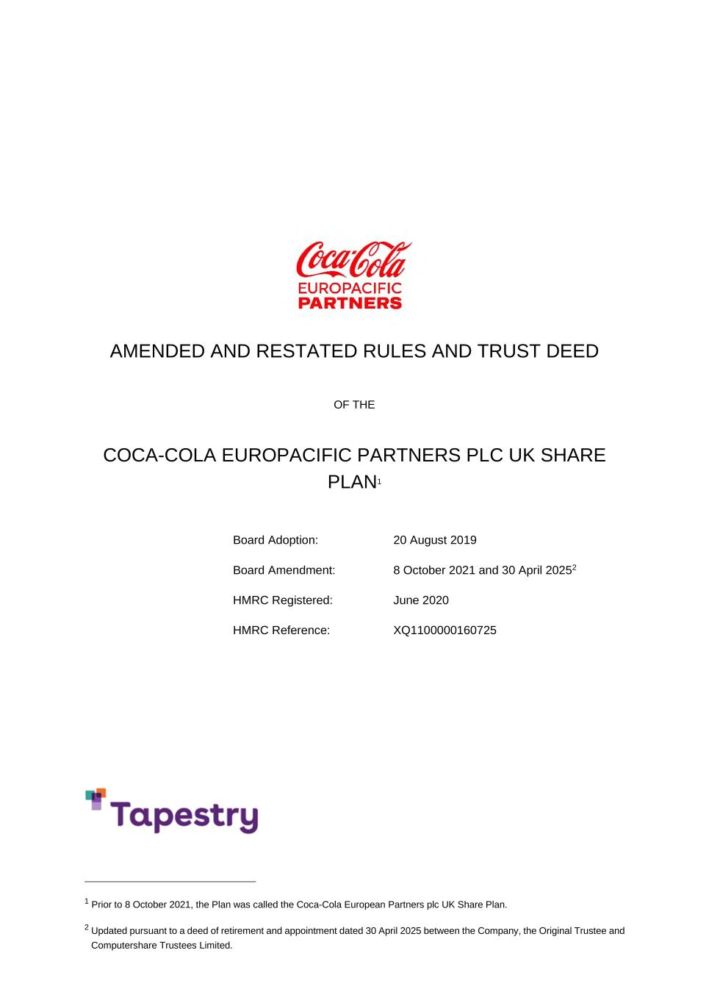
AMENDED AND RESTATED RULES AND TRUST DEED OF THE COCA-COLA EUROPACIFIC PARTNERS PLC UK SHARE PLAN1 Board Adoption: 20 August 2019 Board Amendment: 8 October 2021 and 30 April 20252 HMRC Registered: June 2020 HMRC Reference: XQ1100000160725 1 Prior to 8 October 2021, the Plan was called the Coca-Cola European Partners plc UK Share Plan. 2 Updated pursuant to a deed of retirement and appointment dated 30 April 2025 between the Company, the Original Trustee and Computershare Trustees Limited.

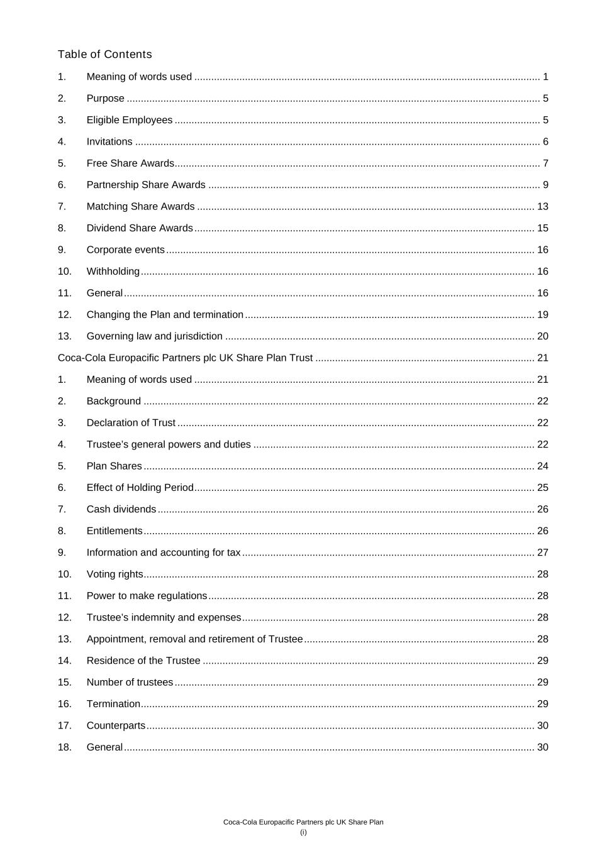
Coca-Cola Europacific Partners plc UK Share Plan (i) Table of Contents 1. Meaning of words used ........................................................................................................................... 1 2. Purpose ................................................................................................................................................... 5 3. Eligible Employees .................................................................................................................................. 5 4. Invitations ................................................................................................................................................ 6 5. Free Share Awards.................................................................................................................................. 7 6. Partnership Share Awards ...................................................................................................................... 9 7. Matching Share Awards ........................................................................................................................ 13 8. Dividend Share Awards ......................................................................................................................... 15 9. Corporate events ................................................................................................................................... 16 10. Withholding ............................................................................................................................................ 16 11. General .................................................................................................................................................. 16 12. Changing the Plan and termination ....................................................................................................... 19 13. Governing law and jurisdiction .............................................................................................................. 20 Coca-Cola Europacific Partners plc UK Share Plan Trust .............................................................................. 21 1. Meaning of words used ......................................................................................................................... 21 2. Background ........................................................................................................................................... 22 3. Declaration of Trust ............................................................................................................................... 22 4. Trustee’s general powers and duties .................................................................................................... 22 5. Plan Shares ........................................................................................................................................... 24 6. Effect of Holding Period ......................................................................................................................... 25 7. Cash dividends ...................................................................................................................................... 26 8. Entitlements ........................................................................................................................................... 26 9. Information and accounting for tax ........................................................................................................ 27 10. Voting rights ........................................................................................................................................... 28 11. Power to make regulations .................................................................................................................... 28 12. Trustee’s indemnity and expenses ........................................................................................................ 28 13. Appointment, removal and retirement of Trustee .................................................................................. 28 14. Residence of the Trustee ...................................................................................................................... 29 15. Number of trustees ................................................................................................................................ 29 16. Termination ............................................................................................................................................ 29 17. Counterparts .......................................................................................................................................... 30 18. General .................................................................................................................................................. 30

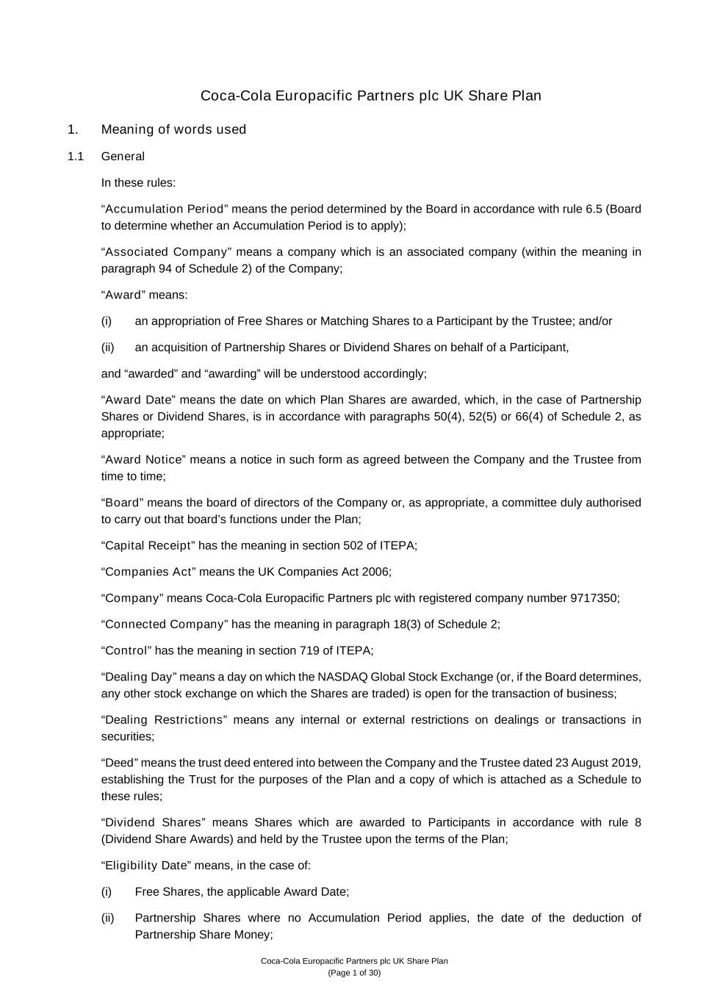
Coca-Cola Europacific Partners plc UK Share Plan (Page 1 of 30) Coca-Cola Europacific Partners plc UK Share Plan 1. Meaning of words used 1.1 General In these rules: “Accumulation Period” means the period determined by the Board in accordance with rule 6.5 (Board to determine whether an Accumulation Period is to apply); “Associated Company” means a company which is an associated company (within the meaning in paragraph 94 of Schedule 2) of the Company; “Award” means: (i) an appropriation of Free Shares or Matching Shares to a Participant by the Trustee; and/or (ii) an acquisition of Partnership Shares or Dividend Shares on behalf of a Participant, and “awarded” and “awarding” will be understood accordingly; “Award Date” means the date on which Plan Shares are awarded, which, in the case of Partnership Shares or Dividend Shares, is in accordance with paragraphs 50(4), 52(5) or 66(4) of Schedule 2, as appropriate; “Award Notice” means a notice in such form as agreed between the Company and the Trustee from time to time; “Board” means the board of directors of the Company or, as appropriate, a committee duly authorised to carry out that board’s functions under the Plan; “Capital Receipt” has the meaning in section 502 of ITEPA; “Companies Act” means the UK Companies Act 2006; “Company” means Coca-Cola Europacific Partners plc with registered company number 9717350; “Connected Company” has the meaning in paragraph 18(3) of Schedule 2; “Control” has the meaning in section 719 of ITEPA; “Dealing Day” means a day on which the NASDAQ Global Stock Exchange (or, if the Board determines, any other stock exchange on which the Shares are traded) is open for the transaction of business; “Dealing Restrictions” means any internal or external restrictions on dealings or transactions in securities; “Deed” means the trust deed entered into between the Company and the Trustee dated 23 August 2019, establishing the Trust for the purposes of the Plan and a copy of which is attached as a Schedule to these rules; “Dividend Shares” means Shares which are awarded to Participants in accordance with rule 8 (Dividend Share Awards) and held by the Trustee upon the terms of the Plan; “Eligibility Date” means, in the case of: (i) Free Shares, the applicable Award Date; (ii) Partnership Shares where no Accumulation Period applies, the date of the deduction of Partnership Share Money;

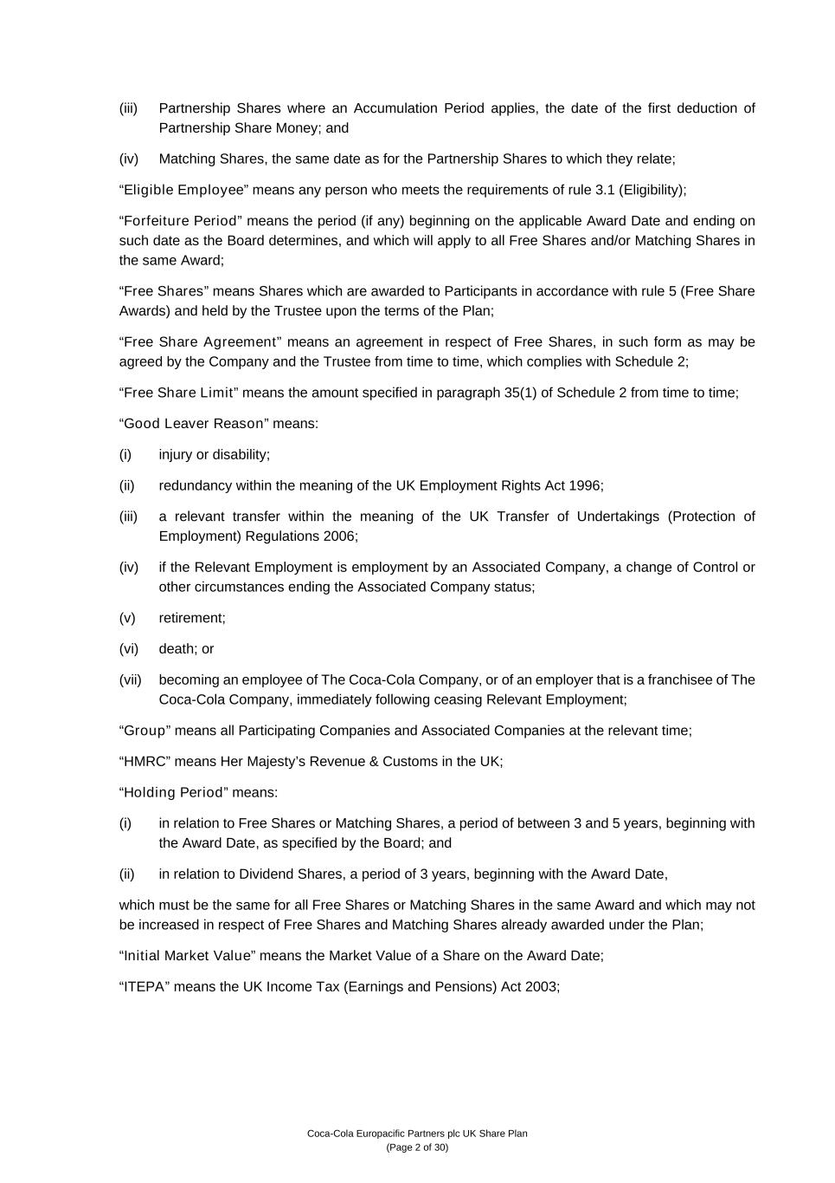
Coca-Cola Europacific Partners plc UK Share Plan (Page 2 of 30) (iii) Partnership Shares where an Accumulation Period applies, the date of the first deduction of Partnership Share Money; and (iv) Matching Shares, the same date as for the Partnership Shares to which they relate; “Eligible Employee” means any person who meets the requirements of rule 3.1 (Eligibility); “Forfeiture Period” means the period (if any) beginning on the applicable Award Date and ending on such date as the Board determines, and which will apply to all Free Shares and/or Matching Shares in the same Award; “Free Shares” means Shares which are awarded to Participants in accordance with rule 5 (Free Share Awards) and held by the Trustee upon the terms of the Plan; “Free Share Agreement” means an agreement in respect of Free Shares, in such form as may be agreed by the Company and the Trustee from time to time, which complies with Schedule 2; “Free Share Limit” means the amount specified in paragraph 35(1) of Schedule 2 from time to time; “Good Leaver Reason” means: (i) injury or disability; (ii) redundancy within the meaning of the UK Employment Rights Act 1996; (iii) a relevant transfer within the meaning of the UK Transfer of Undertakings (Protection of Employment) Regulations 2006; (iv) if the Relevant Employment is employment by an Associated Company, a change of Control or other circumstances ending the Associated Company status; (v) retirement; (vi) death; or (vii) becoming an employee of The Coca-Cola Company, or of an employer that is a franchisee of The Coca-Cola Company, immediately following ceasing Relevant Employment; “Group” means all Participating Companies and Associated Companies at the relevant time; “HMRC” means Her Majesty’s Revenue & Customs in the UK; “Holding Period” means: (i) in relation to Free Shares or Matching Shares, a period of between 3 and 5 years, beginning with the Award Date, as specified by the Board; and (ii) in relation to Dividend Shares, a period of 3 years, beginning with the Award Date, which must be the same for all Free Shares or Matching Shares in the same Award and which may not be increased in respect of Free Shares and Matching Shares already awarded under the Plan; “Initial Market Value” means the Market Value of a Share on the Award Date; “ITEPA” means the UK Income Tax (Earnings and Pensions) Act 2003;

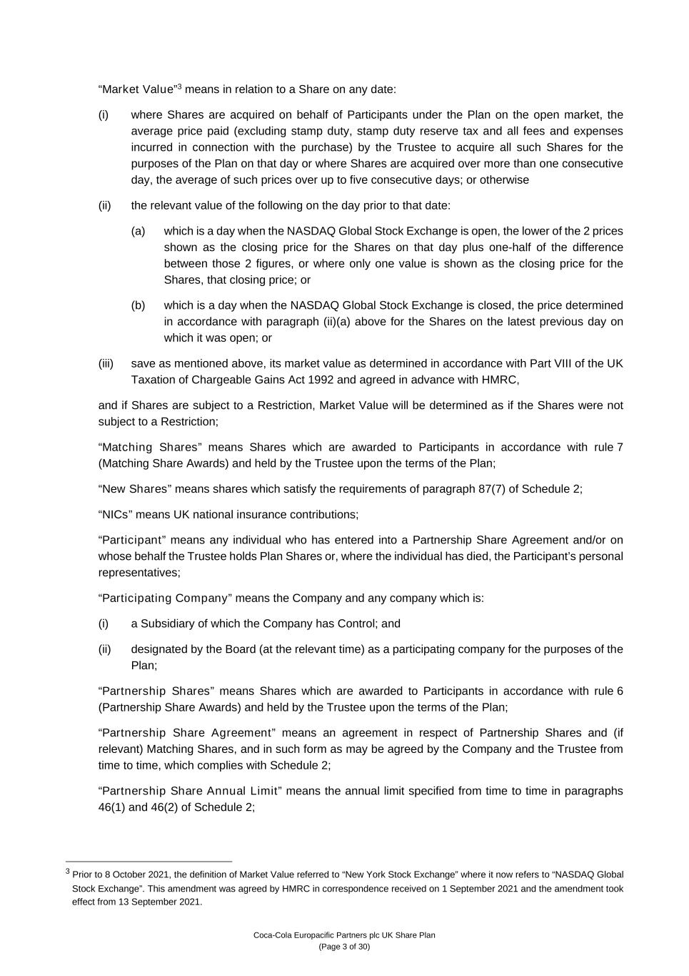
Coca-Cola Europacific Partners plc UK Share Plan (Page 3 of 30) “Market Value”3 means in relation to a Share on any date: (i) where Shares are acquired on behalf of Participants under the Plan on the open market, the average price paid (excluding stamp duty, stamp duty reserve tax and all fees and expenses incurred in connection with the purchase) by the Trustee to acquire all such Shares for the purposes of the Plan on that day or where Shares are acquired over more than one consecutive day, the average of such prices over up to five consecutive days; or otherwise (ii) the relevant value of the following on the day prior to that date: (a) which is a day when the NASDAQ Global Stock Exchange is open, the lower of the 2 prices shown as the closing price for the Shares on that day plus one-half of the difference between those 2 figures, or where only one value is shown as the closing price for the Shares, that closing price; or (b) which is a day when the NASDAQ Global Stock Exchange is closed, the price determined in accordance with paragraph (ii)(a) above for the Shares on the latest previous day on which it was open; or (iii) save as mentioned above, its market value as determined in accordance with Part VIII of the UK Taxation of Chargeable Gains Act 1992 and agreed in advance with HMRC, and if Shares are subject to a Restriction, Market Value will be determined as if the Shares were not subject to a Restriction; “Matching Shares” means Shares which are awarded to Participants in accordance with rule 7 (Matching Share Awards) and held by the Trustee upon the terms of the Plan; “New Shares” means shares which satisfy the requirements of paragraph 87(7) of Schedule 2; “NICs” means UK national insurance contributions; “Participant” means any individual who has entered into a Partnership Share Agreement and/or on whose behalf the Trustee holds Plan Shares or, where the individual has died, the Participant’s personal representatives; “Participating Company” means the Company and any company which is: (i) a Subsidiary of which the Company has Control; and (ii) designated by the Board (at the relevant time) as a participating company for the purposes of the Plan; “Partnership Shares” means Shares which are awarded to Participants in accordance with rule 6 (Partnership Share Awards) and held by the Trustee upon the terms of the Plan; “Partnership Share Agreement” means an agreement in respect of Partnership Shares and (if relevant) Matching Shares, and in such form as may be agreed by the Company and the Trustee from time to time, which complies with Schedule 2; “Partnership Share Annual Limit” means the annual limit specified from time to time in paragraphs 46(1) and 46(2) of Schedule 2; 3 Prior to 8 October 2021, the definition of Market Value referred to “New York Stock Exchange” where it now refers to “NASDAQ Global Stock Exchange”. This amendment was agreed by HMRC in correspondence received on 1 September 2021 and the amendment took effect from 13 September 2021.

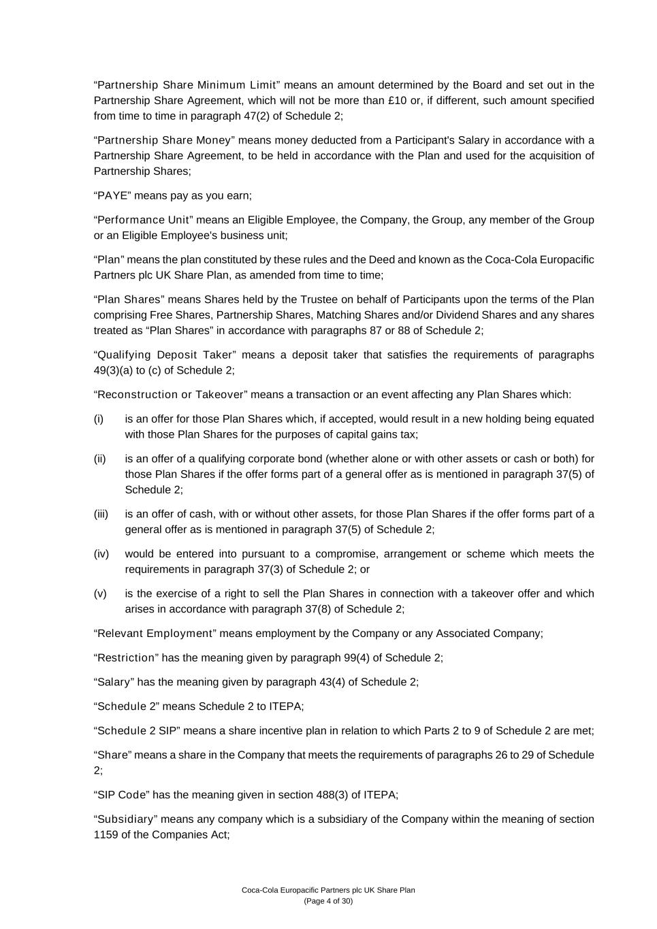
Coca-Cola Europacific Partners plc UK Share Plan (Page 4 of 30) “Partnership Share Minimum Limit” means an amount determined by the Board and set out in the Partnership Share Agreement, which will not be more than £10 or, if different, such amount specified from time to time in paragraph 47(2) of Schedule 2; “Partnership Share Money” means money deducted from a Participant's Salary in accordance with a Partnership Share Agreement, to be held in accordance with the Plan and used for the acquisition of Partnership Shares; “PAYE” means pay as you earn; “Performance Unit” means an Eligible Employee, the Company, the Group, any member of the Group or an Eligible Employee's business unit; “Plan” means the plan constituted by these rules and the Deed and known as the Coca-Cola Europacific Partners plc UK Share Plan, as amended from time to time; “Plan Shares” means Shares held by the Trustee on behalf of Participants upon the terms of the Plan comprising Free Shares, Partnership Shares, Matching Shares and/or Dividend Shares and any shares treated as “Plan Shares” in accordance with paragraphs 87 or 88 of Schedule 2; “Qualifying Deposit Taker” means a deposit taker that satisfies the requirements of paragraphs 49(3)(a) to (c) of Schedule 2; “Reconstruction or Takeover” means a transaction or an event affecting any Plan Shares which: (i) is an offer for those Plan Shares which, if accepted, would result in a new holding being equated with those Plan Shares for the purposes of capital gains tax; (ii) is an offer of a qualifying corporate bond (whether alone or with other assets or cash or both) for those Plan Shares if the offer forms part of a general offer as is mentioned in paragraph 37(5) of Schedule 2; (iii) is an offer of cash, with or without other assets, for those Plan Shares if the offer forms part of a general offer as is mentioned in paragraph 37(5) of Schedule 2; (iv) would be entered into pursuant to a compromise, arrangement or scheme which meets the requirements in paragraph 37(3) of Schedule 2; or (v) is the exercise of a right to sell the Plan Shares in connection with a takeover offer and which arises in accordance with paragraph 37(8) of Schedule 2; “Relevant Employment” means employment by the Company or any Associated Company; “Restriction” has the meaning given by paragraph 99(4) of Schedule 2; “Salary” has the meaning given by paragraph 43(4) of Schedule 2; “Schedule 2” means Schedule 2 to ITEPA; “Schedule 2 SIP” means a share incentive plan in relation to which Parts 2 to 9 of Schedule 2 are met; “Share” means a share in the Company that meets the requirements of paragraphs 26 to 29 of Schedule 2; “SIP Code” has the meaning given in section 488(3) of ITEPA; “Subsidiary” means any company which is a subsidiary of the Company within the meaning of section 1159 of the Companies Act;

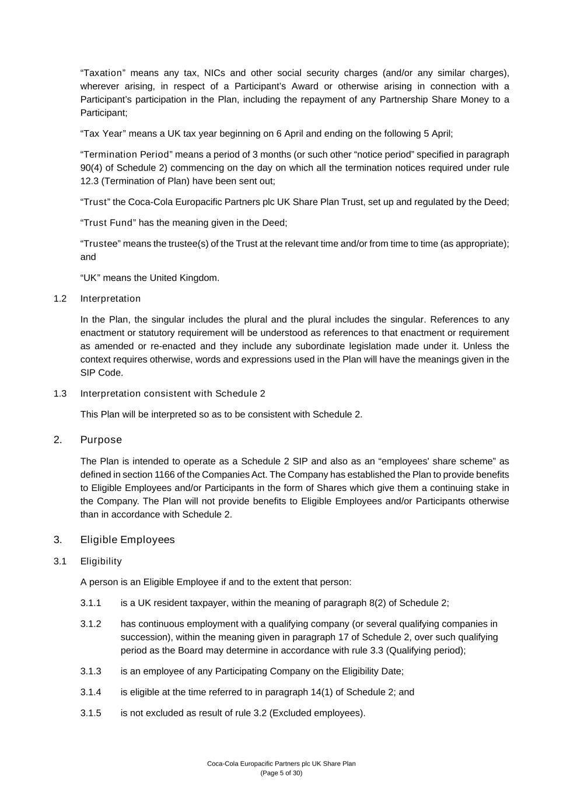
Coca-Cola Europacific Partners plc UK Share Plan (Page 5 of 30) “Taxation” means any tax, NICs and other social security charges (and/or any similar charges), wherever arising, in respect of a Participant’s Award or otherwise arising in connection with a Participant’s participation in the Plan, including the repayment of any Partnership Share Money to a Participant; “Tax Year” means a UK tax year beginning on 6 April and ending on the following 5 April; “Termination Period” means a period of 3 months (or such other “notice period” specified in paragraph 90(4) of Schedule 2) commencing on the day on which all the termination notices required under rule 12.3 (Termination of Plan) have been sent out; “Trust” the Coca-Cola Europacific Partners plc UK Share Plan Trust, set up and regulated by the Deed; “Trust Fund” has the meaning given in the Deed; “Trustee” means the trustee(s) of the Trust at the relevant time and/or from time to time (as appropriate); and “UK” means the United Kingdom. 1.2 Interpretation In the Plan, the singular includes the plural and the plural includes the singular. References to any enactment or statutory requirement will be understood as references to that enactment or requirement as amended or re-enacted and they include any subordinate legislation made under it. Unless the context requires otherwise, words and expressions used in the Plan will have the meanings given in the SIP Code. 1.3 Interpretation consistent with Schedule 2 This Plan will be interpreted so as to be consistent with Schedule 2. 2. Purpose The Plan is intended to operate as a Schedule 2 SIP and also as an “employees' share scheme” as defined in section 1166 of the Companies Act. The Company has established the Plan to provide benefits to Eligible Employees and/or Participants in the form of Shares which give them a continuing stake in the Company. The Plan will not provide benefits to Eligible Employees and/or Participants otherwise than in accordance with Schedule 2. 3. Eligible Employees 3.1 Eligibility A person is an Eligible Employee if and to the extent that person: 3.1.1 is a UK resident taxpayer, within the meaning of paragraph 8(2) of Schedule 2; 3.1.2 has continuous employment with a qualifying company (or several qualifying companies in succession), within the meaning given in paragraph 17 of Schedule 2, over such qualifying period as the Board may determine in accordance with rule 3.3 (Qualifying period); 3.1.3 is an employee of any Participating Company on the Eligibility Date; 3.1.4 is eligible at the time referred to in paragraph 14(1) of Schedule 2; and 3.1.5 is not excluded as result of rule 3.2 (Excluded employees).

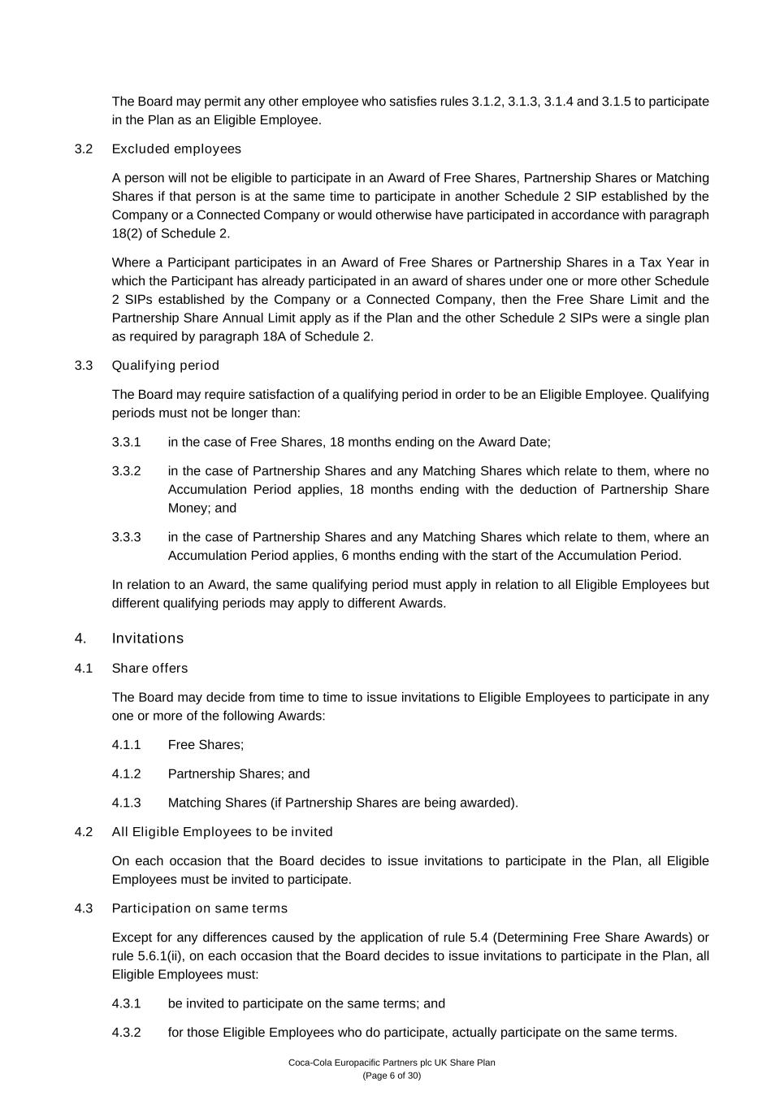
Coca-Cola Europacific Partners plc UK Share Plan (Page 6 of 30) The Board may permit any other employee who satisfies rules 3.1.2, 3.1.3, 3.1.4 and 3.1.5 to participate in the Plan as an Eligible Employee. 3.2 Excluded employees A person will not be eligible to participate in an Award of Free Shares, Partnership Shares or Matching Shares if that person is at the same time to participate in another Schedule 2 SIP established by the Company or a Connected Company or would otherwise have participated in accordance with paragraph 18(2) of Schedule 2. Where a Participant participates in an Award of Free Shares or Partnership Shares in a Tax Year in which the Participant has already participated in an award of shares under one or more other Schedule 2 SIPs established by the Company or a Connected Company, then the Free Share Limit and the Partnership Share Annual Limit apply as if the Plan and the other Schedule 2 SIPs were a single plan as required by paragraph 18A of Schedule 2. 3.3 Qualifying period The Board may require satisfaction of a qualifying period in order to be an Eligible Employee. Qualifying periods must not be longer than: 3.3.1 in the case of Free Shares, 18 months ending on the Award Date; 3.3.2 in the case of Partnership Shares and any Matching Shares which relate to them, where no Accumulation Period applies, 18 months ending with the deduction of Partnership Share Money; and 3.3.3 in the case of Partnership Shares and any Matching Shares which relate to them, where an Accumulation Period applies, 6 months ending with the start of the Accumulation Period. In relation to an Award, the same qualifying period must apply in relation to all Eligible Employees but different qualifying periods may apply to different Awards. 4. Invitations 4.1 Share offers The Board may decide from time to time to issue invitations to Eligible Employees to participate in any one or more of the following Awards: 4.1.1 Free Shares; 4.1.2 Partnership Shares; and 4.1.3 Matching Shares (if Partnership Shares are being awarded). 4.2 All Eligible Employees to be invited On each occasion that the Board decides to issue invitations to participate in the Plan, all Eligible Employees must be invited to participate. 4.3 Participation on same terms Except for any differences caused by the application of rule 5.4 (Determining Free Share Awards) or rule 5.6.1(ii), on each occasion that the Board decides to issue invitations to participate in the Plan, all Eligible Employees must: 4.3.1 be invited to participate on the same terms; and 4.3.2 for those Eligible Employees who do participate, actually participate on the same terms.

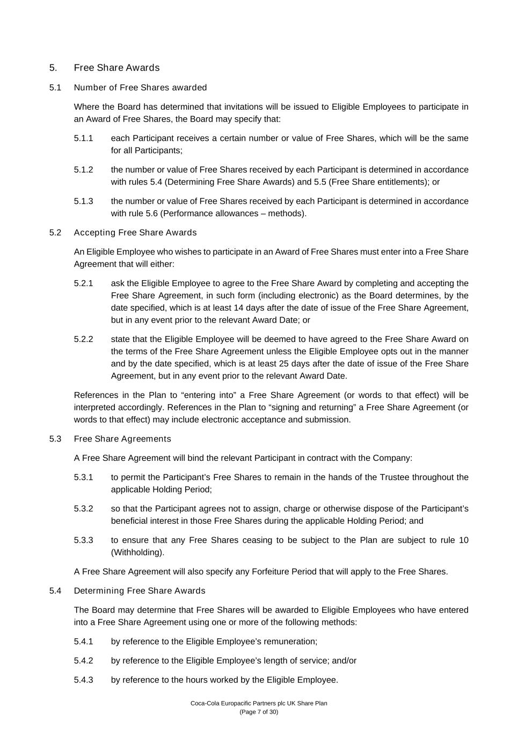
Coca-Cola Europacific Partners plc UK Share Plan (Page 7 of 30) 5. Free Share Awards 5.1 Number of Free Shares awarded Where the Board has determined that invitations will be issued to Eligible Employees to participate in an Award of Free Shares, the Board may specify that: 5.1.1 each Participant receives a certain number or value of Free Shares, which will be the same for all Participants; 5.1.2 the number or value of Free Shares received by each Participant is determined in accordance with rules 5.4 (Determining Free Share Awards) and 5.5 (Free Share entitlements); or 5.1.3 the number or value of Free Shares received by each Participant is determined in accordance with rule 5.6 (Performance allowances – methods). 5.2 Accepting Free Share Awards An Eligible Employee who wishes to participate in an Award of Free Shares must enter into a Free Share Agreement that will either: 5.2.1 ask the Eligible Employee to agree to the Free Share Award by completing and accepting the Free Share Agreement, in such form (including electronic) as the Board determines, by the date specified, which is at least 14 days after the date of issue of the Free Share Agreement, but in any event prior to the relevant Award Date; or 5.2.2 state that the Eligible Employee will be deemed to have agreed to the Free Share Award on the terms of the Free Share Agreement unless the Eligible Employee opts out in the manner and by the date specified, which is at least 25 days after the date of issue of the Free Share Agreement, but in any event prior to the relevant Award Date. References in the Plan to “entering into” a Free Share Agreement (or words to that effect) will be interpreted accordingly. References in the Plan to “signing and returning” a Free Share Agreement (or words to that effect) may include electronic acceptance and submission. 5.3 Free Share Agreements A Free Share Agreement will bind the relevant Participant in contract with the Company: 5.3.1 to permit the Participant’s Free Shares to remain in the hands of the Trustee throughout the applicable Holding Period; 5.3.2 so that the Participant agrees not to assign, charge or otherwise dispose of the Participant’s beneficial interest in those Free Shares during the applicable Holding Period; and 5.3.3 to ensure that any Free Shares ceasing to be subject to the Plan are subject to rule 10 (Withholding). A Free Share Agreement will also specify any Forfeiture Period that will apply to the Free Shares. 5.4 Determining Free Share Awards The Board may determine that Free Shares will be awarded to Eligible Employees who have entered into a Free Share Agreement using one or more of the following methods: 5.4.1 by reference to the Eligible Employee’s remuneration; 5.4.2 by reference to the Eligible Employee’s length of service; and/or 5.4.3 by reference to the hours worked by the Eligible Employee.

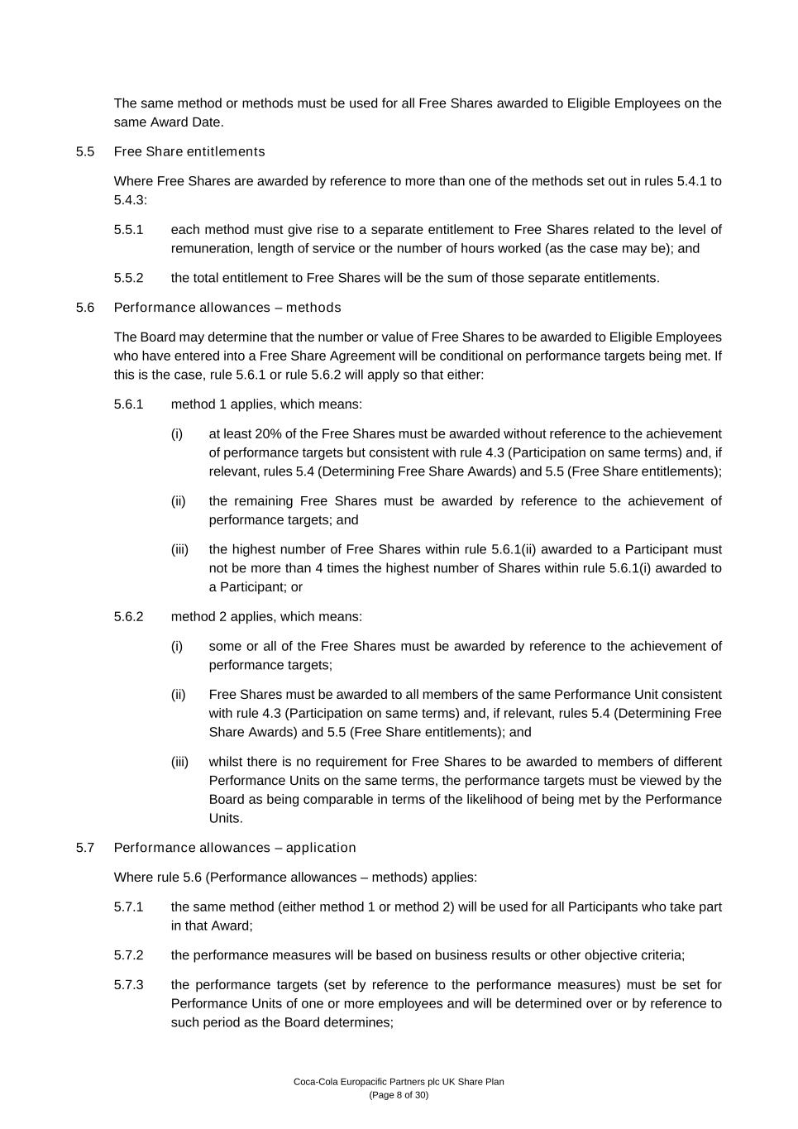
Coca-Cola Europacific Partners plc UK Share Plan (Page 8 of 30) The same method or methods must be used for all Free Shares awarded to Eligible Employees on the same Award Date. 5.5 Free Share entitlements Where Free Shares are awarded by reference to more than one of the methods set out in rules 5.4.1 to 5.4.3: 5.5.1 each method must give rise to a separate entitlement to Free Shares related to the level of remuneration, length of service or the number of hours worked (as the case may be); and 5.5.2 the total entitlement to Free Shares will be the sum of those separate entitlements. 5.6 Performance allowances – methods The Board may determine that the number or value of Free Shares to be awarded to Eligible Employees who have entered into a Free Share Agreement will be conditional on performance targets being met. If this is the case, rule 5.6.1 or rule 5.6.2 will apply so that either: 5.6.1 method 1 applies, which means: (i) at least 20% of the Free Shares must be awarded without reference to the achievement of performance targets but consistent with rule 4.3 (Participation on same terms) and, if relevant, rules 5.4 (Determining Free Share Awards) and 5.5 (Free Share entitlements); (ii) the remaining Free Shares must be awarded by reference to the achievement of performance targets; and (iii) the highest number of Free Shares within rule 5.6.1(ii) awarded to a Participant must not be more than 4 times the highest number of Shares within rule 5.6.1(i) awarded to a Participant; or 5.6.2 method 2 applies, which means: (i) some or all of the Free Shares must be awarded by reference to the achievement of performance targets; (ii) Free Shares must be awarded to all members of the same Performance Unit consistent with rule 4.3 (Participation on same terms) and, if relevant, rules 5.4 (Determining Free Share Awards) and 5.5 (Free Share entitlements); and (iii) whilst there is no requirement for Free Shares to be awarded to members of different Performance Units on the same terms, the performance targets must be viewed by the Board as being comparable in terms of the likelihood of being met by the Performance Units. 5.7 Performance allowances – application Where rule 5.6 (Performance allowances – methods) applies: 5.7.1 the same method (either method 1 or method 2) will be used for all Participants who take part in that Award; 5.7.2 the performance measures will be based on business results or other objective criteria; 5.7.3 the performance targets (set by reference to the performance measures) must be set for Performance Units of one or more employees and will be determined over or by reference to such period as the Board determines;

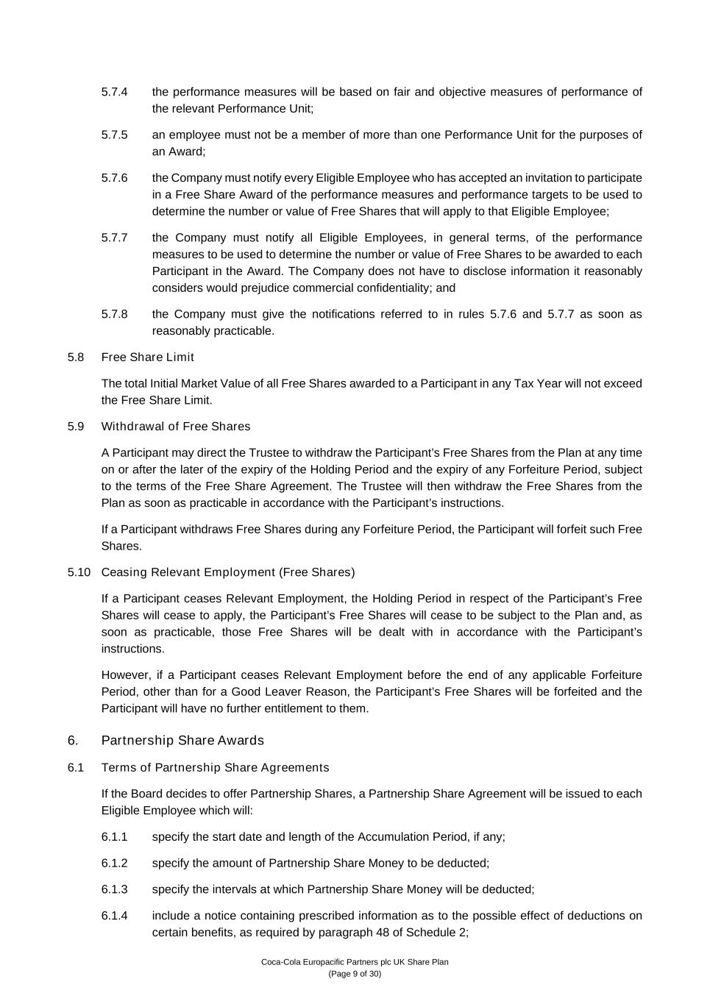
Coca-Cola Europacific Partners plc UK Share Plan (Page 9 of 30) 5.7.4 the performance measures will be based on fair and objective measures of performance of the relevant Performance Unit; 5.7.5 an employee must not be a member of more than one Performance Unit for the purposes of an Award; 5.7.6 the Company must notify every Eligible Employee who has accepted an invitation to participate in a Free Share Award of the performance measures and performance targets to be used to determine the number or value of Free Shares that will apply to that Eligible Employee; 5.7.7 the Company must notify all Eligible Employees, in general terms, of the performance measures to be used to determine the number or value of Free Shares to be awarded to each Participant in the Award. The Company does not have to disclose information it reasonably considers would prejudice commercial confidentiality; and 5.7.8 the Company must give the notifications referred to in rules 5.7.6 and 5.7.7 as soon as reasonably practicable. 5.8 Free Share Limit The total Initial Market Value of all Free Shares awarded to a Participant in any Tax Year will not exceed the Free Share Limit. 5.9 Withdrawal of Free Shares A Participant may direct the Trustee to withdraw the Participant’s Free Shares from the Plan at any time on or after the later of the expiry of the Holding Period and the expiry of any Forfeiture Period, subject to the terms of the Free Share Agreement. The Trustee will then withdraw the Free Shares from the Plan as soon as practicable in accordance with the Participant’s instructions. If a Participant withdraws Free Shares during any Forfeiture Period, the Participant will forfeit such Free Shares. 5.10 Ceasing Relevant Employment (Free Shares) If a Participant ceases Relevant Employment, the Holding Period in respect of the Participant’s Free Shares will cease to apply, the Participant’s Free Shares will cease to be subject to the Plan and, as soon as practicable, those Free Shares will be dealt with in accordance with the Participant’s instructions. However, if a Participant ceases Relevant Employment before the end of any applicable Forfeiture Period, other than for a Good Leaver Reason, the Participant’s Free Shares will be forfeited and the Participant will have no further entitlement to them. 6. Partnership Share Awards 6.1 Terms of Partnership Share Agreements If the Board decides to offer Partnership Shares, a Partnership Share Agreement will be issued to each Eligible Employee which will: 6.1.1 specify the start date and length of the Accumulation Period, if any; 6.1.2 specify the amount of Partnership Share Money to be deducted; 6.1.3 specify the intervals at which Partnership Share Money will be deducted; 6.1.4 include a notice containing prescribed information as to the possible effect of deductions on certain benefits, as required by paragraph 48 of Schedule 2;

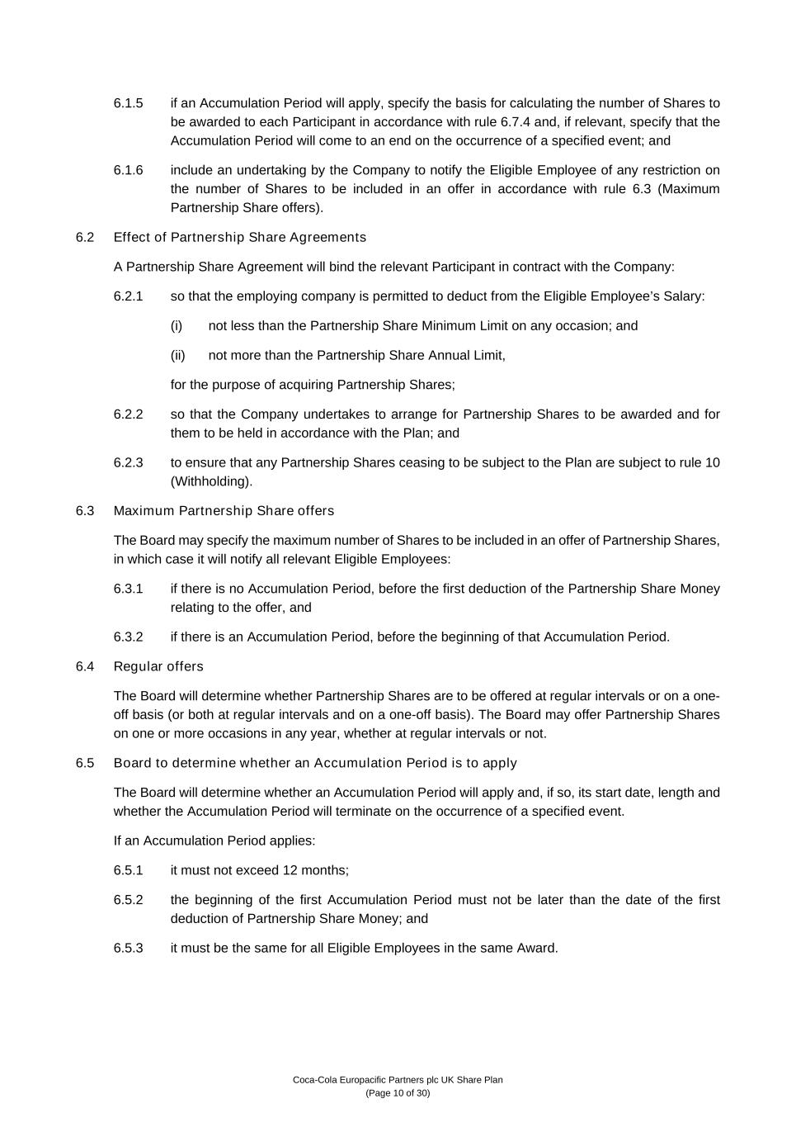
Coca-Cola Europacific Partners plc UK Share Plan (Page 10 of 30) 6.1.5 if an Accumulation Period will apply, specify the basis for calculating the number of Shares to be awarded to each Participant in accordance with rule 6.7.4 and, if relevant, specify that the Accumulation Period will come to an end on the occurrence of a specified event; and 6.1.6 include an undertaking by the Company to notify the Eligible Employee of any restriction on the number of Shares to be included in an offer in accordance with rule 6.3 (Maximum Partnership Share offers). 6.2 Effect of Partnership Share Agreements A Partnership Share Agreement will bind the relevant Participant in contract with the Company: 6.2.1 so that the employing company is permitted to deduct from the Eligible Employee’s Salary: (i) not less than the Partnership Share Minimum Limit on any occasion; and (ii) not more than the Partnership Share Annual Limit, for the purpose of acquiring Partnership Shares; 6.2.2 so that the Company undertakes to arrange for Partnership Shares to be awarded and for them to be held in accordance with the Plan; and 6.2.3 to ensure that any Partnership Shares ceasing to be subject to the Plan are subject to rule 10 (Withholding). 6.3 Maximum Partnership Share offers The Board may specify the maximum number of Shares to be included in an offer of Partnership Shares, in which case it will notify all relevant Eligible Employees: 6.3.1 if there is no Accumulation Period, before the first deduction of the Partnership Share Money relating to the offer, and 6.3.2 if there is an Accumulation Period, before the beginning of that Accumulation Period. 6.4 Regular offers The Board will determine whether Partnership Shares are to be offered at regular intervals or on a one- off basis (or both at regular intervals and on a one-off basis). The Board may offer Partnership Shares on one or more occasions in any year, whether at regular intervals or not. 6.5 Board to determine whether an Accumulation Period is to apply The Board will determine whether an Accumulation Period will apply and, if so, its start date, length and whether the Accumulation Period will terminate on the occurrence of a specified event. If an Accumulation Period applies: 6.5.1 it must not exceed 12 months; 6.5.2 the beginning of the first Accumulation Period must not be later than the date of the first deduction of Partnership Share Money; and 6.5.3 it must be the same for all Eligible Employees in the same Award.

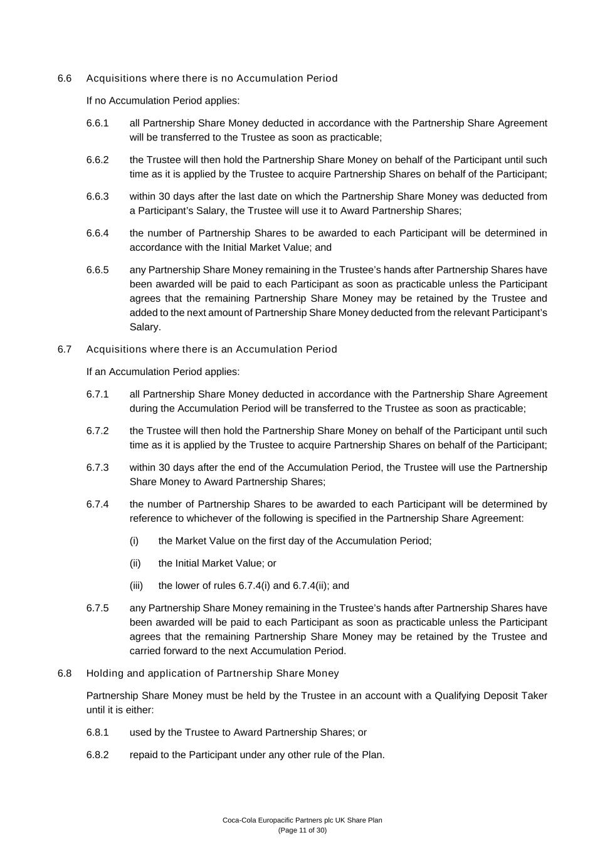
Coca-Cola Europacific Partners plc UK Share Plan (Page 11 of 30) 6.6 Acquisitions where there is no Accumulation Period If no Accumulation Period applies: 6.6.1 all Partnership Share Money deducted in accordance with the Partnership Share Agreement will be transferred to the Trustee as soon as practicable; 6.6.2 the Trustee will then hold the Partnership Share Money on behalf of the Participant until such time as it is applied by the Trustee to acquire Partnership Shares on behalf of the Participant; 6.6.3 within 30 days after the last date on which the Partnership Share Money was deducted from a Participant’s Salary, the Trustee will use it to Award Partnership Shares; 6.6.4 the number of Partnership Shares to be awarded to each Participant will be determined in accordance with the Initial Market Value; and 6.6.5 any Partnership Share Money remaining in the Trustee’s hands after Partnership Shares have been awarded will be paid to each Participant as soon as practicable unless the Participant agrees that the remaining Partnership Share Money may be retained by the Trustee and added to the next amount of Partnership Share Money deducted from the relevant Participant’s Salary. 6.7 Acquisitions where there is an Accumulation Period If an Accumulation Period applies: 6.7.1 all Partnership Share Money deducted in accordance with the Partnership Share Agreement during the Accumulation Period will be transferred to the Trustee as soon as practicable; 6.7.2 the Trustee will then hold the Partnership Share Money on behalf of the Participant until such time as it is applied by the Trustee to acquire Partnership Shares on behalf of the Participant; 6.7.3 within 30 days after the end of the Accumulation Period, the Trustee will use the Partnership Share Money to Award Partnership Shares; 6.7.4 the number of Partnership Shares to be awarded to each Participant will be determined by reference to whichever of the following is specified in the Partnership Share Agreement: (i) the Market Value on the first day of the Accumulation Period; (ii) the Initial Market Value; or (iii) the lower of rules 6.7.4(i) and 6.7.4(ii); and 6.7.5 any Partnership Share Money remaining in the Trustee’s hands after Partnership Shares have been awarded will be paid to each Participant as soon as practicable unless the Participant agrees that the remaining Partnership Share Money may be retained by the Trustee and carried forward to the next Accumulation Period. 6.8 Holding and application of Partnership Share Money Partnership Share Money must be held by the Trustee in an account with a Qualifying Deposit Taker until it is either: 6.8.1 used by the Trustee to Award Partnership Shares; or 6.8.2 repaid to the Participant under any other rule of the Plan.

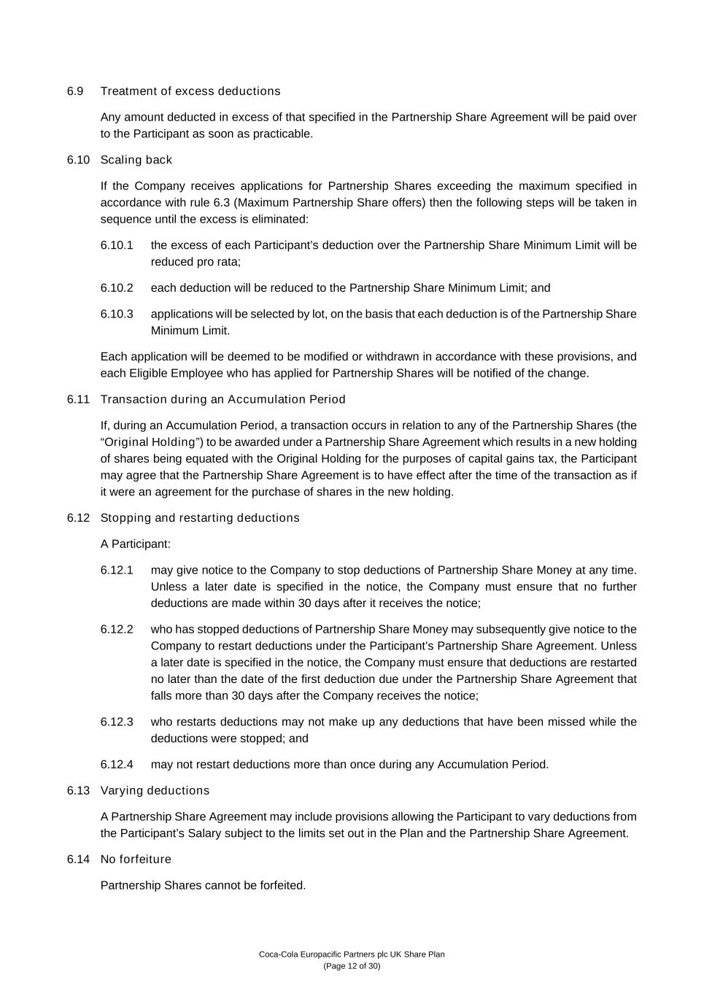
Coca-Cola Europacific Partners plc UK Share Plan (Page 12 of 30) 6.9 Treatment of excess deductions Any amount deducted in excess of that specified in the Partnership Share Agreement will be paid over to the Participant as soon as practicable. 6.10 Scaling back If the Company receives applications for Partnership Shares exceeding the maximum specified in accordance with rule 6.3 (Maximum Partnership Share offers) then the following steps will be taken in sequence until the excess is eliminated: 6.10.1 the excess of each Participant’s deduction over the Partnership Share Minimum Limit will be reduced pro rata; 6.10.2 each deduction will be reduced to the Partnership Share Minimum Limit; and 6.10.3 applications will be selected by lot, on the basis that each deduction is of the Partnership Share Minimum Limit. Each application will be deemed to be modified or withdrawn in accordance with these provisions, and each Eligible Employee who has applied for Partnership Shares will be notified of the change. 6.11 Transaction during an Accumulation Period If, during an Accumulation Period, a transaction occurs in relation to any of the Partnership Shares (the “Original Holding”) to be awarded under a Partnership Share Agreement which results in a new holding of shares being equated with the Original Holding for the purposes of capital gains tax, the Participant may agree that the Partnership Share Agreement is to have effect after the time of the transaction as if it were an agreement for the purchase of shares in the new holding. 6.12 Stopping and restarting deductions A Participant: 6.12.1 may give notice to the Company to stop deductions of Partnership Share Money at any time. Unless a later date is specified in the notice, the Company must ensure that no further deductions are made within 30 days after it receives the notice; 6.12.2 who has stopped deductions of Partnership Share Money may subsequently give notice to the Company to restart deductions under the Participant’s Partnership Share Agreement. Unless a later date is specified in the notice, the Company must ensure that deductions are restarted no later than the date of the first deduction due under the Partnership Share Agreement that falls more than 30 days after the Company receives the notice; 6.12.3 who restarts deductions may not make up any deductions that have been missed while the deductions were stopped; and 6.12.4 may not restart deductions more than once during any Accumulation Period. 6.13 Varying deductions A Partnership Share Agreement may include provisions allowing the Participant to vary deductions from the Participant’s Salary subject to the limits set out in the Plan and the Partnership Share Agreement. 6.14 No forfeiture Partnership Shares cannot be forfeited.

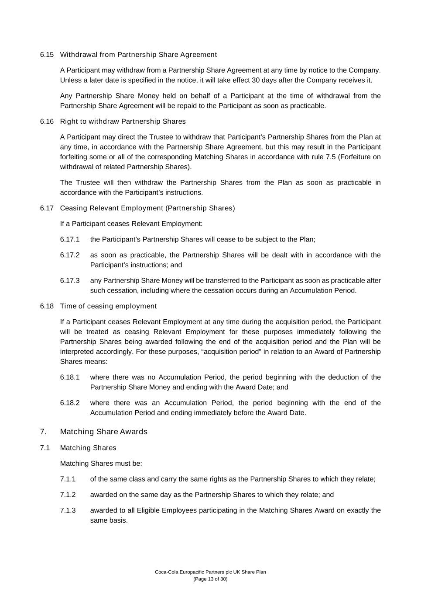
Coca-Cola Europacific Partners plc UK Share Plan (Page 13 of 30) 6.15 Withdrawal from Partnership Share Agreement A Participant may withdraw from a Partnership Share Agreement at any time by notice to the Company. Unless a later date is specified in the notice, it will take effect 30 days after the Company receives it. Any Partnership Share Money held on behalf of a Participant at the time of withdrawal from the Partnership Share Agreement will be repaid to the Participant as soon as practicable. 6.16 Right to withdraw Partnership Shares A Participant may direct the Trustee to withdraw that Participant’s Partnership Shares from the Plan at any time, in accordance with the Partnership Share Agreement, but this may result in the Participant forfeiting some or all of the corresponding Matching Shares in accordance with rule 7.5 (Forfeiture on withdrawal of related Partnership Shares). The Trustee will then withdraw the Partnership Shares from the Plan as soon as practicable in accordance with the Participant’s instructions. 6.17 Ceasing Relevant Employment (Partnership Shares) If a Participant ceases Relevant Employment: 6.17.1 the Participant’s Partnership Shares will cease to be subject to the Plan; 6.17.2 as soon as practicable, the Partnership Shares will be dealt with in accordance with the Participant’s instructions; and 6.17.3 any Partnership Share Money will be transferred to the Participant as soon as practicable after such cessation, including where the cessation occurs during an Accumulation Period. 6.18 Time of ceasing employment If a Participant ceases Relevant Employment at any time during the acquisition period, the Participant will be treated as ceasing Relevant Employment for these purposes immediately following the Partnership Shares being awarded following the end of the acquisition period and the Plan will be interpreted accordingly. For these purposes, “acquisition period” in relation to an Award of Partnership Shares means: 6.18.1 where there was no Accumulation Period, the period beginning with the deduction of the Partnership Share Money and ending with the Award Date; and 6.18.2 where there was an Accumulation Period, the period beginning with the end of the Accumulation Period and ending immediately before the Award Date. 7. Matching Share Awards 7.1 Matching Shares Matching Shares must be: 7.1.1 of the same class and carry the same rights as the Partnership Shares to which they relate; 7.1.2 awarded on the same day as the Partnership Shares to which they relate; and 7.1.3 awarded to all Eligible Employees participating in the Matching Shares Award on exactly the same basis.

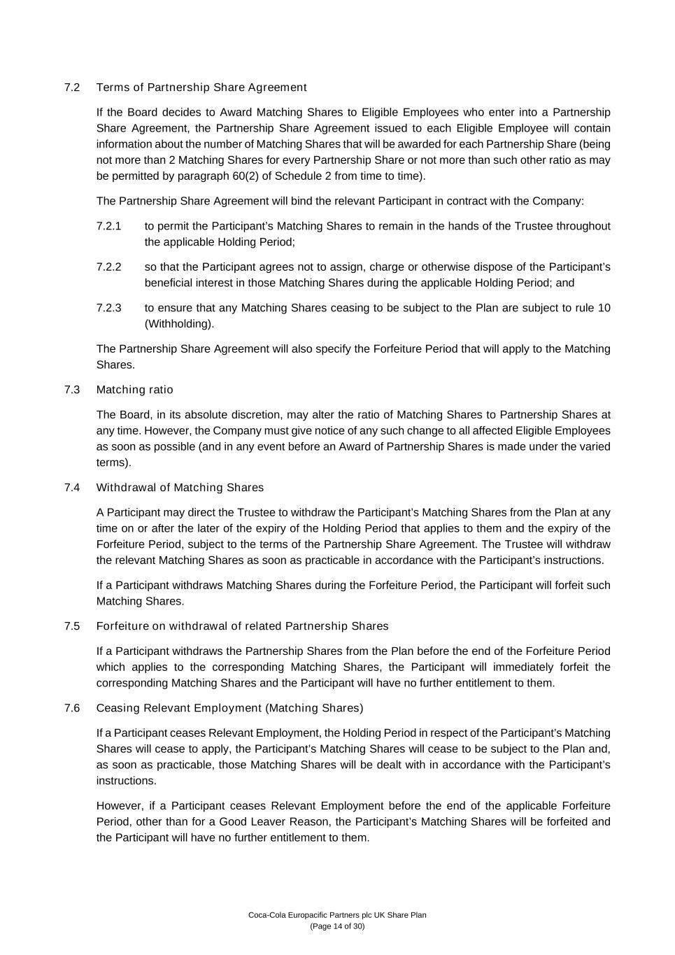
Coca-Cola Europacific Partners plc UK Share Plan (Page 14 of 30) 7.2 Terms of Partnership Share Agreement If the Board decides to Award Matching Shares to Eligible Employees who enter into a Partnership Share Agreement, the Partnership Share Agreement issued to each Eligible Employee will contain information about the number of Matching Shares that will be awarded for each Partnership Share (being not more than 2 Matching Shares for every Partnership Share or not more than such other ratio as may be permitted by paragraph 60(2) of Schedule 2 from time to time). The Partnership Share Agreement will bind the relevant Participant in contract with the Company: 7.2.1 to permit the Participant’s Matching Shares to remain in the hands of the Trustee throughout the applicable Holding Period; 7.2.2 so that the Participant agrees not to assign, charge or otherwise dispose of the Participant’s beneficial interest in those Matching Shares during the applicable Holding Period; and 7.2.3 to ensure that any Matching Shares ceasing to be subject to the Plan are subject to rule 10 (Withholding). The Partnership Share Agreement will also specify the Forfeiture Period that will apply to the Matching Shares. 7.3 Matching ratio The Board, in its absolute discretion, may alter the ratio of Matching Shares to Partnership Shares at any time. However, the Company must give notice of any such change to all affected Eligible Employees as soon as possible (and in any event before an Award of Partnership Shares is made under the varied terms). 7.4 Withdrawal of Matching Shares A Participant may direct the Trustee to withdraw the Participant’s Matching Shares from the Plan at any time on or after the later of the expiry of the Holding Period that applies to them and the expiry of the Forfeiture Period, subject to the terms of the Partnership Share Agreement. The Trustee will withdraw the relevant Matching Shares as soon as practicable in accordance with the Participant’s instructions. If a Participant withdraws Matching Shares during the Forfeiture Period, the Participant will forfeit such Matching Shares. 7.5 Forfeiture on withdrawal of related Partnership Shares If a Participant withdraws the Partnership Shares from the Plan before the end of the Forfeiture Period which applies to the corresponding Matching Shares, the Participant will immediately forfeit the corresponding Matching Shares and the Participant will have no further entitlement to them. 7.6 Ceasing Relevant Employment (Matching Shares) If a Participant ceases Relevant Employment, the Holding Period in respect of the Participant’s Matching Shares will cease to apply, the Participant’s Matching Shares will cease to be subject to the Plan and, as soon as practicable, those Matching Shares will be dealt with in accordance with the Participant’s instructions. However, if a Participant ceases Relevant Employment before the end of the applicable Forfeiture Period, other than for a Good Leaver Reason, the Participant’s Matching Shares will be forfeited and the Participant will have no further entitlement to them.

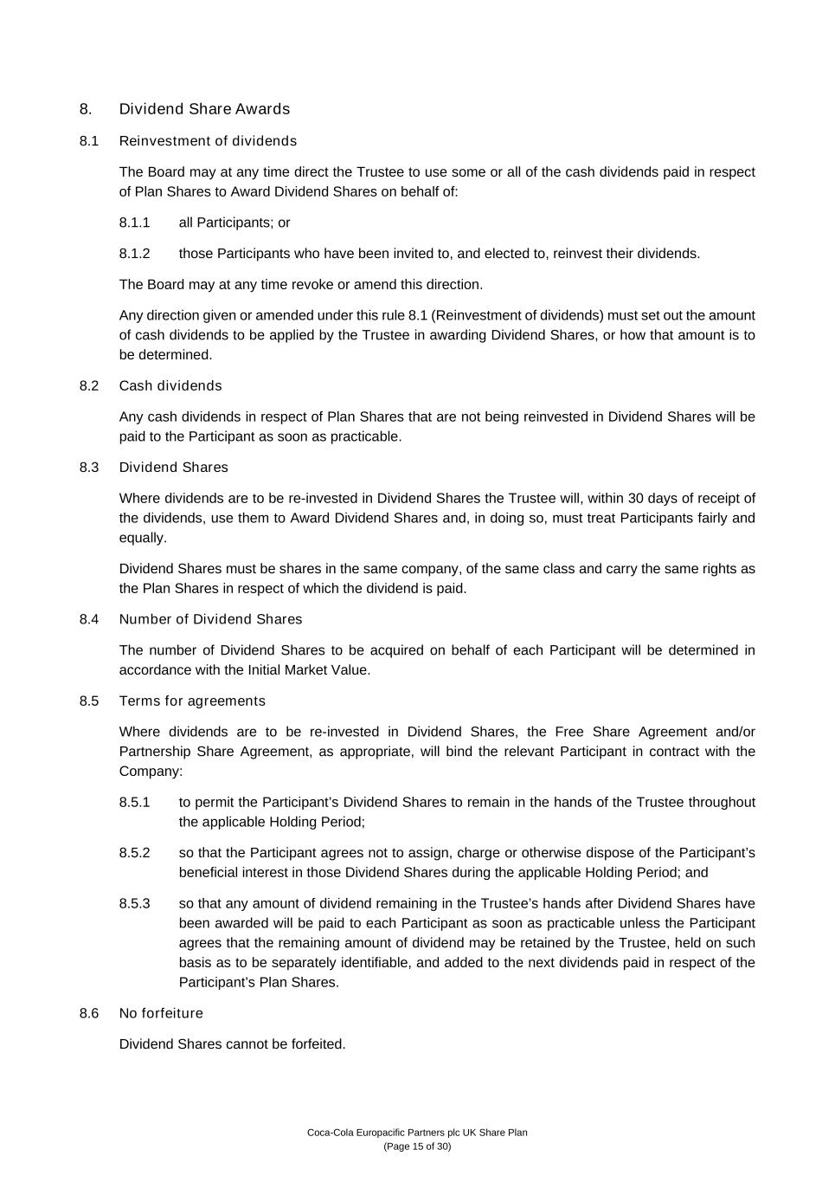
Coca-Cola Europacific Partners plc UK Share Plan (Page 15 of 30) 8. Dividend Share Awards 8.1 Reinvestment of dividends The Board may at any time direct the Trustee to use some or all of the cash dividends paid in respect of Plan Shares to Award Dividend Shares on behalf of: 8.1.1 all Participants; or 8.1.2 those Participants who have been invited to, and elected to, reinvest their dividends. The Board may at any time revoke or amend this direction. Any direction given or amended under this rule 8.1 (Reinvestment of dividends) must set out the amount of cash dividends to be applied by the Trustee in awarding Dividend Shares, or how that amount is to be determined. 8.2 Cash dividends Any cash dividends in respect of Plan Shares that are not being reinvested in Dividend Shares will be paid to the Participant as soon as practicable. 8.3 Dividend Shares Where dividends are to be re-invested in Dividend Shares the Trustee will, within 30 days of receipt of the dividends, use them to Award Dividend Shares and, in doing so, must treat Participants fairly and equally. Dividend Shares must be shares in the same company, of the same class and carry the same rights as the Plan Shares in respect of which the dividend is paid. 8.4 Number of Dividend Shares The number of Dividend Shares to be acquired on behalf of each Participant will be determined in accordance with the Initial Market Value. 8.5 Terms for agreements Where dividends are to be re-invested in Dividend Shares, the Free Share Agreement and/or Partnership Share Agreement, as appropriate, will bind the relevant Participant in contract with the Company: 8.5.1 to permit the Participant’s Dividend Shares to remain in the hands of the Trustee throughout the applicable Holding Period; 8.5.2 so that the Participant agrees not to assign, charge or otherwise dispose of the Participant’s beneficial interest in those Dividend Shares during the applicable Holding Period; and 8.5.3 so that any amount of dividend remaining in the Trustee’s hands after Dividend Shares have been awarded will be paid to each Participant as soon as practicable unless the Participant agrees that the remaining amount of dividend may be retained by the Trustee, held on such basis as to be separately identifiable, and added to the next dividends paid in respect of the Participant’s Plan Shares. 8.6 No forfeiture Dividend Shares cannot be forfeited.

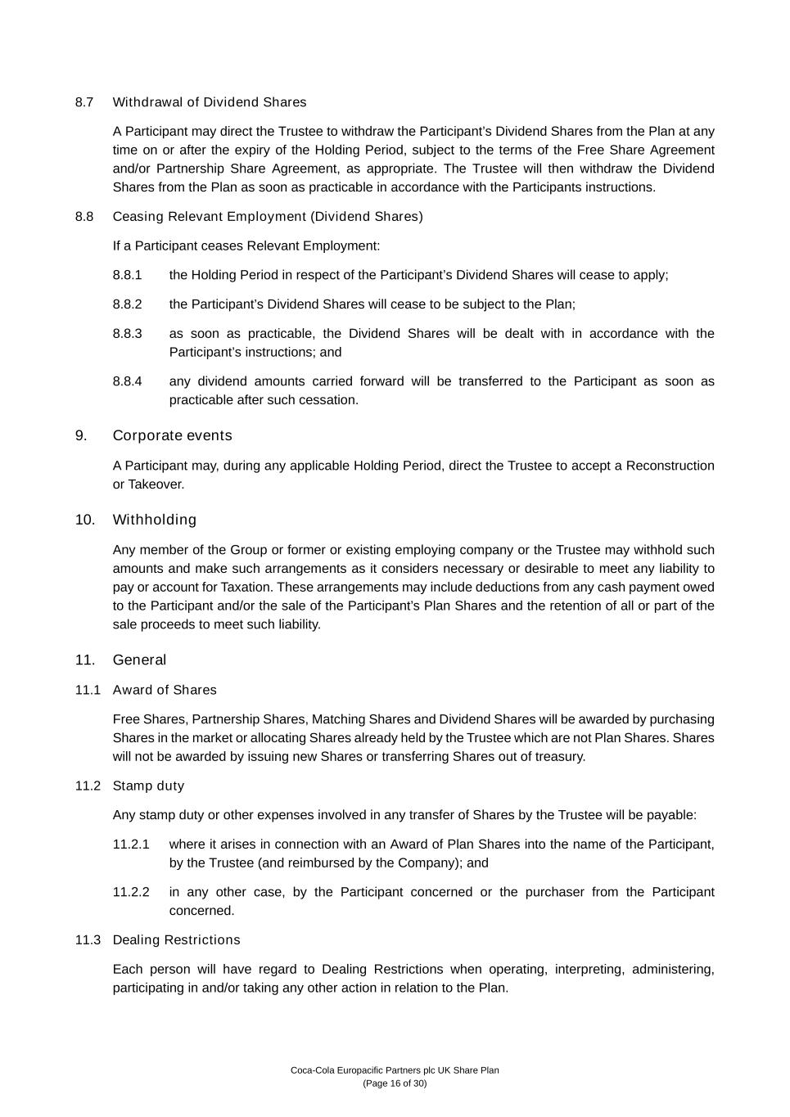
Coca-Cola Europacific Partners plc UK Share Plan (Page 16 of 30) 8.7 Withdrawal of Dividend Shares A Participant may direct the Trustee to withdraw the Participant’s Dividend Shares from the Plan at any time on or after the expiry of the Holding Period, subject to the terms of the Free Share Agreement and/or Partnership Share Agreement, as appropriate. The Trustee will then withdraw the Dividend Shares from the Plan as soon as practicable in accordance with the Participants instructions. 8.8 Ceasing Relevant Employment (Dividend Shares) If a Participant ceases Relevant Employment: 8.8.1 the Holding Period in respect of the Participant’s Dividend Shares will cease to apply; 8.8.2 the Participant’s Dividend Shares will cease to be subject to the Plan; 8.8.3 as soon as practicable, the Dividend Shares will be dealt with in accordance with the Participant’s instructions; and 8.8.4 any dividend amounts carried forward will be transferred to the Participant as soon as practicable after such cessation. 9. Corporate events A Participant may, during any applicable Holding Period, direct the Trustee to accept a Reconstruction or Takeover. 10. Withholding Any member of the Group or former or existing employing company or the Trustee may withhold such amounts and make such arrangements as it considers necessary or desirable to meet any liability to pay or account for Taxation. These arrangements may include deductions from any cash payment owed to the Participant and/or the sale of the Participant’s Plan Shares and the retention of all or part of the sale proceeds to meet such liability. 11. General 11.1 Award of Shares Free Shares, Partnership Shares, Matching Shares and Dividend Shares will be awarded by purchasing Shares in the market or allocating Shares already held by the Trustee which are not Plan Shares. Shares will not be awarded by issuing new Shares or transferring Shares out of treasury. 11.2 Stamp duty Any stamp duty or other expenses involved in any transfer of Shares by the Trustee will be payable: 11.2.1 where it arises in connection with an Award of Plan Shares into the name of the Participant, by the Trustee (and reimbursed by the Company); and 11.2.2 in any other case, by the Participant concerned or the purchaser from the Participant concerned. 11.3 Dealing Restrictions Each person will have regard to Dealing Restrictions when operating, interpreting, administering, participating in and/or taking any other action in relation to the Plan.

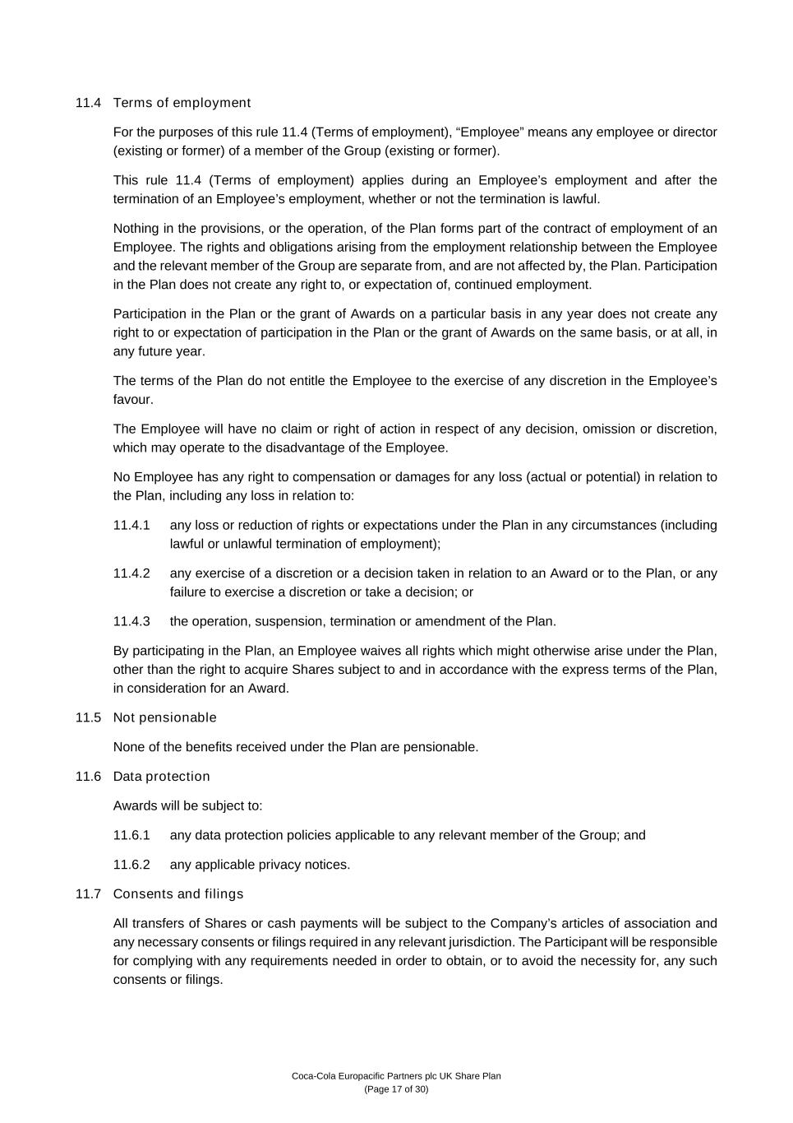
Coca-Cola Europacific Partners plc UK Share Plan (Page 17 of 30) 11.4 Terms of employment For the purposes of this rule 11.4 (Terms of employment), “Employee” means any employee or director (existing or former) of a member of the Group (existing or former). This rule 11.4 (Terms of employment) applies during an Employee’s employment and after the termination of an Employee’s employment, whether or not the termination is lawful. Nothing in the provisions, or the operation, of the Plan forms part of the contract of employment of an Employee. The rights and obligations arising from the employment relationship between the Employee and the relevant member of the Group are separate from, and are not affected by, the Plan. Participation in the Plan does not create any right to, or expectation of, continued employment. Participation in the Plan or the grant of Awards on a particular basis in any year does not create any right to or expectation of participation in the Plan or the grant of Awards on the same basis, or at all, in any future year. The terms of the Plan do not entitle the Employee to the exercise of any discretion in the Employee’s favour. The Employee will have no claim or right of action in respect of any decision, omission or discretion, which may operate to the disadvantage of the Employee. No Employee has any right to compensation or damages for any loss (actual or potential) in relation to the Plan, including any loss in relation to: 11.4.1 any loss or reduction of rights or expectations under the Plan in any circumstances (including lawful or unlawful termination of employment); 11.4.2 any exercise of a discretion or a decision taken in relation to an Award or to the Plan, or any failure to exercise a discretion or take a decision; or 11.4.3 the operation, suspension, termination or amendment of the Plan. By participating in the Plan, an Employee waives all rights which might otherwise arise under the Plan, other than the right to acquire Shares subject to and in accordance with the express terms of the Plan, in consideration for an Award. 11.5 Not pensionable None of the benefits received under the Plan are pensionable. 11.6 Data protection Awards will be subject to: 11.6.1 any data protection policies applicable to any relevant member of the Group; and 11.6.2 any applicable privacy notices. 11.7 Consents and filings All transfers of Shares or cash payments will be subject to the Company’s articles of association and any necessary consents or filings required in any relevant jurisdiction. The Participant will be responsible for complying with any requirements needed in order to obtain, or to avoid the necessity for, any such consents or filings.

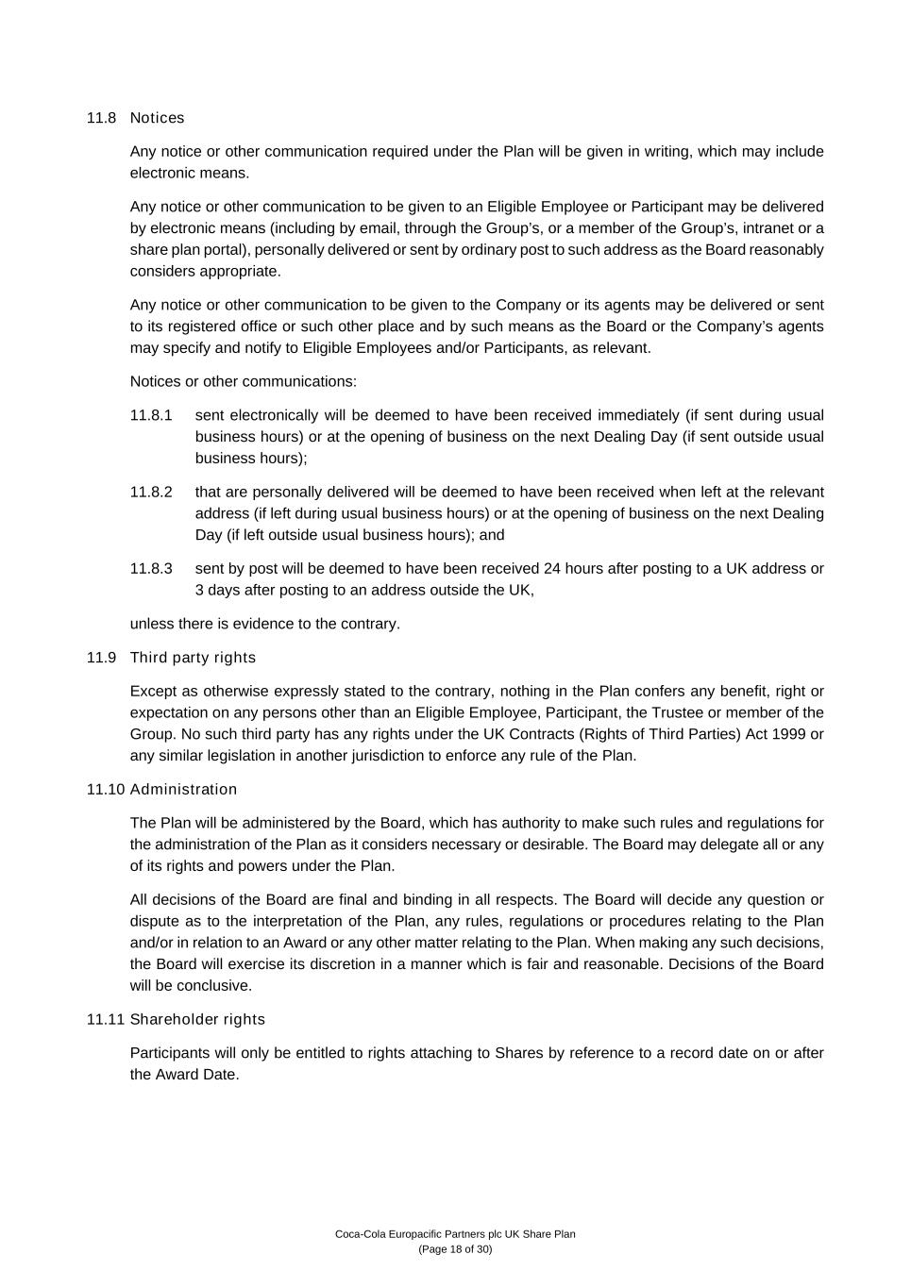
Coca-Cola Europacific Partners plc UK Share Plan (Page 18 of 30) 11.8 Notices Any notice or other communication required under the Plan will be given in writing, which may include electronic means. Any notice or other communication to be given to an Eligible Employee or Participant may be delivered by electronic means (including by email, through the Group’s, or a member of the Group’s, intranet or a share plan portal), personally delivered or sent by ordinary post to such address as the Board reasonably considers appropriate. Any notice or other communication to be given to the Company or its agents may be delivered or sent to its registered office or such other place and by such means as the Board or the Company’s agents may specify and notify to Eligible Employees and/or Participants, as relevant. Notices or other communications: 11.8.1 sent electronically will be deemed to have been received immediately (if sent during usual business hours) or at the opening of business on the next Dealing Day (if sent outside usual business hours); 11.8.2 that are personally delivered will be deemed to have been received when left at the relevant address (if left during usual business hours) or at the opening of business on the next Dealing Day (if left outside usual business hours); and 11.8.3 sent by post will be deemed to have been received 24 hours after posting to a UK address or 3 days after posting to an address outside the UK, unless there is evidence to the contrary. 11.9 Third party rights Except as otherwise expressly stated to the contrary, nothing in the Plan confers any benefit, right or expectation on any persons other than an Eligible Employee, Participant, the Trustee or member of the Group. No such third party has any rights under the UK Contracts (Rights of Third Parties) Act 1999 or any similar legislation in another jurisdiction to enforce any rule of the Plan. 11.10 Administration The Plan will be administered by the Board, which has authority to make such rules and regulations for the administration of the Plan as it considers necessary or desirable. The Board may delegate all or any of its rights and powers under the Plan. All decisions of the Board are final and binding in all respects. The Board will decide any question or dispute as to the interpretation of the Plan, any rules, regulations or procedures relating to the Plan and/or in relation to an Award or any other matter relating to the Plan. When making any such decisions, the Board will exercise its discretion in a manner which is fair and reasonable. Decisions of the Board will be conclusive. 11.11 Shareholder rights Participants will only be entitled to rights attaching to Shares by reference to a record date on or after the Award Date.

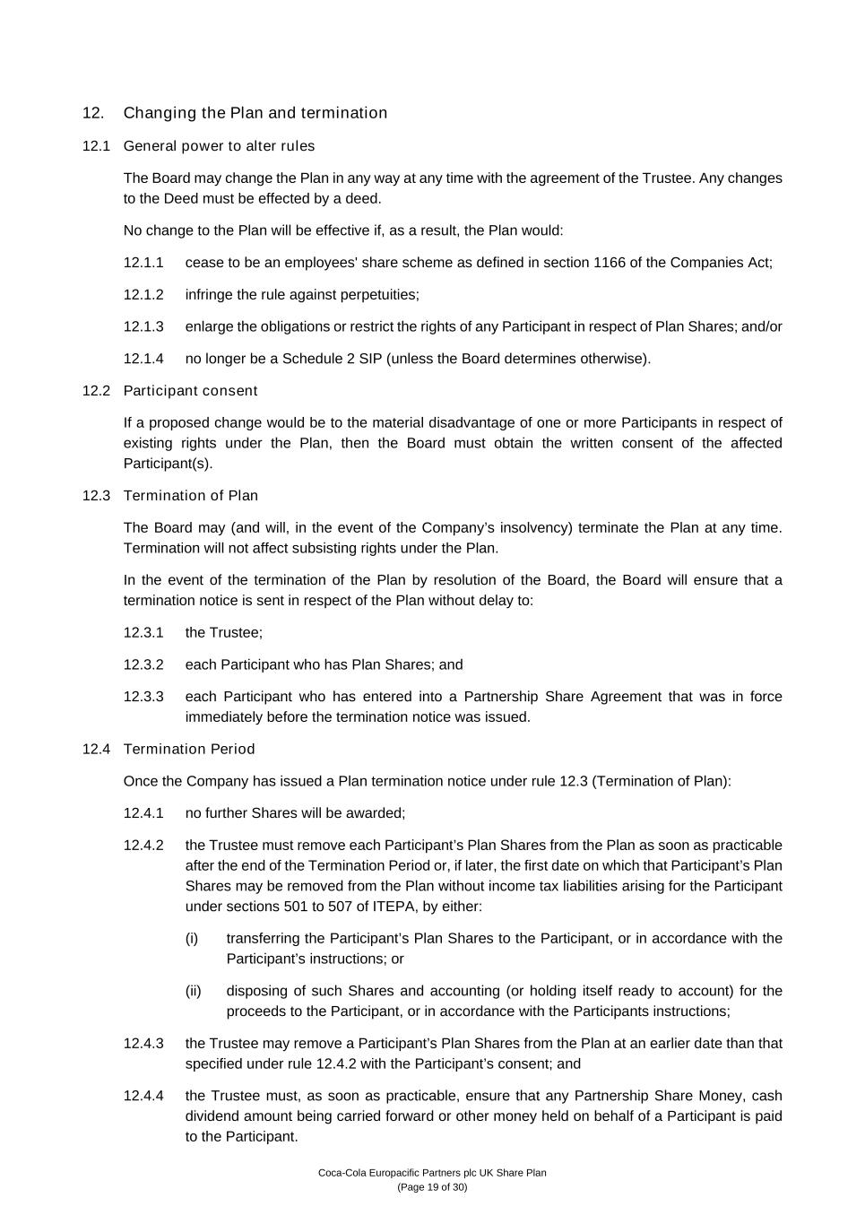
Coca-Cola Europacific Partners plc UK Share Plan (Page 19 of 30) 12. Changing the Plan and termination 12.1 General power to alter rules The Board may change the Plan in any way at any time with the agreement of the Trustee. Any changes to the Deed must be effected by a deed. No change to the Plan will be effective if, as a result, the Plan would: 12.1.1 cease to be an employees' share scheme as defined in section 1166 of the Companies Act; 12.1.2 infringe the rule against perpetuities; 12.1.3 enlarge the obligations or restrict the rights of any Participant in respect of Plan Shares; and/or 12.1.4 no longer be a Schedule 2 SIP (unless the Board determines otherwise). 12.2 Participant consent If a proposed change would be to the material disadvantage of one or more Participants in respect of existing rights under the Plan, then the Board must obtain the written consent of the affected Participant(s). 12.3 Termination of Plan The Board may (and will, in the event of the Company’s insolvency) terminate the Plan at any time. Termination will not affect subsisting rights under the Plan. In the event of the termination of the Plan by resolution of the Board, the Board will ensure that a termination notice is sent in respect of the Plan without delay to: 12.3.1 the Trustee; 12.3.2 each Participant who has Plan Shares; and 12.3.3 each Participant who has entered into a Partnership Share Agreement that was in force immediately before the termination notice was issued. 12.4 Termination Period Once the Company has issued a Plan termination notice under rule 12.3 (Termination of Plan): 12.4.1 no further Shares will be awarded; 12.4.2 the Trustee must remove each Participant’s Plan Shares from the Plan as soon as practicable after the end of the Termination Period or, if later, the first date on which that Participant’s Plan Shares may be removed from the Plan without income tax liabilities arising for the Participant under sections 501 to 507 of ITEPA, by either: (i) transferring the Participant’s Plan Shares to the Participant, or in accordance with the Participant’s instructions; or (ii) disposing of such Shares and accounting (or holding itself ready to account) for the proceeds to the Participant, or in accordance with the Participants instructions; 12.4.3 the Trustee may remove a Participant’s Plan Shares from the Plan at an earlier date than that specified under rule 12.4.2 with the Participant’s consent; and 12.4.4 the Trustee must, as soon as practicable, ensure that any Partnership Share Money, cash dividend amount being carried forward or other money held on behalf of a Participant is paid to the Participant.


Coca-Cola Europacific Partners plc UK Share Plan (Page 20 of 30) 12.5 HMRC notice of termination Where HMRC issues a notice under paragraphs 81H or 81I of Schedule 2 that the Plan is not a Schedule 2 SIP, any Partnership Share Money, and any dividends held by the Trustee for the purposes of acquiring Dividend Shares, held on behalf of a Participant must be paid over to the Participant. This payment must be made as soon as practicable after the relevant day, within the meaning given in paragraph 56 of Schedule 2. 13. Governing law and jurisdiction The laws of England and Wales govern the Plan and all Awards. The courts of England and Wales have exclusive jurisdiction in respect of any disputes arising in connection with the Plan or any Award.

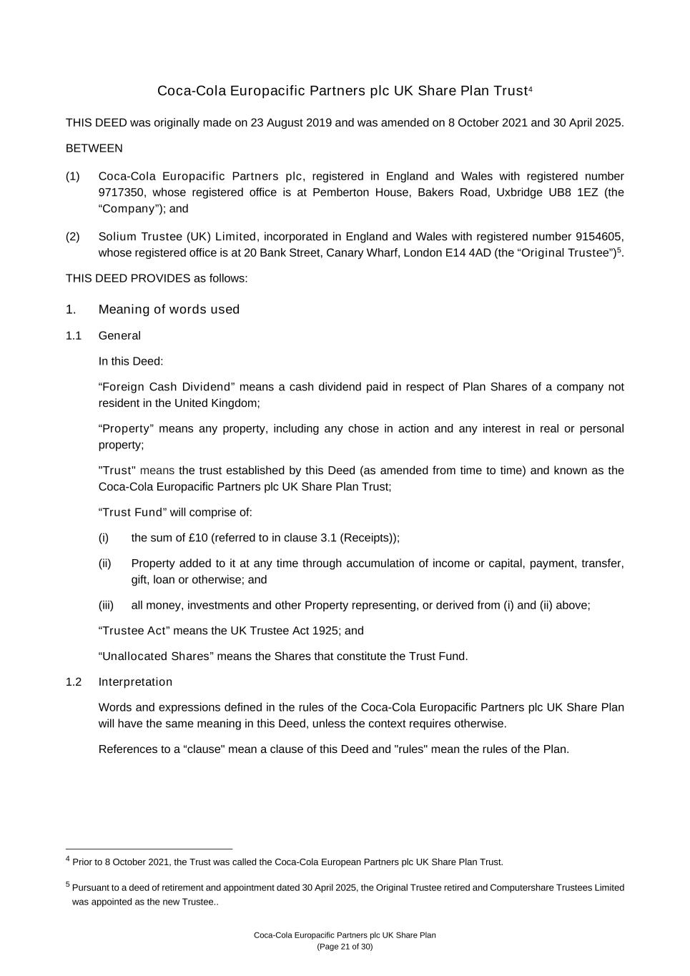
Coca-Cola Europacific Partners plc UK Share Plan (Page 21 of 30) Coca-Cola Europacific Partners plc UK Share Plan Trust4 THIS DEED was originally made on 23 August 2019 and was amended on 8 October 2021 and 30 April 2025. BETWEEN (1) Coca-Cola Europacific Partners plc, registered in England and Wales with registered number 9717350, whose registered office is at Pemberton House, Bakers Road, Uxbridge UB8 1EZ (the “Company”); and (2) Solium Trustee (UK) Limited, incorporated in England and Wales with registered number 9154605, whose registered office is at 20 Bank Street, Canary Wharf, London E14 4AD (the “Original Trustee”)5. THIS DEED PROVIDES as follows: 1. Meaning of words used 1.1 General In this Deed: “Foreign Cash Dividend” means a cash dividend paid in respect of Plan Shares of a company not resident in the United Kingdom; “Property” means any property, including any chose in action and any interest in real or personal property; "Trust" means the trust established by this Deed (as amended from time to time) and known as the Coca-Cola Europacific Partners plc UK Share Plan Trust; “Trust Fund” will comprise of: (i) the sum of £10 (referred to in clause 3.1 (Receipts)); (ii) Property added to it at any time through accumulation of income or capital, payment, transfer, gift, loan or otherwise; and (iii) all money, investments and other Property representing, or derived from (i) and (ii) above; “Trustee Act” means the UK Trustee Act 1925; and “Unallocated Shares” means the Shares that constitute the Trust Fund. 1.2 Interpretation Words and expressions defined in the rules of the Coca-Cola Europacific Partners plc UK Share Plan will have the same meaning in this Deed, unless the context requires otherwise. References to a “clause" mean a clause of this Deed and "rules" mean the rules of the Plan. 4 Prior to 8 October 2021, the Trust was called the Coca-Cola European Partners plc UK Share Plan Trust. 5 Pursuant to a deed of retirement and appointment dated 30 April 2025, the Original Trustee retired and Computershare Trustees Limited was appointed as the new Trustee..

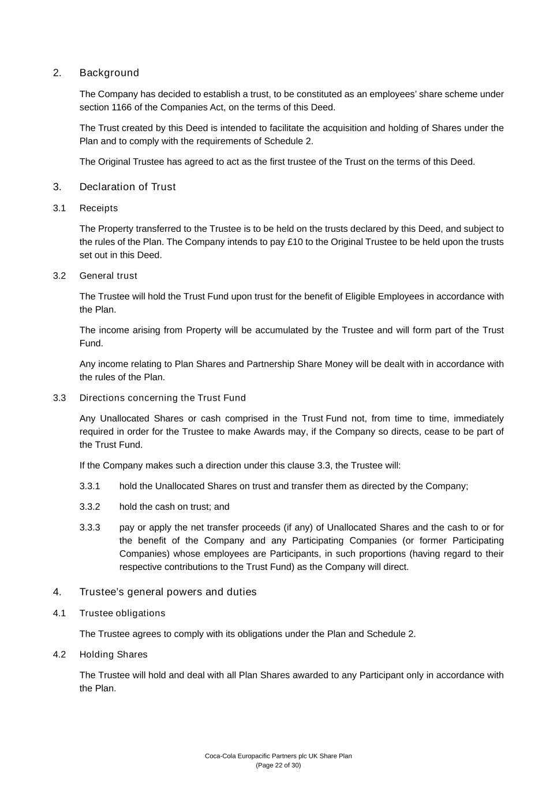
Coca-Cola Europacific Partners plc UK Share Plan (Page 22 of 30) 2. Background The Company has decided to establish a trust, to be constituted as an employees’ share scheme under section 1166 of the Companies Act, on the terms of this Deed. The Trust created by this Deed is intended to facilitate the acquisition and holding of Shares under the Plan and to comply with the requirements of Schedule 2. The Original Trustee has agreed to act as the first trustee of the Trust on the terms of this Deed. 3. Declaration of Trust 3.1 Receipts The Property transferred to the Trustee is to be held on the trusts declared by this Deed, and subject to the rules of the Plan. The Company intends to pay £10 to the Original Trustee to be held upon the trusts set out in this Deed. 3.2 General trust The Trustee will hold the Trust Fund upon trust for the benefit of Eligible Employees in accordance with the Plan. The income arising from Property will be accumulated by the Trustee and will form part of the Trust Fund. Any income relating to Plan Shares and Partnership Share Money will be dealt with in accordance with the rules of the Plan. 3.3 Directions concerning the Trust Fund Any Unallocated Shares or cash comprised in the Trust Fund not, from time to time, immediately required in order for the Trustee to make Awards may, if the Company so directs, cease to be part of the Trust Fund. If the Company makes such a direction under this clause 3.3, the Trustee will: 3.3.1 hold the Unallocated Shares on trust and transfer them as directed by the Company; 3.3.2 hold the cash on trust; and 3.3.3 pay or apply the net transfer proceeds (if any) of Unallocated Shares and the cash to or for the benefit of the Company and any Participating Companies (or former Participating Companies) whose employees are Participants, in such proportions (having regard to their respective contributions to the Trust Fund) as the Company will direct. 4. Trustee’s general powers and duties 4.1 Trustee obligations The Trustee agrees to comply with its obligations under the Plan and Schedule 2. 4.2 Holding Shares The Trustee will hold and deal with all Plan Shares awarded to any Participant only in accordance with the Plan.

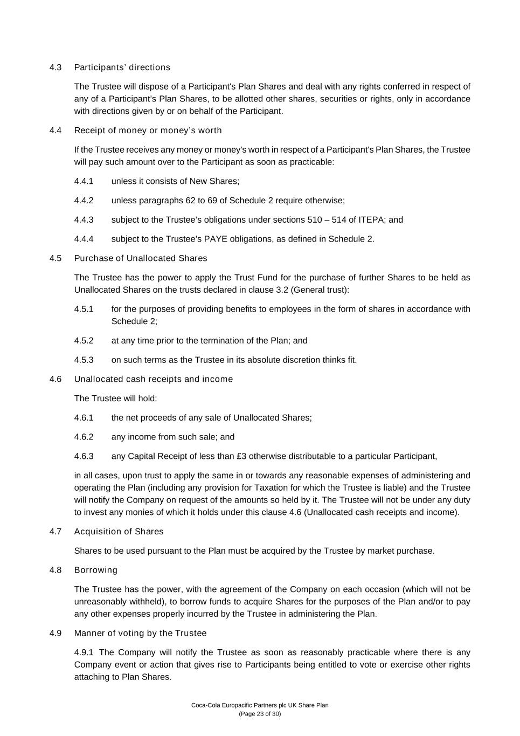
Coca-Cola Europacific Partners plc UK Share Plan (Page 23 of 30) 4.3 Participants’ directions The Trustee will dispose of a Participant's Plan Shares and deal with any rights conferred in respect of any of a Participant’s Plan Shares, to be allotted other shares, securities or rights, only in accordance with directions given by or on behalf of the Participant. 4.4 Receipt of money or money’s worth If the Trustee receives any money or money's worth in respect of a Participant's Plan Shares, the Trustee will pay such amount over to the Participant as soon as practicable: 4.4.1 unless it consists of New Shares; 4.4.2 unless paragraphs 62 to 69 of Schedule 2 require otherwise; 4.4.3 subject to the Trustee’s obligations under sections 510 – 514 of ITEPA; and 4.4.4 subject to the Trustee’s PAYE obligations, as defined in Schedule 2. 4.5 Purchase of Unallocated Shares The Trustee has the power to apply the Trust Fund for the purchase of further Shares to be held as Unallocated Shares on the trusts declared in clause 3.2 (General trust): 4.5.1 for the purposes of providing benefits to employees in the form of shares in accordance with Schedule 2; 4.5.2 at any time prior to the termination of the Plan; and 4.5.3 on such terms as the Trustee in its absolute discretion thinks fit. 4.6 Unallocated cash receipts and income The Trustee will hold: 4.6.1 the net proceeds of any sale of Unallocated Shares; 4.6.2 any income from such sale; and 4.6.3 any Capital Receipt of less than £3 otherwise distributable to a particular Participant, in all cases, upon trust to apply the same in or towards any reasonable expenses of administering and operating the Plan (including any provision for Taxation for which the Trustee is liable) and the Trustee will notify the Company on request of the amounts so held by it. The Trustee will not be under any duty to invest any monies of which it holds under this clause 4.6 (Unallocated cash receipts and income). 4.7 Acquisition of Shares Shares to be used pursuant to the Plan must be acquired by the Trustee by market purchase. 4.8 Borrowing The Trustee has the power, with the agreement of the Company on each occasion (which will not be unreasonably withheld), to borrow funds to acquire Shares for the purposes of the Plan and/or to pay any other expenses properly incurred by the Trustee in administering the Plan. 4.9 Manner of voting by the Trustee 4.9.1 The Company will notify the Trustee as soon as reasonably practicable where there is any Company event or action that gives rise to Participants being entitled to vote or exercise other rights attaching to Plan Shares.

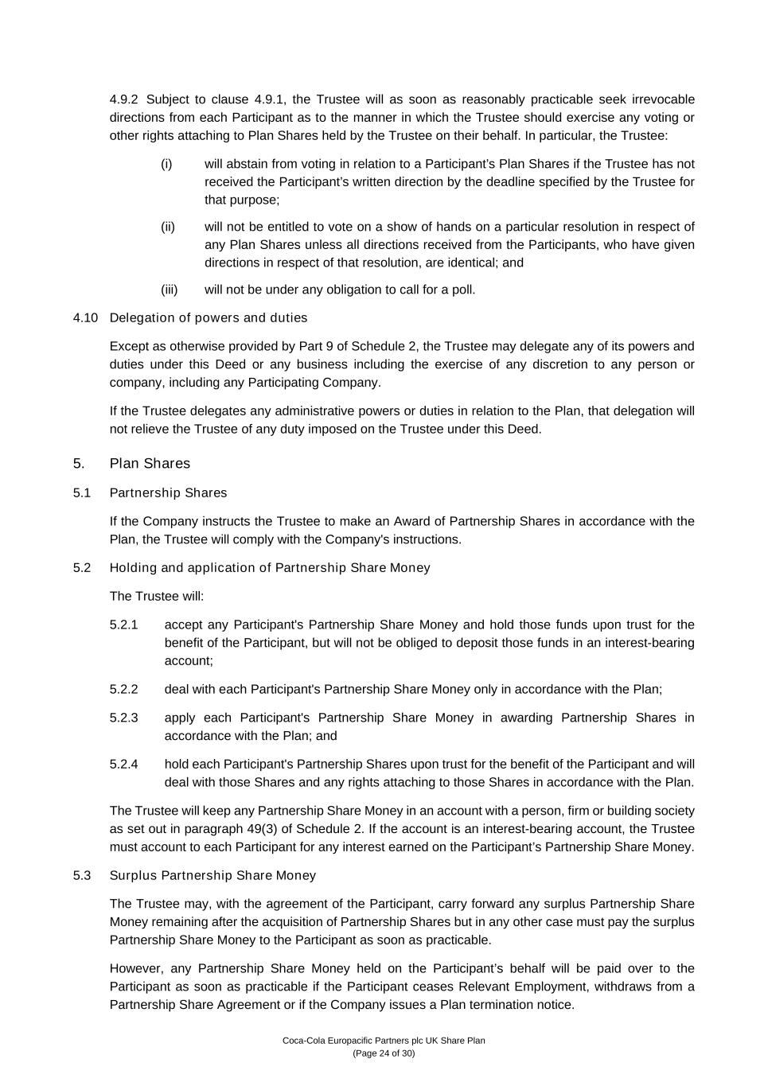
Coca-Cola Europacific Partners plc UK Share Plan (Page 24 of 30) 4.9.2 Subject to clause 4.9.1, the Trustee will as soon as reasonably practicable seek irrevocable directions from each Participant as to the manner in which the Trustee should exercise any voting or other rights attaching to Plan Shares held by the Trustee on their behalf. In particular, the Trustee: (i) will abstain from voting in relation to a Participant’s Plan Shares if the Trustee has not received the Participant’s written direction by the deadline specified by the Trustee for that purpose; (ii) will not be entitled to vote on a show of hands on a particular resolution in respect of any Plan Shares unless all directions received from the Participants, who have given directions in respect of that resolution, are identical; and (iii) will not be under any obligation to call for a poll. 4.10 Delegation of powers and duties Except as otherwise provided by Part 9 of Schedule 2, the Trustee may delegate any of its powers and duties under this Deed or any business including the exercise of any discretion to any person or company, including any Participating Company. If the Trustee delegates any administrative powers or duties in relation to the Plan, that delegation will not relieve the Trustee of any duty imposed on the Trustee under this Deed. 5. Plan Shares 5.1 Partnership Shares If the Company instructs the Trustee to make an Award of Partnership Shares in accordance with the Plan, the Trustee will comply with the Company's instructions. 5.2 Holding and application of Partnership Share Money The Trustee will: 5.2.1 accept any Participant's Partnership Share Money and hold those funds upon trust for the benefit of the Participant, but will not be obliged to deposit those funds in an interest-bearing account; 5.2.2 deal with each Participant's Partnership Share Money only in accordance with the Plan; 5.2.3 apply each Participant's Partnership Share Money in awarding Partnership Shares in accordance with the Plan; and 5.2.4 hold each Participant's Partnership Shares upon trust for the benefit of the Participant and will deal with those Shares and any rights attaching to those Shares in accordance with the Plan. The Trustee will keep any Partnership Share Money in an account with a person, firm or building society as set out in paragraph 49(3) of Schedule 2. If the account is an interest-bearing account, the Trustee must account to each Participant for any interest earned on the Participant’s Partnership Share Money. 5.3 Surplus Partnership Share Money The Trustee may, with the agreement of the Participant, carry forward any surplus Partnership Share Money remaining after the acquisition of Partnership Shares but in any other case must pay the surplus Partnership Share Money to the Participant as soon as practicable. However, any Partnership Share Money held on the Participant’s behalf will be paid over to the Participant as soon as practicable if the Participant ceases Relevant Employment, withdraws from a Partnership Share Agreement or if the Company issues a Plan termination notice.

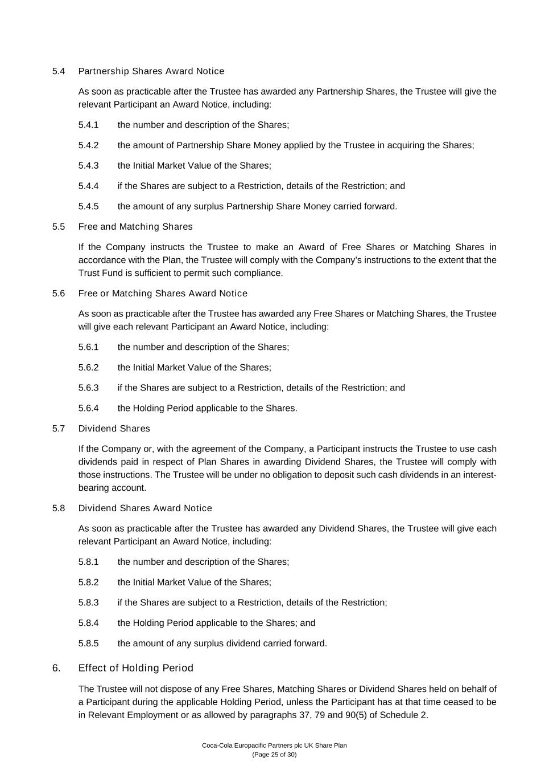
Coca-Cola Europacific Partners plc UK Share Plan (Page 25 of 30) 5.4 Partnership Shares Award Notice As soon as practicable after the Trustee has awarded any Partnership Shares, the Trustee will give the relevant Participant an Award Notice, including: 5.4.1 the number and description of the Shares; 5.4.2 the amount of Partnership Share Money applied by the Trustee in acquiring the Shares; 5.4.3 the Initial Market Value of the Shares; 5.4.4 if the Shares are subject to a Restriction, details of the Restriction; and 5.4.5 the amount of any surplus Partnership Share Money carried forward. 5.5 Free and Matching Shares If the Company instructs the Trustee to make an Award of Free Shares or Matching Shares in accordance with the Plan, the Trustee will comply with the Company’s instructions to the extent that the Trust Fund is sufficient to permit such compliance. 5.6 Free or Matching Shares Award Notice As soon as practicable after the Trustee has awarded any Free Shares or Matching Shares, the Trustee will give each relevant Participant an Award Notice, including: 5.6.1 the number and description of the Shares; 5.6.2 the Initial Market Value of the Shares; 5.6.3 if the Shares are subject to a Restriction, details of the Restriction; and 5.6.4 the Holding Period applicable to the Shares. 5.7 Dividend Shares If the Company or, with the agreement of the Company, a Participant instructs the Trustee to use cash dividends paid in respect of Plan Shares in awarding Dividend Shares, the Trustee will comply with those instructions. The Trustee will be under no obligation to deposit such cash dividends in an interest- bearing account. 5.8 Dividend Shares Award Notice As soon as practicable after the Trustee has awarded any Dividend Shares, the Trustee will give each relevant Participant an Award Notice, including: 5.8.1 the number and description of the Shares; 5.8.2 the Initial Market Value of the Shares; 5.8.3 if the Shares are subject to a Restriction, details of the Restriction; 5.8.4 the Holding Period applicable to the Shares; and 5.8.5 the amount of any surplus dividend carried forward. 6. Effect of Holding Period The Trustee will not dispose of any Free Shares, Matching Shares or Dividend Shares held on behalf of a Participant during the applicable Holding Period, unless the Participant has at that time ceased to be in Relevant Employment or as allowed by paragraphs 37, 79 and 90(5) of Schedule 2.

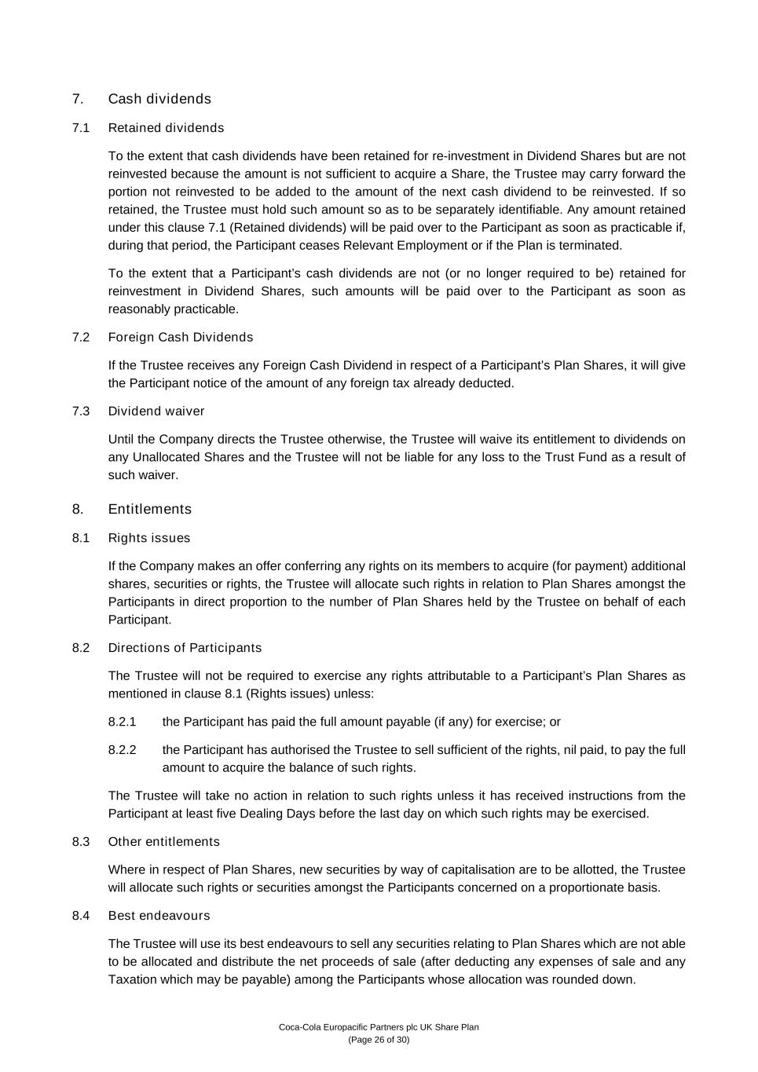
Coca-Cola Europacific Partners plc UK Share Plan (Page 26 of 30) 7. Cash dividends 7.1 Retained dividends To the extent that cash dividends have been retained for re-investment in Dividend Shares but are not reinvested because the amount is not sufficient to acquire a Share, the Trustee may carry forward the portion not reinvested to be added to the amount of the next cash dividend to be reinvested. If so retained, the Trustee must hold such amount so as to be separately identifiable. Any amount retained under this clause 7.1 (Retained dividends) will be paid over to the Participant as soon as practicable if, during that period, the Participant ceases Relevant Employment or if the Plan is terminated. To the extent that a Participant’s cash dividends are not (or no longer required to be) retained for reinvestment in Dividend Shares, such amounts will be paid over to the Participant as soon as reasonably practicable. 7.2 Foreign Cash Dividends If the Trustee receives any Foreign Cash Dividend in respect of a Participant’s Plan Shares, it will give the Participant notice of the amount of any foreign tax already deducted. 7.3 Dividend waiver Until the Company directs the Trustee otherwise, the Trustee will waive its entitlement to dividends on any Unallocated Shares and the Trustee will not be liable for any loss to the Trust Fund as a result of such waiver. 8. Entitlements 8.1 Rights issues If the Company makes an offer conferring any rights on its members to acquire (for payment) additional shares, securities or rights, the Trustee will allocate such rights in relation to Plan Shares amongst the Participants in direct proportion to the number of Plan Shares held by the Trustee on behalf of each Participant. 8.2 Directions of Participants The Trustee will not be required to exercise any rights attributable to a Participant’s Plan Shares as mentioned in clause 8.1 (Rights issues) unless: 8.2.1 the Participant has paid the full amount payable (if any) for exercise; or 8.2.2 the Participant has authorised the Trustee to sell sufficient of the rights, nil paid, to pay the full amount to acquire the balance of such rights. The Trustee will take no action in relation to such rights unless it has received instructions from the Participant at least five Dealing Days before the last day on which such rights may be exercised. 8.3 Other entitlements Where in respect of Plan Shares, new securities by way of capitalisation are to be allotted, the Trustee will allocate such rights or securities amongst the Participants concerned on a proportionate basis. 8.4 Best endeavours The Trustee will use its best endeavours to sell any securities relating to Plan Shares which are not able to be allocated and distribute the net proceeds of sale (after deducting any expenses of sale and any Taxation which may be payable) among the Participants whose allocation was rounded down.

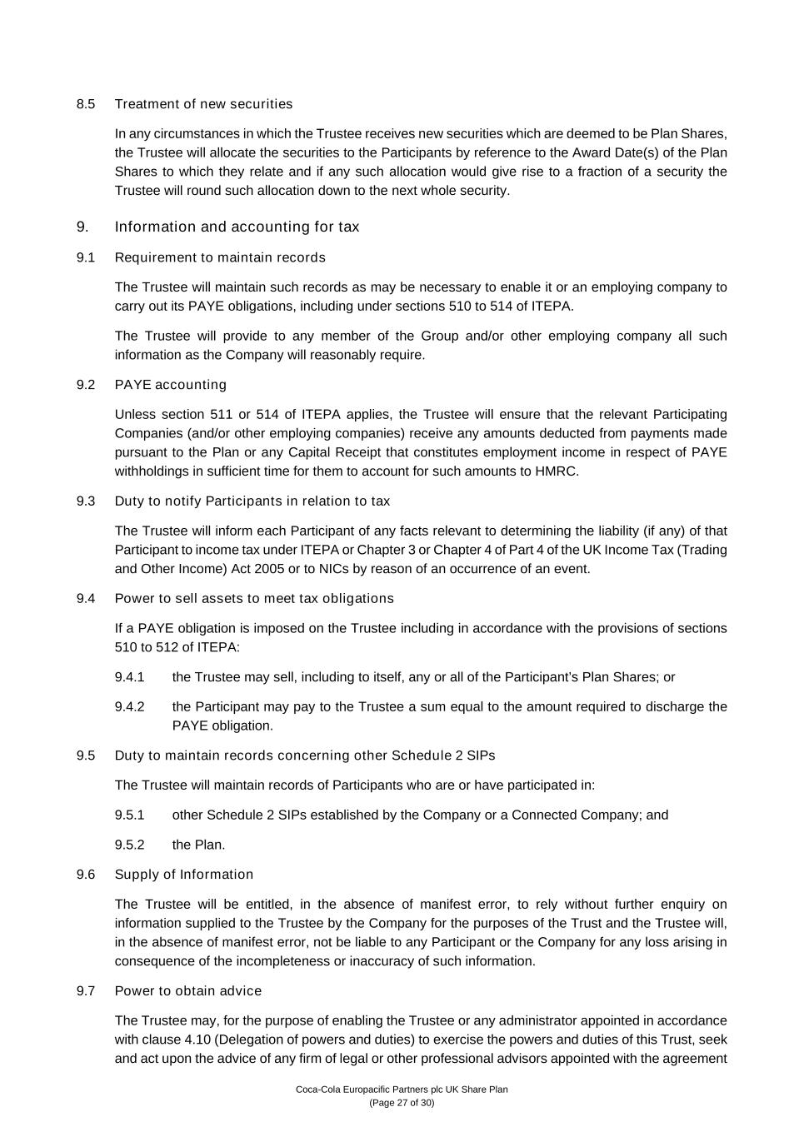
Coca-Cola Europacific Partners plc UK Share Plan (Page 27 of 30) 8.5 Treatment of new securities In any circumstances in which the Trustee receives new securities which are deemed to be Plan Shares, the Trustee will allocate the securities to the Participants by reference to the Award Date(s) of the Plan Shares to which they relate and if any such allocation would give rise to a fraction of a security the Trustee will round such allocation down to the next whole security. 9. Information and accounting for tax 9.1 Requirement to maintain records The Trustee will maintain such records as may be necessary to enable it or an employing company to carry out its PAYE obligations, including under sections 510 to 514 of ITEPA. The Trustee will provide to any member of the Group and/or other employing company all such information as the Company will reasonably require. 9.2 PAYE accounting Unless section 511 or 514 of ITEPA applies, the Trustee will ensure that the relevant Participating Companies (and/or other employing companies) receive any amounts deducted from payments made pursuant to the Plan or any Capital Receipt that constitutes employment income in respect of PAYE withholdings in sufficient time for them to account for such amounts to HMRC. 9.3 Duty to notify Participants in relation to tax The Trustee will inform each Participant of any facts relevant to determining the liability (if any) of that Participant to income tax under ITEPA or Chapter 3 or Chapter 4 of Part 4 of the UK Income Tax (Trading and Other Income) Act 2005 or to NICs by reason of an occurrence of an event. 9.4 Power to sell assets to meet tax obligations If a PAYE obligation is imposed on the Trustee including in accordance with the provisions of sections 510 to 512 of ITEPA: 9.4.1 the Trustee may sell, including to itself, any or all of the Participant’s Plan Shares; or 9.4.2 the Participant may pay to the Trustee a sum equal to the amount required to discharge the PAYE obligation. 9.5 Duty to maintain records concerning other Schedule 2 SIPs The Trustee will maintain records of Participants who are or have participated in: 9.5.1 other Schedule 2 SIPs established by the Company or a Connected Company; and 9.5.2 the Plan. 9.6 Supply of Information The Trustee will be entitled, in the absence of manifest error, to rely without further enquiry on information supplied to the Trustee by the Company for the purposes of the Trust and the Trustee will, in the absence of manifest error, not be liable to any Participant or the Company for any loss arising in consequence of the incompleteness or inaccuracy of such information. 9.7 Power to obtain advice The Trustee may, for the purpose of enabling the Trustee or any administrator appointed in accordance with clause 4.10 (Delegation of powers and duties) to exercise the powers and duties of this Trust, seek and act upon the advice of any firm of legal or other professional advisors appointed with the agreement

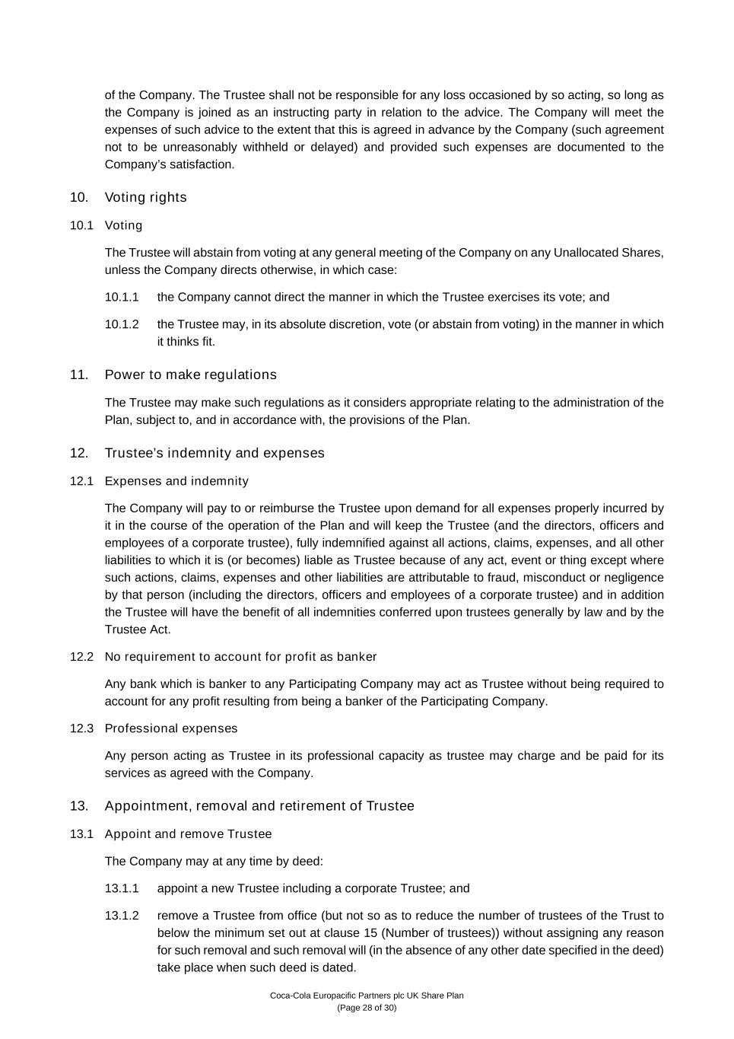
Coca-Cola Europacific Partners plc UK Share Plan (Page 28 of 30) of the Company. The Trustee shall not be responsible for any loss occasioned by so acting, so long as the Company is joined as an instructing party in relation to the advice. The Company will meet the expenses of such advice to the extent that this is agreed in advance by the Company (such agreement not to be unreasonably withheld or delayed) and provided such expenses are documented to the Company’s satisfaction. 10. Voting rights 10.1 Voting The Trustee will abstain from voting at any general meeting of the Company on any Unallocated Shares, unless the Company directs otherwise, in which case: 10.1.1 the Company cannot direct the manner in which the Trustee exercises its vote; and 10.1.2 the Trustee may, in its absolute discretion, vote (or abstain from voting) in the manner in which it thinks fit. 11. Power to make regulations The Trustee may make such regulations as it considers appropriate relating to the administration of the Plan, subject to, and in accordance with, the provisions of the Plan. 12. Trustee’s indemnity and expenses 12.1 Expenses and indemnity The Company will pay to or reimburse the Trustee upon demand for all expenses properly incurred by it in the course of the operation of the Plan and will keep the Trustee (and the directors, officers and employees of a corporate trustee), fully indemnified against all actions, claims, expenses, and all other liabilities to which it is (or becomes) liable as Trustee because of any act, event or thing except where such actions, claims, expenses and other liabilities are attributable to fraud, misconduct or negligence by that person (including the directors, officers and employees of a corporate trustee) and in addition the Trustee will have the benefit of all indemnities conferred upon trustees generally by law and by the Trustee Act. 12.2 No requirement to account for profit as banker Any bank which is banker to any Participating Company may act as Trustee without being required to account for any profit resulting from being a banker of the Participating Company. 12.3 Professional expenses Any person acting as Trustee in its professional capacity as trustee may charge and be paid for its services as agreed with the Company. 13. Appointment, removal and retirement of Trustee 13.1 Appoint and remove Trustee The Company may at any time by deed: 13.1.1 appoint a new Trustee including a corporate Trustee; and 13.1.2 remove a Trustee from office (but not so as to reduce the number of trustees of the Trust to below the minimum set out at clause 15 (Number of trustees)) without assigning any reason for such removal and such removal will (in the absence of any other date specified in the deed) take place when such deed is dated.

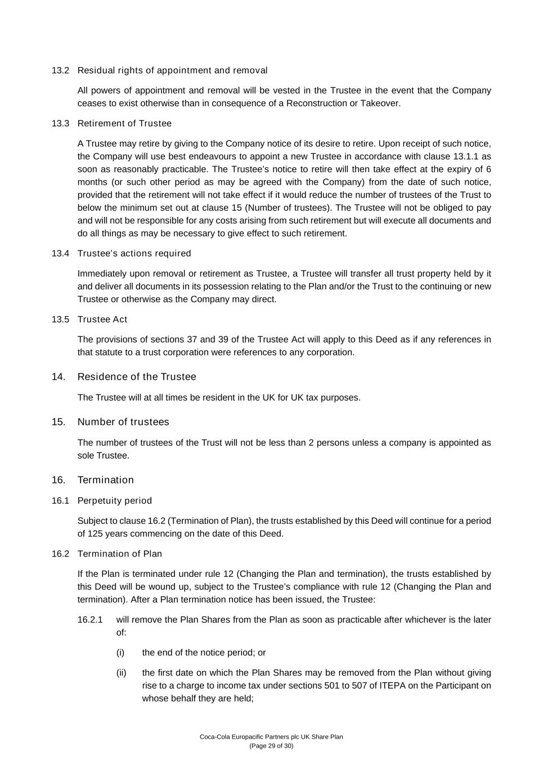
Coca-Cola Europacific Partners plc UK Share Plan (Page 29 of 30) 13.2 Residual rights of appointment and removal All powers of appointment and removal will be vested in the Trustee in the event that the Company ceases to exist otherwise than in consequence of a Reconstruction or Takeover. 13.3 Retirement of Trustee A Trustee may retire by giving to the Company notice of its desire to retire. Upon receipt of such notice, the Company will use best endeavours to appoint a new Trustee in accordance with clause 13.1.1 as soon as reasonably practicable. The Trustee’s notice to retire will then take effect at the expiry of 6 months (or such other period as may be agreed with the Company) from the date of such notice, provided that the retirement will not take effect if it would reduce the number of trustees of the Trust to below the minimum set out at clause 15 (Number of trustees). The Trustee will not be obliged to pay and will not be responsible for any costs arising from such retirement but will execute all documents and do all things as may be necessary to give effect to such retirement. 13.4 Trustee’s actions required Immediately upon removal or retirement as Trustee, a Trustee will transfer all trust property held by it and deliver all documents in its possession relating to the Plan and/or the Trust to the continuing or new Trustee or otherwise as the Company may direct. 13.5 Trustee Act The provisions of sections 37 and 39 of the Trustee Act will apply to this Deed as if any references in that statute to a trust corporation were references to any corporation. 14. Residence of the Trustee The Trustee will at all times be resident in the UK for UK tax purposes. 15. Number of trustees The number of trustees of the Trust will not be less than 2 persons unless a company is appointed as sole Trustee. 16. Termination 16.1 Perpetuity period Subject to clause 16.2 (Termination of Plan), the trusts established by this Deed will continue for a period of 125 years commencing on the date of this Deed. 16.2 Termination of Plan If the Plan is terminated under rule 12 (Changing the Plan and termination), the trusts established by this Deed will be wound up, subject to the Trustee’s compliance with rule 12 (Changing the Plan and termination). After a Plan termination notice has been issued, the Trustee: 16.2.1 will remove the Plan Shares from the Plan as soon as practicable after whichever is the later of: (i) the end of the notice period; or (ii) the first date on which the Plan Shares may be removed from the Plan without giving rise to a charge to income tax under sections 501 to 507 of ITEPA on the Participant on whose behalf they are held;

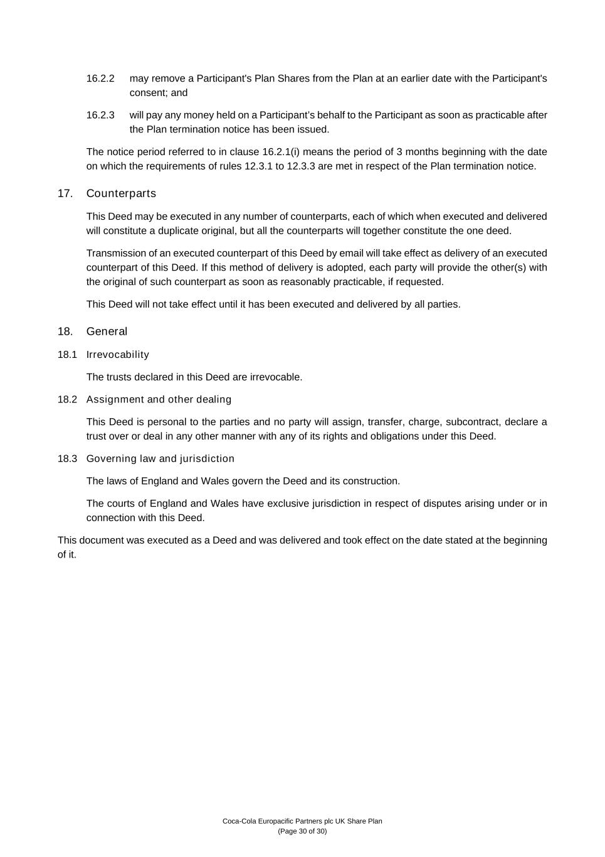
Coca-Cola Europacific Partners plc UK Share Plan (Page 30 of 30) 16.2.2 may remove a Participant's Plan Shares from the Plan at an earlier date with the Participant's consent; and 16.2.3 will pay any money held on a Participant’s behalf to the Participant as soon as practicable after the Plan termination notice has been issued. The notice period referred to in clause 16.2.1(i) means the period of 3 months beginning with the date on which the requirements of rules 12.3.1 to 12.3.3 are met in respect of the Plan termination notice. 17. Counterparts This Deed may be executed in any number of counterparts, each of which when executed and delivered will constitute a duplicate original, but all the counterparts will together constitute the one deed. Transmission of an executed counterpart of this Deed by email will take effect as delivery of an executed counterpart of this Deed. If this method of delivery is adopted, each party will provide the other(s) with the original of such counterpart as soon as reasonably practicable, if requested. This Deed will not take effect until it has been executed and delivered by all parties. 18. General 18.1 Irrevocability The trusts declared in this Deed are irrevocable. 18.2 Assignment and other dealing This Deed is personal to the parties and no party will assign, transfer, charge, subcontract, declare a trust over or deal in any other manner with any of its rights and obligations under this Deed. 18.3 Governing law and jurisdiction The laws of England and Wales govern the Deed and its construction. The courts of England and Wales have exclusive jurisdiction in respect of disputes arising under or in connection with this Deed. This document was executed as a Deed and was delivered and took effect on the date stated at the beginning of it.

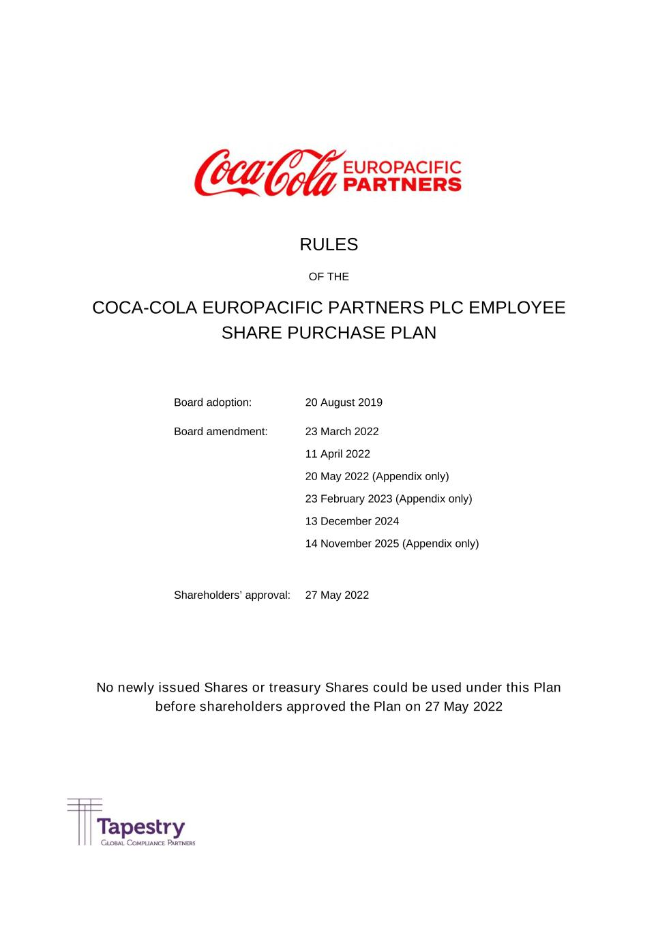
RULES OF THE COCA-COLA EUROPACIFIC PARTNERS PLC EMPLOYEE SHARE PURCHASE PLAN No newly issued Shares or treasury Shares could be used under this Plan before shareholders approved the Plan on 27 May 2022 Board adoption: 20 August 2019 Board amendment: 23 March 2022 11 April 2022 20 May 2022 (Appendix only) 23 February 2023 (Appendix only) 13 December 2024 14 November 2025 (Appendix only) Shareholders’ approval: 27 May 2022

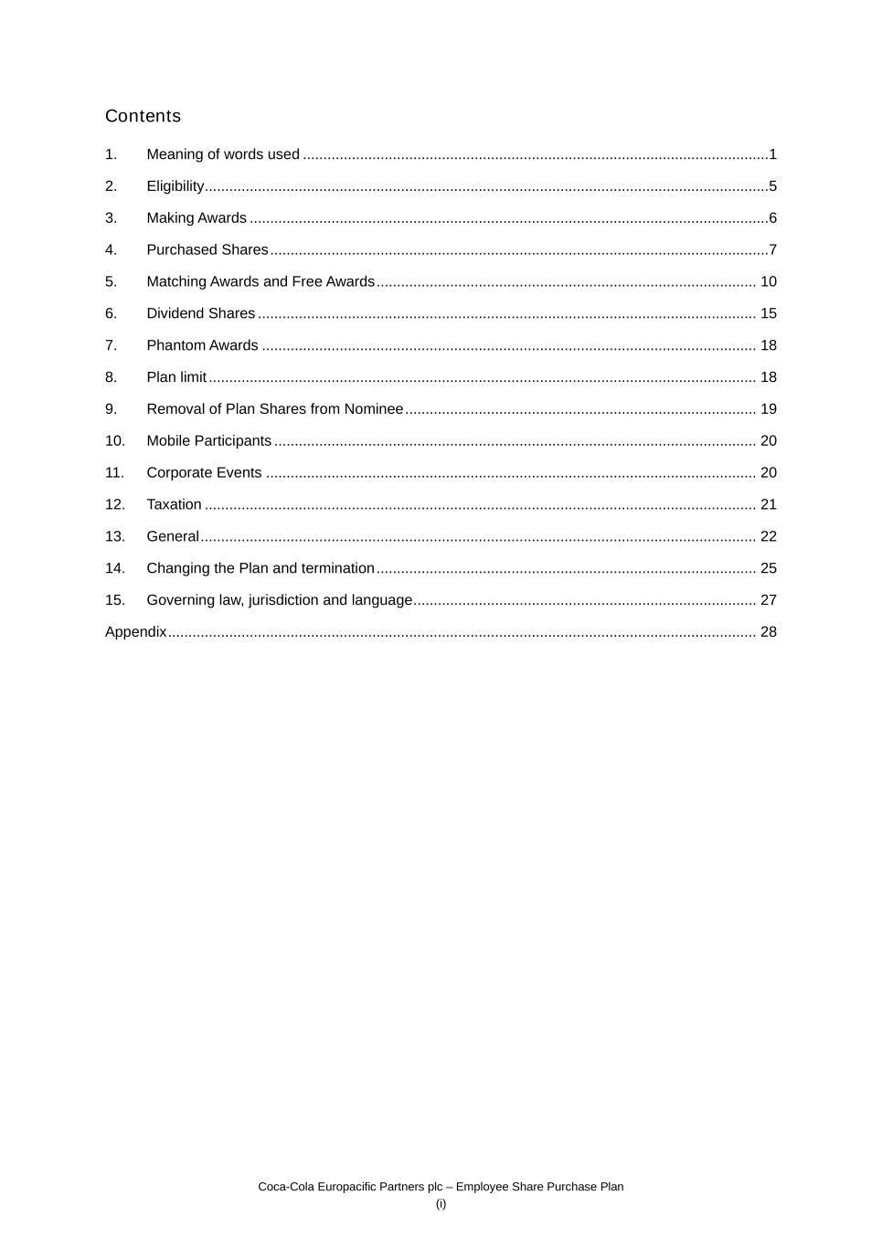
Coca-Cola Europacific Partners plc – Employee Share Purchase Plan (i) Contents 1. Meaning of words used ..................................................................................................................1 2. Eligibility ..........................................................................................................................................5 3. Making Awards ...............................................................................................................................6 4. Purchased Shares ..........................................................................................................................7 5. Matching Awards and Free Awards ............................................................................................. 10 6. Dividend Shares .......................................................................................................................... 15 7. Phantom Awards ......................................................................................................................... 18 8. Plan limit ...................................................................................................................................... 18 9. Removal of Plan Shares from Nominee ...................................................................................... 19 10. Mobile Participants ...................................................................................................................... 20 11. Corporate Events ........................................................................................................................ 20 12. Taxation ....................................................................................................................................... 21 13. General ........................................................................................................................................ 22 14. Changing the Plan and termination ............................................................................................. 25 15. Governing law, jurisdiction and language .................................................................................... 27 Appendix ................................................................................................................................................ 28

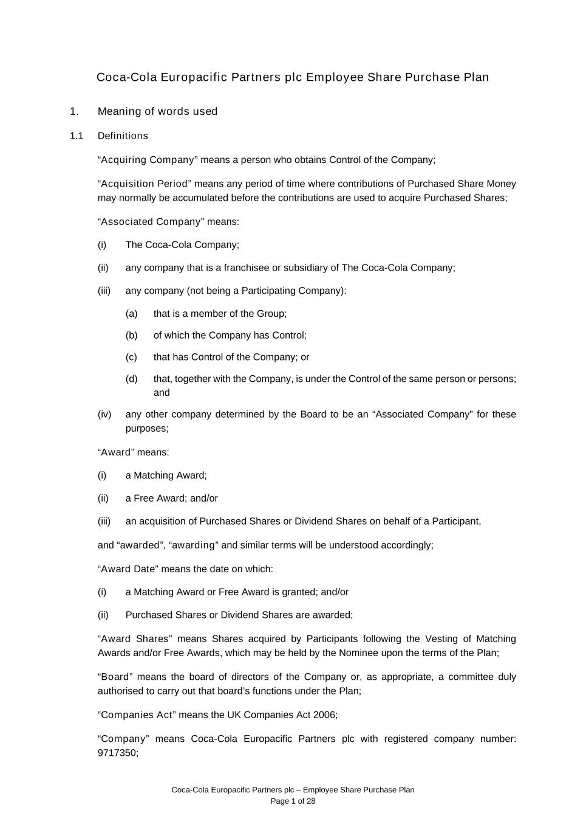
Coca-Cola Europacific Partners plc – Employee Share Purchase Plan Page 1 of 28 Coca-Cola Europacific Partners plc Employee Share Purchase Plan 1. Meaning of words used 1.1 Definitions “Acquiring Company” means a person who obtains Control of the Company; “Acquisition Period” means any period of time where contributions of Purchased Share Money may normally be accumulated before the contributions are used to acquire Purchased Shares; “Associated Company” means: (i) The Coca-Cola Company; (ii) any company that is a franchisee or subsidiary of The Coca-Cola Company; (iii) any company (not being a Participating Company): (a) that is a member of the Group; (b) of which the Company has Control; (c) that has Control of the Company; or (d) that, together with the Company, is under the Control of the same person or persons; and (iv) any other company determined by the Board to be an “Associated Company” for these purposes; “Award” means: (i) a Matching Award; (ii) a Free Award; and/or (iii) an acquisition of Purchased Shares or Dividend Shares on behalf of a Participant, and “awarded”, “awarding” and similar terms will be understood accordingly; “Award Date” means the date on which: (i) a Matching Award or Free Award is granted; and/or (ii) Purchased Shares or Dividend Shares are awarded; “Award Shares” means Shares acquired by Participants following the Vesting of Matching Awards and/or Free Awards, which may be held by the Nominee upon the terms of the Plan; “Board” means the board of directors of the Company or, as appropriate, a committee duly authorised to carry out that board’s functions under the Plan; “Companies Act” means the UK Companies Act 2006; “Company” means Coca-Cola Europacific Partners plc with registered company number: 9717350;

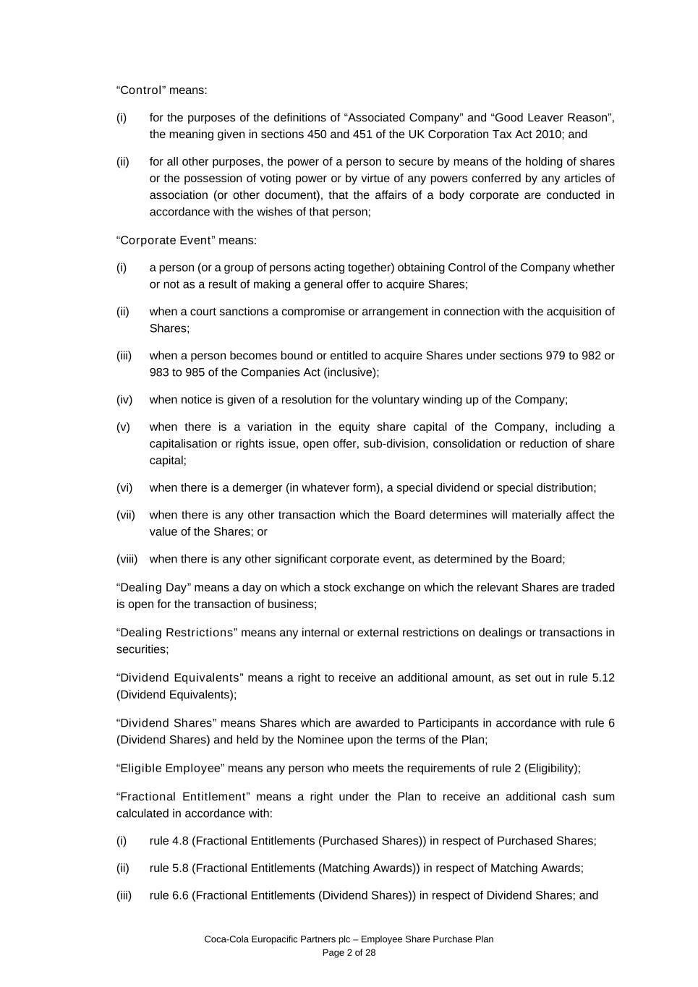
Coca-Cola Europacific Partners plc – Employee Share Purchase Plan Page 2 of 28 “Control” means: (i) for the purposes of the definitions of “Associated Company” and “Good Leaver Reason”, the meaning given in sections 450 and 451 of the UK Corporation Tax Act 2010; and (ii) for all other purposes, the power of a person to secure by means of the holding of shares or the possession of voting power or by virtue of any powers conferred by any articles of association (or other document), that the affairs of a body corporate are conducted in accordance with the wishes of that person; “Corporate Event” means: (i) a person (or a group of persons acting together) obtaining Control of the Company whether or not as a result of making a general offer to acquire Shares; (ii) when a court sanctions a compromise or arrangement in connection with the acquisition of Shares; (iii) when a person becomes bound or entitled to acquire Shares under sections 979 to 982 or 983 to 985 of the Companies Act (inclusive); (iv) when notice is given of a resolution for the voluntary winding up of the Company; (v) when there is a variation in the equity share capital of the Company, including a capitalisation or rights issue, open offer, sub-division, consolidation or reduction of share capital; (vi) when there is a demerger (in whatever form), a special dividend or special distribution; (vii) when there is any other transaction which the Board determines will materially affect the value of the Shares; or (viii) when there is any other significant corporate event, as determined by the Board; “Dealing Day” means a day on which a stock exchange on which the relevant Shares are traded is open for the transaction of business; “Dealing Restrictions” means any internal or external restrictions on dealings or transactions in securities; “Dividend Equivalents” means a right to receive an additional amount, as set out in rule 5.12 (Dividend Equivalents); “Dividend Shares” means Shares which are awarded to Participants in accordance with rule 6 (Dividend Shares) and held by the Nominee upon the terms of the Plan; “Eligible Employee” means any person who meets the requirements of rule 2 (Eligibility); “Fractional Entitlement” means a right under the Plan to receive an additional cash sum calculated in accordance with: (i) rule 4.8 (Fractional Entitlements (Purchased Shares)) in respect of Purchased Shares; (ii) rule 5.8 (Fractional Entitlements (Matching Awards)) in respect of Matching Awards; (iii) rule 6.6 (Fractional Entitlements (Dividend Shares)) in respect of Dividend Shares; and

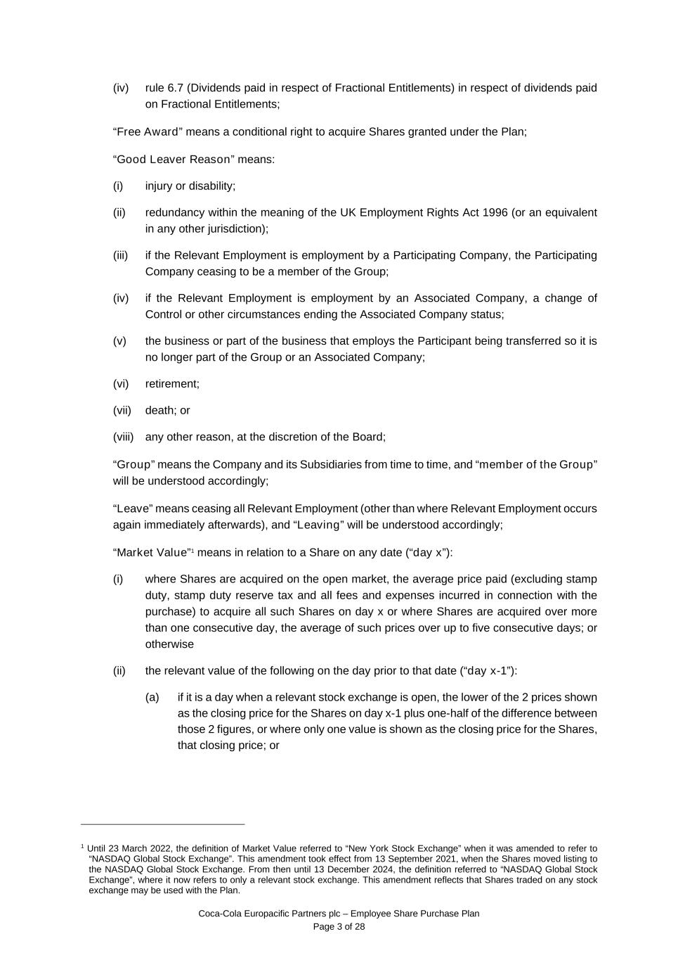
Coca-Cola Europacific Partners plc – Employee Share Purchase Plan Page 3 of 28 (iv) rule 6.7 (Dividends paid in respect of Fractional Entitlements) in respect of dividends paid on Fractional Entitlements; “Free Award” means a conditional right to acquire Shares granted under the Plan; “Good Leaver Reason” means: (i) injury or disability; (ii) redundancy within the meaning of the UK Employment Rights Act 1996 (or an equivalent in any other jurisdiction); (iii) if the Relevant Employment is employment by a Participating Company, the Participating Company ceasing to be a member of the Group; (iv) if the Relevant Employment is employment by an Associated Company, a change of Control or other circumstances ending the Associated Company status; (v) the business or part of the business that employs the Participant being transferred so it is no longer part of the Group or an Associated Company; (vi) retirement; (vii) death; or (viii) any other reason, at the discretion of the Board; “Group” means the Company and its Subsidiaries from time to time, and “member of the Group” will be understood accordingly; “Leave” means ceasing all Relevant Employment (other than where Relevant Employment occurs again immediately afterwards), and “Leaving” will be understood accordingly; “Market Value”1 means in relation to a Share on any date (“day x”): (i) where Shares are acquired on the open market, the average price paid (excluding stamp duty, stamp duty reserve tax and all fees and expenses incurred in connection with the purchase) to acquire all such Shares on day x or where Shares are acquired over more than one consecutive day, the average of such prices over up to five consecutive days; or otherwise (ii) the relevant value of the following on the day prior to that date (“day x-1”): (a) if it is a day when a relevant stock exchange is open, the lower of the 2 prices shown as the closing price for the Shares on day x-1 plus one-half of the difference between those 2 figures, or where only one value is shown as the closing price for the Shares, that closing price; or 1 Until 23 March 2022, the definition of Market Value referred to “New York Stock Exchange” when it was amended to refer to “NASDAQ Global Stock Exchange”. This amendment took effect from 13 September 2021, when the Shares moved listing to the NASDAQ Global Stock Exchange. From then until 13 December 2024, the definition referred to “NASDAQ Global Stock Exchange”, where it now refers to only a relevant stock exchange. This amendment reflects that Shares traded on any stock exchange may be used with the Plan.

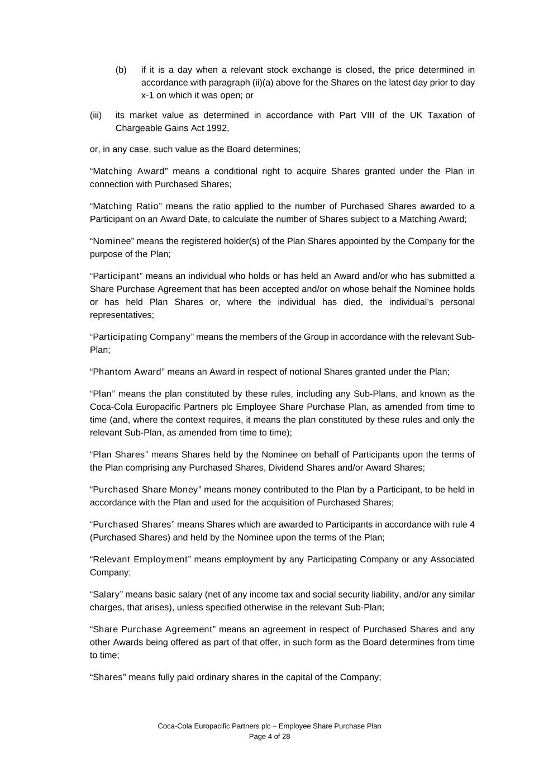
Coca-Cola Europacific Partners plc – Employee Share Purchase Plan Page 4 of 28 (b) if it is a day when a relevant stock exchange is closed, the price determined in accordance with paragraph (ii)(a) above for the Shares on the latest day prior to day x-1 on which it was open; or (iii) its market value as determined in accordance with Part VIII of the UK Taxation of Chargeable Gains Act 1992, or, in any case, such value as the Board determines; “Matching Award” means a conditional right to acquire Shares granted under the Plan in connection with Purchased Shares; “Matching Ratio” means the ratio applied to the number of Purchased Shares awarded to a Participant on an Award Date, to calculate the number of Shares subject to a Matching Award; “Nominee” means the registered holder(s) of the Plan Shares appointed by the Company for the purpose of the Plan; “Participant” means an individual who holds or has held an Award and/or who has submitted a Share Purchase Agreement that has been accepted and/or on whose behalf the Nominee holds or has held Plan Shares or, where the individual has died, the individual’s personal representatives; “Participating Company” means the members of the Group in accordance with the relevant Sub- Plan; “Phantom Award” means an Award in respect of notional Shares granted under the Plan; “Plan” means the plan constituted by these rules, including any Sub-Plans, and known as the Coca-Cola Europacific Partners plc Employee Share Purchase Plan, as amended from time to time (and, where the context requires, it means the plan constituted by these rules and only the relevant Sub-Plan, as amended from time to time); “Plan Shares” means Shares held by the Nominee on behalf of Participants upon the terms of the Plan comprising any Purchased Shares, Dividend Shares and/or Award Shares; “Purchased Share Money” means money contributed to the Plan by a Participant, to be held in accordance with the Plan and used for the acquisition of Purchased Shares; “Purchased Shares” means Shares which are awarded to Participants in accordance with rule 4 (Purchased Shares) and held by the Nominee upon the terms of the Plan; “Relevant Employment” means employment by any Participating Company or any Associated Company; “Salary” means basic salary (net of any income tax and social security liability, and/or any similar charges, that arises), unless specified otherwise in the relevant Sub-Plan; “Share Purchase Agreement” means an agreement in respect of Purchased Shares and any other Awards being offered as part of that offer, in such form as the Board determines from time to time; “Shares” means fully paid ordinary shares in the capital of the Company;

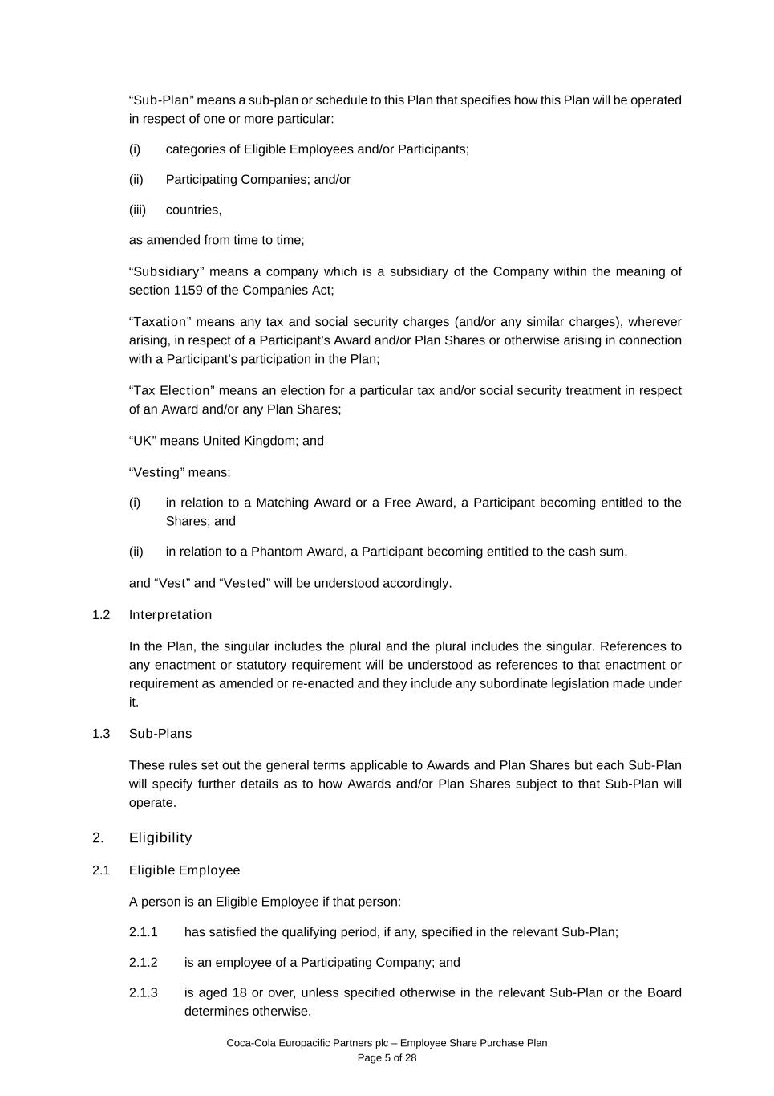
Coca-Cola Europacific Partners plc – Employee Share Purchase Plan Page 5 of 28 “Sub-Plan” means a sub-plan or schedule to this Plan that specifies how this Plan will be operated in respect of one or more particular: (i) categories of Eligible Employees and/or Participants; (ii) Participating Companies; and/or (iii) countries, as amended from time to time; “Subsidiary” means a company which is a subsidiary of the Company within the meaning of section 1159 of the Companies Act; “Taxation” means any tax and social security charges (and/or any similar charges), wherever arising, in respect of a Participant’s Award and/or Plan Shares or otherwise arising in connection with a Participant’s participation in the Plan; “Tax Election” means an election for a particular tax and/or social security treatment in respect of an Award and/or any Plan Shares; “UK” means United Kingdom; and “Vesting” means: (i) in relation to a Matching Award or a Free Award, a Participant becoming entitled to the Shares; and (ii) in relation to a Phantom Award, a Participant becoming entitled to the cash sum, and “Vest” and “Vested” will be understood accordingly. 1.2 Interpretation In the Plan, the singular includes the plural and the plural includes the singular. References to any enactment or statutory requirement will be understood as references to that enactment or requirement as amended or re-enacted and they include any subordinate legislation made under it. 1.3 Sub-Plans These rules set out the general terms applicable to Awards and Plan Shares but each Sub-Plan will specify further details as to how Awards and/or Plan Shares subject to that Sub-Plan will operate. 2. Eligibility 2.1 Eligible Employee A person is an Eligible Employee if that person: 2.1.1 has satisfied the qualifying period, if any, specified in the relevant Sub-Plan; 2.1.2 is an employee of a Participating Company; and 2.1.3 is aged 18 or over, unless specified otherwise in the relevant Sub-Plan or the Board determines otherwise.

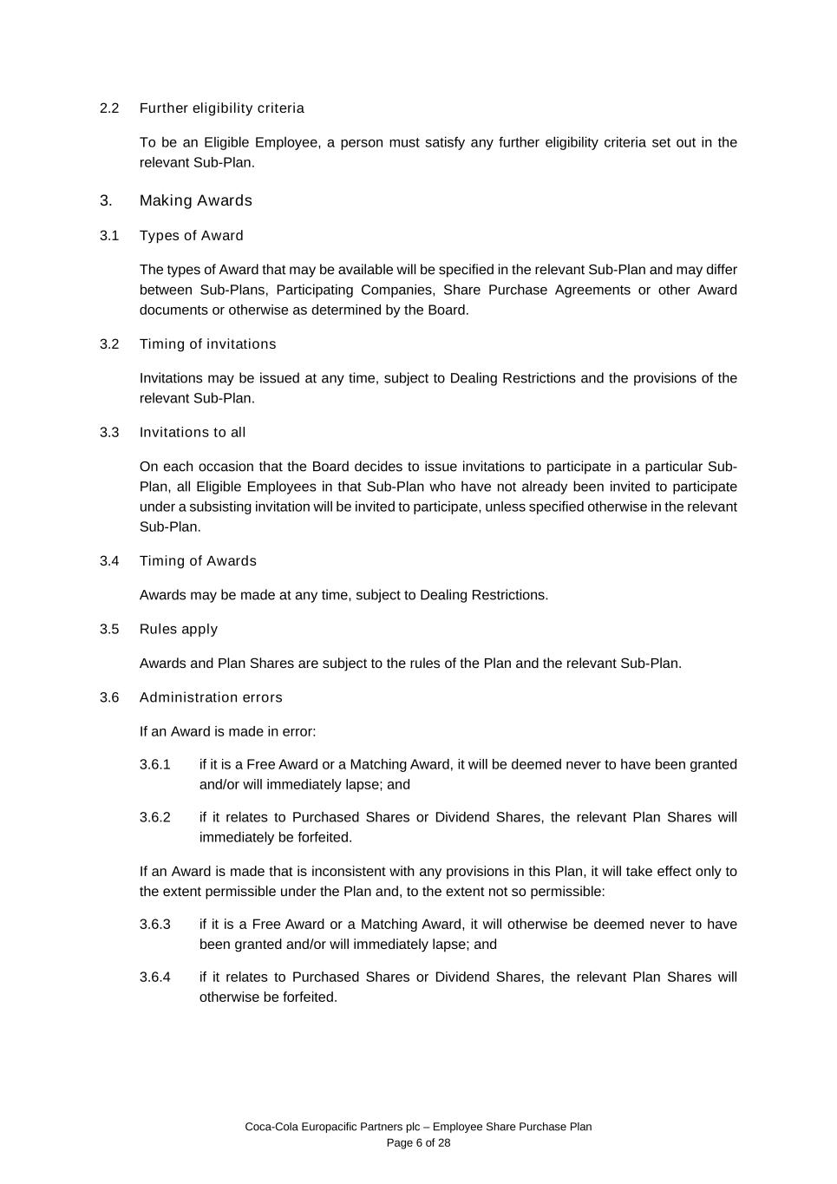
Coca-Cola Europacific Partners plc – Employee Share Purchase Plan Page 6 of 28 2.2 Further eligibility criteria To be an Eligible Employee, a person must satisfy any further eligibility criteria set out in the relevant Sub-Plan. 3. Making Awards 3.1 Types of Award The types of Award that may be available will be specified in the relevant Sub-Plan and may differ between Sub-Plans, Participating Companies, Share Purchase Agreements or other Award documents or otherwise as determined by the Board. 3.2 Timing of invitations Invitations may be issued at any time, subject to Dealing Restrictions and the provisions of the relevant Sub-Plan. 3.3 Invitations to all On each occasion that the Board decides to issue invitations to participate in a particular Sub- Plan, all Eligible Employees in that Sub-Plan who have not already been invited to participate under a subsisting invitation will be invited to participate, unless specified otherwise in the relevant Sub-Plan. 3.4 Timing of Awards Awards may be made at any time, subject to Dealing Restrictions. 3.5 Rules apply Awards and Plan Shares are subject to the rules of the Plan and the relevant Sub-Plan. 3.6 Administration errors If an Award is made in error: 3.6.1 if it is a Free Award or a Matching Award, it will be deemed never to have been granted and/or will immediately lapse; and 3.6.2 if it relates to Purchased Shares or Dividend Shares, the relevant Plan Shares will immediately be forfeited. If an Award is made that is inconsistent with any provisions in this Plan, it will take effect only to the extent permissible under the Plan and, to the extent not so permissible: 3.6.3 if it is a Free Award or a Matching Award, it will otherwise be deemed never to have been granted and/or will immediately lapse; and 3.6.4 if it relates to Purchased Shares or Dividend Shares, the relevant Plan Shares will otherwise be forfeited.

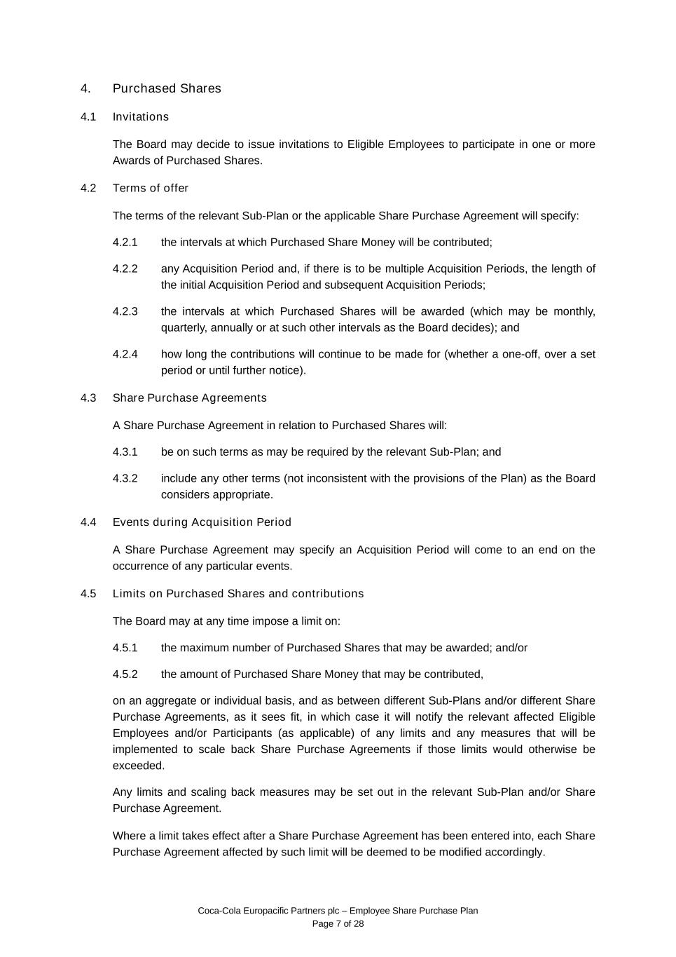
Coca-Cola Europacific Partners plc – Employee Share Purchase Plan Page 7 of 28 4. Purchased Shares 4.1 Invitations The Board may decide to issue invitations to Eligible Employees to participate in one or more Awards of Purchased Shares. 4.2 Terms of offer The terms of the relevant Sub-Plan or the applicable Share Purchase Agreement will specify: 4.2.1 the intervals at which Purchased Share Money will be contributed; 4.2.2 any Acquisition Period and, if there is to be multiple Acquisition Periods, the length of the initial Acquisition Period and subsequent Acquisition Periods; 4.2.3 the intervals at which Purchased Shares will be awarded (which may be monthly, quarterly, annually or at such other intervals as the Board decides); and 4.2.4 how long the contributions will continue to be made for (whether a one-off, over a set period or until further notice). 4.3 Share Purchase Agreements A Share Purchase Agreement in relation to Purchased Shares will: 4.3.1 be on such terms as may be required by the relevant Sub-Plan; and 4.3.2 include any other terms (not inconsistent with the provisions of the Plan) as the Board considers appropriate. 4.4 Events during Acquisition Period A Share Purchase Agreement may specify an Acquisition Period will come to an end on the occurrence of any particular events. 4.5 Limits on Purchased Shares and contributions The Board may at any time impose a limit on: 4.5.1 the maximum number of Purchased Shares that may be awarded; and/or 4.5.2 the amount of Purchased Share Money that may be contributed, on an aggregate or individual basis, and as between different Sub-Plans and/or different Share Purchase Agreements, as it sees fit, in which case it will notify the relevant affected Eligible Employees and/or Participants (as applicable) of any limits and any measures that will be implemented to scale back Share Purchase Agreements if those limits would otherwise be exceeded. Any limits and scaling back measures may be set out in the relevant Sub-Plan and/or Share Purchase Agreement. Where a limit takes effect after a Share Purchase Agreement has been entered into, each Share Purchase Agreement affected by such limit will be deemed to be modified accordingly.

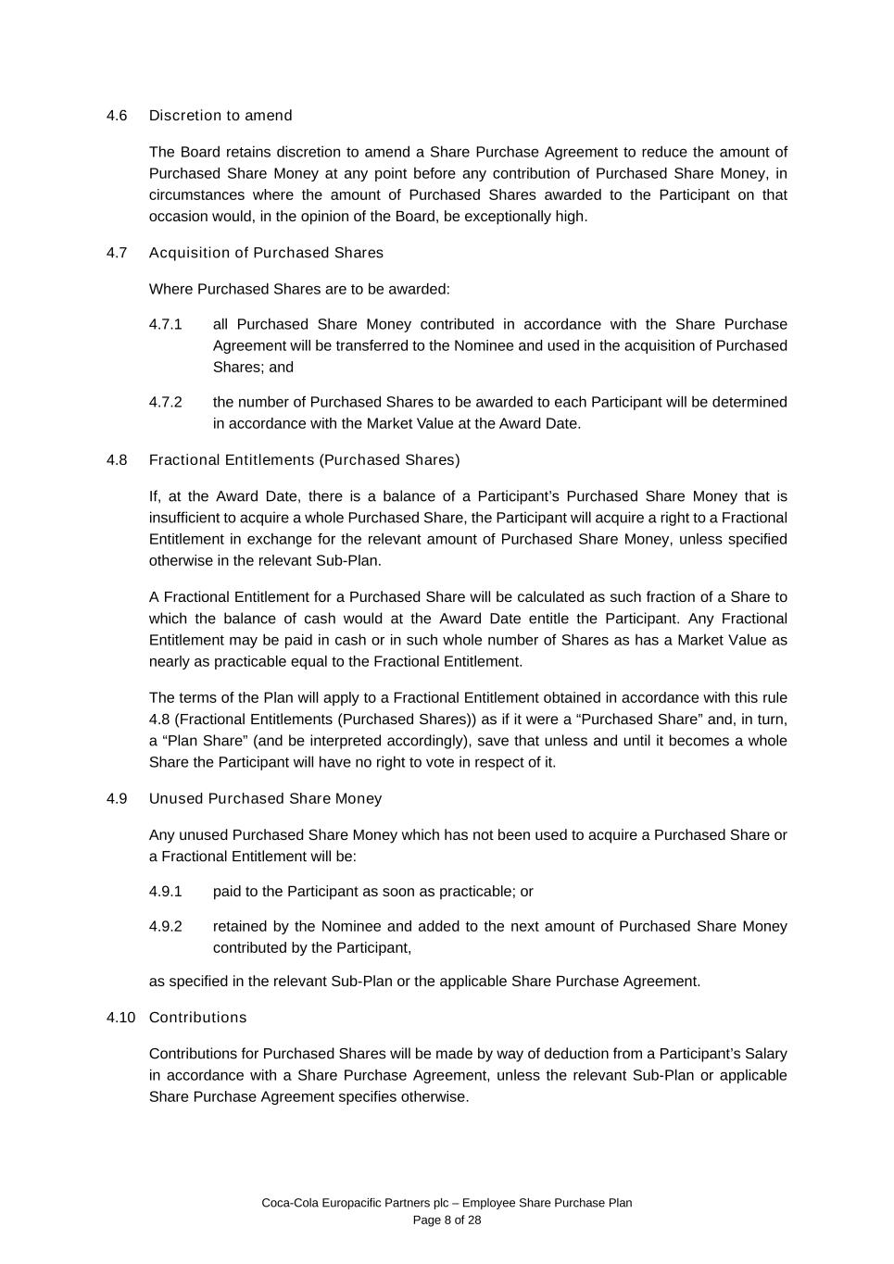
Coca-Cola Europacific Partners plc – Employee Share Purchase Plan Page 8 of 28 4.6 Discretion to amend The Board retains discretion to amend a Share Purchase Agreement to reduce the amount of Purchased Share Money at any point before any contribution of Purchased Share Money, in circumstances where the amount of Purchased Shares awarded to the Participant on that occasion would, in the opinion of the Board, be exceptionally high. 4.7 Acquisition of Purchased Shares Where Purchased Shares are to be awarded: 4.7.1 all Purchased Share Money contributed in accordance with the Share Purchase Agreement will be transferred to the Nominee and used in the acquisition of Purchased Shares; and 4.7.2 the number of Purchased Shares to be awarded to each Participant will be determined in accordance with the Market Value at the Award Date. 4.8 Fractional Entitlements (Purchased Shares) If, at the Award Date, there is a balance of a Participant’s Purchased Share Money that is insufficient to acquire a whole Purchased Share, the Participant will acquire a right to a Fractional Entitlement in exchange for the relevant amount of Purchased Share Money, unless specified otherwise in the relevant Sub-Plan. A Fractional Entitlement for a Purchased Share will be calculated as such fraction of a Share to which the balance of cash would at the Award Date entitle the Participant. Any Fractional Entitlement may be paid in cash or in such whole number of Shares as has a Market Value as nearly as practicable equal to the Fractional Entitlement. The terms of the Plan will apply to a Fractional Entitlement obtained in accordance with this rule 4.8 (Fractional Entitlements (Purchased Shares)) as if it were a “Purchased Share” and, in turn, a “Plan Share” (and be interpreted accordingly), save that unless and until it becomes a whole Share the Participant will have no right to vote in respect of it. 4.9 Unused Purchased Share Money Any unused Purchased Share Money which has not been used to acquire a Purchased Share or a Fractional Entitlement will be: 4.9.1 paid to the Participant as soon as practicable; or 4.9.2 retained by the Nominee and added to the next amount of Purchased Share Money contributed by the Participant, as specified in the relevant Sub-Plan or the applicable Share Purchase Agreement. 4.10 Contributions Contributions for Purchased Shares will be made by way of deduction from a Participant’s Salary in accordance with a Share Purchase Agreement, unless the relevant Sub-Plan or applicable Share Purchase Agreement specifies otherwise.

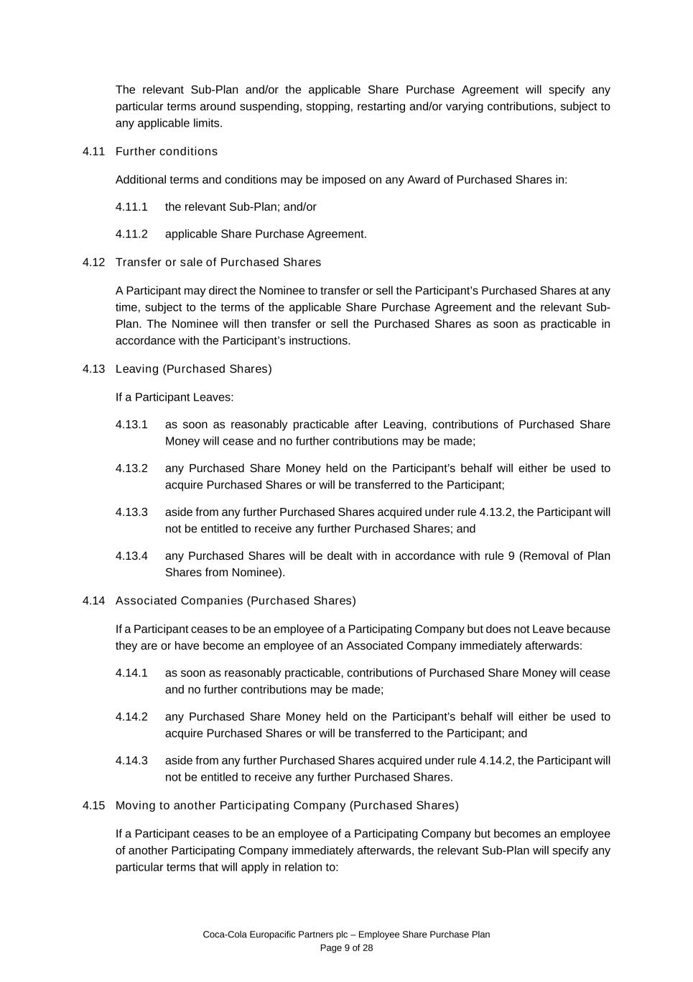
Coca-Cola Europacific Partners plc – Employee Share Purchase Plan Page 9 of 28 The relevant Sub-Plan and/or the applicable Share Purchase Agreement will specify any particular terms around suspending, stopping, restarting and/or varying contributions, subject to any applicable limits. 4.11 Further conditions Additional terms and conditions may be imposed on any Award of Purchased Shares in: 4.11.1 the relevant Sub-Plan; and/or 4.11.2 applicable Share Purchase Agreement. 4.12 Transfer or sale of Purchased Shares A Participant may direct the Nominee to transfer or sell the Participant’s Purchased Shares at any time, subject to the terms of the applicable Share Purchase Agreement and the relevant Sub- Plan. The Nominee will then transfer or sell the Purchased Shares as soon as practicable in accordance with the Participant’s instructions. 4.13 Leaving (Purchased Shares) If a Participant Leaves: 4.13.1 as soon as reasonably practicable after Leaving, contributions of Purchased Share Money will cease and no further contributions may be made; 4.13.2 any Purchased Share Money held on the Participant’s behalf will either be used to acquire Purchased Shares or will be transferred to the Participant; 4.13.3 aside from any further Purchased Shares acquired under rule 4.13.2, the Participant will not be entitled to receive any further Purchased Shares; and 4.13.4 any Purchased Shares will be dealt with in accordance with rule 9 (Removal of Plan Shares from Nominee). 4.14 Associated Companies (Purchased Shares) If a Participant ceases to be an employee of a Participating Company but does not Leave because they are or have become an employee of an Associated Company immediately afterwards: 4.14.1 as soon as reasonably practicable, contributions of Purchased Share Money will cease and no further contributions may be made; 4.14.2 any Purchased Share Money held on the Participant’s behalf will either be used to acquire Purchased Shares or will be transferred to the Participant; and 4.14.3 aside from any further Purchased Shares acquired under rule 4.14.2, the Participant will not be entitled to receive any further Purchased Shares. 4.15 Moving to another Participating Company (Purchased Shares) If a Participant ceases to be an employee of a Participating Company but becomes an employee of another Participating Company immediately afterwards, the relevant Sub-Plan will specify any particular terms that will apply in relation to:

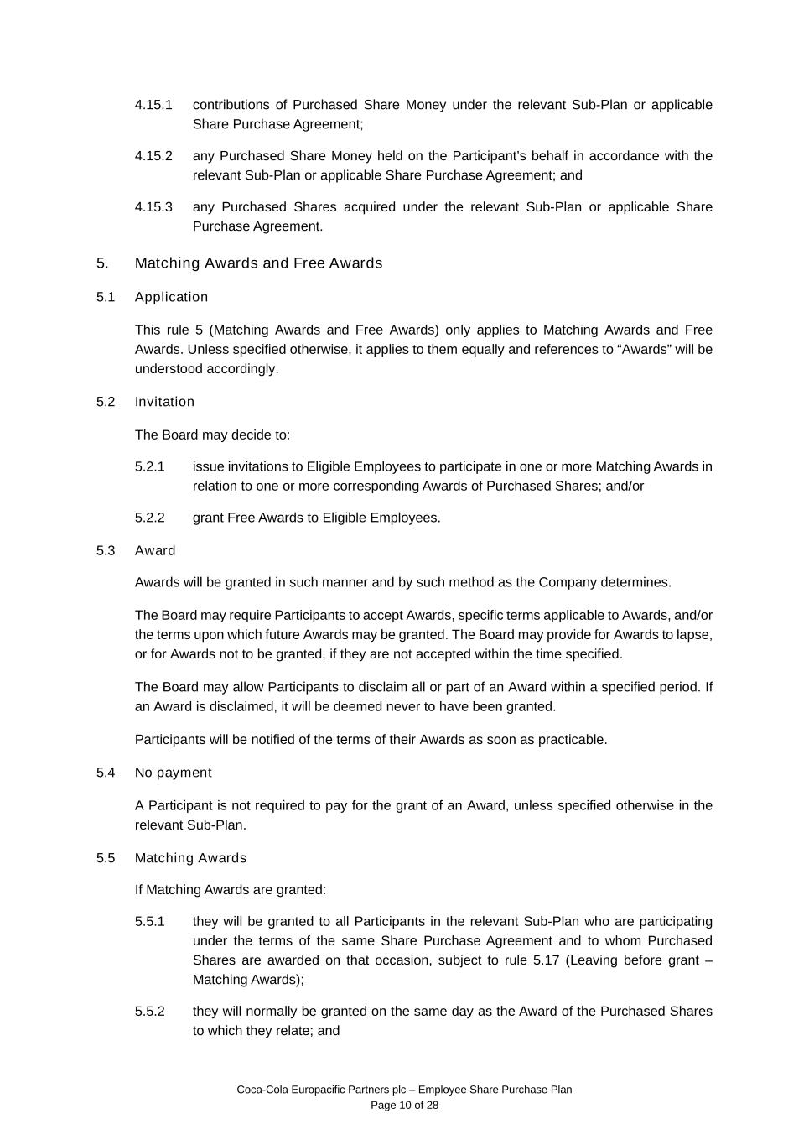
Coca-Cola Europacific Partners plc – Employee Share Purchase Plan Page 10 of 28 4.15.1 contributions of Purchased Share Money under the relevant Sub-Plan or applicable Share Purchase Agreement; 4.15.2 any Purchased Share Money held on the Participant’s behalf in accordance with the relevant Sub-Plan or applicable Share Purchase Agreement; and 4.15.3 any Purchased Shares acquired under the relevant Sub-Plan or applicable Share Purchase Agreement. 5. Matching Awards and Free Awards 5.1 Application This rule 5 (Matching Awards and Free Awards) only applies to Matching Awards and Free Awards. Unless specified otherwise, it applies to them equally and references to “Awards” will be understood accordingly. 5.2 Invitation The Board may decide to: 5.2.1 issue invitations to Eligible Employees to participate in one or more Matching Awards in relation to one or more corresponding Awards of Purchased Shares; and/or 5.2.2 grant Free Awards to Eligible Employees. 5.3 Award Awards will be granted in such manner and by such method as the Company determines. The Board may require Participants to accept Awards, specific terms applicable to Awards, and/or the terms upon which future Awards may be granted. The Board may provide for Awards to lapse, or for Awards not to be granted, if they are not accepted within the time specified. The Board may allow Participants to disclaim all or part of an Award within a specified period. If an Award is disclaimed, it will be deemed never to have been granted. Participants will be notified of the terms of their Awards as soon as practicable. 5.4 No payment A Participant is not required to pay for the grant of an Award, unless specified otherwise in the relevant Sub-Plan. 5.5 Matching Awards If Matching Awards are granted: 5.5.1 they will be granted to all Participants in the relevant Sub-Plan who are participating under the terms of the same Share Purchase Agreement and to whom Purchased Shares are awarded on that occasion, subject to rule 5.17 (Leaving before grant – Matching Awards); 5.5.2 they will normally be granted on the same day as the Award of the Purchased Shares to which they relate; and

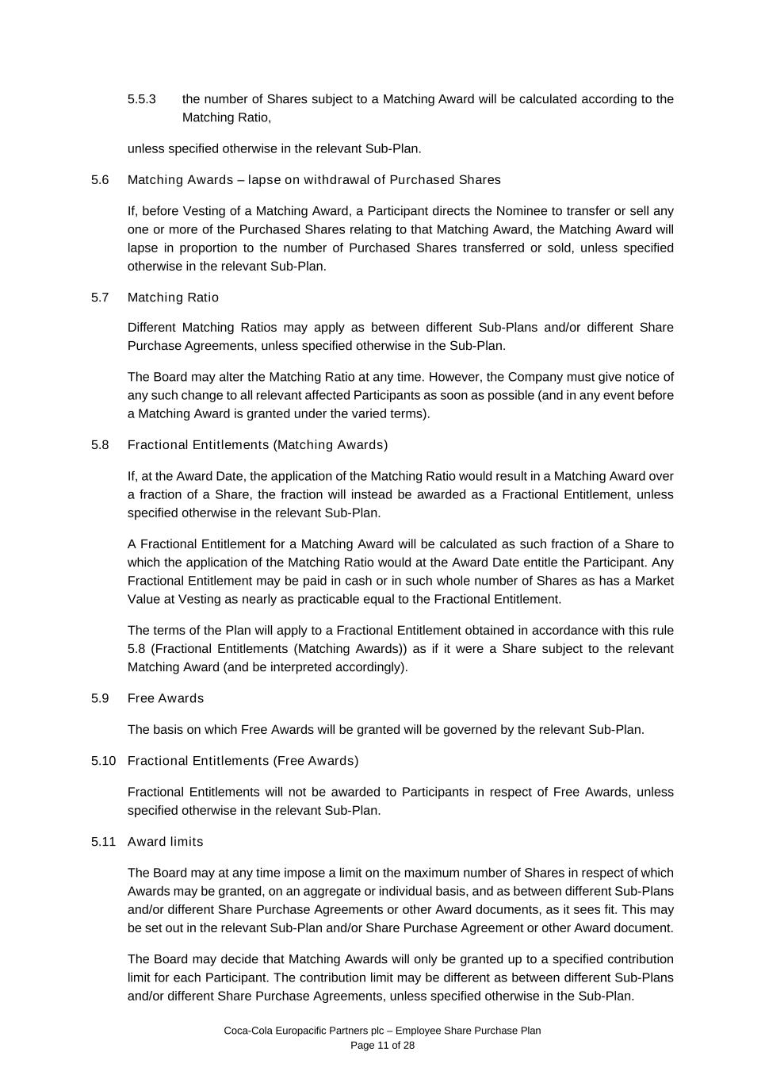
Coca-Cola Europacific Partners plc – Employee Share Purchase Plan Page 11 of 28 5.5.3 the number of Shares subject to a Matching Award will be calculated according to the Matching Ratio, unless specified otherwise in the relevant Sub-Plan. 5.6 Matching Awards – lapse on withdrawal of Purchased Shares If, before Vesting of a Matching Award, a Participant directs the Nominee to transfer or sell any one or more of the Purchased Shares relating to that Matching Award, the Matching Award will lapse in proportion to the number of Purchased Shares transferred or sold, unless specified otherwise in the relevant Sub-Plan. 5.7 Matching Ratio Different Matching Ratios may apply as between different Sub-Plans and/or different Share Purchase Agreements, unless specified otherwise in the Sub-Plan. The Board may alter the Matching Ratio at any time. However, the Company must give notice of any such change to all relevant affected Participants as soon as possible (and in any event before a Matching Award is granted under the varied terms). 5.8 Fractional Entitlements (Matching Awards) If, at the Award Date, the application of the Matching Ratio would result in a Matching Award over a fraction of a Share, the fraction will instead be awarded as a Fractional Entitlement, unless specified otherwise in the relevant Sub-Plan. A Fractional Entitlement for a Matching Award will be calculated as such fraction of a Share to which the application of the Matching Ratio would at the Award Date entitle the Participant. Any Fractional Entitlement may be paid in cash or in such whole number of Shares as has a Market Value at Vesting as nearly as practicable equal to the Fractional Entitlement. The terms of the Plan will apply to a Fractional Entitlement obtained in accordance with this rule 5.8 (Fractional Entitlements (Matching Awards)) as if it were a Share subject to the relevant Matching Award (and be interpreted accordingly). 5.9 Free Awards The basis on which Free Awards will be granted will be governed by the relevant Sub-Plan. 5.10 Fractional Entitlements (Free Awards) Fractional Entitlements will not be awarded to Participants in respect of Free Awards, unless specified otherwise in the relevant Sub-Plan. 5.11 Award limits The Board may at any time impose a limit on the maximum number of Shares in respect of which Awards may be granted, on an aggregate or individual basis, and as between different Sub-Plans and/or different Share Purchase Agreements or other Award documents, as it sees fit. This may be set out in the relevant Sub-Plan and/or Share Purchase Agreement or other Award document. The Board may decide that Matching Awards will only be granted up to a specified contribution limit for each Participant. The contribution limit may be different as between different Sub-Plans and/or different Share Purchase Agreements, unless specified otherwise in the Sub-Plan.

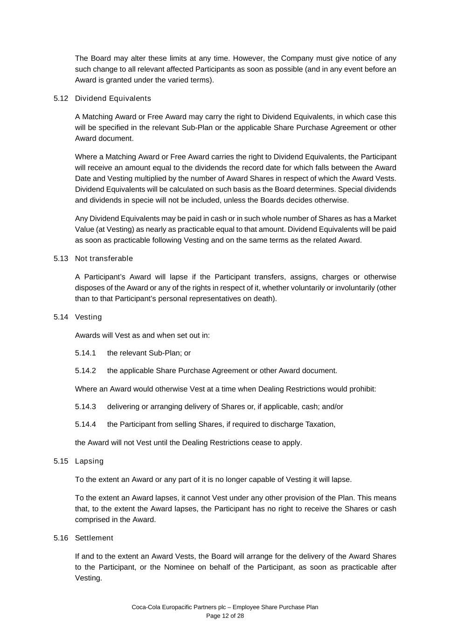
Coca-Cola Europacific Partners plc – Employee Share Purchase Plan Page 12 of 28 The Board may alter these limits at any time. However, the Company must give notice of any such change to all relevant affected Participants as soon as possible (and in any event before an Award is granted under the varied terms). 5.12 Dividend Equivalents A Matching Award or Free Award may carry the right to Dividend Equivalents, in which case this will be specified in the relevant Sub-Plan or the applicable Share Purchase Agreement or other Award document. Where a Matching Award or Free Award carries the right to Dividend Equivalents, the Participant will receive an amount equal to the dividends the record date for which falls between the Award Date and Vesting multiplied by the number of Award Shares in respect of which the Award Vests. Dividend Equivalents will be calculated on such basis as the Board determines. Special dividends and dividends in specie will not be included, unless the Boards decides otherwise. Any Dividend Equivalents may be paid in cash or in such whole number of Shares as has a Market Value (at Vesting) as nearly as practicable equal to that amount. Dividend Equivalents will be paid as soon as practicable following Vesting and on the same terms as the related Award. 5.13 Not transferable A Participant’s Award will lapse if the Participant transfers, assigns, charges or otherwise disposes of the Award or any of the rights in respect of it, whether voluntarily or involuntarily (other than to that Participant’s personal representatives on death). 5.14 Vesting Awards will Vest as and when set out in: 5.14.1 the relevant Sub-Plan; or 5.14.2 the applicable Share Purchase Agreement or other Award document. Where an Award would otherwise Vest at a time when Dealing Restrictions would prohibit: 5.14.3 delivering or arranging delivery of Shares or, if applicable, cash; and/or 5.14.4 the Participant from selling Shares, if required to discharge Taxation, the Award will not Vest until the Dealing Restrictions cease to apply. 5.15 Lapsing To the extent an Award or any part of it is no longer capable of Vesting it will lapse. To the extent an Award lapses, it cannot Vest under any other provision of the Plan. This means that, to the extent the Award lapses, the Participant has no right to receive the Shares or cash comprised in the Award. 5.16 Settlement If and to the extent an Award Vests, the Board will arrange for the delivery of the Award Shares to the Participant, or the Nominee on behalf of the Participant, as soon as practicable after Vesting.

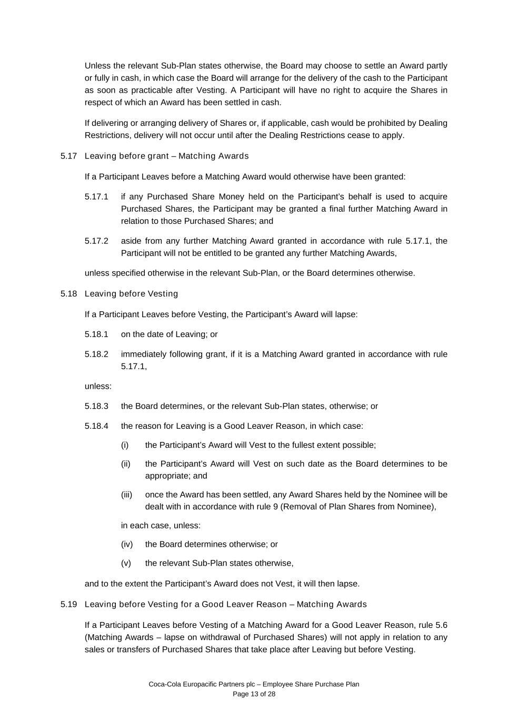
Coca-Cola Europacific Partners plc – Employee Share Purchase Plan Page 13 of 28 Unless the relevant Sub-Plan states otherwise, the Board may choose to settle an Award partly or fully in cash, in which case the Board will arrange for the delivery of the cash to the Participant as soon as practicable after Vesting. A Participant will have no right to acquire the Shares in respect of which an Award has been settled in cash. If delivering or arranging delivery of Shares or, if applicable, cash would be prohibited by Dealing Restrictions, delivery will not occur until after the Dealing Restrictions cease to apply. 5.17 Leaving before grant – Matching Awards If a Participant Leaves before a Matching Award would otherwise have been granted: 5.17.1 if any Purchased Share Money held on the Participant’s behalf is used to acquire Purchased Shares, the Participant may be granted a final further Matching Award in relation to those Purchased Shares; and 5.17.2 aside from any further Matching Award granted in accordance with rule 5.17.1, the Participant will not be entitled to be granted any further Matching Awards, unless specified otherwise in the relevant Sub-Plan, or the Board determines otherwise. 5.18 Leaving before Vesting If a Participant Leaves before Vesting, the Participant’s Award will lapse: 5.18.1 on the date of Leaving; or 5.18.2 immediately following grant, if it is a Matching Award granted in accordance with rule 5.17.1, unless: 5.18.3 the Board determines, or the relevant Sub-Plan states, otherwise; or 5.18.4 the reason for Leaving is a Good Leaver Reason, in which case: (i) the Participant’s Award will Vest to the fullest extent possible; (ii) the Participant’s Award will Vest on such date as the Board determines to be appropriate; and (iii) once the Award has been settled, any Award Shares held by the Nominee will be dealt with in accordance with rule 9 (Removal of Plan Shares from Nominee), in each case, unless: (iv) the Board determines otherwise; or (v) the relevant Sub-Plan states otherwise, and to the extent the Participant’s Award does not Vest, it will then lapse. 5.19 Leaving before Vesting for a Good Leaver Reason – Matching Awards If a Participant Leaves before Vesting of a Matching Award for a Good Leaver Reason, rule 5.6 (Matching Awards – lapse on withdrawal of Purchased Shares) will not apply in relation to any sales or transfers of Purchased Shares that take place after Leaving but before Vesting.

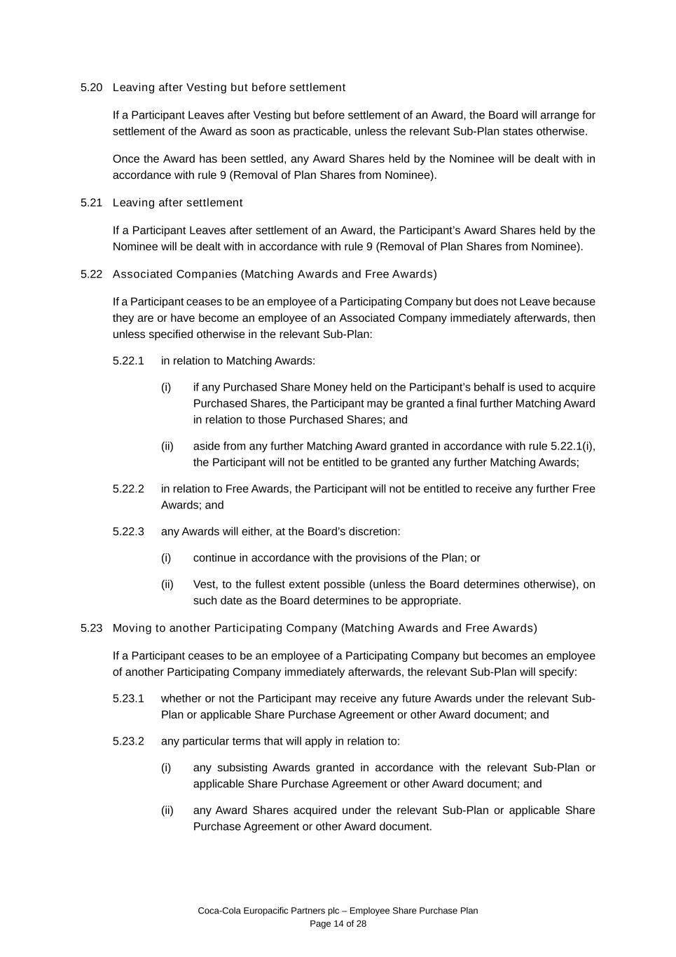
Coca-Cola Europacific Partners plc – Employee Share Purchase Plan Page 14 of 28 5.20 Leaving after Vesting but before settlement If a Participant Leaves after Vesting but before settlement of an Award, the Board will arrange for settlement of the Award as soon as practicable, unless the relevant Sub-Plan states otherwise. Once the Award has been settled, any Award Shares held by the Nominee will be dealt with in accordance with rule 9 (Removal of Plan Shares from Nominee). 5.21 Leaving after settlement If a Participant Leaves after settlement of an Award, the Participant’s Award Shares held by the Nominee will be dealt with in accordance with rule 9 (Removal of Plan Shares from Nominee). 5.22 Associated Companies (Matching Awards and Free Awards) If a Participant ceases to be an employee of a Participating Company but does not Leave because they are or have become an employee of an Associated Company immediately afterwards, then unless specified otherwise in the relevant Sub-Plan: 5.22.1 in relation to Matching Awards: (i) if any Purchased Share Money held on the Participant’s behalf is used to acquire Purchased Shares, the Participant may be granted a final further Matching Award in relation to those Purchased Shares; and (ii) aside from any further Matching Award granted in accordance with rule 5.22.1(i), the Participant will not be entitled to be granted any further Matching Awards; 5.22.2 in relation to Free Awards, the Participant will not be entitled to receive any further Free Awards; and 5.22.3 any Awards will either, at the Board’s discretion: (i) continue in accordance with the provisions of the Plan; or (ii) Vest, to the fullest extent possible (unless the Board determines otherwise), on such date as the Board determines to be appropriate. 5.23 Moving to another Participating Company (Matching Awards and Free Awards) If a Participant ceases to be an employee of a Participating Company but becomes an employee of another Participating Company immediately afterwards, the relevant Sub-Plan will specify: 5.23.1 whether or not the Participant may receive any future Awards under the relevant Sub- Plan or applicable Share Purchase Agreement or other Award document; and 5.23.2 any particular terms that will apply in relation to: (i) any subsisting Awards granted in accordance with the relevant Sub-Plan or applicable Share Purchase Agreement or other Award document; and (ii) any Award Shares acquired under the relevant Sub-Plan or applicable Share Purchase Agreement or other Award document.

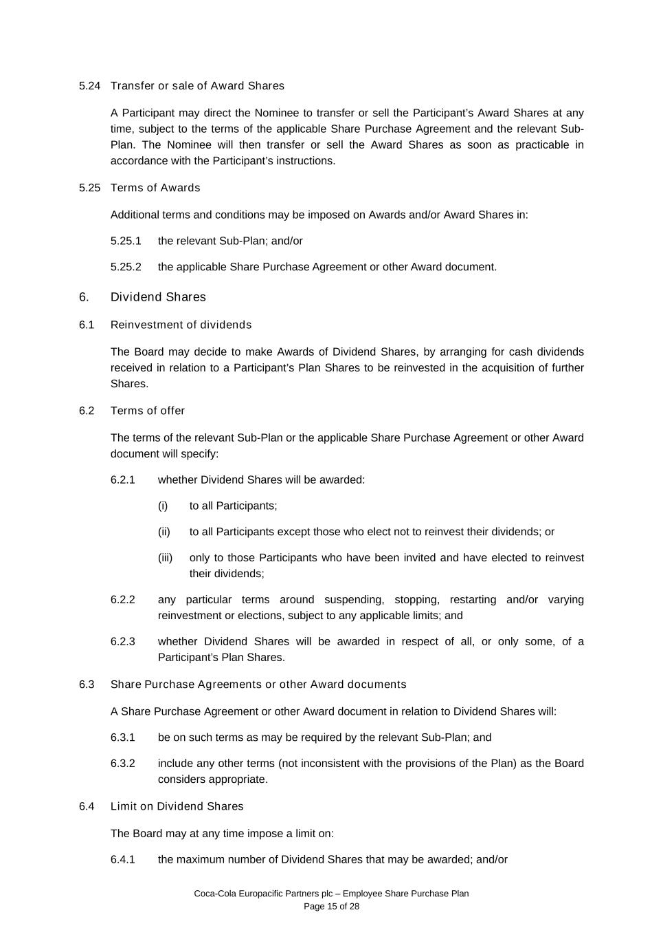
Coca-Cola Europacific Partners plc – Employee Share Purchase Plan Page 15 of 28 5.24 Transfer or sale of Award Shares A Participant may direct the Nominee to transfer or sell the Participant’s Award Shares at any time, subject to the terms of the applicable Share Purchase Agreement and the relevant Sub- Plan. The Nominee will then transfer or sell the Award Shares as soon as practicable in accordance with the Participant’s instructions. 5.25 Terms of Awards Additional terms and conditions may be imposed on Awards and/or Award Shares in: 5.25.1 the relevant Sub-Plan; and/or 5.25.2 the applicable Share Purchase Agreement or other Award document. 6. Dividend Shares 6.1 Reinvestment of dividends The Board may decide to make Awards of Dividend Shares, by arranging for cash dividends received in relation to a Participant’s Plan Shares to be reinvested in the acquisition of further Shares. 6.2 Terms of offer The terms of the relevant Sub-Plan or the applicable Share Purchase Agreement or other Award document will specify: 6.2.1 whether Dividend Shares will be awarded: (i) to all Participants; (ii) to all Participants except those who elect not to reinvest their dividends; or (iii) only to those Participants who have been invited and have elected to reinvest their dividends; 6.2.2 any particular terms around suspending, stopping, restarting and/or varying reinvestment or elections, subject to any applicable limits; and 6.2.3 whether Dividend Shares will be awarded in respect of all, or only some, of a Participant’s Plan Shares. 6.3 Share Purchase Agreements or other Award documents A Share Purchase Agreement or other Award document in relation to Dividend Shares will: 6.3.1 be on such terms as may be required by the relevant Sub-Plan; and 6.3.2 include any other terms (not inconsistent with the provisions of the Plan) as the Board considers appropriate. 6.4 Limit on Dividend Shares The Board may at any time impose a limit on: 6.4.1 the maximum number of Dividend Shares that may be awarded; and/or

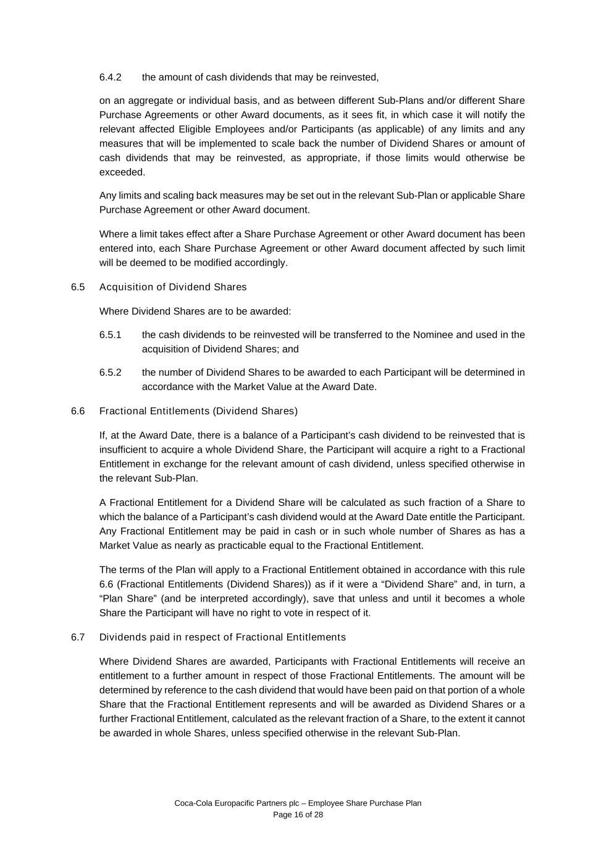
Coca-Cola Europacific Partners plc – Employee Share Purchase Plan Page 16 of 28 6.4.2 the amount of cash dividends that may be reinvested, on an aggregate or individual basis, and as between different Sub-Plans and/or different Share Purchase Agreements or other Award documents, as it sees fit, in which case it will notify the relevant affected Eligible Employees and/or Participants (as applicable) of any limits and any measures that will be implemented to scale back the number of Dividend Shares or amount of cash dividends that may be reinvested, as appropriate, if those limits would otherwise be exceeded. Any limits and scaling back measures may be set out in the relevant Sub-Plan or applicable Share Purchase Agreement or other Award document. Where a limit takes effect after a Share Purchase Agreement or other Award document has been entered into, each Share Purchase Agreement or other Award document affected by such limit will be deemed to be modified accordingly. 6.5 Acquisition of Dividend Shares Where Dividend Shares are to be awarded: 6.5.1 the cash dividends to be reinvested will be transferred to the Nominee and used in the acquisition of Dividend Shares; and 6.5.2 the number of Dividend Shares to be awarded to each Participant will be determined in accordance with the Market Value at the Award Date. 6.6 Fractional Entitlements (Dividend Shares) If, at the Award Date, there is a balance of a Participant’s cash dividend to be reinvested that is insufficient to acquire a whole Dividend Share, the Participant will acquire a right to a Fractional Entitlement in exchange for the relevant amount of cash dividend, unless specified otherwise in the relevant Sub-Plan. A Fractional Entitlement for a Dividend Share will be calculated as such fraction of a Share to which the balance of a Participant’s cash dividend would at the Award Date entitle the Participant. Any Fractional Entitlement may be paid in cash or in such whole number of Shares as has a Market Value as nearly as practicable equal to the Fractional Entitlement. The terms of the Plan will apply to a Fractional Entitlement obtained in accordance with this rule 6.6 (Fractional Entitlements (Dividend Shares)) as if it were a “Dividend Share” and, in turn, a “Plan Share” (and be interpreted accordingly), save that unless and until it becomes a whole Share the Participant will have no right to vote in respect of it. 6.7 Dividends paid in respect of Fractional Entitlements Where Dividend Shares are awarded, Participants with Fractional Entitlements will receive an entitlement to a further amount in respect of those Fractional Entitlements. The amount will be determined by reference to the cash dividend that would have been paid on that portion of a whole Share that the Fractional Entitlement represents and will be awarded as Dividend Shares or a further Fractional Entitlement, calculated as the relevant fraction of a Share, to the extent it cannot be awarded in whole Shares, unless specified otherwise in the relevant Sub-Plan.

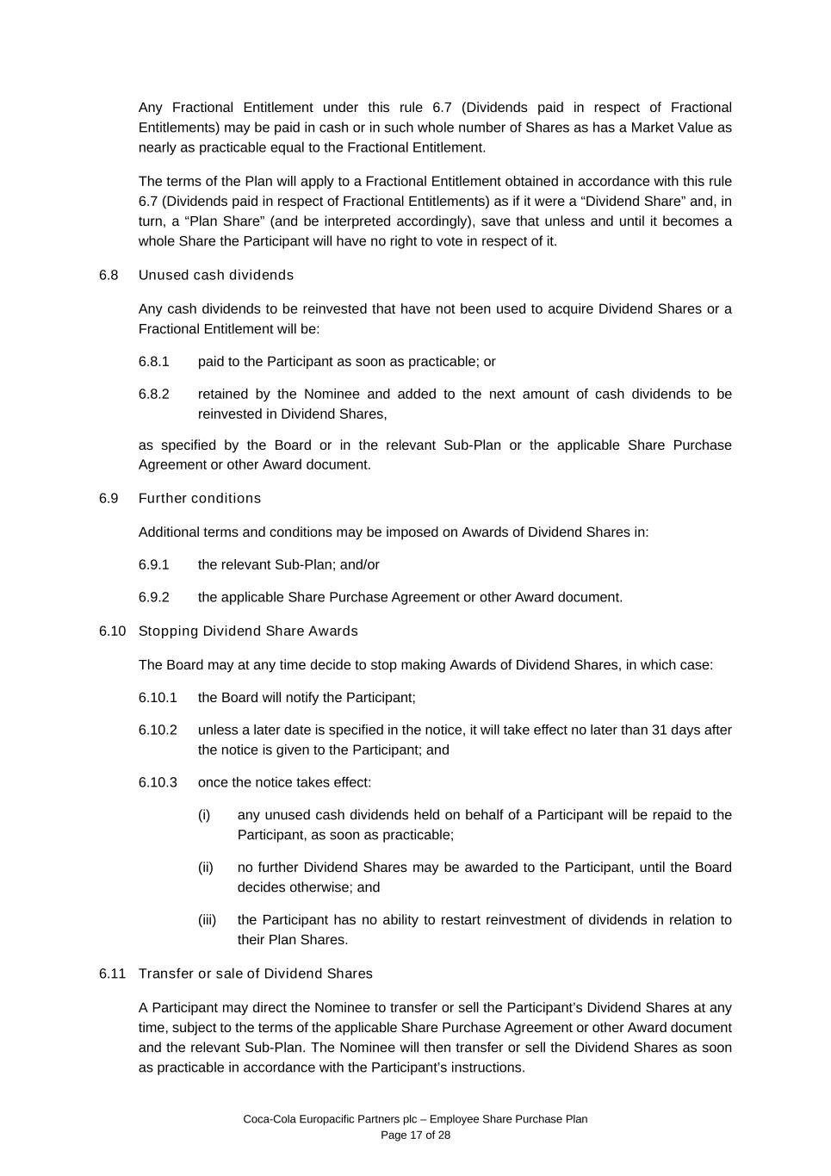
Coca-Cola Europacific Partners plc – Employee Share Purchase Plan Page 17 of 28 Any Fractional Entitlement under this rule 6.7 (Dividends paid in respect of Fractional Entitlements) may be paid in cash or in such whole number of Shares as has a Market Value as nearly as practicable equal to the Fractional Entitlement. The terms of the Plan will apply to a Fractional Entitlement obtained in accordance with this rule 6.7 (Dividends paid in respect of Fractional Entitlements) as if it were a “Dividend Share” and, in turn, a “Plan Share” (and be interpreted accordingly), save that unless and until it becomes a whole Share the Participant will have no right to vote in respect of it. 6.8 Unused cash dividends Any cash dividends to be reinvested that have not been used to acquire Dividend Shares or a Fractional Entitlement will be: 6.8.1 paid to the Participant as soon as practicable; or 6.8.2 retained by the Nominee and added to the next amount of cash dividends to be reinvested in Dividend Shares, as specified by the Board or in the relevant Sub-Plan or the applicable Share Purchase Agreement or other Award document. 6.9 Further conditions Additional terms and conditions may be imposed on Awards of Dividend Shares in: 6.9.1 the relevant Sub-Plan; and/or 6.9.2 the applicable Share Purchase Agreement or other Award document. 6.10 Stopping Dividend Share Awards The Board may at any time decide to stop making Awards of Dividend Shares, in which case: 6.10.1 the Board will notify the Participant; 6.10.2 unless a later date is specified in the notice, it will take effect no later than 31 days after the notice is given to the Participant; and 6.10.3 once the notice takes effect: (i) any unused cash dividends held on behalf of a Participant will be repaid to the Participant, as soon as practicable; (ii) no further Dividend Shares may be awarded to the Participant, until the Board decides otherwise; and (iii) the Participant has no ability to restart reinvestment of dividends in relation to their Plan Shares. 6.11 Transfer or sale of Dividend Shares A Participant may direct the Nominee to transfer or sell the Participant’s Dividend Shares at any time, subject to the terms of the applicable Share Purchase Agreement or other Award document and the relevant Sub-Plan. The Nominee will then transfer or sell the Dividend Shares as soon as practicable in accordance with the Participant’s instructions.

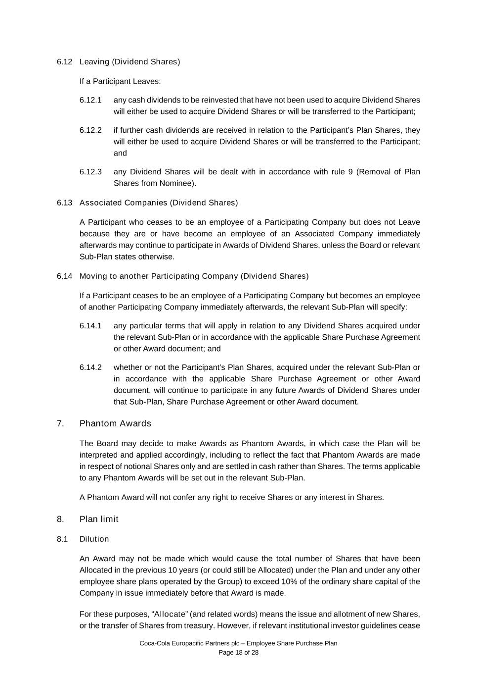
Coca-Cola Europacific Partners plc – Employee Share Purchase Plan Page 18 of 28 6.12 Leaving (Dividend Shares) If a Participant Leaves: 6.12.1 any cash dividends to be reinvested that have not been used to acquire Dividend Shares will either be used to acquire Dividend Shares or will be transferred to the Participant; 6.12.2 if further cash dividends are received in relation to the Participant’s Plan Shares, they will either be used to acquire Dividend Shares or will be transferred to the Participant; and 6.12.3 any Dividend Shares will be dealt with in accordance with rule 9 (Removal of Plan Shares from Nominee). 6.13 Associated Companies (Dividend Shares) A Participant who ceases to be an employee of a Participating Company but does not Leave because they are or have become an employee of an Associated Company immediately afterwards may continue to participate in Awards of Dividend Shares, unless the Board or relevant Sub-Plan states otherwise. 6.14 Moving to another Participating Company (Dividend Shares) If a Participant ceases to be an employee of a Participating Company but becomes an employee of another Participating Company immediately afterwards, the relevant Sub-Plan will specify: 6.14.1 any particular terms that will apply in relation to any Dividend Shares acquired under the relevant Sub-Plan or in accordance with the applicable Share Purchase Agreement or other Award document; and 6.14.2 whether or not the Participant’s Plan Shares, acquired under the relevant Sub-Plan or in accordance with the applicable Share Purchase Agreement or other Award document, will continue to participate in any future Awards of Dividend Shares under that Sub-Plan, Share Purchase Agreement or other Award document. 7. Phantom Awards The Board may decide to make Awards as Phantom Awards, in which case the Plan will be interpreted and applied accordingly, including to reflect the fact that Phantom Awards are made in respect of notional Shares only and are settled in cash rather than Shares. The terms applicable to any Phantom Awards will be set out in the relevant Sub-Plan. A Phantom Award will not confer any right to receive Shares or any interest in Shares. 8. Plan limit 8.1 Dilution An Award may not be made which would cause the total number of Shares that have been Allocated in the previous 10 years (or could still be Allocated) under the Plan and under any other employee share plans operated by the Group) to exceed 10% of the ordinary share capital of the Company in issue immediately before that Award is made. For these purposes, “Allocate” (and related words) means the issue and allotment of new Shares, or the transfer of Shares from treasury. However, if relevant institutional investor guidelines cease

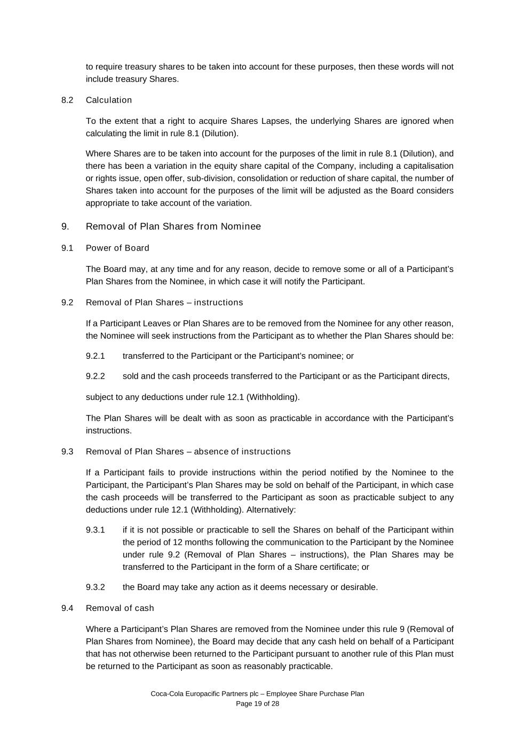
Coca-Cola Europacific Partners plc – Employee Share Purchase Plan Page 19 of 28 to require treasury shares to be taken into account for these purposes, then these words will not include treasury Shares. 8.2 Calculation To the extent that a right to acquire Shares Lapses, the underlying Shares are ignored when calculating the limit in rule 8.1 (Dilution). Where Shares are to be taken into account for the purposes of the limit in rule 8.1 (Dilution), and there has been a variation in the equity share capital of the Company, including a capitalisation or rights issue, open offer, sub-division, consolidation or reduction of share capital, the number of Shares taken into account for the purposes of the limit will be adjusted as the Board considers appropriate to take account of the variation. 9. Removal of Plan Shares from Nominee 9.1 Power of Board The Board may, at any time and for any reason, decide to remove some or all of a Participant’s Plan Shares from the Nominee, in which case it will notify the Participant. 9.2 Removal of Plan Shares – instructions If a Participant Leaves or Plan Shares are to be removed from the Nominee for any other reason, the Nominee will seek instructions from the Participant as to whether the Plan Shares should be: 9.2.1 transferred to the Participant or the Participant’s nominee; or 9.2.2 sold and the cash proceeds transferred to the Participant or as the Participant directs, subject to any deductions under rule 12.1 (Withholding). The Plan Shares will be dealt with as soon as practicable in accordance with the Participant’s instructions. 9.3 Removal of Plan Shares – absence of instructions If a Participant fails to provide instructions within the period notified by the Nominee to the Participant, the Participant’s Plan Shares may be sold on behalf of the Participant, in which case the cash proceeds will be transferred to the Participant as soon as practicable subject to any deductions under rule 12.1 (Withholding). Alternatively: 9.3.1 if it is not possible or practicable to sell the Shares on behalf of the Participant within the period of 12 months following the communication to the Participant by the Nominee under rule 9.2 (Removal of Plan Shares – instructions), the Plan Shares may be transferred to the Participant in the form of a Share certificate; or 9.3.2 the Board may take any action as it deems necessary or desirable. 9.4 Removal of cash Where a Participant’s Plan Shares are removed from the Nominee under this rule 9 (Removal of Plan Shares from Nominee), the Board may decide that any cash held on behalf of a Participant that has not otherwise been returned to the Participant pursuant to another rule of this Plan must be returned to the Participant as soon as reasonably practicable.

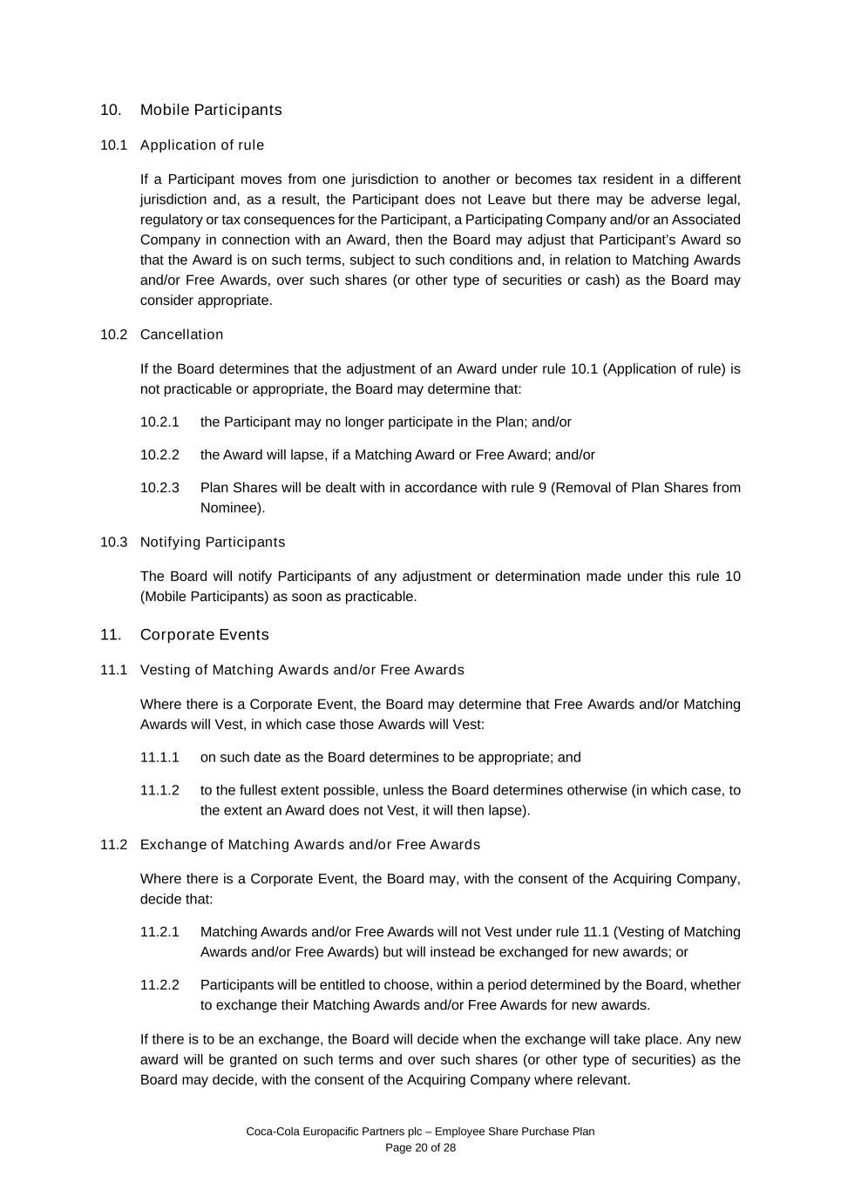
Coca-Cola Europacific Partners plc – Employee Share Purchase Plan Page 20 of 28 10. Mobile Participants 10.1 Application of rule If a Participant moves from one jurisdiction to another or becomes tax resident in a different jurisdiction and, as a result, the Participant does not Leave but there may be adverse legal, regulatory or tax consequences for the Participant, a Participating Company and/or an Associated Company in connection with an Award, then the Board may adjust that Participant’s Award so that the Award is on such terms, subject to such conditions and, in relation to Matching Awards and/or Free Awards, over such shares (or other type of securities or cash) as the Board may consider appropriate. 10.2 Cancellation If the Board determines that the adjustment of an Award under rule 10.1 (Application of rule) is not practicable or appropriate, the Board may determine that: 10.2.1 the Participant may no longer participate in the Plan; and/or 10.2.2 the Award will lapse, if a Matching Award or Free Award; and/or 10.2.3 Plan Shares will be dealt with in accordance with rule 9 (Removal of Plan Shares from Nominee). 10.3 Notifying Participants The Board will notify Participants of any adjustment or determination made under this rule 10 (Mobile Participants) as soon as practicable. 11. Corporate Events 11.1 Vesting of Matching Awards and/or Free Awards Where there is a Corporate Event, the Board may determine that Free Awards and/or Matching Awards will Vest, in which case those Awards will Vest: 11.1.1 on such date as the Board determines to be appropriate; and 11.1.2 to the fullest extent possible, unless the Board determines otherwise (in which case, to the extent an Award does not Vest, it will then lapse). 11.2 Exchange of Matching Awards and/or Free Awards Where there is a Corporate Event, the Board may, with the consent of the Acquiring Company, decide that: 11.2.1 Matching Awards and/or Free Awards will not Vest under rule 11.1 (Vesting of Matching Awards and/or Free Awards) but will instead be exchanged for new awards; or 11.2.2 Participants will be entitled to choose, within a period determined by the Board, whether to exchange their Matching Awards and/or Free Awards for new awards. If there is to be an exchange, the Board will decide when the exchange will take place. Any new award will be granted on such terms and over such shares (or other type of securities) as the Board may decide, with the consent of the Acquiring Company where relevant.

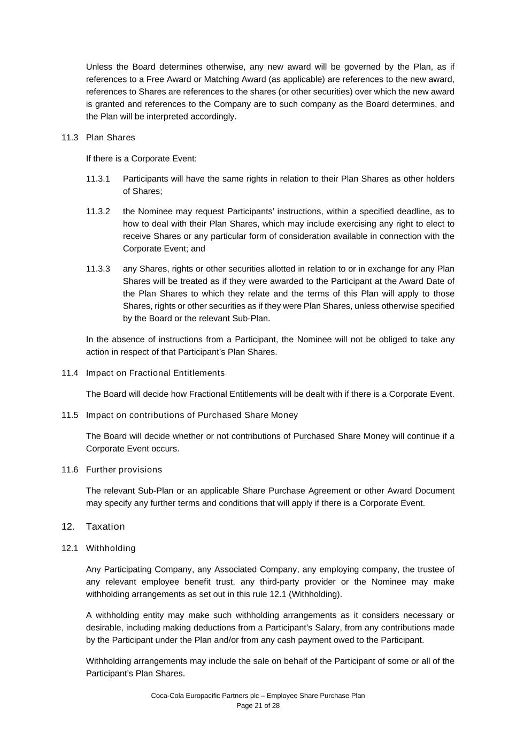
Coca-Cola Europacific Partners plc – Employee Share Purchase Plan Page 21 of 28 Unless the Board determines otherwise, any new award will be governed by the Plan, as if references to a Free Award or Matching Award (as applicable) are references to the new award, references to Shares are references to the shares (or other securities) over which the new award is granted and references to the Company are to such company as the Board determines, and the Plan will be interpreted accordingly. 11.3 Plan Shares If there is a Corporate Event: 11.3.1 Participants will have the same rights in relation to their Plan Shares as other holders of Shares; 11.3.2 the Nominee may request Participants’ instructions, within a specified deadline, as to how to deal with their Plan Shares, which may include exercising any right to elect to receive Shares or any particular form of consideration available in connection with the Corporate Event; and 11.3.3 any Shares, rights or other securities allotted in relation to or in exchange for any Plan Shares will be treated as if they were awarded to the Participant at the Award Date of the Plan Shares to which they relate and the terms of this Plan will apply to those Shares, rights or other securities as if they were Plan Shares, unless otherwise specified by the Board or the relevant Sub-Plan. In the absence of instructions from a Participant, the Nominee will not be obliged to take any action in respect of that Participant’s Plan Shares. 11.4 Impact on Fractional Entitlements The Board will decide how Fractional Entitlements will be dealt with if there is a Corporate Event. 11.5 Impact on contributions of Purchased Share Money The Board will decide whether or not contributions of Purchased Share Money will continue if a Corporate Event occurs. 11.6 Further provisions The relevant Sub-Plan or an applicable Share Purchase Agreement or other Award Document may specify any further terms and conditions that will apply if there is a Corporate Event. 12. Taxation 12.1 Withholding Any Participating Company, any Associated Company, any employing company, the trustee of any relevant employee benefit trust, any third-party provider or the Nominee may make withholding arrangements as set out in this rule 12.1 (Withholding). A withholding entity may make such withholding arrangements as it considers necessary or desirable, including making deductions from a Participant’s Salary, from any contributions made by the Participant under the Plan and/or from any cash payment owed to the Participant. Withholding arrangements may include the sale on behalf of the Participant of some or all of the Participant’s Plan Shares.

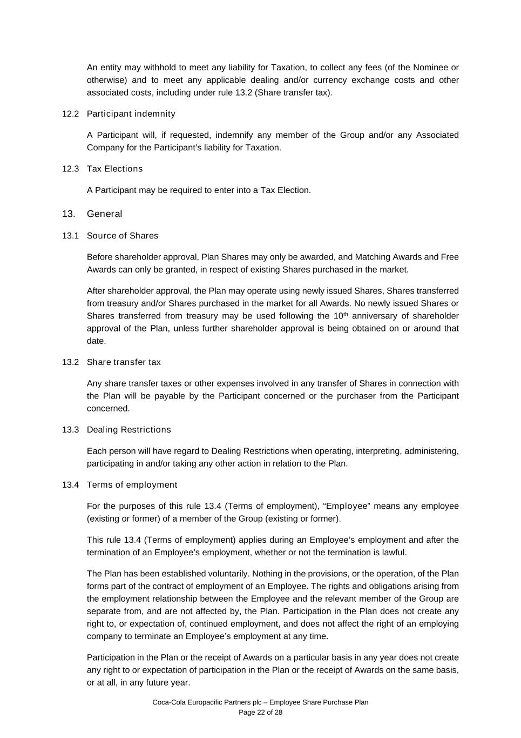
Coca-Cola Europacific Partners plc – Employee Share Purchase Plan Page 22 of 28 An entity may withhold to meet any liability for Taxation, to collect any fees (of the Nominee or otherwise) and to meet any applicable dealing and/or currency exchange costs and other associated costs, including under rule 13.2 (Share transfer tax). 12.2 Participant indemnity A Participant will, if requested, indemnify any member of the Group and/or any Associated Company for the Participant’s liability for Taxation. 12.3 Tax Elections A Participant may be required to enter into a Tax Election. 13. General 13.1 Source of Shares Before shareholder approval, Plan Shares may only be awarded, and Matching Awards and Free Awards can only be granted, in respect of existing Shares purchased in the market. After shareholder approval, the Plan may operate using newly issued Shares, Shares transferred from treasury and/or Shares purchased in the market for all Awards. No newly issued Shares or Shares transferred from treasury may be used following the 10th anniversary of shareholder approval of the Plan, unless further shareholder approval is being obtained on or around that date. 13.2 Share transfer tax Any share transfer taxes or other expenses involved in any transfer of Shares in connection with the Plan will be payable by the Participant concerned or the purchaser from the Participant concerned. 13.3 Dealing Restrictions Each person will have regard to Dealing Restrictions when operating, interpreting, administering, participating in and/or taking any other action in relation to the Plan. 13.4 Terms of employment For the purposes of this rule 13.4 (Terms of employment), “Employee” means any employee (existing or former) of a member of the Group (existing or former). This rule 13.4 (Terms of employment) applies during an Employee’s employment and after the termination of an Employee’s employment, whether or not the termination is lawful. The Plan has been established voluntarily. Nothing in the provisions, or the operation, of the Plan forms part of the contract of employment of an Employee. The rights and obligations arising from the employment relationship between the Employee and the relevant member of the Group are separate from, and are not affected by, the Plan. Participation in the Plan does not create any right to, or expectation of, continued employment, and does not affect the right of an employing company to terminate an Employee’s employment at any time. Participation in the Plan or the receipt of Awards on a particular basis in any year does not create any right to or expectation of participation in the Plan or the receipt of Awards on the same basis, or at all, in any future year.

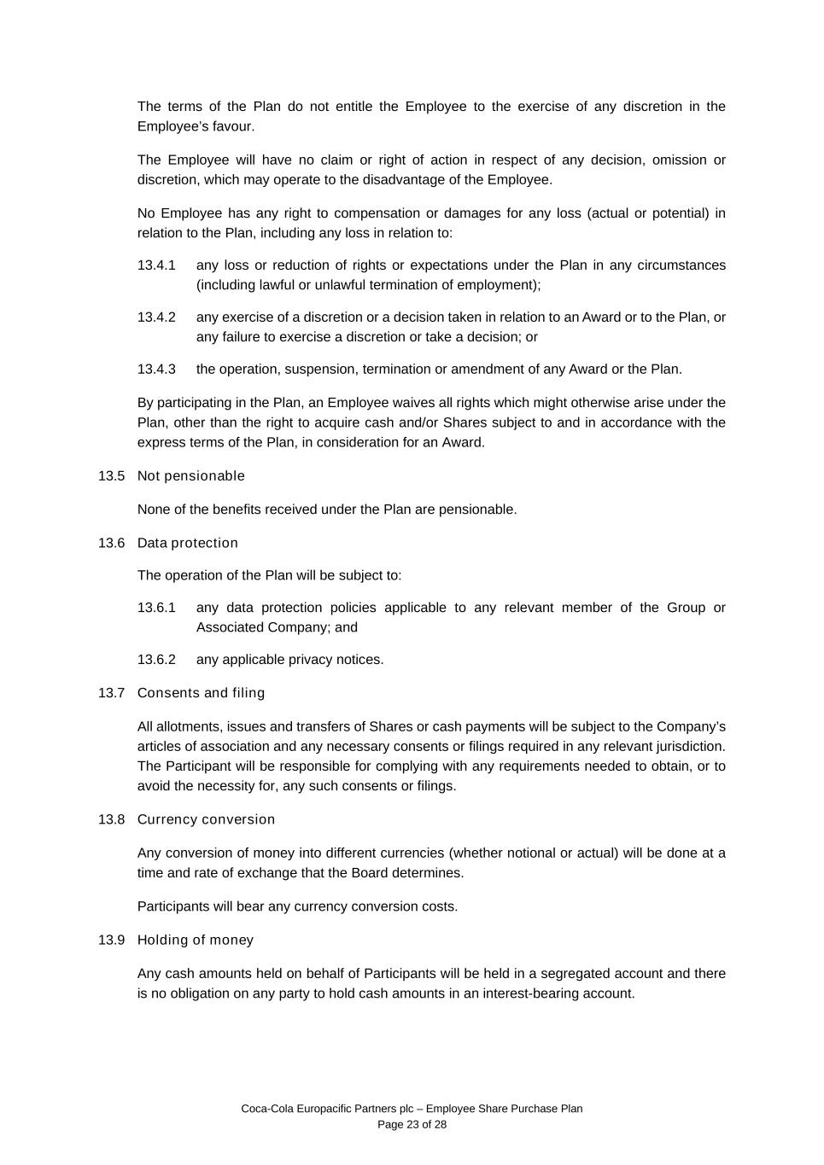
Coca-Cola Europacific Partners plc – Employee Share Purchase Plan Page 23 of 28 The terms of the Plan do not entitle the Employee to the exercise of any discretion in the Employee’s favour. The Employee will have no claim or right of action in respect of any decision, omission or discretion, which may operate to the disadvantage of the Employee. No Employee has any right to compensation or damages for any loss (actual or potential) in relation to the Plan, including any loss in relation to: 13.4.1 any loss or reduction of rights or expectations under the Plan in any circumstances (including lawful or unlawful termination of employment); 13.4.2 any exercise of a discretion or a decision taken in relation to an Award or to the Plan, or any failure to exercise a discretion or take a decision; or 13.4.3 the operation, suspension, termination or amendment of any Award or the Plan. By participating in the Plan, an Employee waives all rights which might otherwise arise under the Plan, other than the right to acquire cash and/or Shares subject to and in accordance with the express terms of the Plan, in consideration for an Award. 13.5 Not pensionable None of the benefits received under the Plan are pensionable. 13.6 Data protection The operation of the Plan will be subject to: 13.6.1 any data protection policies applicable to any relevant member of the Group or Associated Company; and 13.6.2 any applicable privacy notices. 13.7 Consents and filing All allotments, issues and transfers of Shares or cash payments will be subject to the Company’s articles of association and any necessary consents or filings required in any relevant jurisdiction. The Participant will be responsible for complying with any requirements needed to obtain, or to avoid the necessity for, any such consents or filings. 13.8 Currency conversion Any conversion of money into different currencies (whether notional or actual) will be done at a time and rate of exchange that the Board determines. Participants will bear any currency conversion costs. 13.9 Holding of money Any cash amounts held on behalf of Participants will be held in a segregated account and there is no obligation on any party to hold cash amounts in an interest-bearing account.

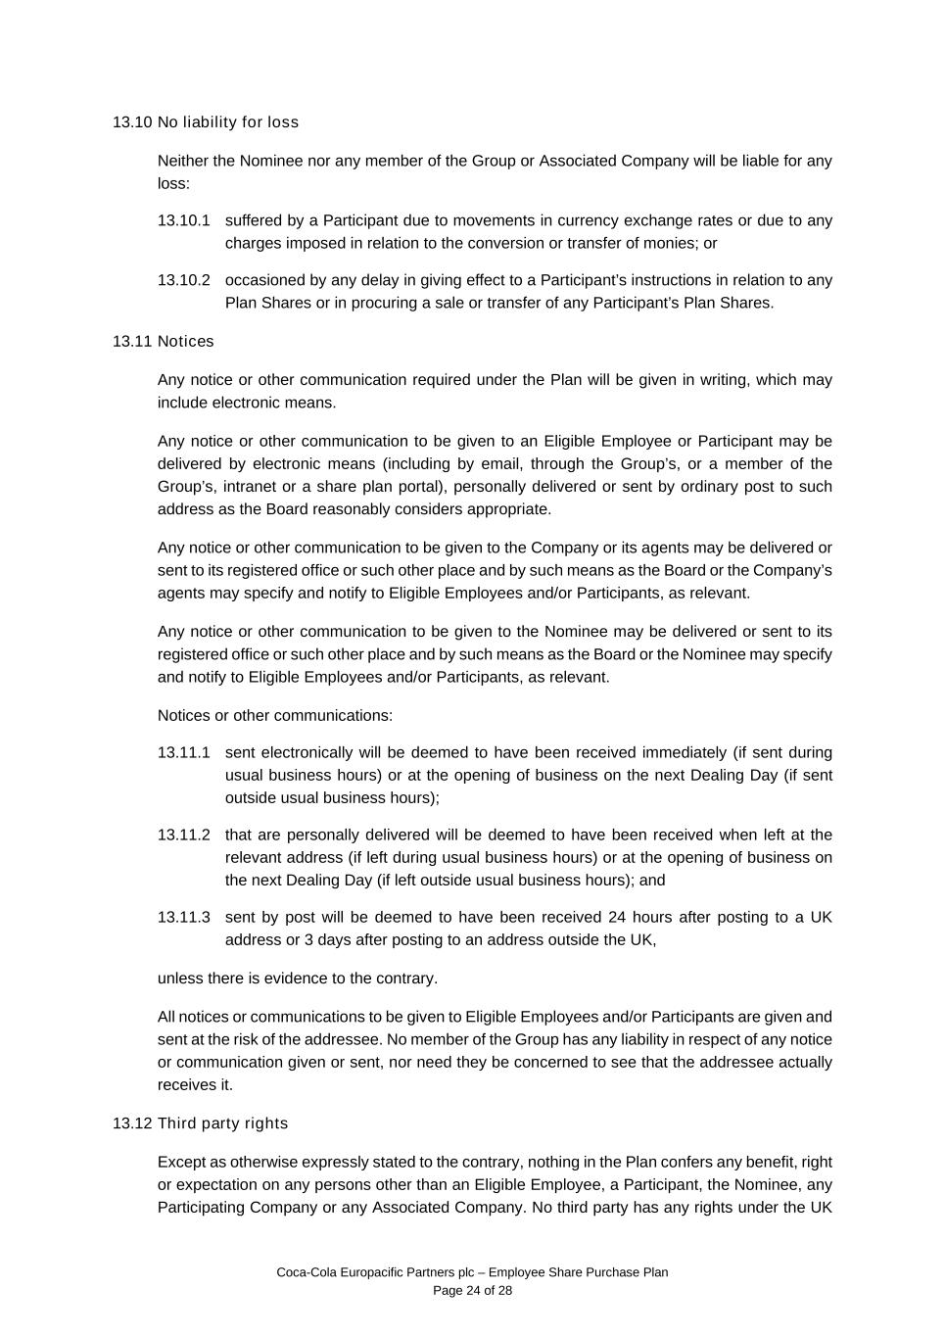
Coca-Cola Europacific Partners plc – Employee Share Purchase Plan Page 24 of 28 13.10 No liability for loss Neither the Nominee nor any member of the Group or Associated Company will be liable for any loss: 13.10.1 suffered by a Participant due to movements in currency exchange rates or due to any charges imposed in relation to the conversion or transfer of monies; or 13.10.2 occasioned by any delay in giving effect to a Participant’s instructions in relation to any Plan Shares or in procuring a sale or transfer of any Participant’s Plan Shares. 13.11 Notices Any notice or other communication required under the Plan will be given in writing, which may include electronic means. Any notice or other communication to be given to an Eligible Employee or Participant may be delivered by electronic means (including by email, through the Group’s, or a member of the Group’s, intranet or a share plan portal), personally delivered or sent by ordinary post to such address as the Board reasonably considers appropriate. Any notice or other communication to be given to the Company or its agents may be delivered or sent to its registered office or such other place and by such means as the Board or the Company’s agents may specify and notify to Eligible Employees and/or Participants, as relevant. Any notice or other communication to be given to the Nominee may be delivered or sent to its registered office or such other place and by such means as the Board or the Nominee may specify and notify to Eligible Employees and/or Participants, as relevant. Notices or other communications: 13.11.1 sent electronically will be deemed to have been received immediately (if sent during usual business hours) or at the opening of business on the next Dealing Day (if sent outside usual business hours); 13.11.2 that are personally delivered will be deemed to have been received when left at the relevant address (if left during usual business hours) or at the opening of business on the next Dealing Day (if left outside usual business hours); and 13.11.3 sent by post will be deemed to have been received 24 hours after posting to a UK address or 3 days after posting to an address outside the UK, unless there is evidence to the contrary. All notices or communications to be given to Eligible Employees and/or Participants are given and sent at the risk of the addressee. No member of the Group has any liability in respect of any notice or communication given or sent, nor need they be concerned to see that the addressee actually receives it. 13.12 Third party rights Except as otherwise expressly stated to the contrary, nothing in the Plan confers any benefit, right or expectation on any persons other than an Eligible Employee, a Participant, the Nominee, any Participating Company or any Associated Company. No third party has any rights under the UK

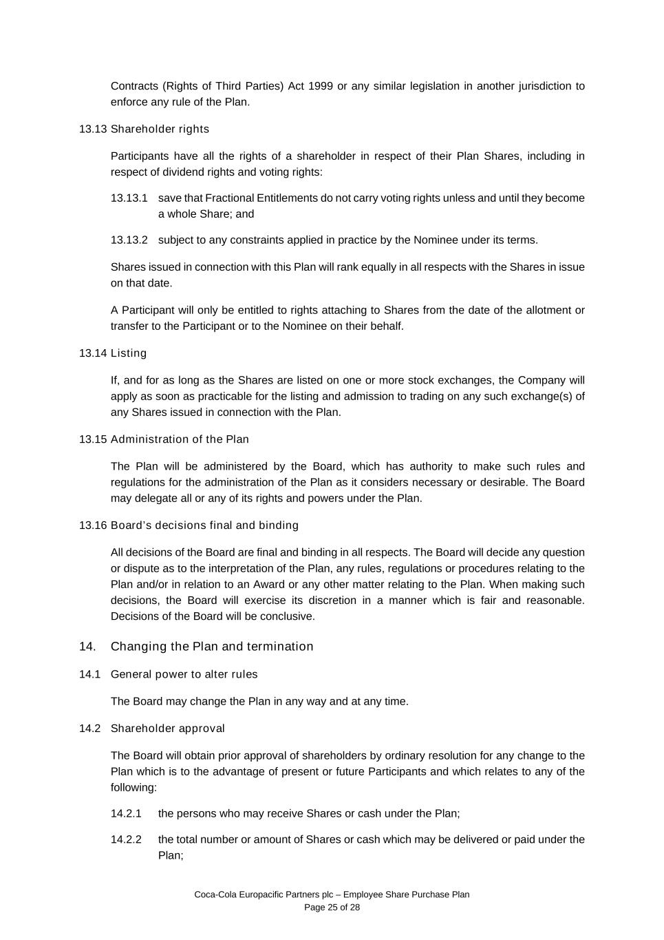
Coca-Cola Europacific Partners plc – Employee Share Purchase Plan Page 25 of 28 Contracts (Rights of Third Parties) Act 1999 or any similar legislation in another jurisdiction to enforce any rule of the Plan. 13.13 Shareholder rights Participants have all the rights of a shareholder in respect of their Plan Shares, including in respect of dividend rights and voting rights: 13.13.1 save that Fractional Entitlements do not carry voting rights unless and until they become a whole Share; and 13.13.2 subject to any constraints applied in practice by the Nominee under its terms. Shares issued in connection with this Plan will rank equally in all respects with the Shares in issue on that date. A Participant will only be entitled to rights attaching to Shares from the date of the allotment or transfer to the Participant or to the Nominee on their behalf. 13.14 Listing If, and for as long as the Shares are listed on one or more stock exchanges, the Company will apply as soon as practicable for the listing and admission to trading on any such exchange(s) of any Shares issued in connection with the Plan. 13.15 Administration of the Plan The Plan will be administered by the Board, which has authority to make such rules and regulations for the administration of the Plan as it considers necessary or desirable. The Board may delegate all or any of its rights and powers under the Plan. 13.16 Board’s decisions final and binding All decisions of the Board are final and binding in all respects. The Board will decide any question or dispute as to the interpretation of the Plan, any rules, regulations or procedures relating to the Plan and/or in relation to an Award or any other matter relating to the Plan. When making such decisions, the Board will exercise its discretion in a manner which is fair and reasonable. Decisions of the Board will be conclusive. 14. Changing the Plan and termination 14.1 General power to alter rules The Board may change the Plan in any way and at any time. 14.2 Shareholder approval The Board will obtain prior approval of shareholders by ordinary resolution for any change to the Plan which is to the advantage of present or future Participants and which relates to any of the following: 14.2.1 the persons who may receive Shares or cash under the Plan; 14.2.2 the total number or amount of Shares or cash which may be delivered or paid under the Plan;

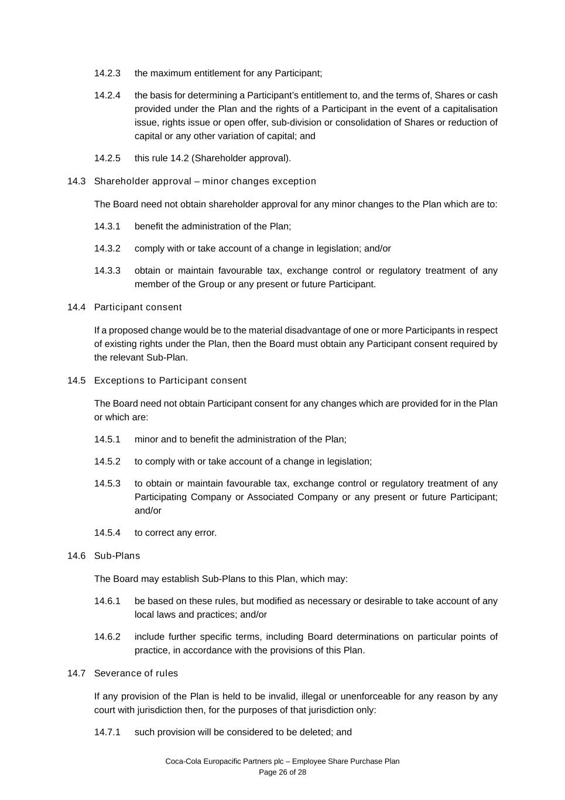
Coca-Cola Europacific Partners plc – Employee Share Purchase Plan Page 26 of 28 14.2.3 the maximum entitlement for any Participant; 14.2.4 the basis for determining a Participant’s entitlement to, and the terms of, Shares or cash provided under the Plan and the rights of a Participant in the event of a capitalisation issue, rights issue or open offer, sub-division or consolidation of Shares or reduction of capital or any other variation of capital; and 14.2.5 this rule 14.2 (Shareholder approval). 14.3 Shareholder approval – minor changes exception The Board need not obtain shareholder approval for any minor changes to the Plan which are to: 14.3.1 benefit the administration of the Plan; 14.3.2 comply with or take account of a change in legislation; and/or 14.3.3 obtain or maintain favourable tax, exchange control or regulatory treatment of any member of the Group or any present or future Participant. 14.4 Participant consent If a proposed change would be to the material disadvantage of one or more Participants in respect of existing rights under the Plan, then the Board must obtain any Participant consent required by the relevant Sub-Plan. 14.5 Exceptions to Participant consent The Board need not obtain Participant consent for any changes which are provided for in the Plan or which are: 14.5.1 minor and to benefit the administration of the Plan; 14.5.2 to comply with or take account of a change in legislation; 14.5.3 to obtain or maintain favourable tax, exchange control or regulatory treatment of any Participating Company or Associated Company or any present or future Participant; and/or 14.5.4 to correct any error. 14.6 Sub-Plans The Board may establish Sub-Plans to this Plan, which may: 14.6.1 be based on these rules, but modified as necessary or desirable to take account of any local laws and practices; and/or 14.6.2 include further specific terms, including Board determinations on particular points of practice, in accordance with the provisions of this Plan. 14.7 Severance of rules If any provision of the Plan is held to be invalid, illegal or unenforceable for any reason by any court with jurisdiction then, for the purposes of that jurisdiction only: 14.7.1 such provision will be considered to be deleted; and

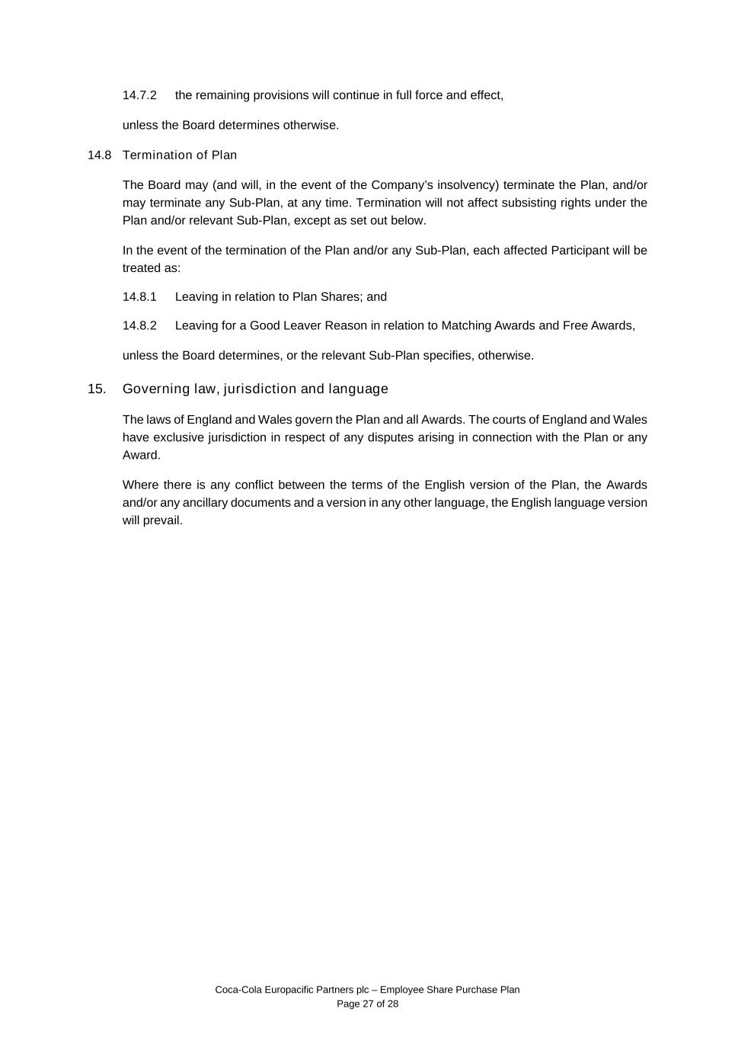
Coca-Cola Europacific Partners plc – Employee Share Purchase Plan Page 27 of 28 14.7.2 the remaining provisions will continue in full force and effect, unless the Board determines otherwise. 14.8 Termination of Plan The Board may (and will, in the event of the Company’s insolvency) terminate the Plan, and/or may terminate any Sub-Plan, at any time. Termination will not affect subsisting rights under the Plan and/or relevant Sub-Plan, except as set out below. In the event of the termination of the Plan and/or any Sub-Plan, each affected Participant will be treated as: 14.8.1 Leaving in relation to Plan Shares; and 14.8.2 Leaving for a Good Leaver Reason in relation to Matching Awards and Free Awards, unless the Board determines, or the relevant Sub-Plan specifies, otherwise. 15. Governing law, jurisdiction and language The laws of England and Wales govern the Plan and all Awards. The courts of England and Wales have exclusive jurisdiction in respect of any disputes arising in connection with the Plan or any Award. Where there is any conflict between the terms of the English version of the Plan, the Awards and/or any ancillary documents and a version in any other language, the English language version will prevail.

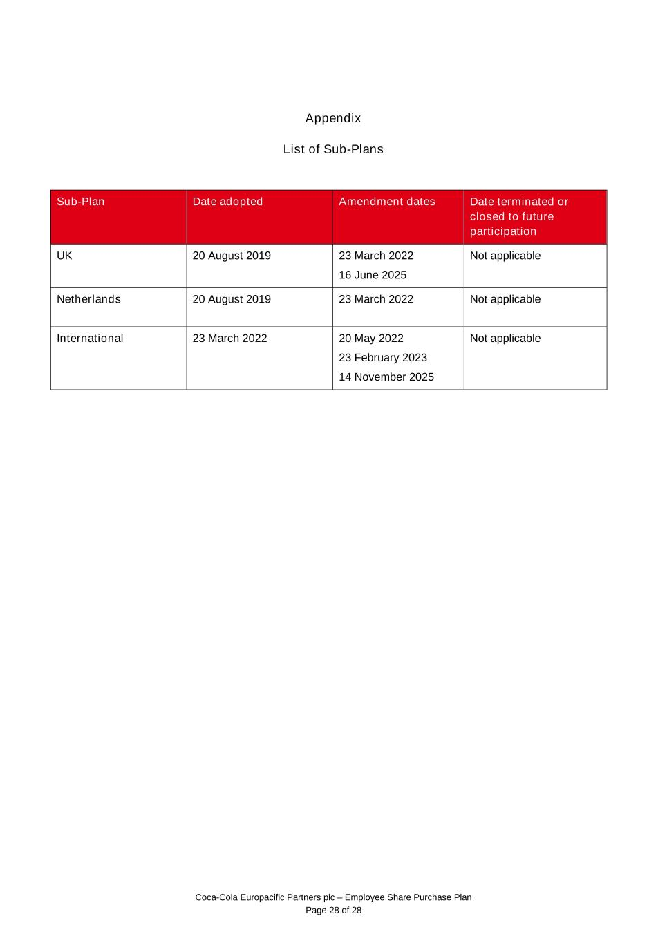
Coca-Cola Europacific Partners plc – Employee Share Purchase Plan Page 28 of 28 Appendix List of Sub-Plans Sub-Plan Date adopted Amendment dates Date terminated or closed to future participation UK 20 August 2019 23 March 2022 16 June 2025 Not applicable Netherlands 20 August 2019 23 March 2022 Not applicable International 23 March 2022 20 May 2022 23 February 2023 14 November 2025 Not applicable

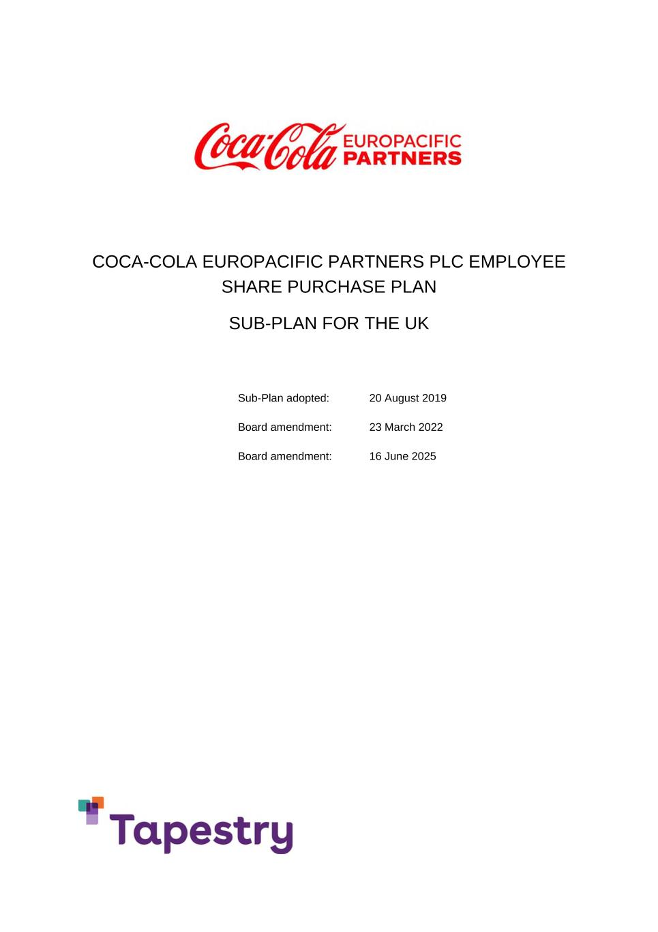
COCA-COLA EUROPACIFIC PARTNERS PLC EMPLOYEE SHARE PURCHASE PLAN SUB-PLAN FOR THE UK Sub-Plan adopted: 20 August 2019 Board amendment: 23 March 2022 Board amendment: 16 June 2025

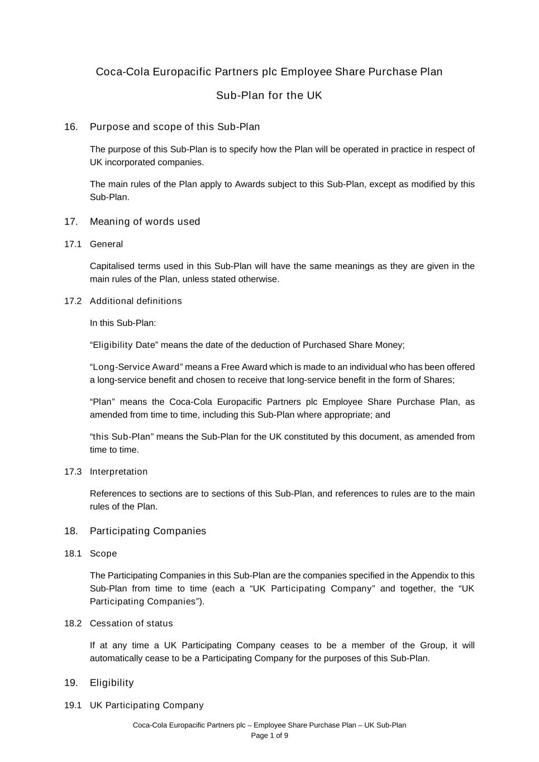
Coca-Cola Europacific Partners plc – Employee Share Purchase Plan – UK Sub-Plan Page 1 of 9 Coca-Cola Europacific Partners plc Employee Share Purchase Plan Sub-Plan for the UK 16. Purpose and scope of this Sub-Plan The purpose of this Sub-Plan is to specify how the Plan will be operated in practice in respect of UK incorporated companies. The main rules of the Plan apply to Awards subject to this Sub-Plan, except as modified by this Sub-Plan. 17. Meaning of words used 17.1 General Capitalised terms used in this Sub-Plan will have the same meanings as they are given in the main rules of the Plan, unless stated otherwise. 17.2 Additional definitions In this Sub-Plan: “Eligibility Date” means the date of the deduction of Purchased Share Money; “Long-Service Award” means a Free Award which is made to an individual who has been offered a long-service benefit and chosen to receive that long-service benefit in the form of Shares; “Plan” means the Coca-Cola Europacific Partners plc Employee Share Purchase Plan, as amended from time to time, including this Sub-Plan where appropriate; and “this Sub-Plan” means the Sub-Plan for the UK constituted by this document, as amended from time to time. 17.3 Interpretation References to sections are to sections of this Sub-Plan, and references to rules are to the main rules of the Plan. 18. Participating Companies 18.1 Scope The Participating Companies in this Sub-Plan are the companies specified in the Appendix to this Sub-Plan from time to time (each a “UK Participating Company” and together, the “UK Participating Companies”). 18.2 Cessation of status If at any time a UK Participating Company ceases to be a member of the Group, it will automatically cease to be a Participating Company for the purposes of this Sub-Plan. 19. Eligibility 19.1 UK Participating Company

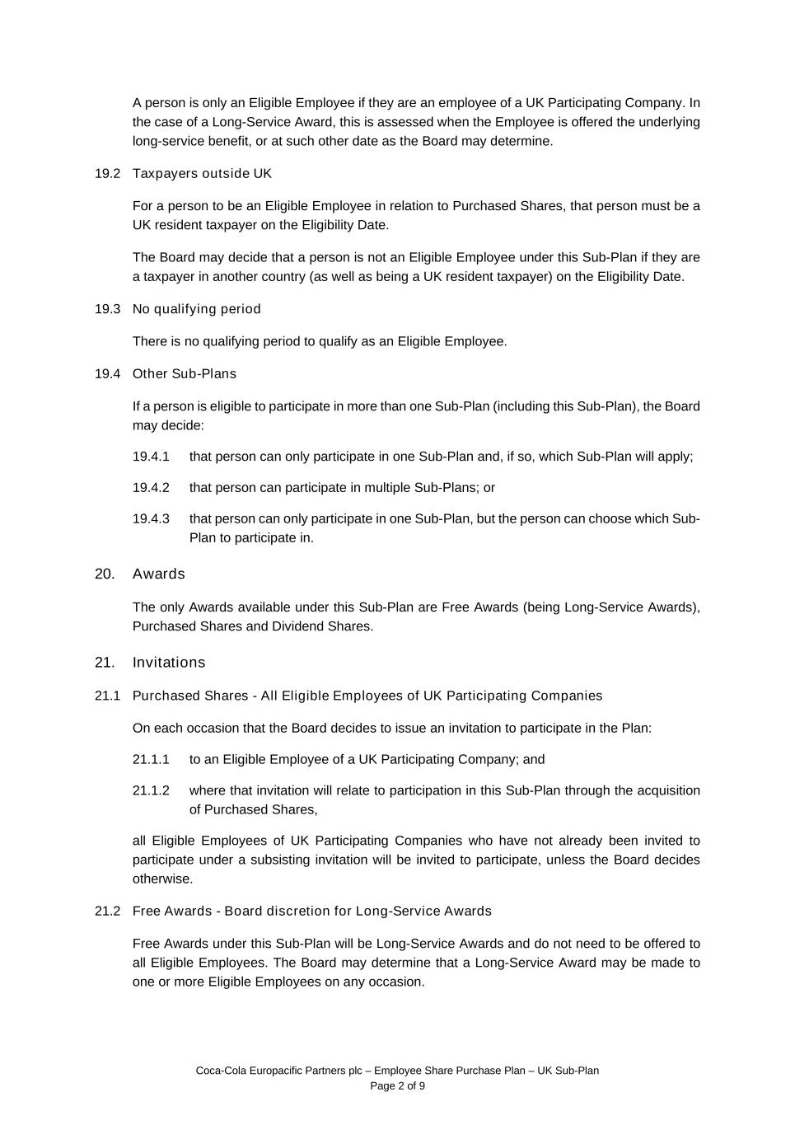
Coca-Cola Europacific Partners plc – Employee Share Purchase Plan – UK Sub-Plan Page 2 of 9 A person is only an Eligible Employee if they are an employee of a UK Participating Company. In the case of a Long-Service Award, this is assessed when the Employee is offered the underlying long-service benefit, or at such other date as the Board may determine. 19.2 Taxpayers outside UK For a person to be an Eligible Employee in relation to Purchased Shares, that person must be a UK resident taxpayer on the Eligibility Date. The Board may decide that a person is not an Eligible Employee under this Sub-Plan if they are a taxpayer in another country (as well as being a UK resident taxpayer) on the Eligibility Date. 19.3 No qualifying period There is no qualifying period to qualify as an Eligible Employee. 19.4 Other Sub-Plans If a person is eligible to participate in more than one Sub-Plan (including this Sub-Plan), the Board may decide: 19.4.1 that person can only participate in one Sub-Plan and, if so, which Sub-Plan will apply; 19.4.2 that person can participate in multiple Sub-Plans; or 19.4.3 that person can only participate in one Sub-Plan, but the person can choose which Sub- Plan to participate in. 20. Awards The only Awards available under this Sub-Plan are Free Awards (being Long-Service Awards), Purchased Shares and Dividend Shares. 21. Invitations 21.1 Purchased Shares - All Eligible Employees of UK Participating Companies On each occasion that the Board decides to issue an invitation to participate in the Plan: 21.1.1 to an Eligible Employee of a UK Participating Company; and 21.1.2 where that invitation will relate to participation in this Sub-Plan through the acquisition of Purchased Shares, all Eligible Employees of UK Participating Companies who have not already been invited to participate under a subsisting invitation will be invited to participate, unless the Board decides otherwise. 21.2 Free Awards - Board discretion for Long-Service Awards Free Awards under this Sub-Plan will be Long-Service Awards and do not need to be offered to all Eligible Employees. The Board may determine that a Long-Service Award may be made to one or more Eligible Employees on any occasion.

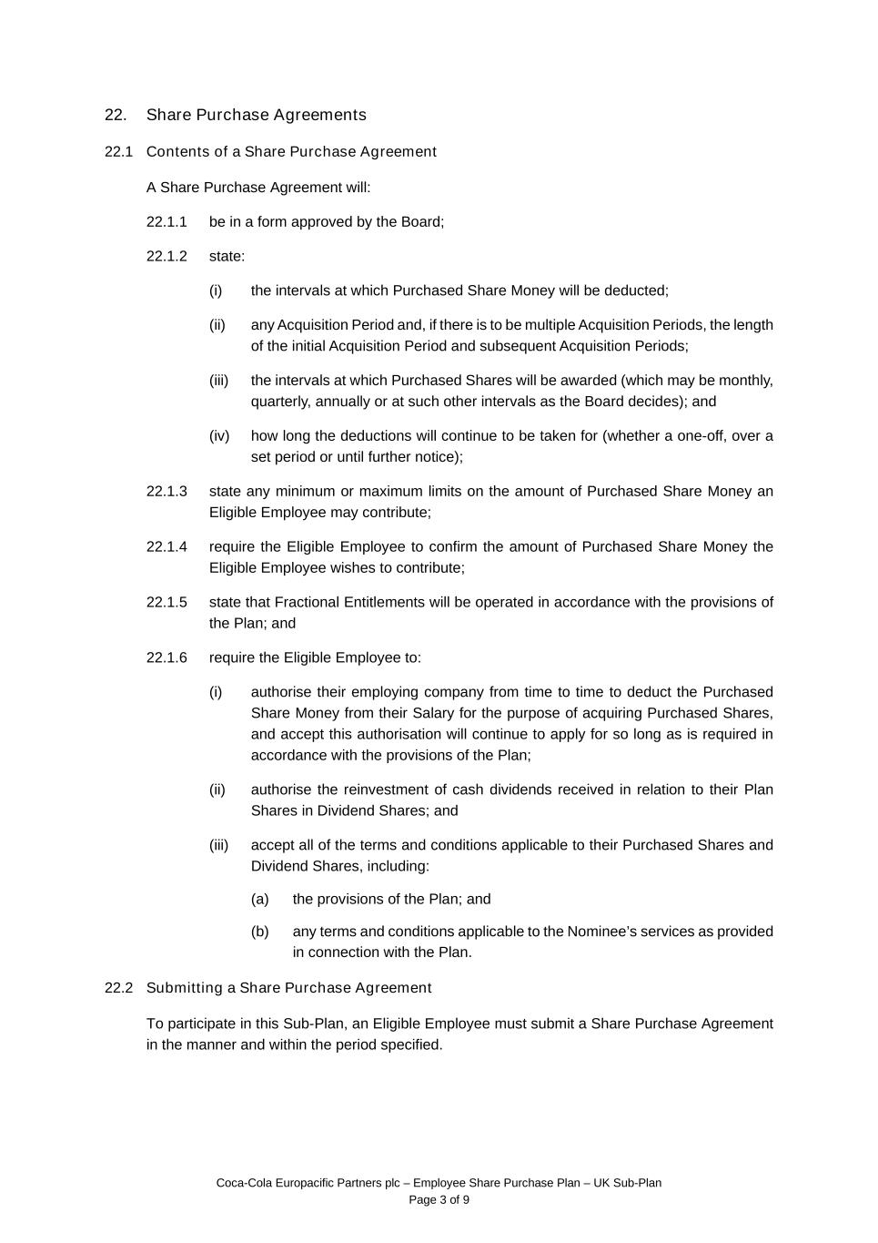
Coca-Cola Europacific Partners plc – Employee Share Purchase Plan – UK Sub-Plan Page 3 of 9 22. Share Purchase Agreements 22.1 Contents of a Share Purchase Agreement A Share Purchase Agreement will: 22.1.1 be in a form approved by the Board; 22.1.2 state: (i) the intervals at which Purchased Share Money will be deducted; (ii) any Acquisition Period and, if there is to be multiple Acquisition Periods, the length of the initial Acquisition Period and subsequent Acquisition Periods; (iii) the intervals at which Purchased Shares will be awarded (which may be monthly, quarterly, annually or at such other intervals as the Board decides); and (iv) how long the deductions will continue to be taken for (whether a one-off, over a set period or until further notice); 22.1.3 state any minimum or maximum limits on the amount of Purchased Share Money an Eligible Employee may contribute; 22.1.4 require the Eligible Employee to confirm the amount of Purchased Share Money the Eligible Employee wishes to contribute; 22.1.5 state that Fractional Entitlements will be operated in accordance with the provisions of the Plan; and 22.1.6 require the Eligible Employee to: (i) authorise their employing company from time to time to deduct the Purchased Share Money from their Salary for the purpose of acquiring Purchased Shares, and accept this authorisation will continue to apply for so long as is required in accordance with the provisions of the Plan; (ii) authorise the reinvestment of cash dividends received in relation to their Plan Shares in Dividend Shares; and (iii) accept all of the terms and conditions applicable to their Purchased Shares and Dividend Shares, including: (a) the provisions of the Plan; and (b) any terms and conditions applicable to the Nominee’s services as provided in connection with the Plan. 22.2 Submitting a Share Purchase Agreement To participate in this Sub-Plan, an Eligible Employee must submit a Share Purchase Agreement in the manner and within the period specified.

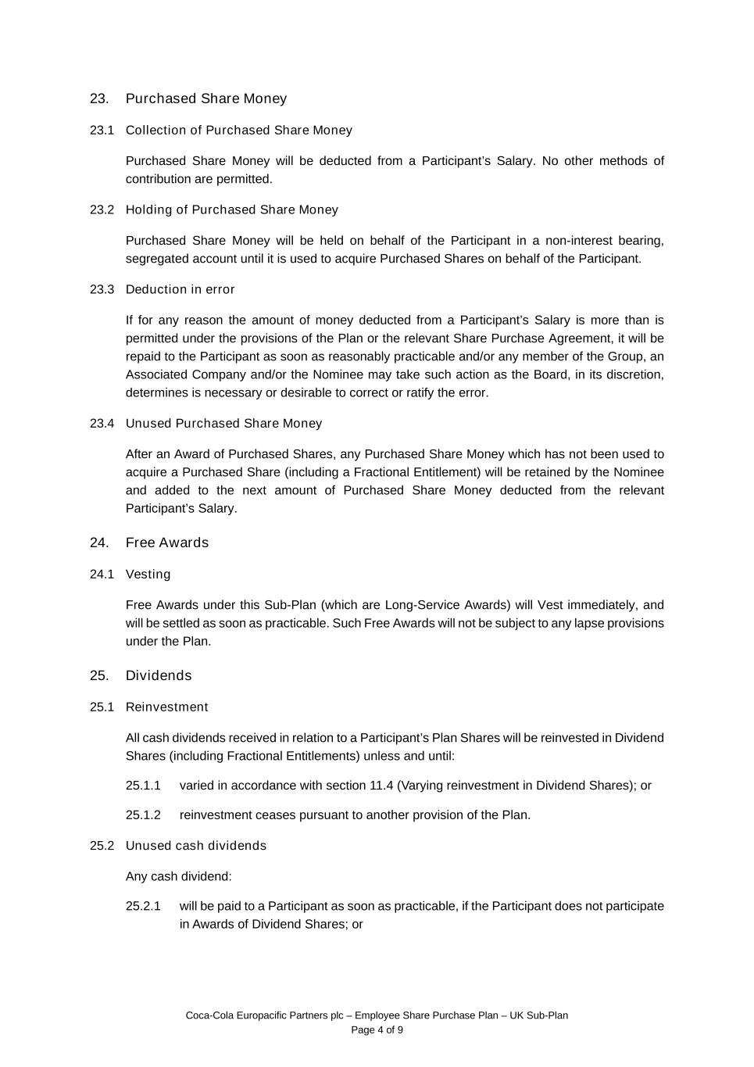
Coca-Cola Europacific Partners plc – Employee Share Purchase Plan – UK Sub-Plan Page 4 of 9 23. Purchased Share Money 23.1 Collection of Purchased Share Money Purchased Share Money will be deducted from a Participant’s Salary. No other methods of contribution are permitted. 23.2 Holding of Purchased Share Money Purchased Share Money will be held on behalf of the Participant in a non-interest bearing, segregated account until it is used to acquire Purchased Shares on behalf of the Participant. 23.3 Deduction in error If for any reason the amount of money deducted from a Participant’s Salary is more than is permitted under the provisions of the Plan or the relevant Share Purchase Agreement, it will be repaid to the Participant as soon as reasonably practicable and/or any member of the Group, an Associated Company and/or the Nominee may take such action as the Board, in its discretion, determines is necessary or desirable to correct or ratify the error. 23.4 Unused Purchased Share Money After an Award of Purchased Shares, any Purchased Share Money which has not been used to acquire a Purchased Share (including a Fractional Entitlement) will be retained by the Nominee and added to the next amount of Purchased Share Money deducted from the relevant Participant’s Salary. 24. Free Awards 24.1 Vesting Free Awards under this Sub-Plan (which are Long-Service Awards) will Vest immediately, and will be settled as soon as practicable. Such Free Awards will not be subject to any lapse provisions under the Plan. 25. Dividends 25.1 Reinvestment All cash dividends received in relation to a Participant’s Plan Shares will be reinvested in Dividend Shares (including Fractional Entitlements) unless and until: 25.1.1 varied in accordance with section 11.4 (Varying reinvestment in Dividend Shares); or 25.1.2 reinvestment ceases pursuant to another provision of the Plan. 25.2 Unused cash dividends Any cash dividend: 25.2.1 will be paid to a Participant as soon as practicable, if the Participant does not participate in Awards of Dividend Shares; or

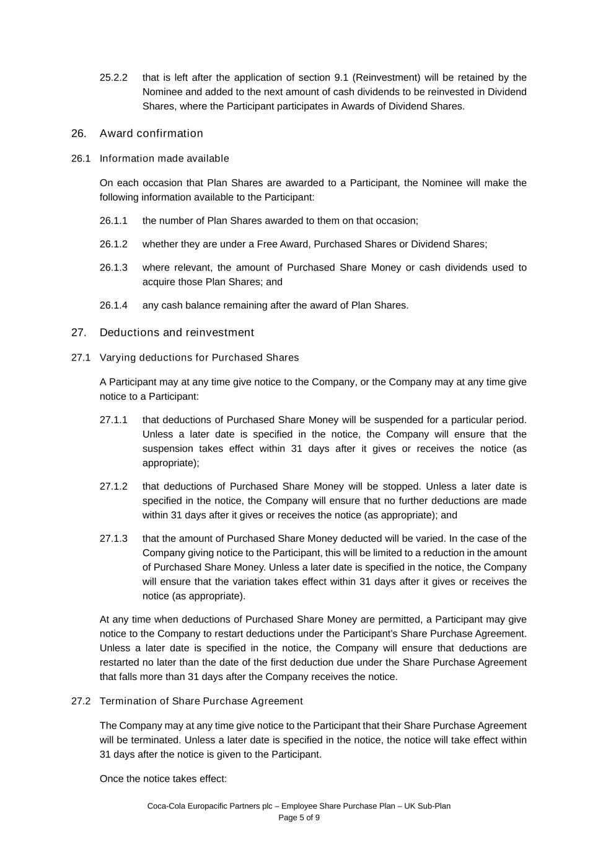
Coca-Cola Europacific Partners plc – Employee Share Purchase Plan – UK Sub-Plan Page 5 of 9 25.2.2 that is left after the application of section 9.1 (Reinvestment) will be retained by the Nominee and added to the next amount of cash dividends to be reinvested in Dividend Shares, where the Participant participates in Awards of Dividend Shares. 26. Award confirmation 26.1 Information made available On each occasion that Plan Shares are awarded to a Participant, the Nominee will make the following information available to the Participant: 26.1.1 the number of Plan Shares awarded to them on that occasion; 26.1.2 whether they are under a Free Award, Purchased Shares or Dividend Shares; 26.1.3 where relevant, the amount of Purchased Share Money or cash dividends used to acquire those Plan Shares; and 26.1.4 any cash balance remaining after the award of Plan Shares. 27. Deductions and reinvestment 27.1 Varying deductions for Purchased Shares A Participant may at any time give notice to the Company, or the Company may at any time give notice to a Participant: 27.1.1 that deductions of Purchased Share Money will be suspended for a particular period. Unless a later date is specified in the notice, the Company will ensure that the suspension takes effect within 31 days after it gives or receives the notice (as appropriate); 27.1.2 that deductions of Purchased Share Money will be stopped. Unless a later date is specified in the notice, the Company will ensure that no further deductions are made within 31 days after it gives or receives the notice (as appropriate); and 27.1.3 that the amount of Purchased Share Money deducted will be varied. In the case of the Company giving notice to the Participant, this will be limited to a reduction in the amount of Purchased Share Money. Unless a later date is specified in the notice, the Company will ensure that the variation takes effect within 31 days after it gives or receives the notice (as appropriate). At any time when deductions of Purchased Share Money are permitted, a Participant may give notice to the Company to restart deductions under the Participant’s Share Purchase Agreement. Unless a later date is specified in the notice, the Company will ensure that deductions are restarted no later than the date of the first deduction due under the Share Purchase Agreement that falls more than 31 days after the Company receives the notice. 27.2 Termination of Share Purchase Agreement The Company may at any time give notice to the Participant that their Share Purchase Agreement will be terminated. Unless a later date is specified in the notice, the notice will take effect within 31 days after the notice is given to the Participant. Once the notice takes effect:

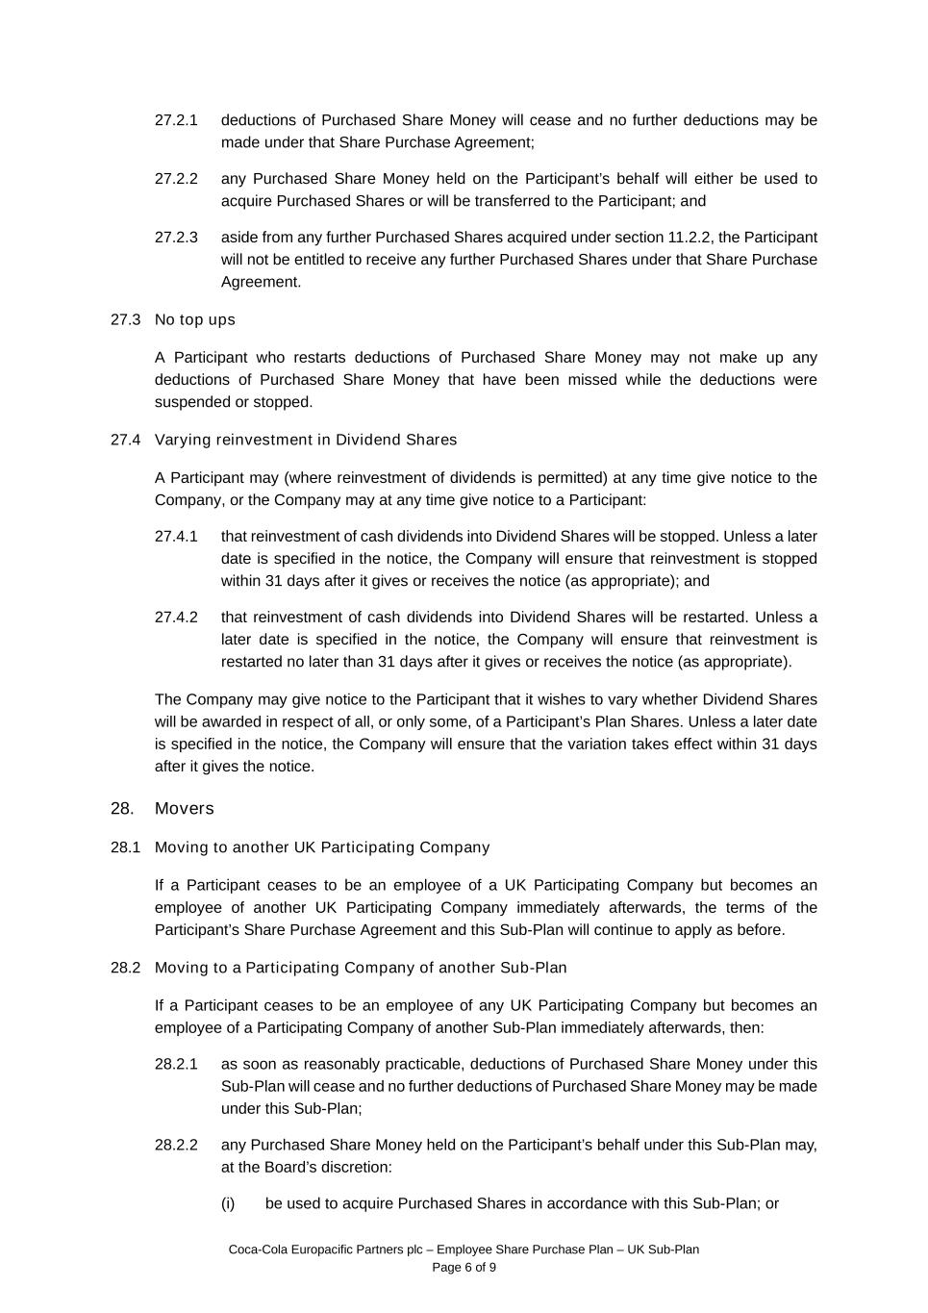
Coca-Cola Europacific Partners plc – Employee Share Purchase Plan – UK Sub-Plan Page 6 of 9 27.2.1 deductions of Purchased Share Money will cease and no further deductions may be made under that Share Purchase Agreement; 27.2.2 any Purchased Share Money held on the Participant’s behalf will either be used to acquire Purchased Shares or will be transferred to the Participant; and 27.2.3 aside from any further Purchased Shares acquired under section 11.2.2, the Participant will not be entitled to receive any further Purchased Shares under that Share Purchase Agreement. 27.3 No top ups A Participant who restarts deductions of Purchased Share Money may not make up any deductions of Purchased Share Money that have been missed while the deductions were suspended or stopped. 27.4 Varying reinvestment in Dividend Shares A Participant may (where reinvestment of dividends is permitted) at any time give notice to the Company, or the Company may at any time give notice to a Participant: 27.4.1 that reinvestment of cash dividends into Dividend Shares will be stopped. Unless a later date is specified in the notice, the Company will ensure that reinvestment is stopped within 31 days after it gives or receives the notice (as appropriate); and 27.4.2 that reinvestment of cash dividends into Dividend Shares will be restarted. Unless a later date is specified in the notice, the Company will ensure that reinvestment is restarted no later than 31 days after it gives or receives the notice (as appropriate). The Company may give notice to the Participant that it wishes to vary whether Dividend Shares will be awarded in respect of all, or only some, of a Participant’s Plan Shares. Unless a later date is specified in the notice, the Company will ensure that the variation takes effect within 31 days after it gives the notice. 28. Movers 28.1 Moving to another UK Participating Company If a Participant ceases to be an employee of a UK Participating Company but becomes an employee of another UK Participating Company immediately afterwards, the terms of the Participant’s Share Purchase Agreement and this Sub-Plan will continue to apply as before. 28.2 Moving to a Participating Company of another Sub-Plan If a Participant ceases to be an employee of any UK Participating Company but becomes an employee of a Participating Company of another Sub-Plan immediately afterwards, then: 28.2.1 as soon as reasonably practicable, deductions of Purchased Share Money under this Sub-Plan will cease and no further deductions of Purchased Share Money may be made under this Sub-Plan; 28.2.2 any Purchased Share Money held on the Participant’s behalf under this Sub-Plan may, at the Board’s discretion: (i) be used to acquire Purchased Shares in accordance with this Sub-Plan; or

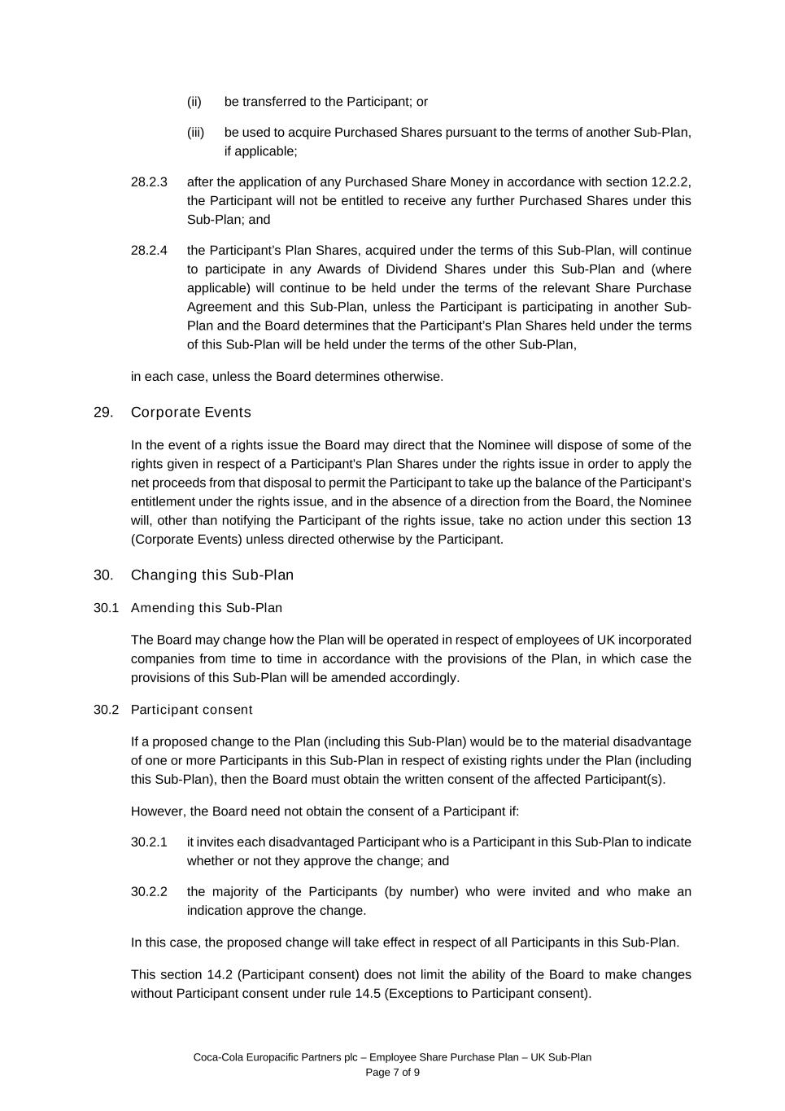
Coca-Cola Europacific Partners plc – Employee Share Purchase Plan – UK Sub-Plan Page 7 of 9 (ii) be transferred to the Participant; or (iii) be used to acquire Purchased Shares pursuant to the terms of another Sub-Plan, if applicable; 28.2.3 after the application of any Purchased Share Money in accordance with section 12.2.2, the Participant will not be entitled to receive any further Purchased Shares under this Sub-Plan; and 28.2.4 the Participant’s Plan Shares, acquired under the terms of this Sub-Plan, will continue to participate in any Awards of Dividend Shares under this Sub-Plan and (where applicable) will continue to be held under the terms of the relevant Share Purchase Agreement and this Sub-Plan, unless the Participant is participating in another Sub- Plan and the Board determines that the Participant’s Plan Shares held under the terms of this Sub-Plan will be held under the terms of the other Sub-Plan, in each case, unless the Board determines otherwise. 29. Corporate Events In the event of a rights issue the Board may direct that the Nominee will dispose of some of the rights given in respect of a Participant's Plan Shares under the rights issue in order to apply the net proceeds from that disposal to permit the Participant to take up the balance of the Participant’s entitlement under the rights issue, and in the absence of a direction from the Board, the Nominee will, other than notifying the Participant of the rights issue, take no action under this section 13 (Corporate Events) unless directed otherwise by the Participant. 30. Changing this Sub-Plan 30.1 Amending this Sub-Plan The Board may change how the Plan will be operated in respect of employees of UK incorporated companies from time to time in accordance with the provisions of the Plan, in which case the provisions of this Sub-Plan will be amended accordingly. 30.2 Participant consent If a proposed change to the Plan (including this Sub-Plan) would be to the material disadvantage of one or more Participants in this Sub-Plan in respect of existing rights under the Plan (including this Sub-Plan), then the Board must obtain the written consent of the affected Participant(s). However, the Board need not obtain the consent of a Participant if: 30.2.1 it invites each disadvantaged Participant who is a Participant in this Sub-Plan to indicate whether or not they approve the change; and 30.2.2 the majority of the Participants (by number) who were invited and who make an indication approve the change. In this case, the proposed change will take effect in respect of all Participants in this Sub-Plan. This section 14.2 (Participant consent) does not limit the ability of the Board to make changes without Participant consent under rule 14.5 (Exceptions to Participant consent).


Coca-Cola Europacific Partners plc – Employee Share Purchase Plan – UK Sub-Plan Page 8 of 9 31. Conflict If there is any conflict between a section of this Sub-Plan and the other rules of the Plan, the section of this Sub-Plan will take precedence.

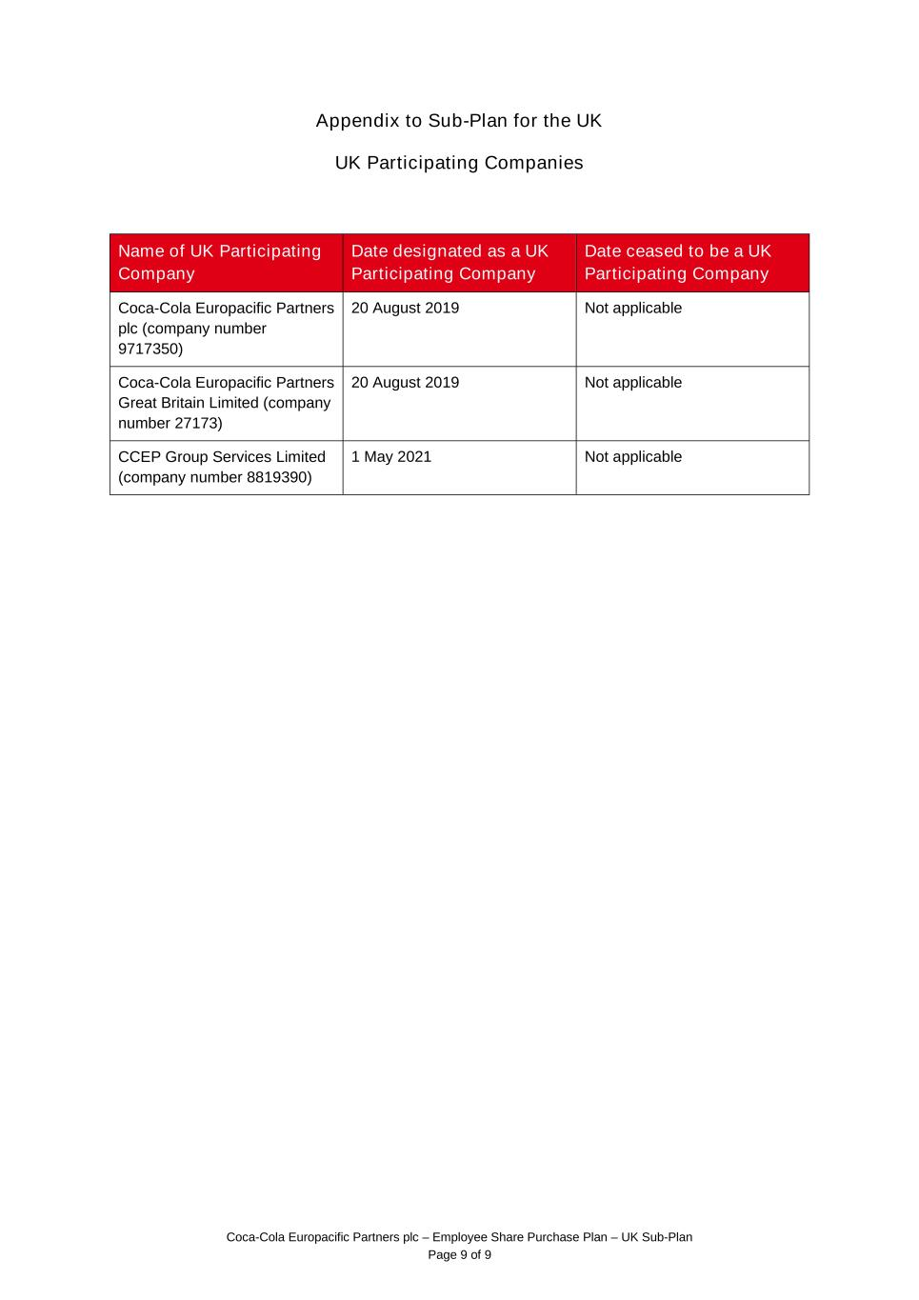
Coca-Cola Europacific Partners plc – Employee Share Purchase Plan – UK Sub-Plan Page 9 of 9 Appendix to Sub-Plan for the UK UK Participating Companies Name of UK Participating Company Date designated as a UK Participating Company Date ceased to be a UK Participating Company Coca-Cola Europacific Partners plc (company number 9717350) 20 August 2019 Not applicable Coca-Cola Europacific Partners Great Britain Limited (company number 27173) 20 August 2019 Not applicable CCEP Group Services Limited (company number 8819390) 1 May 2021 Not applicable

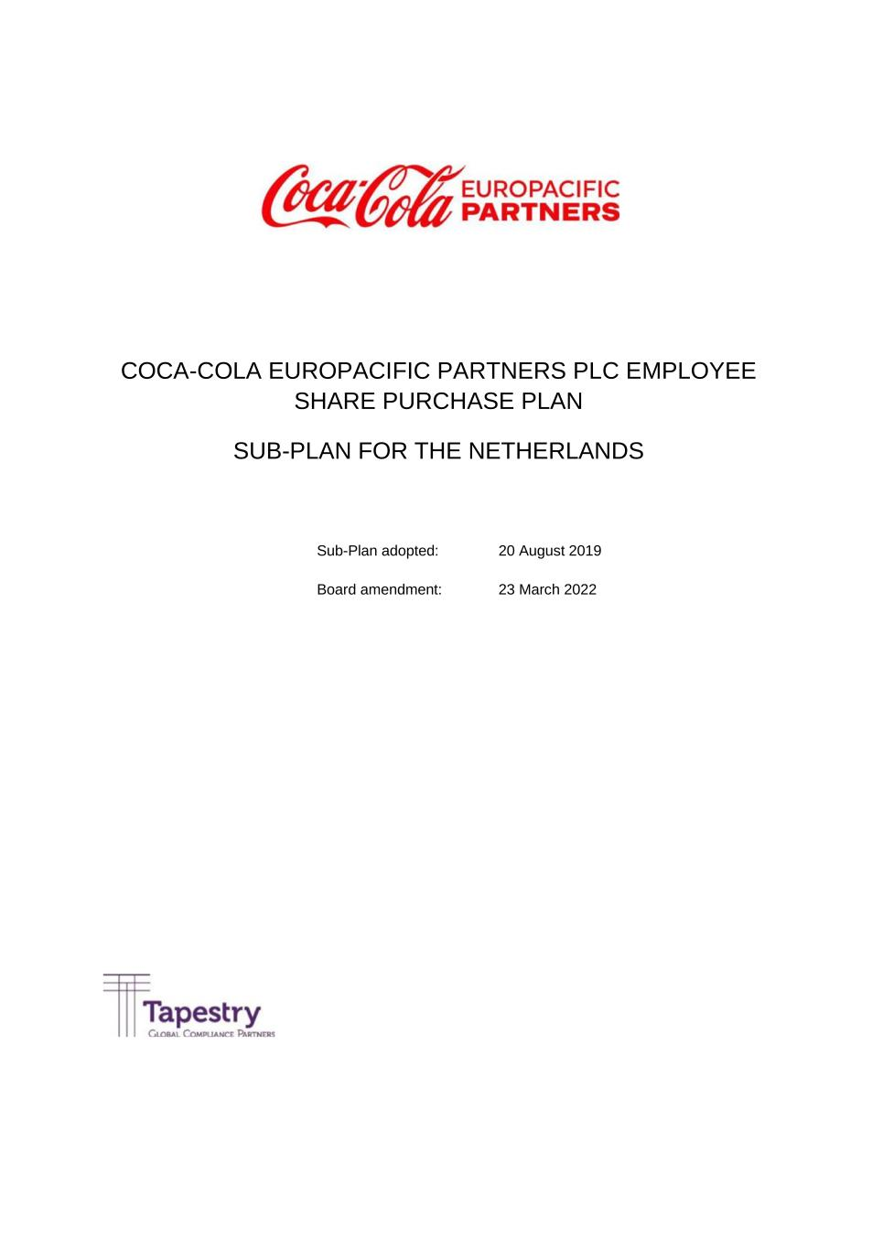
COCA-COLA EUROPACIFIC PARTNERS PLC EMPLOYEE SHARE PURCHASE PLAN SUB-PLAN FOR THE NETHERLANDS Sub-Plan adopted: 20 August 2019 Board amendment: 23 March 2022

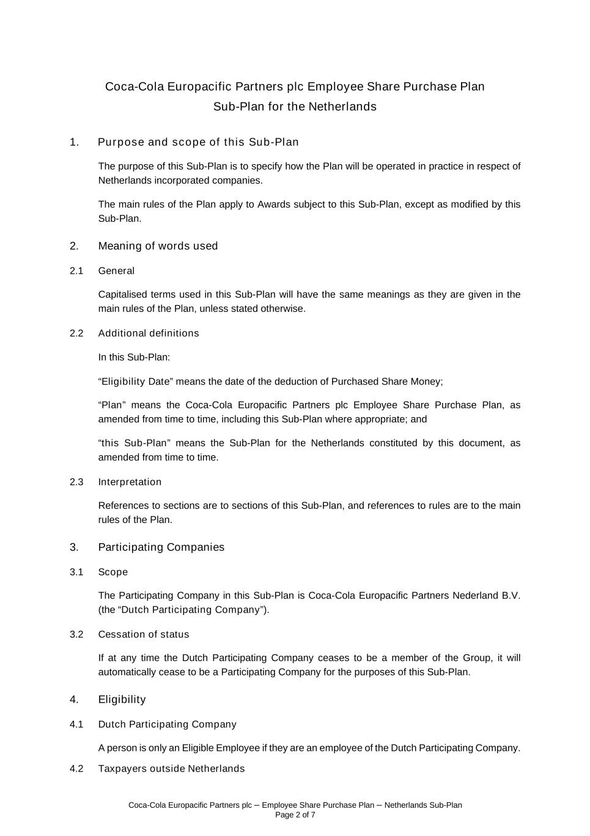
Coca-Cola Europacific Partners plc – Employee Share Purchase Plan – Netherlands Sub-Plan Page 2 of 7 Coca-Cola Europacific Partners plc Employee Share Purchase Plan Sub-Plan for the Netherlands 1. Purpose and scope of this Sub-Plan The purpose of this Sub-Plan is to specify how the Plan will be operated in practice in respect of Netherlands incorporated companies. The main rules of the Plan apply to Awards subject to this Sub-Plan, except as modified by this Sub-Plan. 2. Meaning of words used 2.1 General Capitalised terms used in this Sub-Plan will have the same meanings as they are given in the main rules of the Plan, unless stated otherwise. 2.2 Additional definitions In this Sub-Plan: “Eligibility Date” means the date of the deduction of Purchased Share Money; “Plan” means the Coca-Cola Europacific Partners plc Employee Share Purchase Plan, as amended from time to time, including this Sub-Plan where appropriate; and “this Sub-Plan” means the Sub-Plan for the Netherlands constituted by this document, as amended from time to time. 2.3 Interpretation References to sections are to sections of this Sub-Plan, and references to rules are to the main rules of the Plan. 3. Participating Companies 3.1 Scope The Participating Company in this Sub-Plan is Coca-Cola Europacific Partners Nederland B.V. (the “Dutch Participating Company”). 3.2 Cessation of status If at any time the Dutch Participating Company ceases to be a member of the Group, it will automatically cease to be a Participating Company for the purposes of this Sub-Plan. 4. Eligibility 4.1 Dutch Participating Company A person is only an Eligible Employee if they are an employee of the Dutch Participating Company. 4.2 Taxpayers outside Netherlands

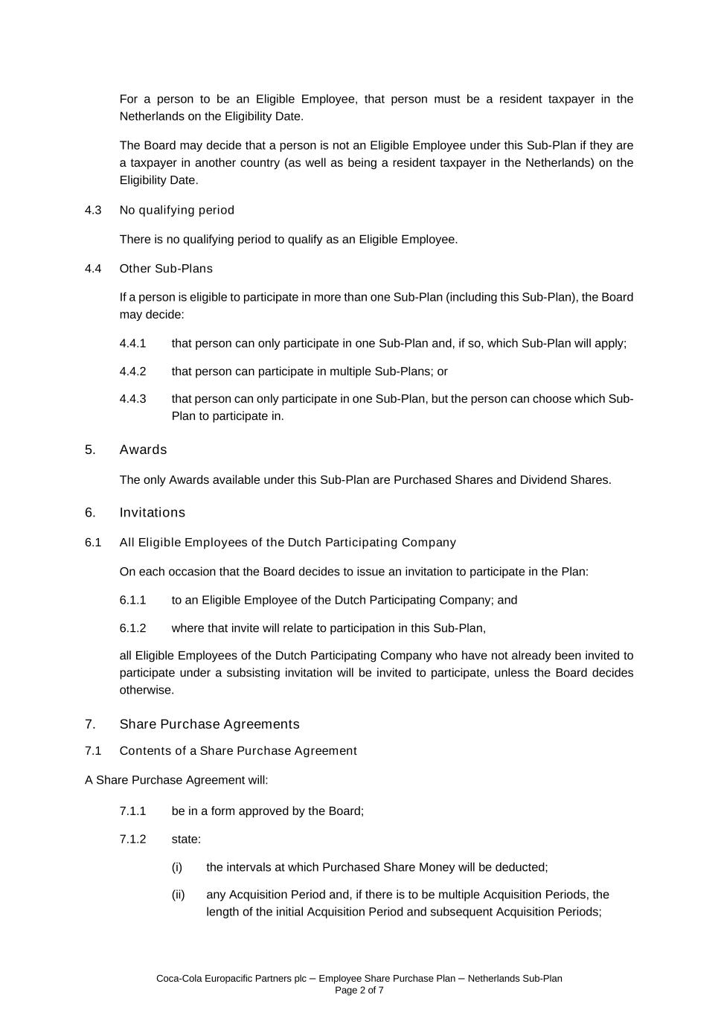
Coca-Cola Europacific Partners plc – Employee Share Purchase Plan – Netherlands Sub-Plan Page 2 of 7 For a person to be an Eligible Employee, that person must be a resident taxpayer in the Netherlands on the Eligibility Date. The Board may decide that a person is not an Eligible Employee under this Sub-Plan if they are a taxpayer in another country (as well as being a resident taxpayer in the Netherlands) on the Eligibility Date. 4.3 No qualifying period There is no qualifying period to qualify as an Eligible Employee. 4.4 Other Sub-Plans If a person is eligible to participate in more than one Sub-Plan (including this Sub-Plan), the Board may decide: 4.4.1 that person can only participate in one Sub-Plan and, if so, which Sub-Plan will apply; 4.4.2 that person can participate in multiple Sub-Plans; or 4.4.3 that person can only participate in one Sub-Plan, but the person can choose which Sub- Plan to participate in. 5. Awards The only Awards available under this Sub-Plan are Purchased Shares and Dividend Shares. 6. Invitations 6.1 All Eligible Employees of the Dutch Participating Company On each occasion that the Board decides to issue an invitation to participate in the Plan: 6.1.1 to an Eligible Employee of the Dutch Participating Company; and 6.1.2 where that invite will relate to participation in this Sub-Plan, all Eligible Employees of the Dutch Participating Company who have not already been invited to participate under a subsisting invitation will be invited to participate, unless the Board decides otherwise. 7. Share Purchase Agreements 7.1 Contents of a Share Purchase Agreement A Share Purchase Agreement will: 7.1.1 be in a form approved by the Board; 7.1.2 state: (i) the intervals at which Purchased Share Money will be deducted; (ii) any Acquisition Period and, if there is to be multiple Acquisition Periods, the length of the initial Acquisition Period and subsequent Acquisition Periods;

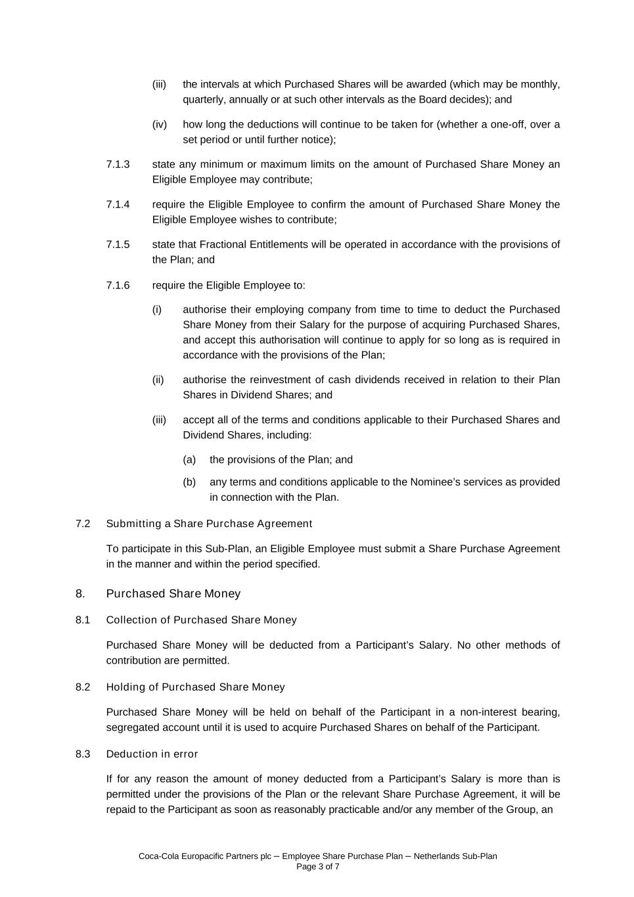
Coca-Cola Europacific Partners plc – Employee Share Purchase Plan – Netherlands Sub-Plan Page 3 of 7 (iii) the intervals at which Purchased Shares will be awarded (which may be monthly, quarterly, annually or at such other intervals as the Board decides); and (iv) how long the deductions will continue to be taken for (whether a one-off, over a set period or until further notice); 7.1.3 state any minimum or maximum limits on the amount of Purchased Share Money an Eligible Employee may contribute; 7.1.4 require the Eligible Employee to confirm the amount of Purchased Share Money the Eligible Employee wishes to contribute; 7.1.5 state that Fractional Entitlements will be operated in accordance with the provisions of the Plan; and 7.1.6 require the Eligible Employee to: (i) authorise their employing company from time to time to deduct the Purchased Share Money from their Salary for the purpose of acquiring Purchased Shares, and accept this authorisation will continue to apply for so long as is required in accordance with the provisions of the Plan; (ii) authorise the reinvestment of cash dividends received in relation to their Plan Shares in Dividend Shares; and (iii) accept all of the terms and conditions applicable to their Purchased Shares and Dividend Shares, including: (a) the provisions of the Plan; and (b) any terms and conditions applicable to the Nominee’s services as provided in connection with the Plan. 7.2 Submitting a Share Purchase Agreement To participate in this Sub-Plan, an Eligible Employee must submit a Share Purchase Agreement in the manner and within the period specified. 8. Purchased Share Money 8.1 Collection of Purchased Share Money Purchased Share Money will be deducted from a Participant’s Salary. No other methods of contribution are permitted. 8.2 Holding of Purchased Share Money Purchased Share Money will be held on behalf of the Participant in a non-interest bearing, segregated account until it is used to acquire Purchased Shares on behalf of the Participant. 8.3 Deduction in error If for any reason the amount of money deducted from a Participant’s Salary is more than is permitted under the provisions of the Plan or the relevant Share Purchase Agreement, it will be repaid to the Participant as soon as reasonably practicable and/or any member of the Group, an

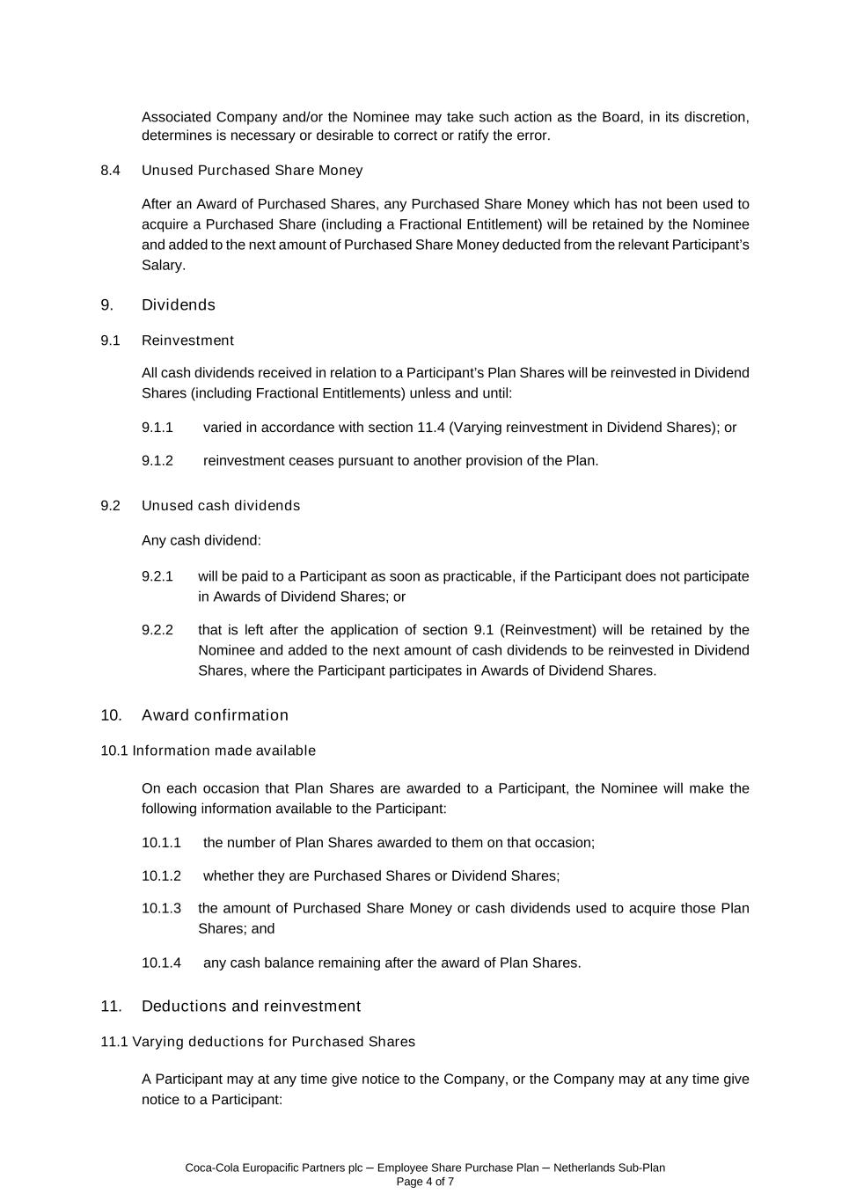
Coca-Cola Europacific Partners plc – Employee Share Purchase Plan – Netherlands Sub-Plan Page 4 of 7 Associated Company and/or the Nominee may take such action as the Board, in its discretion, determines is necessary or desirable to correct or ratify the error. 8.4 Unused Purchased Share Money After an Award of Purchased Shares, any Purchased Share Money which has not been used to acquire a Purchased Share (including a Fractional Entitlement) will be retained by the Nominee and added to the next amount of Purchased Share Money deducted from the relevant Participant’s Salary. 9. Dividends 9.1 Reinvestment All cash dividends received in relation to a Participant’s Plan Shares will be reinvested in Dividend Shares (including Fractional Entitlements) unless and until: 9.1.1 varied in accordance with section 11.4 (Varying reinvestment in Dividend Shares); or 9.1.2 reinvestment ceases pursuant to another provision of the Plan. 9.2 Unused cash dividends Any cash dividend: 9.2.1 will be paid to a Participant as soon as practicable, if the Participant does not participate in Awards of Dividend Shares; or 9.2.2 that is left after the application of section 9.1 (Reinvestment) will be retained by the Nominee and added to the next amount of cash dividends to be reinvested in Dividend Shares, where the Participant participates in Awards of Dividend Shares. 10. Award confirmation 10.1 Information made available On each occasion that Plan Shares are awarded to a Participant, the Nominee will make the following information available to the Participant: 10.1.1 the number of Plan Shares awarded to them on that occasion; 10.1.2 whether they are Purchased Shares or Dividend Shares; 10.1.3 the amount of Purchased Share Money or cash dividends used to acquire those Plan Shares; and 10.1.4 any cash balance remaining after the award of Plan Shares. 11. Deductions and reinvestment 11.1 Varying deductions for Purchased Shares A Participant may at any time give notice to the Company, or the Company may at any time give notice to a Participant:

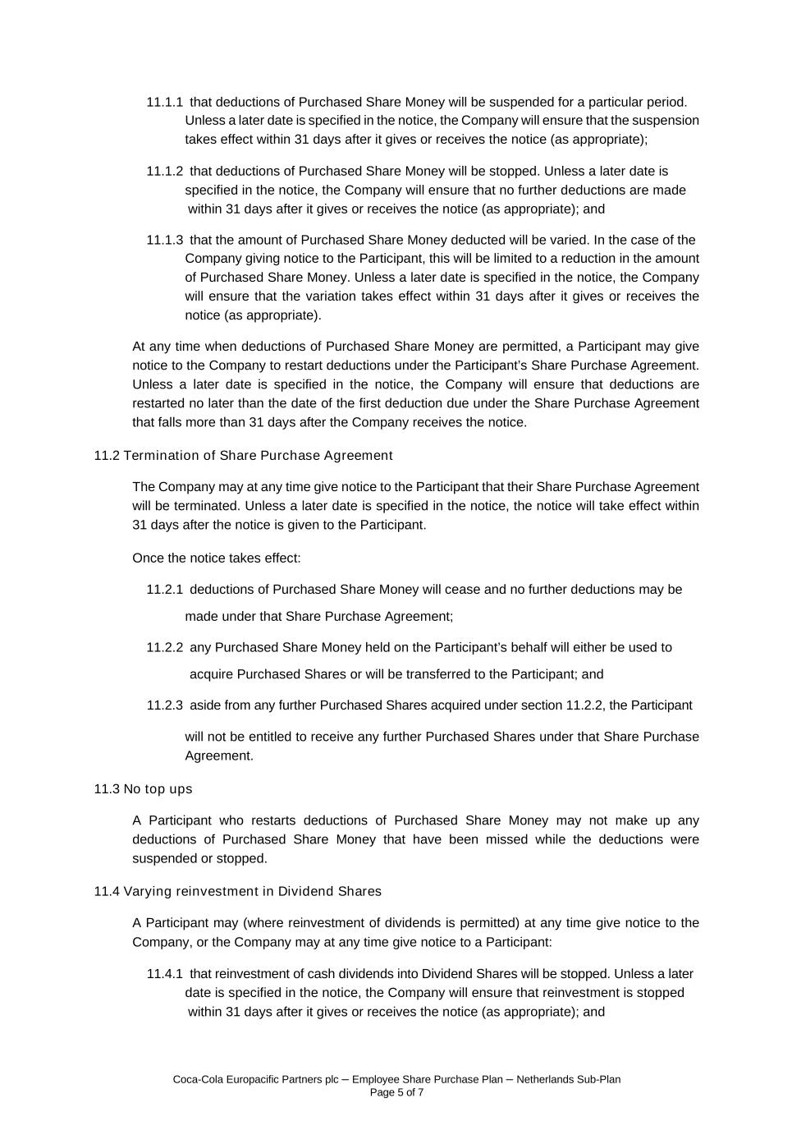
Coca-Cola Europacific Partners plc – Employee Share Purchase Plan – Netherlands Sub-Plan Page 5 of 7 11.1.1 that deductions of Purchased Share Money will be suspended for a particular period. Unless a later date is specified in the notice, the Company will ensure that the suspension takes effect within 31 days after it gives or receives the notice (as appropriate); 11.1.2 that deductions of Purchased Share Money will be stopped. Unless a later date is specified in the notice, the Company will ensure that no further deductions are made within 31 days after it gives or receives the notice (as appropriate); and 11.1.3 that the amount of Purchased Share Money deducted will be varied. In the case of the Company giving notice to the Participant, this will be limited to a reduction in the amount of Purchased Share Money. Unless a later date is specified in the notice, the Company will ensure that the variation takes effect within 31 days after it gives or receives the notice (as appropriate). At any time when deductions of Purchased Share Money are permitted, a Participant may give notice to the Company to restart deductions under the Participant’s Share Purchase Agreement. Unless a later date is specified in the notice, the Company will ensure that deductions are restarted no later than the date of the first deduction due under the Share Purchase Agreement that falls more than 31 days after the Company receives the notice. 11.2 Termination of Share Purchase Agreement The Company may at any time give notice to the Participant that their Share Purchase Agreement will be terminated. Unless a later date is specified in the notice, the notice will take effect within 31 days after the notice is given to the Participant. Once the notice takes effect: 11.2.1 deductions of Purchased Share Money will cease and no further deductions may be made under that Share Purchase Agreement; 11.2.2 any Purchased Share Money held on the Participant’s behalf will either be used to acquire Purchased Shares or will be transferred to the Participant; and 11.2.3 aside from any further Purchased Shares acquired under section 11.2.2, the Participant will not be entitled to receive any further Purchased Shares under that Share Purchase Agreement. 11.3 No top ups A Participant who restarts deductions of Purchased Share Money may not make up any deductions of Purchased Share Money that have been missed while the deductions were suspended or stopped. 11.4 Varying reinvestment in Dividend Shares A Participant may (where reinvestment of dividends is permitted) at any time give notice to the Company, or the Company may at any time give notice to a Participant: 11.4.1 that reinvestment of cash dividends into Dividend Shares will be stopped. Unless a later date is specified in the notice, the Company will ensure that reinvestment is stopped within 31 days after it gives or receives the notice (as appropriate); and

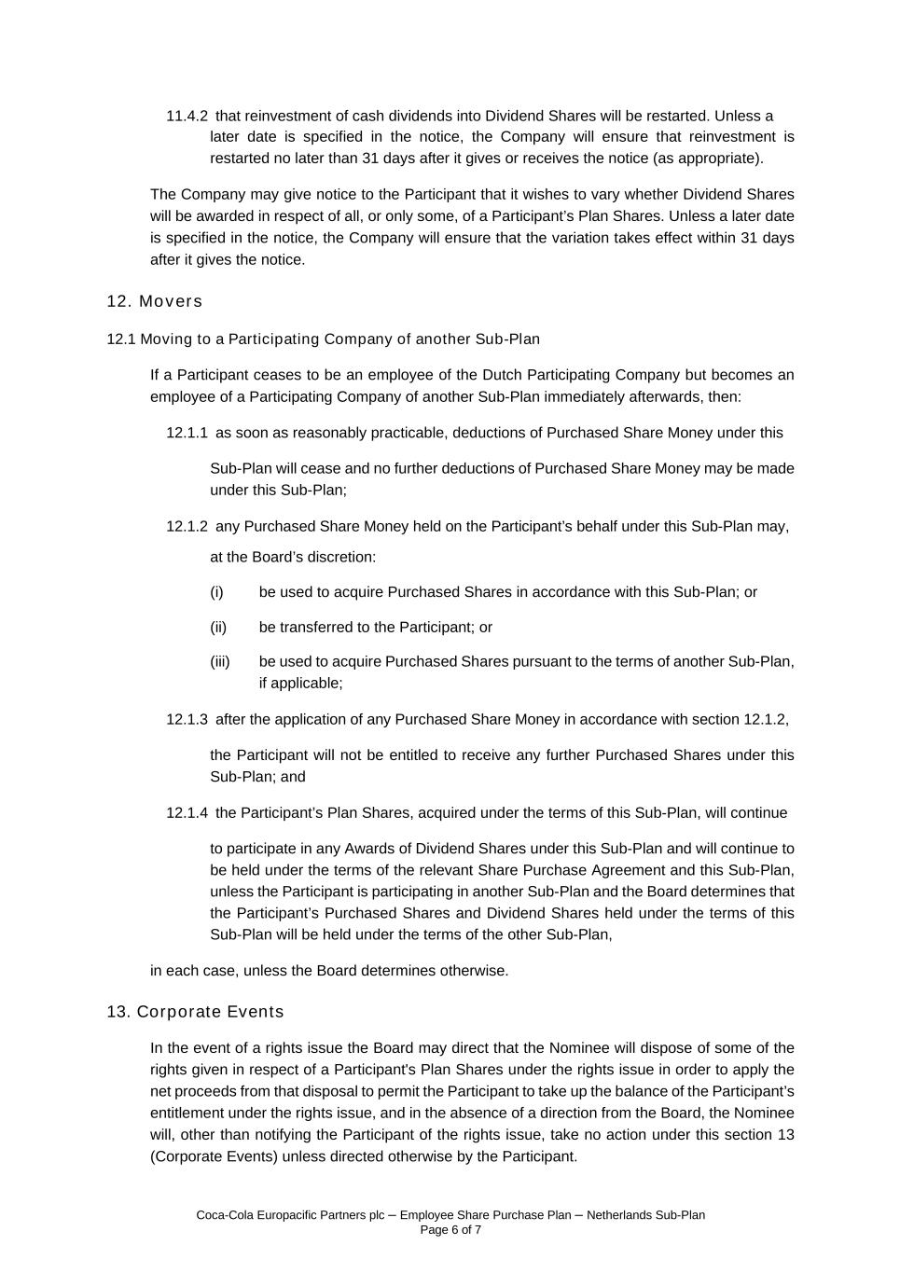
Coca-Cola Europacific Partners plc – Employee Share Purchase Plan – Netherlands Sub-Plan Page 6 of 7 11.4.2 that reinvestment of cash dividends into Dividend Shares will be restarted. Unless a later date is specified in the notice, the Company will ensure that reinvestment is restarted no later than 31 days after it gives or receives the notice (as appropriate). The Company may give notice to the Participant that it wishes to vary whether Dividend Shares will be awarded in respect of all, or only some, of a Participant’s Plan Shares. Unless a later date is specified in the notice, the Company will ensure that the variation takes effect within 31 days after it gives the notice. 12. Movers 12.1 Moving to a Participating Company of another Sub-Plan If a Participant ceases to be an employee of the Dutch Participating Company but becomes an employee of a Participating Company of another Sub-Plan immediately afterwards, then: 12.1.1 as soon as reasonably practicable, deductions of Purchased Share Money under this Sub-Plan will cease and no further deductions of Purchased Share Money may be made under this Sub-Plan; 12.1.2 any Purchased Share Money held on the Participant’s behalf under this Sub-Plan may, at the Board’s discretion: (i) be used to acquire Purchased Shares in accordance with this Sub-Plan; or (ii) be transferred to the Participant; or (iii) be used to acquire Purchased Shares pursuant to the terms of another Sub-Plan, if applicable; 12.1.3 after the application of any Purchased Share Money in accordance with section 12.1.2, the Participant will not be entitled to receive any further Purchased Shares under this Sub-Plan; and 12.1.4 the Participant’s Plan Shares, acquired under the terms of this Sub-Plan, will continue to participate in any Awards of Dividend Shares under this Sub-Plan and will continue to be held under the terms of the relevant Share Purchase Agreement and this Sub-Plan, unless the Participant is participating in another Sub-Plan and the Board determines that the Participant’s Purchased Shares and Dividend Shares held under the terms of this Sub-Plan will be held under the terms of the other Sub-Plan, in each case, unless the Board determines otherwise. 13. Corporate Events In the event of a rights issue the Board may direct that the Nominee will dispose of some of the rights given in respect of a Participant's Plan Shares under the rights issue in order to apply the net proceeds from that disposal to permit the Participant to take up the balance of the Participant’s entitlement under the rights issue, and in the absence of a direction from the Board, the Nominee will, other than notifying the Participant of the rights issue, take no action under this section 13 (Corporate Events) unless directed otherwise by the Participant.

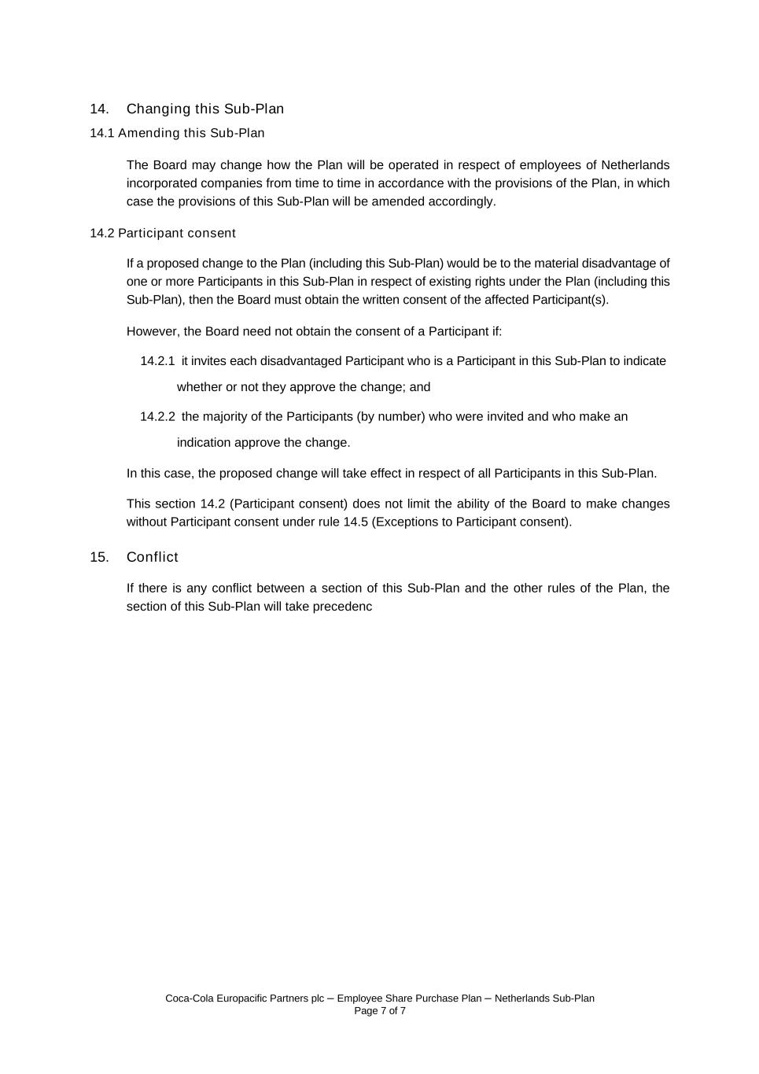
Coca-Cola Europacific Partners plc – Employee Share Purchase Plan – Netherlands Sub-Plan Page 7 of 7 14. Changing this Sub-Plan 14.1 Amending this Sub-Plan The Board may change how the Plan will be operated in respect of employees of Netherlands incorporated companies from time to time in accordance with the provisions of the Plan, in which case the provisions of this Sub-Plan will be amended accordingly. 14.2 Participant consent If a proposed change to the Plan (including this Sub-Plan) would be to the material disadvantage of one or more Participants in this Sub-Plan in respect of existing rights under the Plan (including this Sub-Plan), then the Board must obtain the written consent of the affected Participant(s). However, the Board need not obtain the consent of a Participant if: 14.2.1 it invites each disadvantaged Participant who is a Participant in this Sub-Plan to indicate whether or not they approve the change; and 14.2.2 the majority of the Participants (by number) who were invited and who make an indication approve the change. In this case, the proposed change will take effect in respect of all Participants in this Sub-Plan. This section 14.2 (Participant consent) does not limit the ability of the Board to make changes without Participant consent under rule 14.5 (Exceptions to Participant consent). 15. Conflict If there is any conflict between a section of this Sub-Plan and the other rules of the Plan, the section of this Sub-Plan will take precedenc

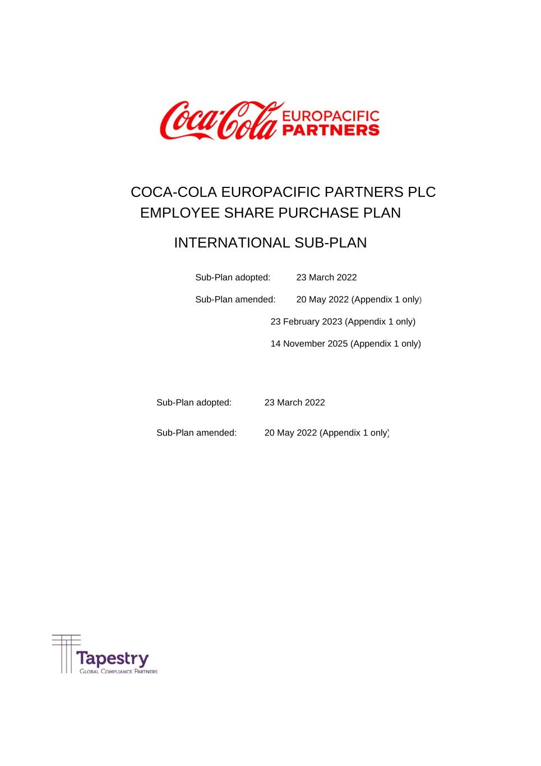
COCA-COLA EUROPACIFIC PARTNERS PLC EMPLOYEE SHARE PURCHASE PLAN INTERNATIONAL SUB-PLAN Sub-Plan adopted: 23 March 2022 Sub-Plan amended: 20 May 2022 (Appendix 1 only) 23 February 2023 (Appendix 1 only) 14 November 2025 (Appendix 1 only) Sub-Plan adopted: 23 March 2022 Sub-Plan amended: 20 May 2022 (Appendix 1 only)

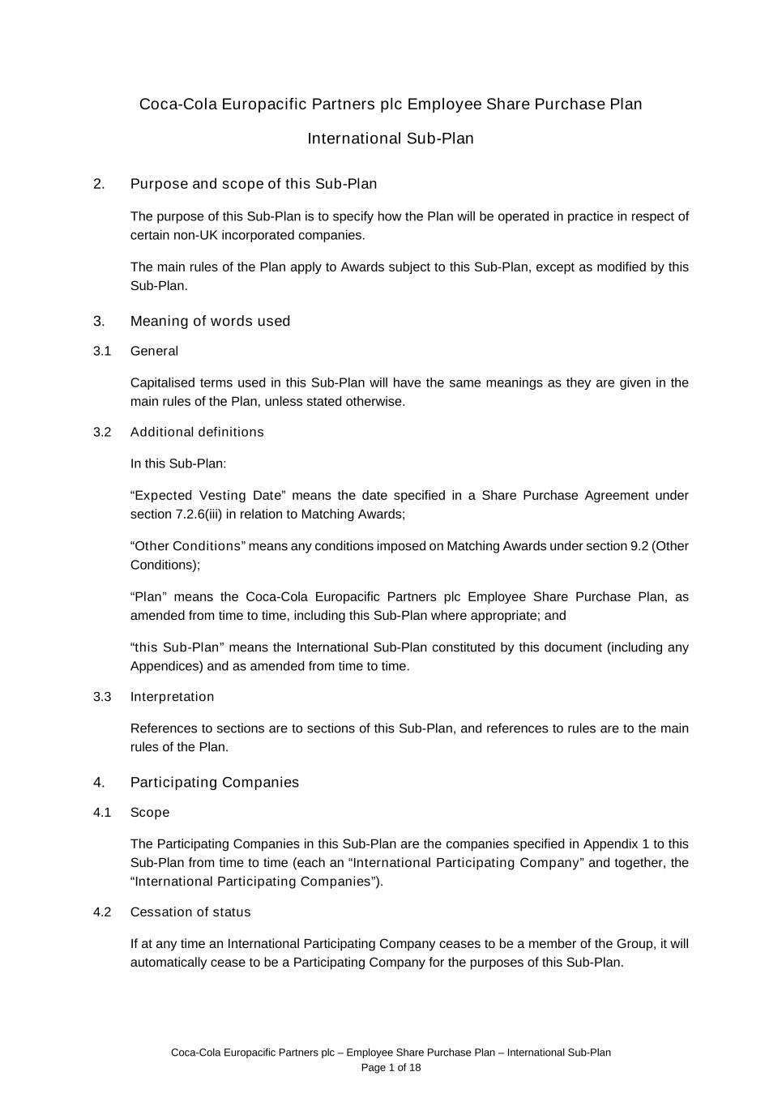
Coca-Cola Europacific Partners plc – Employee Share Purchase Plan – International Sub-Plan Page 1 of 18 Coca-Cola Europacific Partners plc Employee Share Purchase Plan International Sub-Plan 2. Purpose and scope of this Sub-Plan The purpose of this Sub-Plan is to specify how the Plan will be operated in practice in respect of certain non-UK incorporated companies. The main rules of the Plan apply to Awards subject to this Sub-Plan, except as modified by this Sub-Plan. 3. Meaning of words used 3.1 General Capitalised terms used in this Sub-Plan will have the same meanings as they are given in the main rules of the Plan, unless stated otherwise. 3.2 Additional definitions In this Sub-Plan: “Expected Vesting Date” means the date specified in a Share Purchase Agreement under section 7.2.6(iii) in relation to Matching Awards; “Other Conditions” means any conditions imposed on Matching Awards under section 9.2 (Other Conditions); “Plan” means the Coca-Cola Europacific Partners plc Employee Share Purchase Plan, as amended from time to time, including this Sub-Plan where appropriate; and “this Sub-Plan” means the International Sub-Plan constituted by this document (including any Appendices) and as amended from time to time. 3.3 Interpretation References to sections are to sections of this Sub-Plan, and references to rules are to the main rules of the Plan. 4. Participating Companies 4.1 Scope The Participating Companies in this Sub-Plan are the companies specified in Appendix 1 to this Sub-Plan from time to time (each an “International Participating Company” and together, the “International Participating Companies”). 4.2 Cessation of status If at any time an International Participating Company ceases to be a member of the Group, it will automatically cease to be a Participating Company for the purposes of this Sub-Plan.

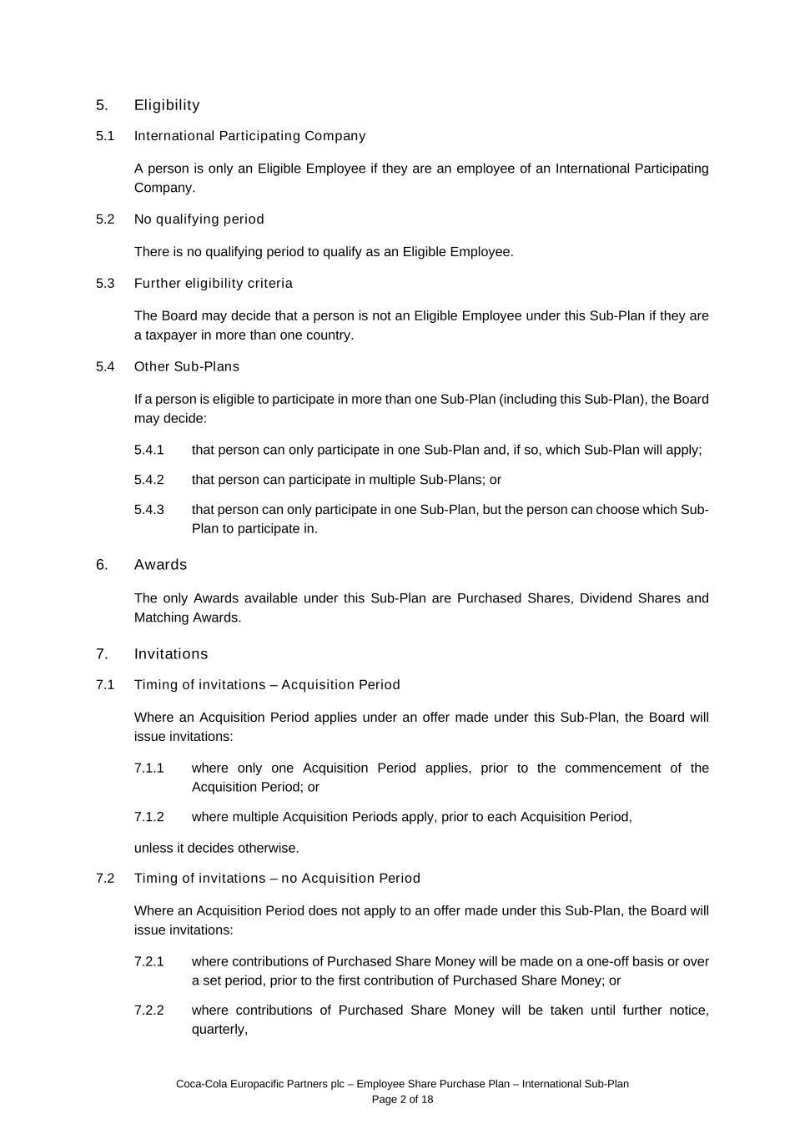
Coca-Cola Europacific Partners plc – Employee Share Purchase Plan – International Sub-Plan Page 2 of 18 5. Eligibility 5.1 International Participating Company A person is only an Eligible Employee if they are an employee of an International Participating Company. 5.2 No qualifying period There is no qualifying period to qualify as an Eligible Employee. 5.3 Further eligibility criteria The Board may decide that a person is not an Eligible Employee under this Sub-Plan if they are a taxpayer in more than one country. 5.4 Other Sub-Plans If a person is eligible to participate in more than one Sub-Plan (including this Sub-Plan), the Board may decide: 5.4.1 that person can only participate in one Sub-Plan and, if so, which Sub-Plan will apply; 5.4.2 that person can participate in multiple Sub-Plans; or 5.4.3 that person can only participate in one Sub-Plan, but the person can choose which Sub- Plan to participate in. 6. Awards The only Awards available under this Sub-Plan are Purchased Shares, Dividend Shares and Matching Awards. 7. Invitations 7.1 Timing of invitations – Acquisition Period Where an Acquisition Period applies under an offer made under this Sub-Plan, the Board will issue invitations: 7.1.1 where only one Acquisition Period applies, prior to the commencement of the Acquisition Period; or 7.1.2 where multiple Acquisition Periods apply, prior to each Acquisition Period, unless it decides otherwise. 7.2 Timing of invitations – no Acquisition Period Where an Acquisition Period does not apply to an offer made under this Sub-Plan, the Board will issue invitations: 7.2.1 where contributions of Purchased Share Money will be made on a one-off basis or over a set period, prior to the first contribution of Purchased Share Money; or 7.2.2 where contributions of Purchased Share Money will be taken until further notice, quarterly,

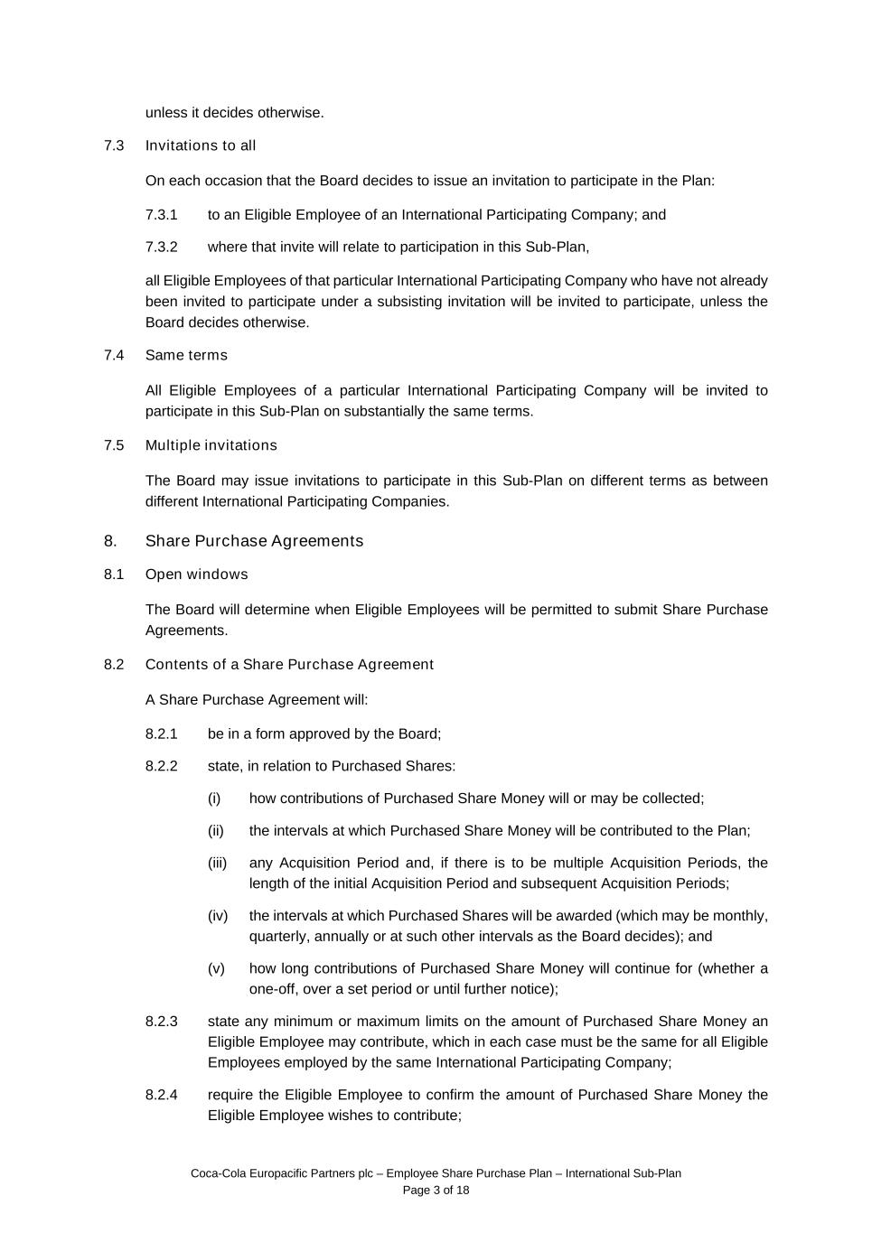
Coca-Cola Europacific Partners plc – Employee Share Purchase Plan – International Sub-Plan Page 3 of 18 unless it decides otherwise. 7.3 Invitations to all On each occasion that the Board decides to issue an invitation to participate in the Plan: 7.3.1 to an Eligible Employee of an International Participating Company; and 7.3.2 where that invite will relate to participation in this Sub-Plan, all Eligible Employees of that particular International Participating Company who have not already been invited to participate under a subsisting invitation will be invited to participate, unless the Board decides otherwise. 7.4 Same terms All Eligible Employees of a particular International Participating Company will be invited to participate in this Sub-Plan on substantially the same terms. 7.5 Multiple invitations The Board may issue invitations to participate in this Sub-Plan on different terms as between different International Participating Companies. 8. Share Purchase Agreements 8.1 Open windows The Board will determine when Eligible Employees will be permitted to submit Share Purchase Agreements. 8.2 Contents of a Share Purchase Agreement A Share Purchase Agreement will: 8.2.1 be in a form approved by the Board; 8.2.2 state, in relation to Purchased Shares: (i) how contributions of Purchased Share Money will or may be collected; (ii) the intervals at which Purchased Share Money will be contributed to the Plan; (iii) any Acquisition Period and, if there is to be multiple Acquisition Periods, the length of the initial Acquisition Period and subsequent Acquisition Periods; (iv) the intervals at which Purchased Shares will be awarded (which may be monthly, quarterly, annually or at such other intervals as the Board decides); and (v) how long contributions of Purchased Share Money will continue for (whether a one-off, over a set period or until further notice); 8.2.3 state any minimum or maximum limits on the amount of Purchased Share Money an Eligible Employee may contribute, which in each case must be the same for all Eligible Employees employed by the same International Participating Company; 8.2.4 require the Eligible Employee to confirm the amount of Purchased Share Money the Eligible Employee wishes to contribute;

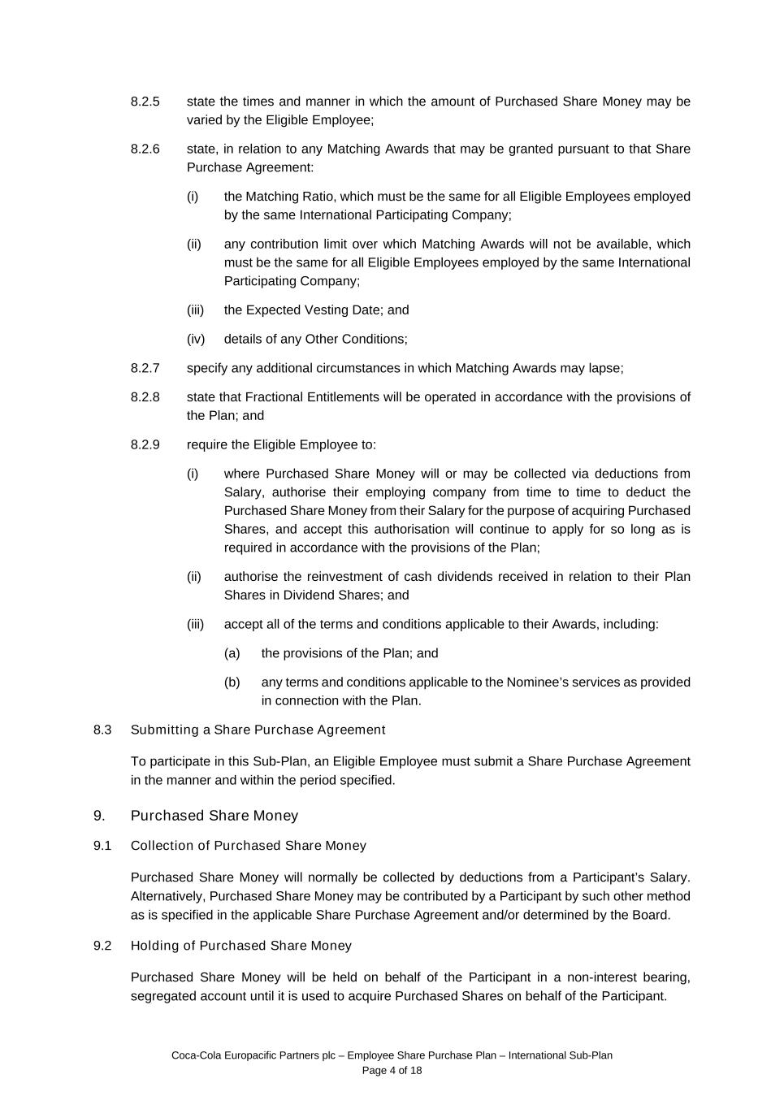
Coca-Cola Europacific Partners plc – Employee Share Purchase Plan – International Sub-Plan Page 4 of 18 8.2.5 state the times and manner in which the amount of Purchased Share Money may be varied by the Eligible Employee; 8.2.6 state, in relation to any Matching Awards that may be granted pursuant to that Share Purchase Agreement: (i) the Matching Ratio, which must be the same for all Eligible Employees employed by the same International Participating Company; (ii) any contribution limit over which Matching Awards will not be available, which must be the same for all Eligible Employees employed by the same International Participating Company; (iii) the Expected Vesting Date; and (iv) details of any Other Conditions; 8.2.7 specify any additional circumstances in which Matching Awards may lapse; 8.2.8 state that Fractional Entitlements will be operated in accordance with the provisions of the Plan; and 8.2.9 require the Eligible Employee to: (i) where Purchased Share Money will or may be collected via deductions from Salary, authorise their employing company from time to time to deduct the Purchased Share Money from their Salary for the purpose of acquiring Purchased Shares, and accept this authorisation will continue to apply for so long as is required in accordance with the provisions of the Plan; (ii) authorise the reinvestment of cash dividends received in relation to their Plan Shares in Dividend Shares; and (iii) accept all of the terms and conditions applicable to their Awards, including: (a) the provisions of the Plan; and (b) any terms and conditions applicable to the Nominee’s services as provided in connection with the Plan. 8.3 Submitting a Share Purchase Agreement To participate in this Sub-Plan, an Eligible Employee must submit a Share Purchase Agreement in the manner and within the period specified. 9. Purchased Share Money 9.1 Collection of Purchased Share Money Purchased Share Money will normally be collected by deductions from a Participant’s Salary. Alternatively, Purchased Share Money may be contributed by a Participant by such other method as is specified in the applicable Share Purchase Agreement and/or determined by the Board. 9.2 Holding of Purchased Share Money Purchased Share Money will be held on behalf of the Participant in a non-interest bearing, segregated account until it is used to acquire Purchased Shares on behalf of the Participant.

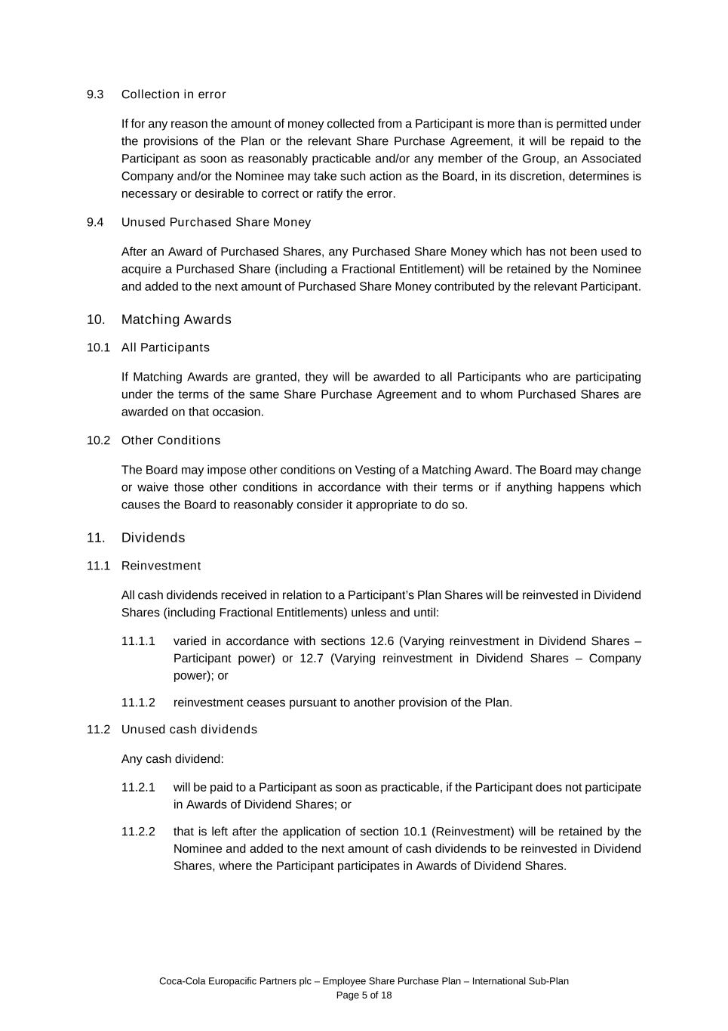
Coca-Cola Europacific Partners plc – Employee Share Purchase Plan – International Sub-Plan Page 5 of 18 9.3 Collection in error If for any reason the amount of money collected from a Participant is more than is permitted under the provisions of the Plan or the relevant Share Purchase Agreement, it will be repaid to the Participant as soon as reasonably practicable and/or any member of the Group, an Associated Company and/or the Nominee may take such action as the Board, in its discretion, determines is necessary or desirable to correct or ratify the error. 9.4 Unused Purchased Share Money After an Award of Purchased Shares, any Purchased Share Money which has not been used to acquire a Purchased Share (including a Fractional Entitlement) will be retained by the Nominee and added to the next amount of Purchased Share Money contributed by the relevant Participant. 10. Matching Awards 10.1 All Participants If Matching Awards are granted, they will be awarded to all Participants who are participating under the terms of the same Share Purchase Agreement and to whom Purchased Shares are awarded on that occasion. 10.2 Other Conditions The Board may impose other conditions on Vesting of a Matching Award. The Board may change or waive those other conditions in accordance with their terms or if anything happens which causes the Board to reasonably consider it appropriate to do so. 11. Dividends 11.1 Reinvestment All cash dividends received in relation to a Participant’s Plan Shares will be reinvested in Dividend Shares (including Fractional Entitlements) unless and until: 11.1.1 varied in accordance with sections 12.6 (Varying reinvestment in Dividend Shares – Participant power) or 12.7 (Varying reinvestment in Dividend Shares – Company power); or 11.1.2 reinvestment ceases pursuant to another provision of the Plan. 11.2 Unused cash dividends Any cash dividend: 11.2.1 will be paid to a Participant as soon as practicable, if the Participant does not participate in Awards of Dividend Shares; or 11.2.2 that is left after the application of section 10.1 (Reinvestment) will be retained by the Nominee and added to the next amount of cash dividends to be reinvested in Dividend Shares, where the Participant participates in Awards of Dividend Shares.

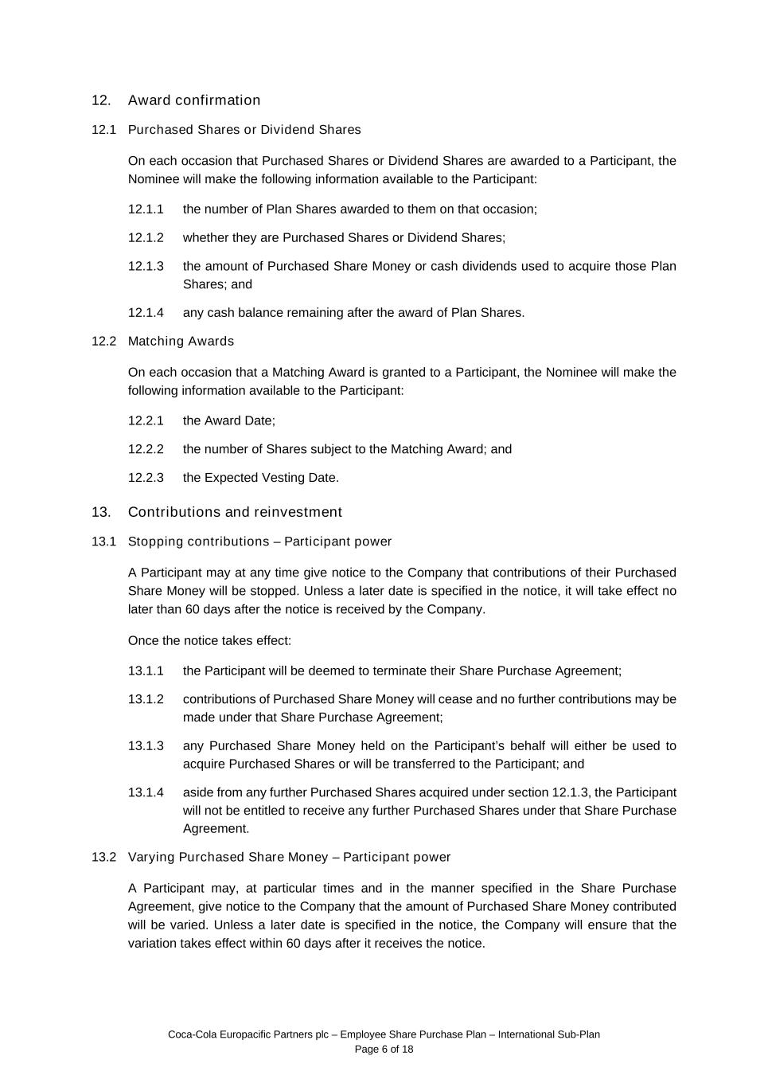
Coca-Cola Europacific Partners plc – Employee Share Purchase Plan – International Sub-Plan Page 6 of 18 12. Award confirmation 12.1 Purchased Shares or Dividend Shares On each occasion that Purchased Shares or Dividend Shares are awarded to a Participant, the Nominee will make the following information available to the Participant: 12.1.1 the number of Plan Shares awarded to them on that occasion; 12.1.2 whether they are Purchased Shares or Dividend Shares; 12.1.3 the amount of Purchased Share Money or cash dividends used to acquire those Plan Shares; and 12.1.4 any cash balance remaining after the award of Plan Shares. 12.2 Matching Awards On each occasion that a Matching Award is granted to a Participant, the Nominee will make the following information available to the Participant: 12.2.1 the Award Date; 12.2.2 the number of Shares subject to the Matching Award; and 12.2.3 the Expected Vesting Date. 13. Contributions and reinvestment 13.1 Stopping contributions – Participant power A Participant may at any time give notice to the Company that contributions of their Purchased Share Money will be stopped. Unless a later date is specified in the notice, it will take effect no later than 60 days after the notice is received by the Company. Once the notice takes effect: 13.1.1 the Participant will be deemed to terminate their Share Purchase Agreement; 13.1.2 contributions of Purchased Share Money will cease and no further contributions may be made under that Share Purchase Agreement; 13.1.3 any Purchased Share Money held on the Participant’s behalf will either be used to acquire Purchased Shares or will be transferred to the Participant; and 13.1.4 aside from any further Purchased Shares acquired under section 12.1.3, the Participant will not be entitled to receive any further Purchased Shares under that Share Purchase Agreement. 13.2 Varying Purchased Share Money – Participant power A Participant may, at particular times and in the manner specified in the Share Purchase Agreement, give notice to the Company that the amount of Purchased Share Money contributed will be varied. Unless a later date is specified in the notice, the Company will ensure that the variation takes effect within 60 days after it receives the notice.

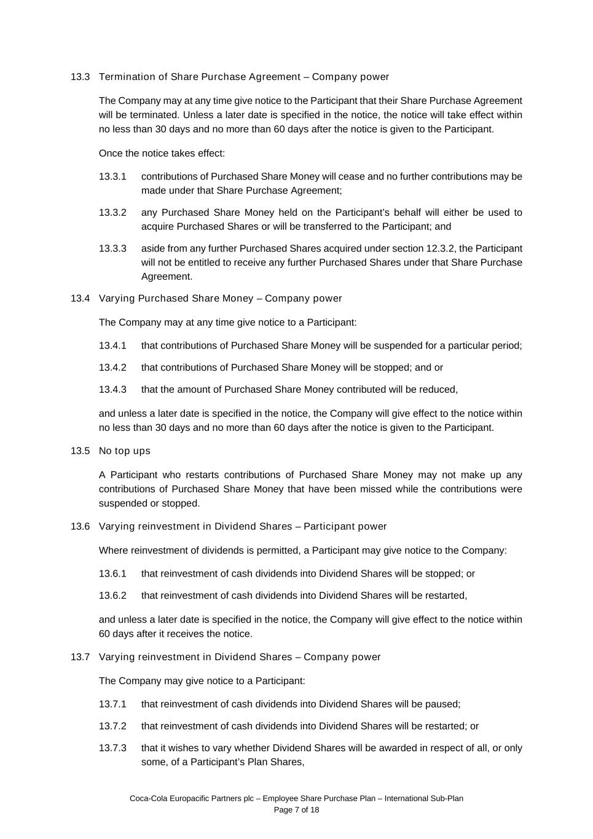
Coca-Cola Europacific Partners plc – Employee Share Purchase Plan – International Sub-Plan Page 7 of 18 13.3 Termination of Share Purchase Agreement – Company power The Company may at any time give notice to the Participant that their Share Purchase Agreement will be terminated. Unless a later date is specified in the notice, the notice will take effect within no less than 30 days and no more than 60 days after the notice is given to the Participant. Once the notice takes effect: 13.3.1 contributions of Purchased Share Money will cease and no further contributions may be made under that Share Purchase Agreement; 13.3.2 any Purchased Share Money held on the Participant’s behalf will either be used to acquire Purchased Shares or will be transferred to the Participant; and 13.3.3 aside from any further Purchased Shares acquired under section 12.3.2, the Participant will not be entitled to receive any further Purchased Shares under that Share Purchase Agreement. 13.4 Varying Purchased Share Money – Company power The Company may at any time give notice to a Participant: 13.4.1 that contributions of Purchased Share Money will be suspended for a particular period; 13.4.2 that contributions of Purchased Share Money will be stopped; and or 13.4.3 that the amount of Purchased Share Money contributed will be reduced, and unless a later date is specified in the notice, the Company will give effect to the notice within no less than 30 days and no more than 60 days after the notice is given to the Participant. 13.5 No top ups A Participant who restarts contributions of Purchased Share Money may not make up any contributions of Purchased Share Money that have been missed while the contributions were suspended or stopped. 13.6 Varying reinvestment in Dividend Shares – Participant power Where reinvestment of dividends is permitted, a Participant may give notice to the Company: 13.6.1 that reinvestment of cash dividends into Dividend Shares will be stopped; or 13.6.2 that reinvestment of cash dividends into Dividend Shares will be restarted, and unless a later date is specified in the notice, the Company will give effect to the notice within 60 days after it receives the notice. 13.7 Varying reinvestment in Dividend Shares – Company power The Company may give notice to a Participant: 13.7.1 that reinvestment of cash dividends into Dividend Shares will be paused; 13.7.2 that reinvestment of cash dividends into Dividend Shares will be restarted; or 13.7.3 that it wishes to vary whether Dividend Shares will be awarded in respect of all, or only some, of a Participant’s Plan Shares,

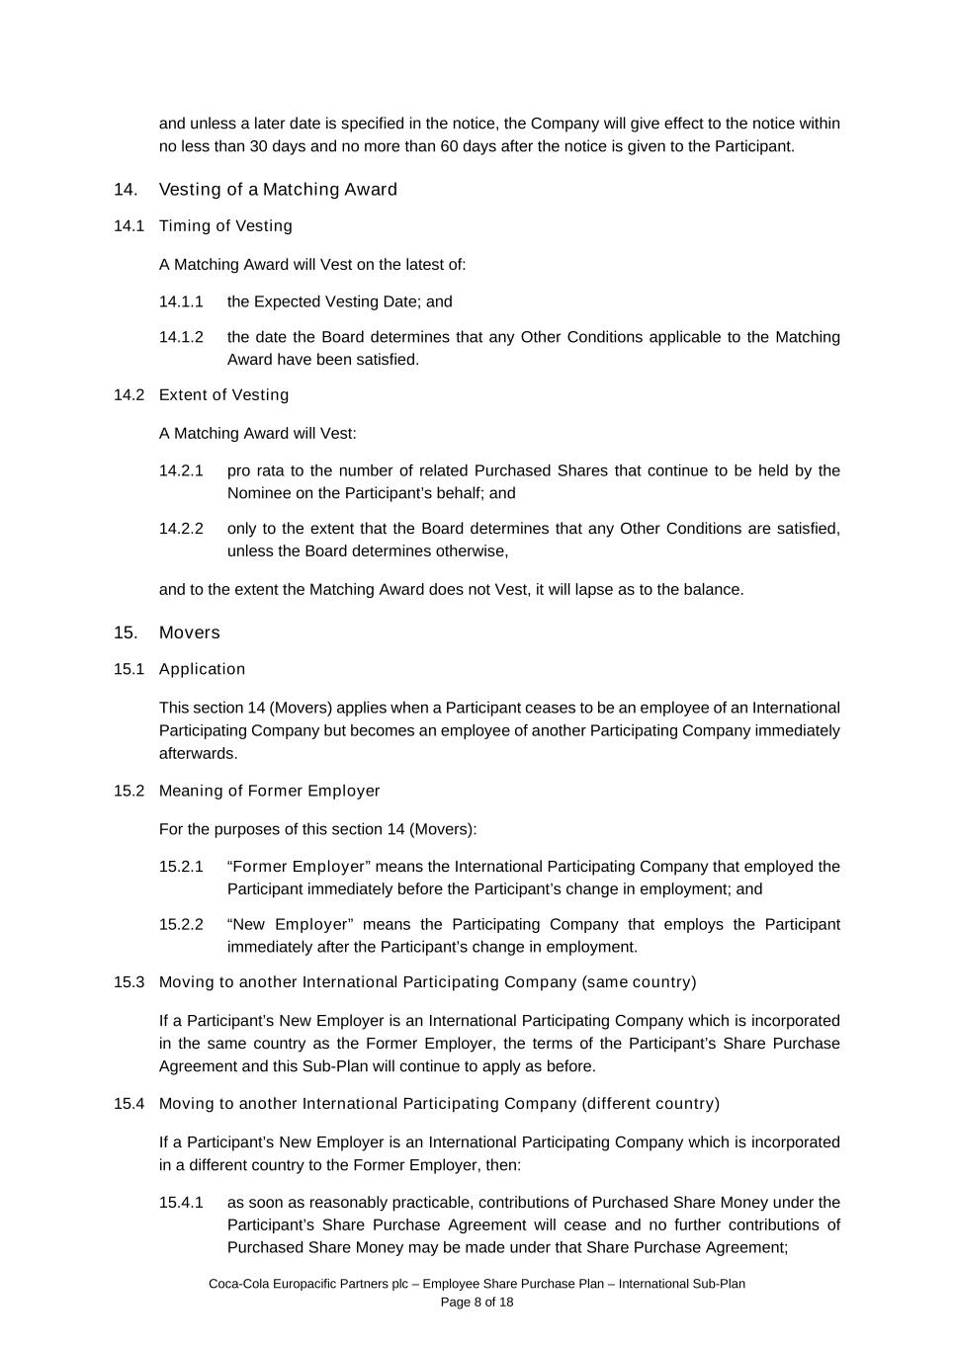
Coca-Cola Europacific Partners plc – Employee Share Purchase Plan – International Sub-Plan Page 8 of 18 and unless a later date is specified in the notice, the Company will give effect to the notice within no less than 30 days and no more than 60 days after the notice is given to the Participant. 14. Vesting of a Matching Award 14.1 Timing of Vesting A Matching Award will Vest on the latest of: 14.1.1 the Expected Vesting Date; and 14.1.2 the date the Board determines that any Other Conditions applicable to the Matching Award have been satisfied. 14.2 Extent of Vesting A Matching Award will Vest: 14.2.1 pro rata to the number of related Purchased Shares that continue to be held by the Nominee on the Participant’s behalf; and 14.2.2 only to the extent that the Board determines that any Other Conditions are satisfied, unless the Board determines otherwise, and to the extent the Matching Award does not Vest, it will lapse as to the balance. 15. Movers 15.1 Application This section 14 (Movers) applies when a Participant ceases to be an employee of an International Participating Company but becomes an employee of another Participating Company immediately afterwards. 15.2 Meaning of Former Employer For the purposes of this section 14 (Movers): 15.2.1 “Former Employer” means the International Participating Company that employed the Participant immediately before the Participant’s change in employment; and 15.2.2 “New Employer” means the Participating Company that employs the Participant immediately after the Participant’s change in employment. 15.3 Moving to another International Participating Company (same country) If a Participant’s New Employer is an International Participating Company which is incorporated in the same country as the Former Employer, the terms of the Participant’s Share Purchase Agreement and this Sub-Plan will continue to apply as before. 15.4 Moving to another International Participating Company (different country) If a Participant’s New Employer is an International Participating Company which is incorporated in a different country to the Former Employer, then: 15.4.1 as soon as reasonably practicable, contributions of Purchased Share Money under the Participant’s Share Purchase Agreement will cease and no further contributions of Purchased Share Money may be made under that Share Purchase Agreement;

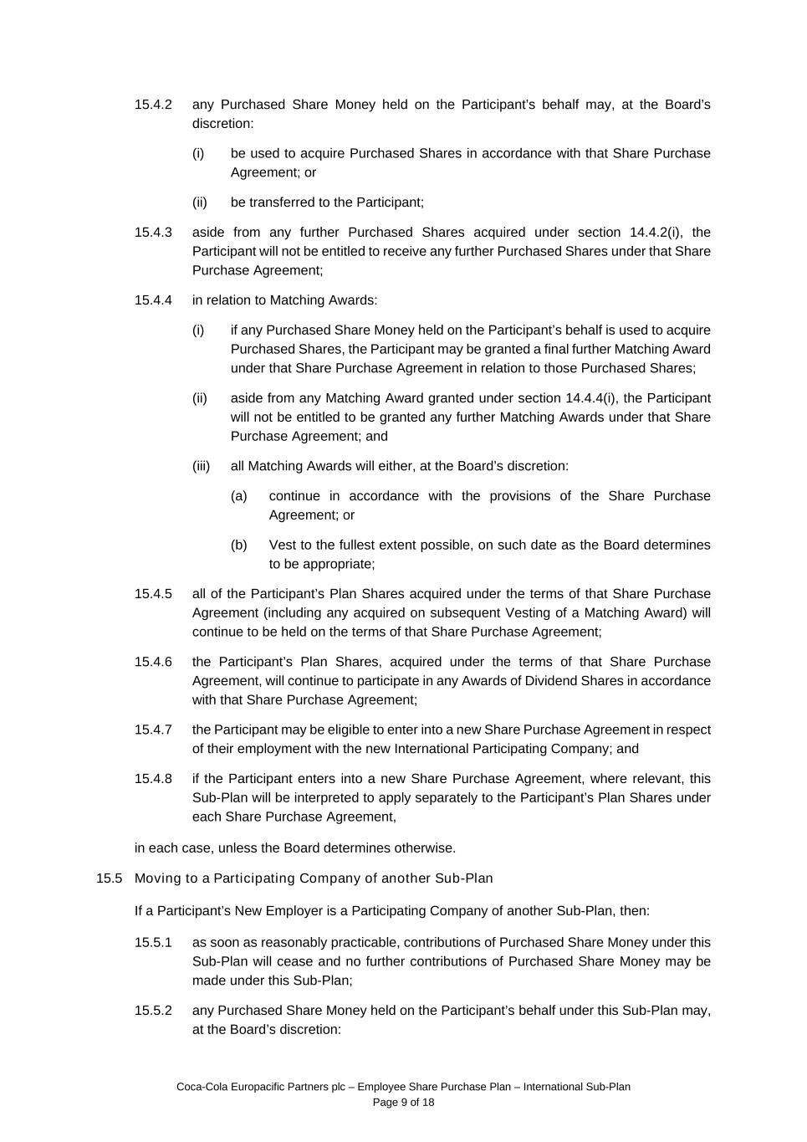
Coca-Cola Europacific Partners plc – Employee Share Purchase Plan – International Sub-Plan Page 9 of 18 15.4.2 any Purchased Share Money held on the Participant’s behalf may, at the Board’s discretion: (i) be used to acquire Purchased Shares in accordance with that Share Purchase Agreement; or (ii) be transferred to the Participant; 15.4.3 aside from any further Purchased Shares acquired under section 14.4.2(i), the Participant will not be entitled to receive any further Purchased Shares under that Share Purchase Agreement; 15.4.4 in relation to Matching Awards: (i) if any Purchased Share Money held on the Participant’s behalf is used to acquire Purchased Shares, the Participant may be granted a final further Matching Award under that Share Purchase Agreement in relation to those Purchased Shares; (ii) aside from any Matching Award granted under section 14.4.4(i), the Participant will not be entitled to be granted any further Matching Awards under that Share Purchase Agreement; and (iii) all Matching Awards will either, at the Board’s discretion: (a) continue in accordance with the provisions of the Share Purchase Agreement; or (b) Vest to the fullest extent possible, on such date as the Board determines to be appropriate; 15.4.5 all of the Participant’s Plan Shares acquired under the terms of that Share Purchase Agreement (including any acquired on subsequent Vesting of a Matching Award) will continue to be held on the terms of that Share Purchase Agreement; 15.4.6 the Participant’s Plan Shares, acquired under the terms of that Share Purchase Agreement, will continue to participate in any Awards of Dividend Shares in accordance with that Share Purchase Agreement; 15.4.7 the Participant may be eligible to enter into a new Share Purchase Agreement in respect of their employment with the new International Participating Company; and 15.4.8 if the Participant enters into a new Share Purchase Agreement, where relevant, this Sub-Plan will be interpreted to apply separately to the Participant’s Plan Shares under each Share Purchase Agreement, in each case, unless the Board determines otherwise. 15.5 Moving to a Participating Company of another Sub-Plan If a Participant’s New Employer is a Participating Company of another Sub-Plan, then: 15.5.1 as soon as reasonably practicable, contributions of Purchased Share Money under this Sub-Plan will cease and no further contributions of Purchased Share Money may be made under this Sub-Plan; 15.5.2 any Purchased Share Money held on the Participant’s behalf under this Sub-Plan may, at the Board’s discretion:

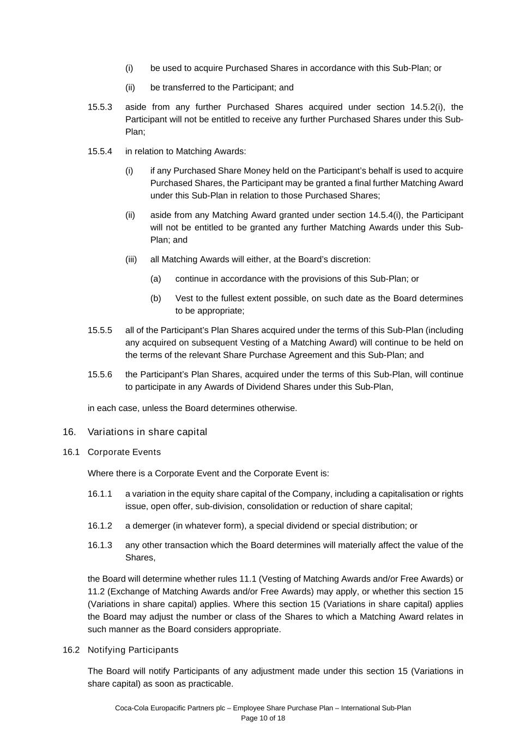
Coca-Cola Europacific Partners plc – Employee Share Purchase Plan – International Sub-Plan Page 10 of 18 (i) be used to acquire Purchased Shares in accordance with this Sub-Plan; or (ii) be transferred to the Participant; and 15.5.3 aside from any further Purchased Shares acquired under section 14.5.2(i), the Participant will not be entitled to receive any further Purchased Shares under this Sub- Plan; 15.5.4 in relation to Matching Awards: (i) if any Purchased Share Money held on the Participant’s behalf is used to acquire Purchased Shares, the Participant may be granted a final further Matching Award under this Sub-Plan in relation to those Purchased Shares; (ii) aside from any Matching Award granted under section 14.5.4(i), the Participant will not be entitled to be granted any further Matching Awards under this Sub- Plan; and (iii) all Matching Awards will either, at the Board’s discretion: (a) continue in accordance with the provisions of this Sub-Plan; or (b) Vest to the fullest extent possible, on such date as the Board determines to be appropriate; 15.5.5 all of the Participant’s Plan Shares acquired under the terms of this Sub-Plan (including any acquired on subsequent Vesting of a Matching Award) will continue to be held on the terms of the relevant Share Purchase Agreement and this Sub-Plan; and 15.5.6 the Participant’s Plan Shares, acquired under the terms of this Sub-Plan, will continue to participate in any Awards of Dividend Shares under this Sub-Plan, in each case, unless the Board determines otherwise. 16. Variations in share capital 16.1 Corporate Events Where there is a Corporate Event and the Corporate Event is: 16.1.1 a variation in the equity share capital of the Company, including a capitalisation or rights issue, open offer, sub-division, consolidation or reduction of share capital; 16.1.2 a demerger (in whatever form), a special dividend or special distribution; or 16.1.3 any other transaction which the Board determines will materially affect the value of the Shares, the Board will determine whether rules 11.1 (Vesting of Matching Awards and/or Free Awards) or 11.2 (Exchange of Matching Awards and/or Free Awards) may apply, or whether this section 15 (Variations in share capital) applies. Where this section 15 (Variations in share capital) applies the Board may adjust the number or class of the Shares to which a Matching Award relates in such manner as the Board considers appropriate. 16.2 Notifying Participants The Board will notify Participants of any adjustment made under this section 15 (Variations in share capital) as soon as practicable.

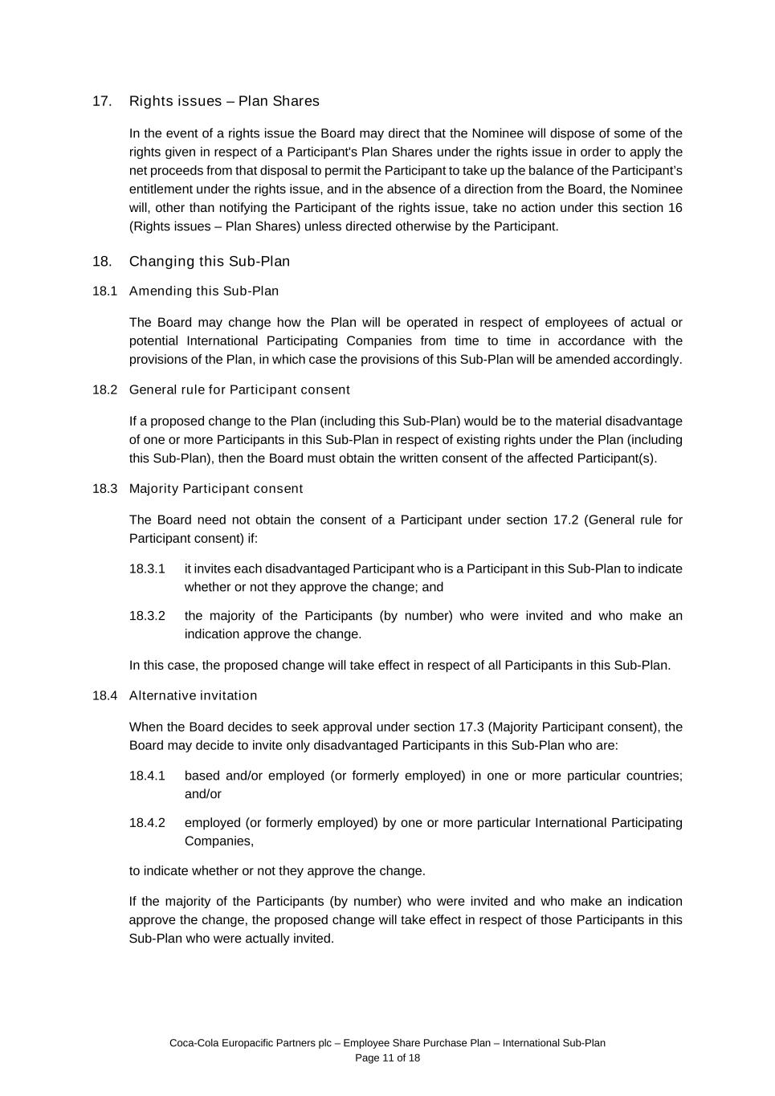
Coca-Cola Europacific Partners plc – Employee Share Purchase Plan – International Sub-Plan Page 11 of 18 17. Rights issues – Plan Shares In the event of a rights issue the Board may direct that the Nominee will dispose of some of the rights given in respect of a Participant's Plan Shares under the rights issue in order to apply the net proceeds from that disposal to permit the Participant to take up the balance of the Participant’s entitlement under the rights issue, and in the absence of a direction from the Board, the Nominee will, other than notifying the Participant of the rights issue, take no action under this section 16 (Rights issues – Plan Shares) unless directed otherwise by the Participant. 18. Changing this Sub-Plan 18.1 Amending this Sub-Plan The Board may change how the Plan will be operated in respect of employees of actual or potential International Participating Companies from time to time in accordance with the provisions of the Plan, in which case the provisions of this Sub-Plan will be amended accordingly. 18.2 General rule for Participant consent If a proposed change to the Plan (including this Sub-Plan) would be to the material disadvantage of one or more Participants in this Sub-Plan in respect of existing rights under the Plan (including this Sub-Plan), then the Board must obtain the written consent of the affected Participant(s). 18.3 Majority Participant consent The Board need not obtain the consent of a Participant under section 17.2 (General rule for Participant consent) if: 18.3.1 it invites each disadvantaged Participant who is a Participant in this Sub-Plan to indicate whether or not they approve the change; and 18.3.2 the majority of the Participants (by number) who were invited and who make an indication approve the change. In this case, the proposed change will take effect in respect of all Participants in this Sub-Plan. 18.4 Alternative invitation When the Board decides to seek approval under section 17.3 (Majority Participant consent), the Board may decide to invite only disadvantaged Participants in this Sub-Plan who are: 18.4.1 based and/or employed (or formerly employed) in one or more particular countries; and/or 18.4.2 employed (or formerly employed) by one or more particular International Participating Companies, to indicate whether or not they approve the change. If the majority of the Participants (by number) who were invited and who make an indication approve the change, the proposed change will take effect in respect of those Participants in this Sub-Plan who were actually invited.

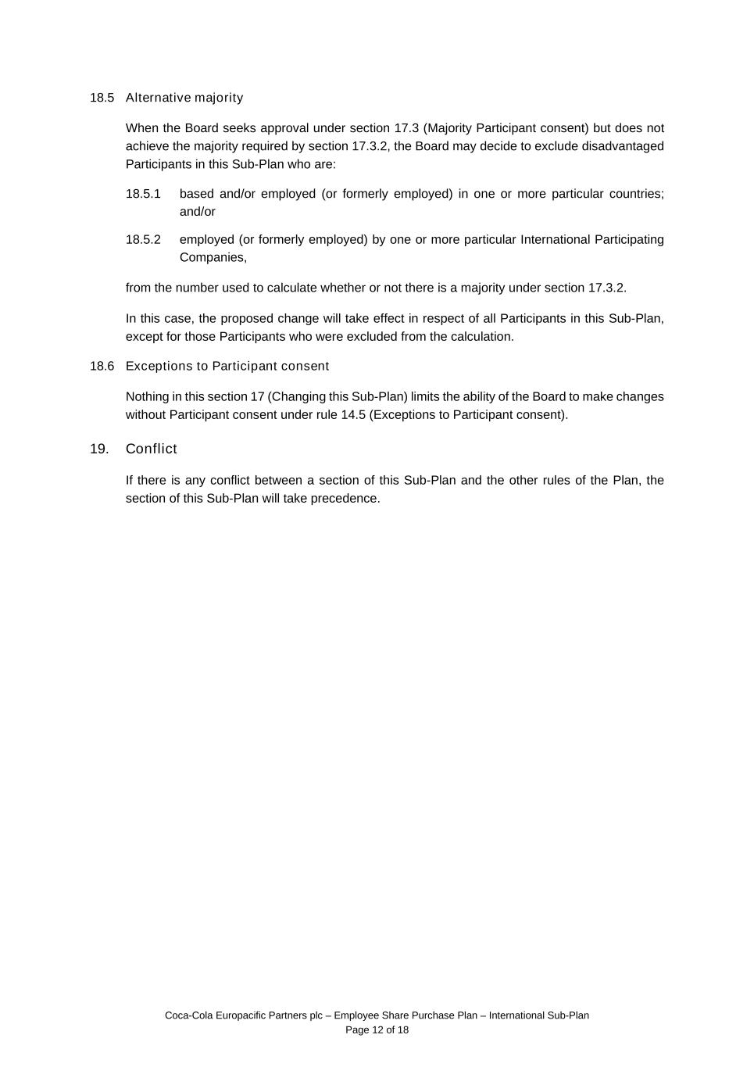
Coca-Cola Europacific Partners plc – Employee Share Purchase Plan – International Sub-Plan Page 12 of 18 18.5 Alternative majority When the Board seeks approval under section 17.3 (Majority Participant consent) but does not achieve the majority required by section 17.3.2, the Board may decide to exclude disadvantaged Participants in this Sub-Plan who are: 18.5.1 based and/or employed (or formerly employed) in one or more particular countries; and/or 18.5.2 employed (or formerly employed) by one or more particular International Participating Companies, from the number used to calculate whether or not there is a majority under section 17.3.2. In this case, the proposed change will take effect in respect of all Participants in this Sub-Plan, except for those Participants who were excluded from the calculation. 18.6 Exceptions to Participant consent Nothing in this section 17 (Changing this Sub-Plan) limits the ability of the Board to make changes without Participant consent under rule 14.5 (Exceptions to Participant consent). 19. Conflict If there is any conflict between a section of this Sub-Plan and the other rules of the Plan, the section of this Sub-Plan will take precedence.

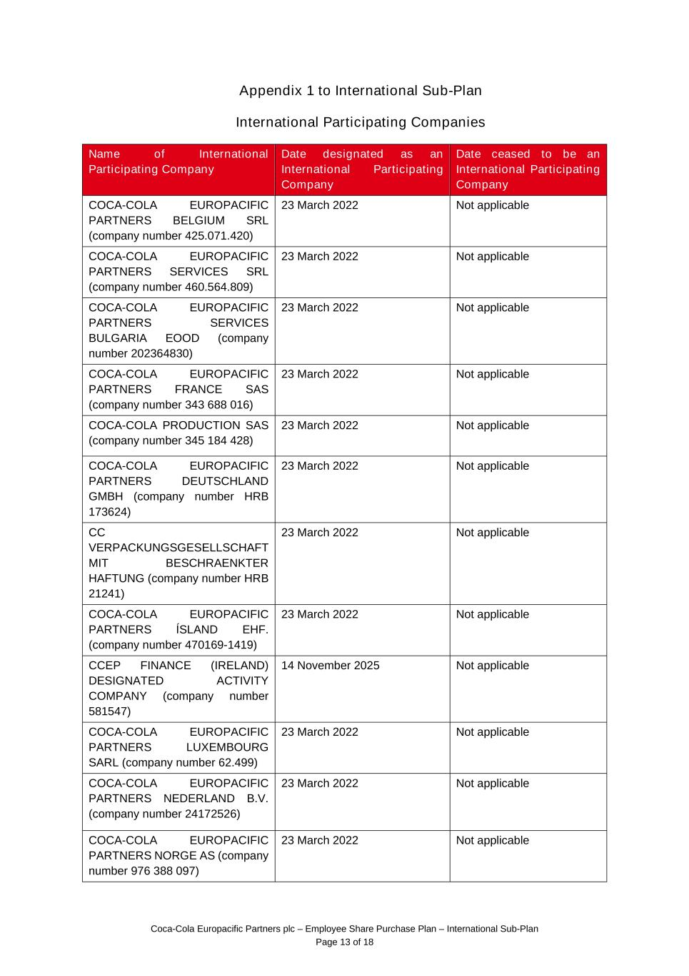
Coca-Cola Europacific Partners plc – Employee Share Purchase Plan – International Sub-Plan Page 13 of 18 Appendix 1 to International Sub-Plan International Participating Companies Name of International Participating Company Date designated as an International Participating Company Date ceased to be an International Participating Company COCA-COLA EUROPACIFIC PARTNERS BELGIUM SRL (company number 425.071.420) 23 March 2022 Not applicable COCA-COLA EUROPACIFIC PARTNERS SERVICES SRL (company number 460.564.809) 23 March 2022 Not applicable COCA-COLA EUROPACIFIC PARTNERS SERVICES BULGARIA EOOD (company number 202364830) 23 March 2022 Not applicable COCA-COLA EUROPACIFIC PARTNERS FRANCE SAS (company number 343 688 016) 23 March 2022 Not applicable COCA-COLA PRODUCTION SAS (company number 345 184 428) 23 March 2022 Not applicable COCA-COLA EUROPACIFIC PARTNERS DEUTSCHLAND GMBH (company number HRB 173624) 23 March 2022 Not applicable CC VERPACKUNGSGESELLSCHAFT MIT BESCHRAENKTER HAFTUNG (company number HRB 21241) 23 March 2022 Not applicable COCA-COLA EUROPACIFIC PARTNERS ÍSLAND EHF. (company number 470169-1419) 23 March 2022 Not applicable CCEP FINANCE (IRELAND) DESIGNATED ACTIVITY COMPANY (company number 581547) 14 November 2025 Not applicable COCA-COLA EUROPACIFIC PARTNERS LUXEMBOURG SARL (company number 62.499) 23 March 2022 Not applicable COCA-COLA EUROPACIFIC PARTNERS NEDERLAND B.V. (company number 24172526) 23 March 2022 Not applicable COCA-COLA EUROPACIFIC PARTNERS NORGE AS (company number 976 388 097) 23 March 2022 Not applicable

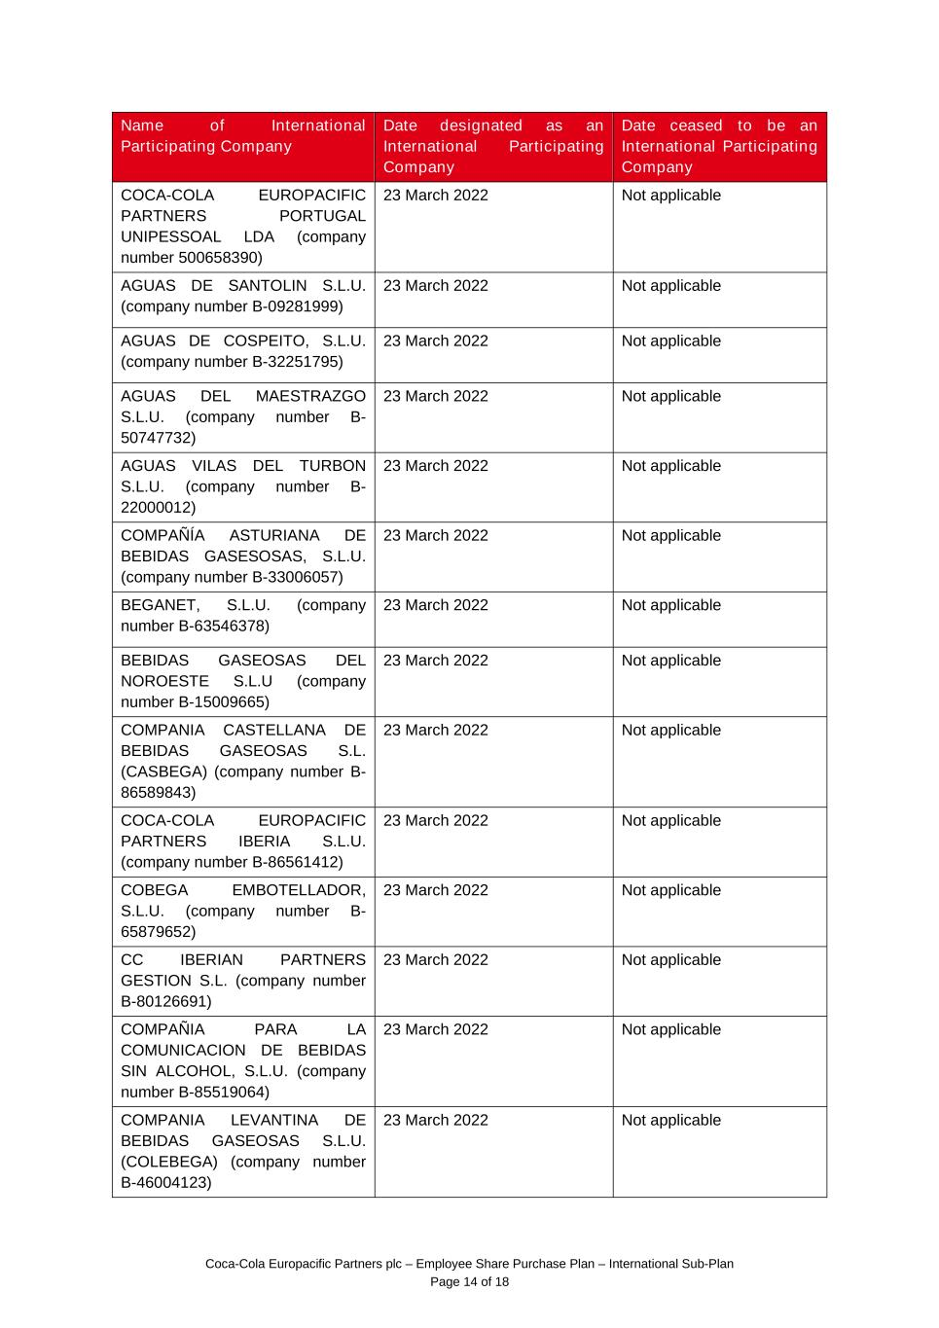
Coca-Cola Europacific Partners plc – Employee Share Purchase Plan – International Sub-Plan Page 14 of 18 Name of International Participating Company Date designated as an International Participating Company Date ceased to be an International Participating Company COCA-COLA EUROPACIFIC PARTNERS PORTUGAL UNIPESSOAL LDA (company number 500658390) 23 March 2022 Not applicable AGUAS DE SANTOLIN S.L.U. (company number B-09281999) 23 March 2022 Not applicable AGUAS DE COSPEITO, S.L.U. (company number B-32251795) 23 March 2022 Not applicable AGUAS DEL MAESTRAZGO S.L.U. (company number B- 50747732) 23 March 2022 Not applicable AGUAS VILAS DEL TURBON S.L.U. (company number B- 22000012) 23 March 2022 Not applicable COMPAÑÍA ASTURIANA DE BEBIDAS GASESOSAS, S.L.U. (company number B-33006057) 23 March 2022 Not applicable BEGANET, S.L.U. (company number B-63546378) 23 March 2022 Not applicable BEBIDAS GASEOSAS DEL NOROESTE S.L.U (company number B-15009665) 23 March 2022 Not applicable COMPANIA CASTELLANA DE BEBIDAS GASEOSAS S.L. (CASBEGA) (company number B- 86589843) 23 March 2022 Not applicable COCA-COLA EUROPACIFIC PARTNERS IBERIA S.L.U. (company number B-86561412) 23 March 2022 Not applicable COBEGA EMBOTELLADOR, S.L.U. (company number B- 65879652) 23 March 2022 Not applicable CC IBERIAN PARTNERS GESTION S.L. (company number B-80126691) 23 March 2022 Not applicable COMPAÑIA PARA LA COMUNICACION DE BEBIDAS SIN ALCOHOL, S.L.U. (company number B-85519064) 23 March 2022 Not applicable COMPANIA LEVANTINA DE BEBIDAS GASEOSAS S.L.U. (COLEBEGA) (company number B-46004123) 23 March 2022 Not applicable

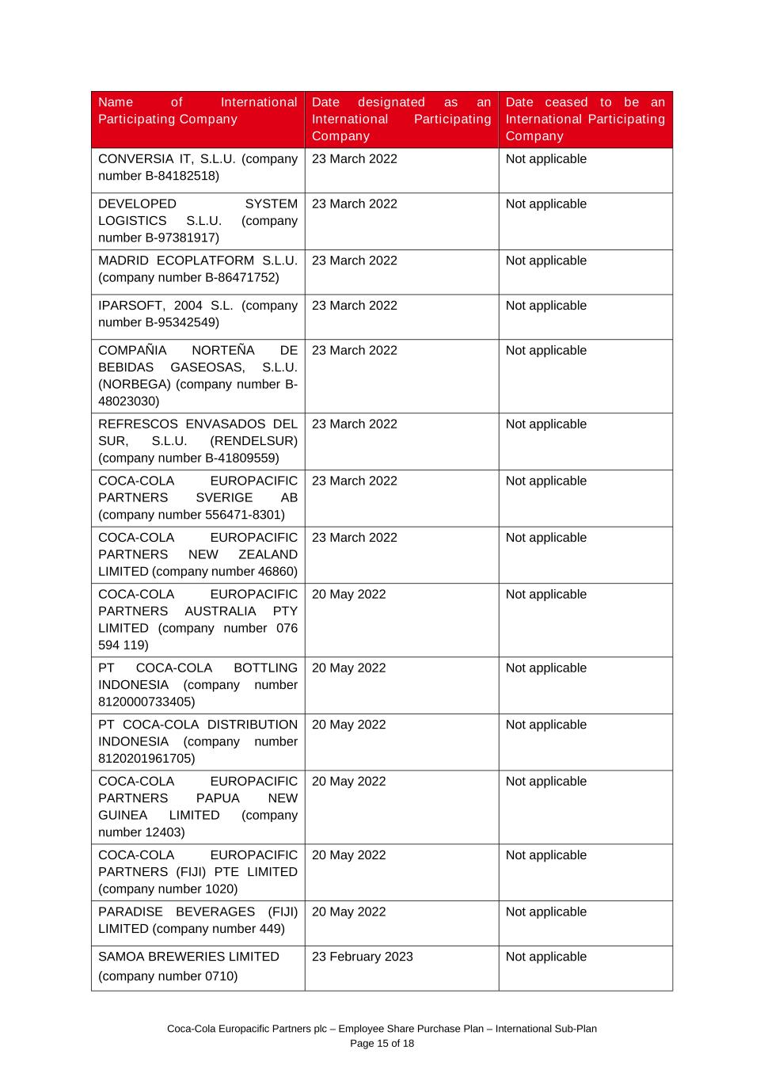
Coca-Cola Europacific Partners plc – Employee Share Purchase Plan – International Sub-Plan Page 15 of 18 Name of International Participating Company Date designated as an International Participating Company Date ceased to be an International Participating Company CONVERSIA IT, S.L.U. (company number B-84182518) 23 March 2022 Not applicable DEVELOPED SYSTEM LOGISTICS S.L.U. (company number B-97381917) 23 March 2022 Not applicable MADRID ECOPLATFORM S.L.U. (company number B-86471752) 23 March 2022 Not applicable IPARSOFT, 2004 S.L. (company number B-95342549) 23 March 2022 Not applicable COMPAÑIA NORTEÑA DE BEBIDAS GASEOSAS, S.L.U. (NORBEGA) (company number B- 48023030) 23 March 2022 Not applicable REFRESCOS ENVASADOS DEL SUR, S.L.U. (RENDELSUR) (company number B-41809559) 23 March 2022 Not applicable COCA-COLA EUROPACIFIC PARTNERS SVERIGE AB (company number 556471-8301) 23 March 2022 Not applicable COCA-COLA EUROPACIFIC PARTNERS NEW ZEALAND LIMITED (company number 46860) 23 March 2022 Not applicable COCA-COLA EUROPACIFIC PARTNERS AUSTRALIA PTY LIMITED (company number 076 594 119) 20 May 2022 Not applicable PT COCA-COLA BOTTLING INDONESIA (company number 8120000733405) 20 May 2022 Not applicable PT COCA-COLA DISTRIBUTION INDONESIA (company number 8120201961705) 20 May 2022 Not applicable COCA-COLA EUROPACIFIC PARTNERS PAPUA NEW GUINEA LIMITED (company number 12403) 20 May 2022 Not applicable COCA-COLA EUROPACIFIC PARTNERS (FIJI) PTE LIMITED (company number 1020) 20 May 2022 Not applicable PARADISE BEVERAGES (FIJI) LIMITED (company number 449) 20 May 2022 Not applicable SAMOA BREWERIES LIMITED (company number 0710) 23 February 2023 Not applicable

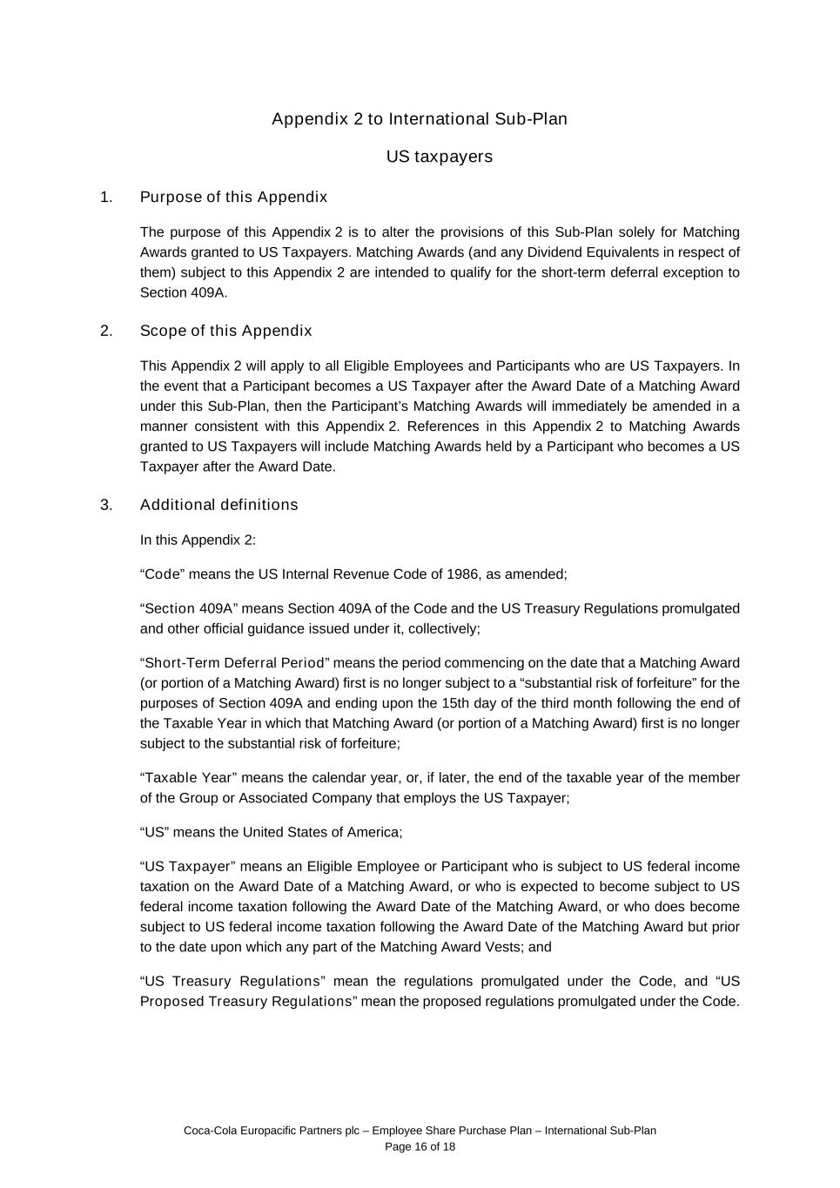
Coca-Cola Europacific Partners plc – Employee Share Purchase Plan – International Sub-Plan Page 16 of 18 Appendix 2 to International Sub-Plan US taxpayers 1. Purpose of this Appendix The purpose of this Appendix 2 is to alter the provisions of this Sub-Plan solely for Matching Awards granted to US Taxpayers. Matching Awards (and any Dividend Equivalents in respect of them) subject to this Appendix 2 are intended to qualify for the short-term deferral exception to Section 409A. 2. Scope of this Appendix This Appendix 2 will apply to all Eligible Employees and Participants who are US Taxpayers. In the event that a Participant becomes a US Taxpayer after the Award Date of a Matching Award under this Sub-Plan, then the Participant’s Matching Awards will immediately be amended in a manner consistent with this Appendix 2. References in this Appendix 2 to Matching Awards granted to US Taxpayers will include Matching Awards held by a Participant who becomes a US Taxpayer after the Award Date. 3. Additional definitions In this Appendix 2: “Code” means the US Internal Revenue Code of 1986, as amended; “Section 409A” means Section 409A of the Code and the US Treasury Regulations promulgated and other official guidance issued under it, collectively; “Short-Term Deferral Period” means the period commencing on the date that a Matching Award (or portion of a Matching Award) first is no longer subject to a “substantial risk of forfeiture” for the purposes of Section 409A and ending upon the 15th day of the third month following the end of the Taxable Year in which that Matching Award (or portion of a Matching Award) first is no longer subject to the substantial risk of forfeiture; “Taxable Year” means the calendar year, or, if later, the end of the taxable year of the member of the Group or Associated Company that employs the US Taxpayer; “US” means the United States of America; “US Taxpayer” means an Eligible Employee or Participant who is subject to US federal income taxation on the Award Date of a Matching Award, or who is expected to become subject to US federal income taxation following the Award Date of the Matching Award, or who does become subject to US federal income taxation following the Award Date of the Matching Award but prior to the date upon which any part of the Matching Award Vests; and “US Treasury Regulations” mean the regulations promulgated under the Code, and “US Proposed Treasury Regulations” mean the proposed regulations promulgated under the Code.

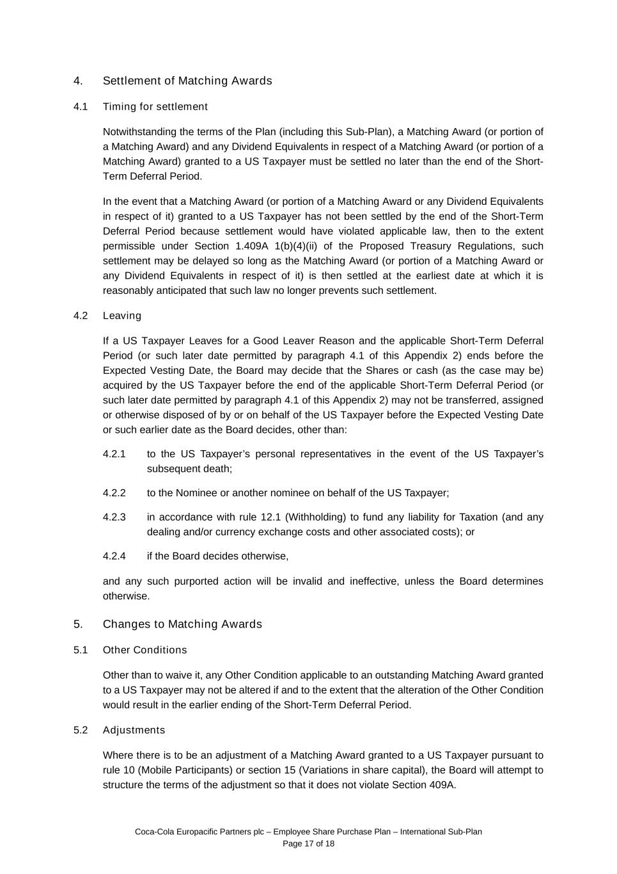
Coca-Cola Europacific Partners plc – Employee Share Purchase Plan – International Sub-Plan Page 17 of 18 4. Settlement of Matching Awards 4.1 Timing for settlement Notwithstanding the terms of the Plan (including this Sub-Plan), a Matching Award (or portion of a Matching Award) and any Dividend Equivalents in respect of a Matching Award (or portion of a Matching Award) granted to a US Taxpayer must be settled no later than the end of the Short- Term Deferral Period. In the event that a Matching Award (or portion of a Matching Award or any Dividend Equivalents in respect of it) granted to a US Taxpayer has not been settled by the end of the Short-Term Deferral Period because settlement would have violated applicable law, then to the extent permissible under Section 1.409A 1(b)(4)(ii) of the Proposed Treasury Regulations, such settlement may be delayed so long as the Matching Award (or portion of a Matching Award or any Dividend Equivalents in respect of it) is then settled at the earliest date at which it is reasonably anticipated that such law no longer prevents such settlement. 4.2 Leaving If a US Taxpayer Leaves for a Good Leaver Reason and the applicable Short-Term Deferral Period (or such later date permitted by paragraph 4.1 of this Appendix 2) ends before the Expected Vesting Date, the Board may decide that the Shares or cash (as the case may be) acquired by the US Taxpayer before the end of the applicable Short-Term Deferral Period (or such later date permitted by paragraph 4.1 of this Appendix 2) may not be transferred, assigned or otherwise disposed of by or on behalf of the US Taxpayer before the Expected Vesting Date or such earlier date as the Board decides, other than: 4.2.1 to the US Taxpayer’s personal representatives in the event of the US Taxpayer’s subsequent death; 4.2.2 to the Nominee or another nominee on behalf of the US Taxpayer; 4.2.3 in accordance with rule 12.1 (Withholding) to fund any liability for Taxation (and any dealing and/or currency exchange costs and other associated costs); or 4.2.4 if the Board decides otherwise, and any such purported action will be invalid and ineffective, unless the Board determines otherwise. 5. Changes to Matching Awards 5.1 Other Conditions Other than to waive it, any Other Condition applicable to an outstanding Matching Award granted to a US Taxpayer may not be altered if and to the extent that the alteration of the Other Condition would result in the earlier ending of the Short-Term Deferral Period. 5.2 Adjustments Where there is to be an adjustment of a Matching Award granted to a US Taxpayer pursuant to rule 10 (Mobile Participants) or section 15 (Variations in share capital), the Board will attempt to structure the terms of the adjustment so that it does not violate Section 409A.

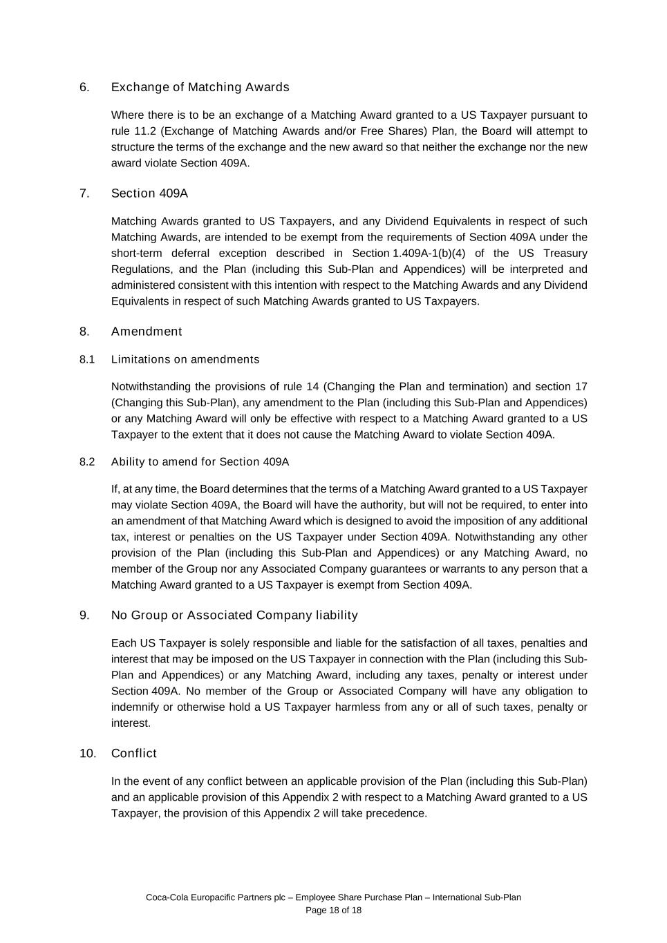
Coca-Cola Europacific Partners plc – Employee Share Purchase Plan – International Sub-Plan Page 18 of 18 6. Exchange of Matching Awards Where there is to be an exchange of a Matching Award granted to a US Taxpayer pursuant to rule 11.2 (Exchange of Matching Awards and/or Free Shares) Plan, the Board will attempt to structure the terms of the exchange and the new award so that neither the exchange nor the new award violate Section 409A. 7. Section 409A Matching Awards granted to US Taxpayers, and any Dividend Equivalents in respect of such Matching Awards, are intended to be exempt from the requirements of Section 409A under the short-term deferral exception described in Section 1.409A-1(b)(4) of the US Treasury Regulations, and the Plan (including this Sub-Plan and Appendices) will be interpreted and administered consistent with this intention with respect to the Matching Awards and any Dividend Equivalents in respect of such Matching Awards granted to US Taxpayers. 8. Amendment 8.1 Limitations on amendments Notwithstanding the provisions of rule 14 (Changing the Plan and termination) and section 17 (Changing this Sub-Plan), any amendment to the Plan (including this Sub-Plan and Appendices) or any Matching Award will only be effective with respect to a Matching Award granted to a US Taxpayer to the extent that it does not cause the Matching Award to violate Section 409A. 8.2 Ability to amend for Section 409A If, at any time, the Board determines that the terms of a Matching Award granted to a US Taxpayer may violate Section 409A, the Board will have the authority, but will not be required, to enter into an amendment of that Matching Award which is designed to avoid the imposition of any additional tax, interest or penalties on the US Taxpayer under Section 409A. Notwithstanding any other provision of the Plan (including this Sub-Plan and Appendices) or any Matching Award, no member of the Group nor any Associated Company guarantees or warrants to any person that a Matching Award granted to a US Taxpayer is exempt from Section 409A. 9. No Group or Associated Company liability Each US Taxpayer is solely responsible and liable for the satisfaction of all taxes, penalties and interest that may be imposed on the US Taxpayer in connection with the Plan (including this Sub- Plan and Appendices) or any Matching Award, including any taxes, penalty or interest under Section 409A. No member of the Group or Associated Company will have any obligation to indemnify or otherwise hold a US Taxpayer harmless from any or all of such taxes, penalty or interest. 10. Conflict In the event of any conflict between an applicable provision of the Plan (including this Sub-Plan) and an applicable provision of this Appendix 2 with respect to a Matching Award granted to a US Taxpayer, the provision of this Appendix 2 will take precedence.

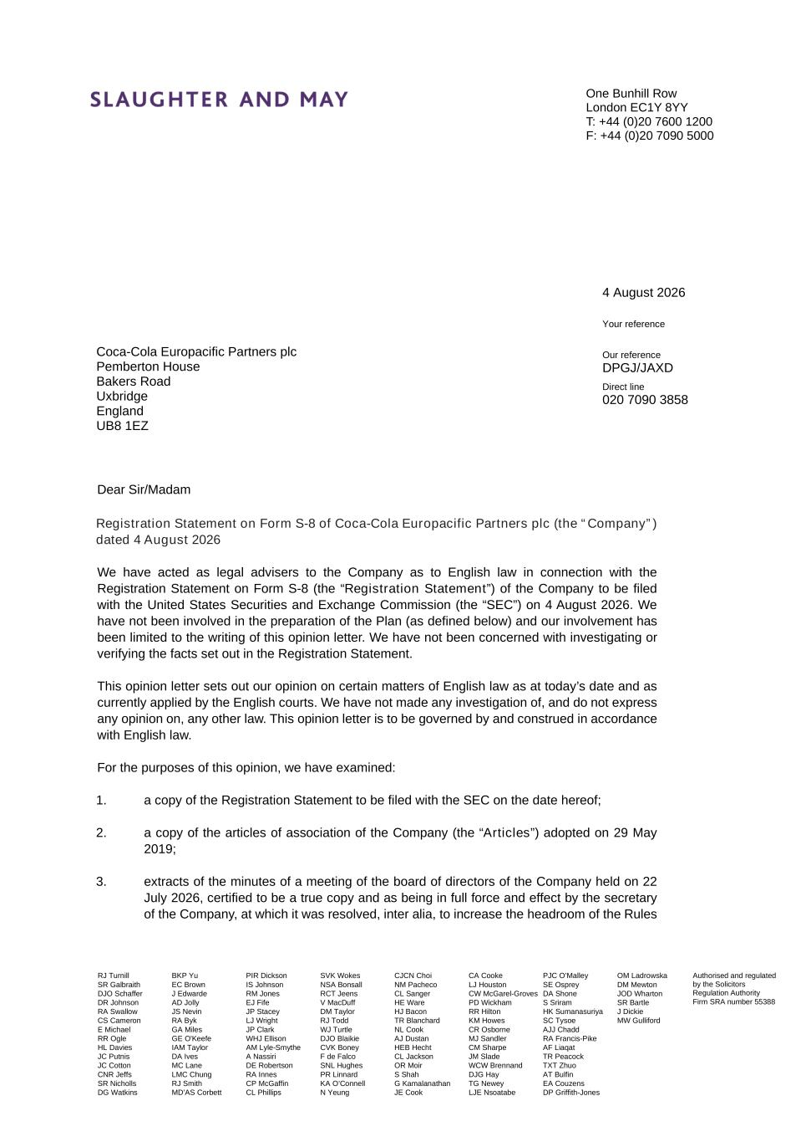
One Bunhill Row London EC1Y 8YY T: +44 (0)20 7600 1200 F: +44 (0)20 7090 5000 RJ Turnill SR Galbraith DJO Schaffer DR Johnson RA Swallow CS Cameron E Michael RR Ogle HL Davies JC Putnis JC Cotton CNR Jeffs SR Nicholls DG Watkins BKP Yu EC Brown J Edwarde AD Jolly JS Nevin RA Byk GA Miles GE O'Keefe IAM Taylor DA Ives MC Lane LMC Chung RJ Smith MD’AS Corbett PIR Dickson IS Johnson RM Jones EJ Fife JP Stacey LJ Wright JP Clark WHJ Ellison AM Lyle-Smythe A Nassiri DE Robertson RA Innes CP McGaffin CL Phillips SVK Wokes NSA Bonsall RCT Jeens V MacDuff DM Taylor RJ Todd WJ Turtle DJO Blaikie CVK Boney F de Falco SNL Hughes PR Linnard KA O’Connell N Yeung CJCN Choi NM Pacheco CL Sanger HE Ware HJ Bacon TR Blanchard NL Cook AJ Dustan HEB Hecht CL Jackson OR Moir S Shah G Kamalanathan JE Cook CA Cooke LJ Houston CW McGarel-Groves PD Wickham RR Hilton KM Howes CR Osborne MJ Sandler CM Sharpe JM Slade WCW Brennand DJG Hay TG Newey LJE Nsoatabe PJC O’Malley SE Osprey DA Shone S Sriram HK Sumanasuriya SC Tysoe AJJ Chadd RA Francis-Pike AF Liaqat TR Peacock TXT Zhuo AT Bulfin EA Couzens DP Griffith-Jones OM Ladrowska DM Mewton JOD Wharton SR Bartle J Dickie MW Gulliford Authorised and regulated by the Solicitors Regulation Authority Firm SRA number 55388 4 August 2026 Your reference Coca-Cola Europacific Partners plc Pemberton House Bakers Road Uxbridge England UB8 1EZ Our reference DPGJ/JAXD Direct line 020 7090 3858 Dear Sir/Madam Registration Statement on Form S-8 of Coca-Cola Europacific Partners plc (the “Company”) dated 4 August 2026 We have acted as legal advisers to the Company as to English law in connection with the Registration Statement on Form S-8 (the “Registration Statement”) of the Company to be filed with the United States Securities and Exchange Commission (the “SEC”) on 4 August 2026. We have not been involved in the preparation of the Plan (as defined below) and our involvement has been limited to the writing of this opinion letter. We have not been concerned with investigating or verifying the facts set out in the Registration Statement. This opinion letter sets out our opinion on certain matters of English law as at today’s date and as currently applied by the English courts. We have not made any investigation of, and do not express any opinion on, any other law. This opinion letter is to be governed by and construed in accordance with English law. For the purposes of this opinion, we have examined: 1. a copy of the Registration Statement to be filed with the SEC on the date hereof; 2. a copy of the articles of association of the Company (the “Articles”) adopted on 29 May 2019; 3. extracts of the minutes of a meeting of the board of directors of the Company held on 22 July 2026, certified to be a true copy and as being in full force and effect by the secretary of the Company, at which it was resolved, inter alia, to increase the headroom of the Rules

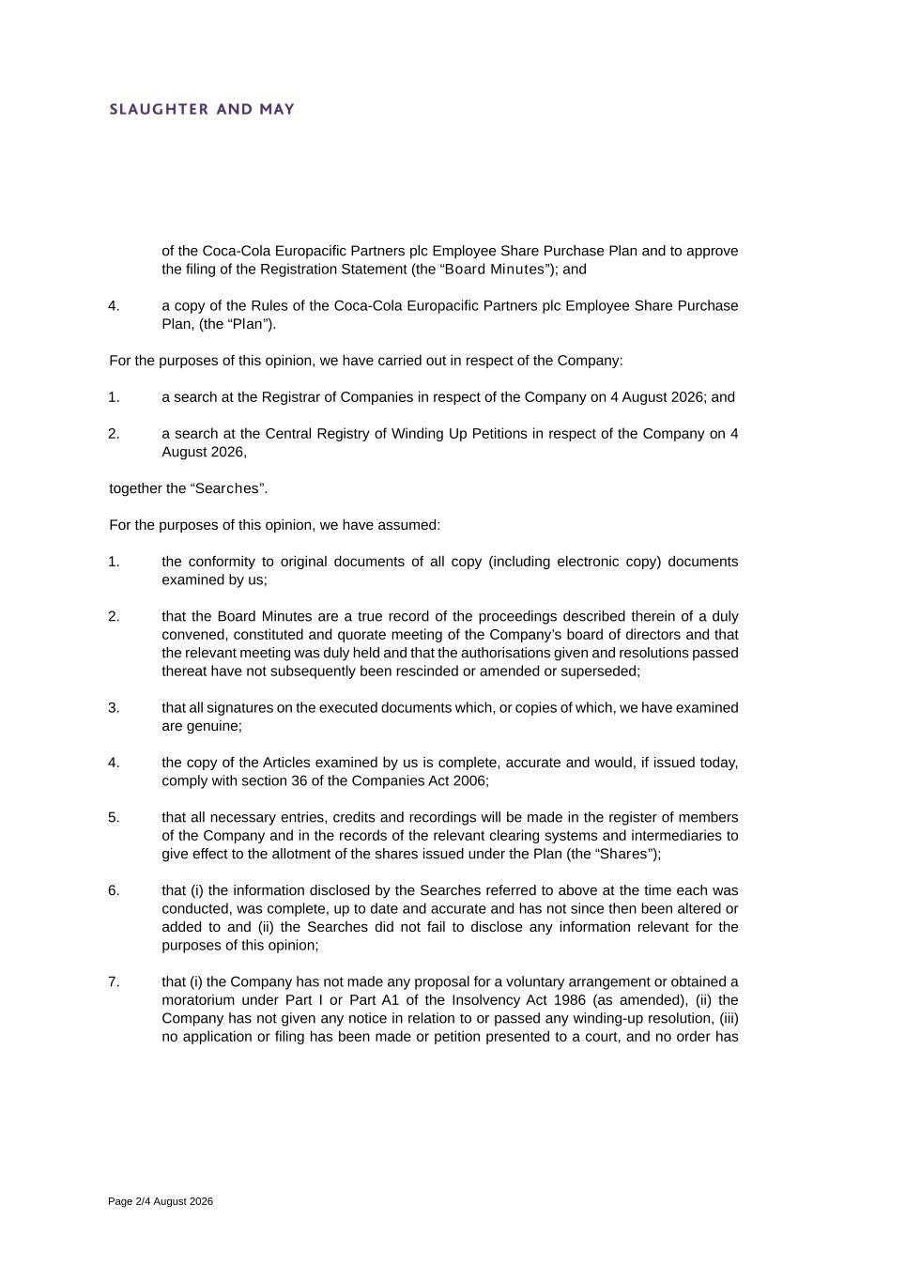
Page 2/4 August 2026 of the Coca-Cola Europacific Partners plc Employee Share Purchase Plan and to approve the filing of the Registration Statement (the “Board Minutes”); and 4. a copy of the Rules of the Coca-Cola Europacific Partners plc Employee Share Purchase Plan, (the “Plan”). For the purposes of this opinion, we have carried out in respect of the Company: 1. a search at the Registrar of Companies in respect of the Company on 4 August 2026; and 2. a search at the Central Registry of Winding Up Petitions in respect of the Company on 4 August 2026, together the “Searches”. For the purposes of this opinion, we have assumed: 1. the conformity to original documents of all copy (including electronic copy) documents examined by us; 2. that the Board Minutes are a true record of the proceedings described therein of a duly convened, constituted and quorate meeting of the Company’s board of directors and that the relevant meeting was duly held and that the authorisations given and resolutions passed thereat have not subsequently been rescinded or amended or superseded; 3. that all signatures on the executed documents which, or copies of which, we have examined are genuine; 4. the copy of the Articles examined by us is complete, accurate and would, if issued today, comply with section 36 of the Companies Act 2006; 5. that all necessary entries, credits and recordings will be made in the register of members of the Company and in the records of the relevant clearing systems and intermediaries to give effect to the allotment of the shares issued under the Plan (the “Shares”); 6. that (i) the information disclosed by the Searches referred to above at the time each was conducted, was complete, up to date and accurate and has not since then been altered or added to and (ii) the Searches did not fail to disclose any information relevant for the purposes of this opinion; 7. that (i) the Company has not made any proposal for a voluntary arrangement or obtained a moratorium under Part I or Part A1 of the Insolvency Act 1986 (as amended), (ii) the Company has not given any notice in relation to or passed any winding-up resolution, (iii) no application or filing has been made or petition presented to a court, and no order has

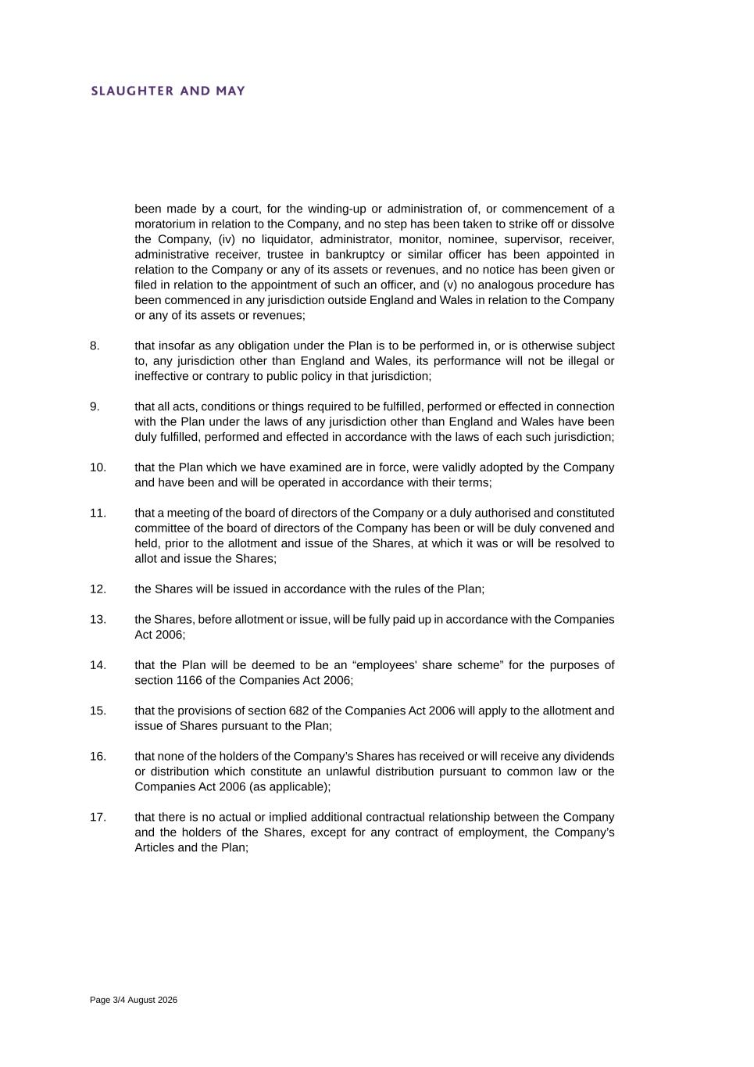
Page 3/4 August 2026 been made by a court, for the winding-up or administration of, or commencement of a moratorium in relation to the Company, and no step has been taken to strike off or dissolve the Company, (iv) no liquidator, administrator, monitor, nominee, supervisor, receiver, administrative receiver, trustee in bankruptcy or similar officer has been appointed in relation to the Company or any of its assets or revenues, and no notice has been given or filed in relation to the appointment of such an officer, and (v) no analogous procedure has been commenced in any jurisdiction outside England and Wales in relation to the Company or any of its assets or revenues; 8. that insofar as any obligation under the Plan is to be performed in, or is otherwise subject to, any jurisdiction other than England and Wales, its performance will not be illegal or ineffective or contrary to public policy in that jurisdiction; 9. that all acts, conditions or things required to be fulfilled, performed or effected in connection with the Plan under the laws of any jurisdiction other than England and Wales have been duly fulfilled, performed and effected in accordance with the laws of each such jurisdiction; 10. that the Plan which we have examined are in force, were validly adopted by the Company and have been and will be operated in accordance with their terms; 11. that a meeting of the board of directors of the Company or a duly authorised and constituted committee of the board of directors of the Company has been or will be duly convened and held, prior to the allotment and issue of the Shares, at which it was or will be resolved to allot and issue the Shares; 12. the Shares will be issued in accordance with the rules of the Plan; 13. the Shares, before allotment or issue, will be fully paid up in accordance with the Companies Act 2006; 14. that the Plan will be deemed to be an “employees' share scheme” for the purposes of section 1166 of the Companies Act 2006; 15. that the provisions of section 682 of the Companies Act 2006 will apply to the allotment and issue of Shares pursuant to the Plan; 16. that none of the holders of the Company’s Shares has received or will receive any dividends or distribution which constitute an unlawful distribution pursuant to common law or the Companies Act 2006 (as applicable); 17. that there is no actual or implied additional contractual relationship between the Company and the holders of the Shares, except for any contract of employment, the Company’s Articles and the Plan;

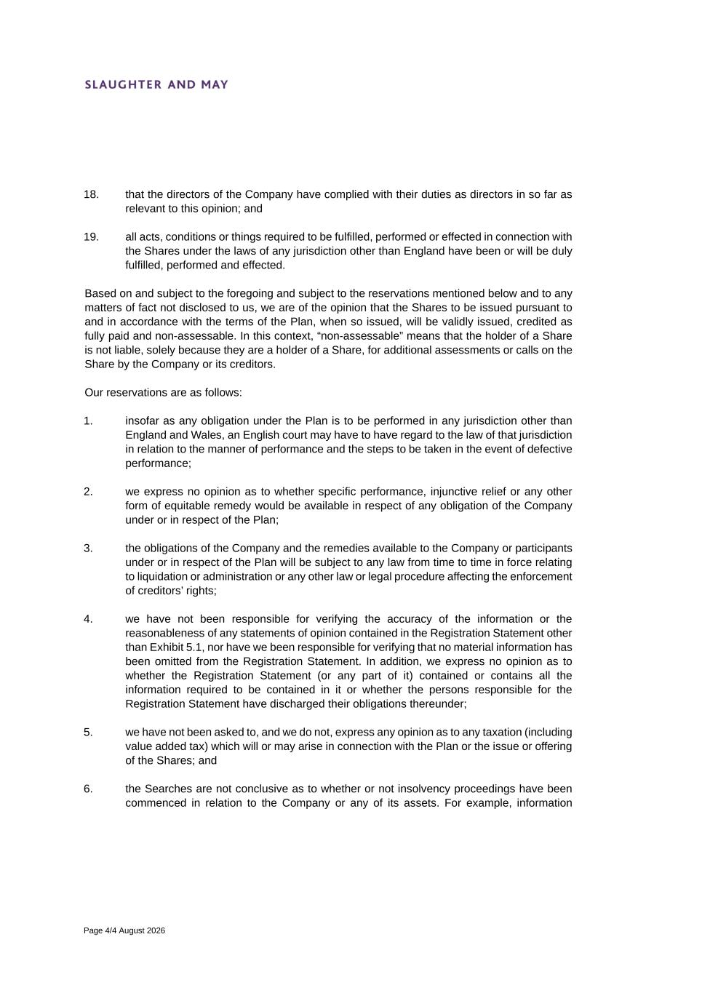
Page 4/4 August 2026 18. that the directors of the Company have complied with their duties as directors in so far as relevant to this opinion; and 19. all acts, conditions or things required to be fulfilled, performed or effected in connection with the Shares under the laws of any jurisdiction other than England have been or will be duly fulfilled, performed and effected. Based on and subject to the foregoing and subject to the reservations mentioned below and to any matters of fact not disclosed to us, we are of the opinion that the Shares to be issued pursuant to and in accordance with the terms of the Plan, when so issued, will be validly issued, credited as fully paid and non-assessable. In this context, “non-assessable” means that the holder of a Share is not liable, solely because they are a holder of a Share, for additional assessments or calls on the Share by the Company or its creditors. Our reservations are as follows: 1. insofar as any obligation under the Plan is to be performed in any jurisdiction other than England and Wales, an English court may have to have regard to the law of that jurisdiction in relation to the manner of performance and the steps to be taken in the event of defective performance; 2. we express no opinion as to whether specific performance, injunctive relief or any other form of equitable remedy would be available in respect of any obligation of the Company under or in respect of the Plan; 3. the obligations of the Company and the remedies available to the Company or participants under or in respect of the Plan will be subject to any law from time to time in force relating to liquidation or administration or any other law or legal procedure affecting the enforcement of creditors’ rights; 4. we have not been responsible for verifying the accuracy of the information or the reasonableness of any statements of opinion contained in the Registration Statement other than Exhibit 5.1, nor have we been responsible for verifying that no material information has been omitted from the Registration Statement. In addition, we express no opinion as to whether the Registration Statement (or any part of it) contained or contains all the information required to be contained in it or whether the persons responsible for the Registration Statement have discharged their obligations thereunder; 5. we have not been asked to, and we do not, express any opinion as to any taxation (including value added tax) which will or may arise in connection with the Plan or the issue or offering of the Shares; and 6. the Searches are not conclusive as to whether or not insolvency proceedings have been commenced in relation to the Company or any of its assets. For example, information

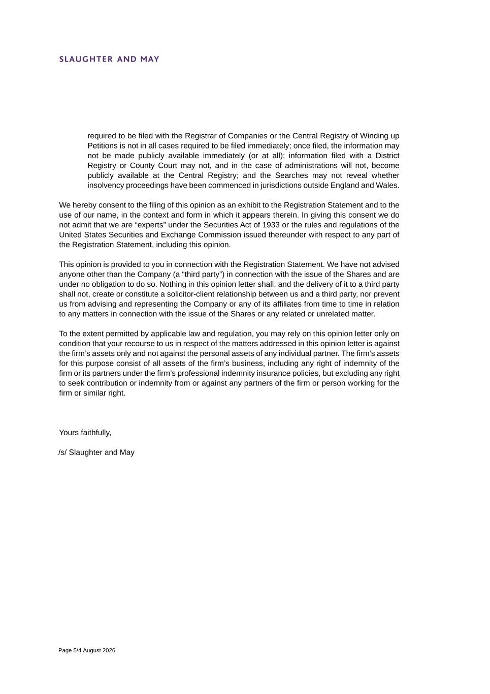
Page 5/4 August 2026 required to be filed with the Registrar of Companies or the Central Registry of Winding up Petitions is not in all cases required to be filed immediately; once filed, the information may not be made publicly available immediately (or at all); information filed with a District Registry or County Court may not, and in the case of administrations will not, become publicly available at the Central Registry; and the Searches may not reveal whether insolvency proceedings have been commenced in jurisdictions outside England and Wales. We hereby consent to the filing of this opinion as an exhibit to the Registration Statement and to the use of our name, in the context and form in which it appears therein. In giving this consent we do not admit that we are “experts” under the Securities Act of 1933 or the rules and regulations of the United States Securities and Exchange Commission issued thereunder with respect to any part of the Registration Statement, including this opinion. This opinion is provided to you in connection with the Registration Statement. We have not advised anyone other than the Company (a “third party”) in connection with the issue of the Shares and are under no obligation to do so. Nothing in this opinion letter shall, and the delivery of it to a third party shall not, create or constitute a solicitor-client relationship between us and a third party, nor prevent us from advising and representing the Company or any of its affiliates from time to time in relation to any matters in connection with the issue of the Shares or any related or unrelated matter. To the extent permitted by applicable law and regulation, you may rely on this opinion letter only on condition that your recourse to us in respect of the matters addressed in this opinion letter is against the firm’s assets only and not against the personal assets of any individual partner. The firm’s assets for this purpose consist of all assets of the firm’s business, including any right of indemnity of the firm or its partners under the firm’s professional indemnity insurance policies, but excluding any right to seek contribution or indemnity from or against any partners of the firm or person working for the firm or similar right. Yours faithfully, /s/ Slaughter and May

Consent of Independent Registered Public Accounting Firm

We consent to the incorporation by reference in the Registration Statement (Form S-8) of Coca-Cola Europacific Partners plc pertaining to the Amended and Restated Rules and Trust Deed of the
Coca-Cola Europacific Partners plc UK Share Plan and the Rules of the Coca-Cola Europacific Partners plc Employee Share Purchase Plan of our reports dated 13 March 2026, with respect to the consolidated financial statements and the effectiveness of internal control over financial reporting of Coca-Cola Europacific Partners plc included in its Annual Report (Form 20-F) for the year ended 31 December 2025, filed with the Securities and Exchange Commission.

/s/ Ernst & Young LLP

London, United Kingdom
August 4, 2026

